TABLE OF CONTENTS
UNITED STATES
SECURITIES AND EXCHANGE COMMISSION
Washington, D.C. 20549
__________________________________________________________________________
FORM 10-Q
__________________________________________________________________________
☒ |  |  | QUARTERLY REPORT PURSUANT TO SECTION 13 or 15(d) OF THE SECURITIES EXCHANGE ACT OF 1934
For the quarterly period ended June 30, 2026
or
☐ |  |  | TRANSITION REPORT PURSUANT TO SECTION 13 or 15(d) OF THE SECURITIES EXCHANGE ACT OF 1934
For the transition period from to
Commission File Number 1-32375
__________________________________________________________________________
Comstock Holding Companies, Inc.
(Exact name of registrant as specified in its charter)
__________________________________________________________________________
Delaware |  |  | 20-1164345
(State or other jurisdiction of  incorporation or organization) |  |  | (I.R.S. Employer  Identification No.)
1900 Reston Metro Plaza, 10th Floor
Reston, Virginia 20190
(703) 230-1985
(Address, including zip code, and telephone number, including area code, of principal executive offices)
__________________________________________________________________________
Securities registered pursuant to Section 12(b) of the Act:
Title of each class |  |  |  |  |  | Trading  Symbol(s) |  |  |  |  |  | Name of each exchange on which registered
Class A Common Stock, $0.01 par value |  |  |  |  |  | CHCI |  |  |  |  |  | Nasdaq Capital Market
Indicate by check mark whether the registrant (1) has filed all reports required to be filed by Section 13 or 15(d) of the Securities Exchange Act of 1934 during the preceding 12 months (or for such shorter period that the registrant was required to file such reports), and (2) has been subject to such filing requirements for the past 90 days. Yes ☒ No ☐
Indicate by check mark whether the registrant has submitted electronically every Interactive Data File required to be submitted pursuant to Rule 405 of Regulation S-T (Section 232.405) during the preceding 12 months (or for such shorter period that the registrant was required to submit such files). Yes ☒ No ☐
Indicate by check mark whether the registrant is a large accelerated filer, an accelerated filer, a non-accelerated filer, a smaller reporting company, or an emerging growth company. See the definitions of “large accelerated filer,” “accelerated filer”, “smaller reporting company” and “emerging growth company” in Rule 12b-2 of the Exchange Act.
Large accelerated filer |  |  | ☐ |  |  |  |  |  | Accelerated filer |  |  | ☐
Non-accelerated filer |  |  | ☒ |  |  |  |  |  | Smaller reporting company |  |  | ☒
 |  |  |  |  |  |  |  |  | Emerging growth company |  |  | ☐
If an emerging growth company, indicate by checkmark if the registrant has elected not to use the extended transition period for complying with any new or revised financial accounting standards provided pursuant to Section 13(a) of the Exchange Act. ☐
Indicate by check mark whether the registrant is a shell company (as defined in Rule 12b-2 of the Act). Yes ☐ No ☒
As of July 31, 2026, 10,061,702 shares of Class A common stock, par value $0.01 per share, and 220,250 shares of Class B common stock, par value $0.01 per share, of the registrant were outstanding.

TABLE OF CONTENTS
COMSTOCK HOLDING COMPANIES, INC.
Form 10-Q
For the Quarter Ended June 30, 2026

TABLE OF CONTENTS

PART I – FINANCIAL INFORMATION
Item 1. |  |  | Financial Statements (unaudited) |  |  | 1
 |  |  | Condensed Consolidated Balance Sheets |  |  | 1
 |  |  | Condensed Consolidated Statements of Operations |  |  | 2
 |  |  | Condensed Consolidated Statements of Changes in Stockholders’ Equity |  |  | 3
 |  |  | Condensed Consolidated Statements of Cash Flows |  |  | 4
 |  |  | Notes to Condensed Consolidated Financial Statements |  |  | 5
Item 2. |  |  | Management's Discussion and Analysis of Financial Condition and Results of Operations |  |  | 20
Item 3. |  |  | Quantitative and Qualitative Disclosures About Market Risk |  |  | 28
Item 4. |  |  | Controls and Procedures |  |  | 28
PART II – OTHER INFORMATION
Item 1. |  |  | Legal Proceedings |  |  | 29
Item 5. |  |  | Other Information |  |  | 29
Item 6. |  |  | Exhibits |  |  | 30
SIGNATURES |  |  |  |  |  | 32

TABLE OF CONTENTS
PART I – FINANCIAL INFORMATION

Item 1. Financial Statements

COMSTOCK HOLDING COMPANIES, INC.
Condensed Consolidated Balance Sheets
(Unaudited; in thousands, except per share data)

 |  |  | June 30, |  |  |  |  |  | December 31,
 |  |  | 2026 |  |  |  |  |  | 2025
Assets
Current assets:
Cash and cash equivalents |  |  | $ | 25,334 |  |  |  |  | $ | 31,282
Accounts receivable, net |  |  | 1,142 |  |  |  |  |  | 829
Accounts receivable - related parties |  |  | 16,514 |  |  |  |  |  | 19,137
Prepaid expenses and other current assets |  |  | 795 |  |  |  |  |  | 2,018
Total current assets |  |  | 43,785 |  |  |  |  |  | 53,266
Fixed assets, net |  |  | 632 |  |  |  |  |  | 674
Intangible assets |  |  | 144 |  |  |  |  |  | 144
Leasehold improvements, net |  |  | 15 |  |  |  |  |  | 30
Investments in real estate ventures |  |  | 19,008 |  |  |  |  |  | 5,953
Equity investments |  |  | 6,196 |  |  |  |  |  | —
Operating lease assets |  |  | 4,529 |  |  |  |  |  | 5,002
Deferred income taxes, net |  |  | 16,346 |  |  |  |  |  | 18,894
Deferred compensation plan assets |  |  | 1,403 |  |  |  |  |  | 897
Other assets |  |  | 125 |  |  |  |  |  | 102
Total assets |  |  | $ | 92,183 |  |  |  |  | $ | 84,962
Liabilities and Stockholders' Equity
Current liabilities:
Accrued personnel costs |  |  | $ | 3,736 |  |  |  |  | $ | 7,839
Accounts payable and accrued liabilities |  |  | 963 |  |  |  |  |  | 847
Current operating lease liabilities |  |  | 1,008 |  |  |  |  |  | 994
Total current liabilities |  |  | 5,707 |  |  |  |  |  | 9,680
Deferred compensation plan liabilities |  |  | 1,421 |  |  |  |  |  | 960
Operating lease liabilities |  |  | 3,850 |  |  |  |  |  | 4,356
Total liabilities |  |  | 10,978 |  |  |  |  |  | 14,996
Commitments and contingencies (Note 7)
Stockholders' equity:
Class A common stock; $0.01 par value; 59,780 shares authorized; 10,146 issued and 10,061 outstanding as of June 30, 2026; 9,958 issued and 9,872 outstanding as of December 31, 2025 |  |  | 100 |  |  |  |  |  | 99
Class B common stock; $0.01 par value; 220 shares authorized, issued, and outstanding as of June 30, 2026 and December 31, 2025 |  |  | 2 |  |  |  |  |  | 2
Additional paid-in capital |  |  | 203,650 |  |  |  |  |  | 203,246
Treasury stock, at cost (86 shares of Class A common stock) |  |  | (2,662) |  |  |  |  |  | (2,662)
Accumulated deficit |  |  | (119,885) |  |  |  |  |  | (130,719)
Total stockholders' equity |  |  | 81,205 |  |  |  |  |  | 69,966
Total liabilities and stockholders' equity |  |  | $ | 92,183 |  |  |  |  | $ | 84,962

See accompanying Notes to Condensed Consolidated Financial Statements

1
TABLE OF CONTENTS
COMSTOCK HOLDING COMPANIES, INC.
Condensed Consolidated Statements of Operations
(Unaudited; in thousands, except per share data)

 |  |  | Three Months Ended June 30, |  |  |  |  |  |  |  |  |  |  |  | Six Months Ended June 30,
 |  |  | 2026 |  |  |  |  |  | 2025 |  |  |  |  |  | 2026 |  |  |  |  |  | 2025
Revenue |  |  | $ | 22,581 |  |  |  |  | $ | 12,972 |  |  |  |  | $ | 40,027 |  |  |  |  | $ | 25,611
Operating costs and expenses:
Cost of revenue |  |  | 14,597 |  |  |  |  |  | 10,502 |  |  |  |  |  | 29,268 |  |  |  |  |  | 20,789
Selling, general, and administrative |  |  | 1,265 |  |  |  |  |  | 609 |  |  |  |  |  | 2,428 |  |  |  |  |  | 1,144
Depreciation and amortization |  |  | 73 |  |  |  |  |  | 78 |  |  |  |  |  | 145 |  |  |  |  |  | 158
Total operating costs and expenses |  |  | 15,935 |  |  |  |  |  | 11,189 |  |  |  |  |  | 31,841 |  |  |  |  |  | 22,091
Income (loss) from operations |  |  | 6,646 |  |  |  |  |  | 1,783 |  |  |  |  |  | 8,186 |  |  |  |  |  | 3,520
Other income (expense):
Interest income |  |  | 68 |  |  |  |  |  | 220 |  |  |  |  |  | 197 |  |  |  |  |  | 404
Gain (loss) on real estate ventures |  |  | 66 |  |  |  |  |  | 9 |  |  |  |  |  | 138 |  |  |  |  |  | 18
Gain (loss) on equity investments |  |  | 4,261 |  |  |  |  |  | — |  |  |  |  |  | 4,696 |  |  |  |  |  | —
Other income (expense), net |  |  | 153 |  |  |  |  |  | 73 |  |  |  |  |  | 165 |  |  |  |  |  | 55
Income (loss) from operations before income tax |  |  | 11,194 |  |  |  |  |  | 2,085 |  |  |  |  |  | 13,382 |  |  |  |  |  | 3,997
Provision for (benefit from) income tax |  |  | 2,349 |  |  |  |  |  | 639 |  |  |  |  |  | 2,548 |  |  |  |  |  | 962
Net income (loss) |  |  | $ | 8,845 |  |  |  |  | $ | 1,446 |  |  |  |  | $ | 10,834 |  |  |  |  | $ | 3,035
Weighted-average common stock outstanding:
Basic |  |  | 10,259 |  |  |  |  |  | 10,069 |  |  |  |  |  | 10,371 |  |  |  |  |  | 10,051
Diluted |  |  | 10,587 |  |  |  |  |  | 10,436 |  |  |  |  |  | 10,685 |  |  |  |  |  | 10,404
Net income (loss) per share:
Basic |  |  | $ | 0.86 |  |  |  |  | $ | 0.14 |  |  |  |  | $ | 1.04 |  |  |  |  | $ | 0.30
Diluted |  |  | $ | 0.84 |  |  |  |  | $ | 0.14 |  |  |  |  | $ | 1.01 |  |  |  |  | $ | 0.29

See accompanying Notes to Condensed Consolidated Financial Statements

2
TABLE OF CONTENTS
COMSTOCK HOLDING COMPANIES, INC.
Condensed Consolidated Statements of Changes in Stockholders' Equity
(Unaudited; in thousands)

 |  |  | Class A |  |  |  |  |  |  |  |  |  |  |  | Class B
 |  |  | Common Stock |  |  |  |  |  |  |  |  |  |  |  | Common Stock |  |  |  |  |  |  |  |  |  |  |  |  |  |  |  |  |  | Treasury |  |  |  |  |  | Accumulated
 |  |  | Shares |  |  |  |  |  | Amount |  |  |  |  |  | Shares |  |  |  |  |  | Amount |  |  |  |  |  | APIC |  |  |  |  |  | stock |  |  |  |  |  | deficit |  |  |  |  |  | Total
Three and Six Months Ended June 30, 2026
Balance as of December 31, 2025 |  |  | 9,958 |  |  |  |  |  | $ | 99 |  |  |  |  | 220 |  |  |  |  |  | $ | 2 |  |  |  |  | $ | 203,246 |  |  |  |  | $ | (2,662) |  |  |  |  | $ | (130,719) |  |  |  |  | $ | 69,966
Issuance of common stock, net of shares withheld for taxes |  |  | 155 |  |  |  |  |  | 1 |  |  |  |  |  | — |  |  |  |  |  | — |  |  |  |  |  | (692) |  |  |  |  |  | — |  |  |  |  |  | — |  |  |  |  |  | (691)
Stock-based compensation |  |  | 12 |  |  |  |  |  | — |  |  |  |  |  | — |  |  |  |  |  | — |  |  |  |  |  | 546 |  |  |  |  |  | — |  |  |  |  |  | — |  |  |  |  |  | 546
Net income (loss) |  |  | — |  |  |  |  |  | — |  |  |  |  |  | — |  |  |  |  |  | — |  |  |  |  |  | — |  |  |  |  |  | — |  |  |  |  |  | 1,989 |  |  |  |  |  | 1,989
Balance as of March 31, 2026 |  |  | 10,125 |  |  |  |  |  | $ | 100 |  |  |  |  | 220 |  |  |  |  |  | $ | 2 |  |  |  |  | $ | 203,100 |  |  |  |  | $ | (2,662) |  |  |  |  | $ | (128,730) |  |  |  |  | $ | 71,810
Issuance of common stock, net of shares withheld for taxes |  |  | 20 |  |  |  |  |  | — |  |  |  |  |  | — |  |  |  |  |  | — |  |  |  |  |  | 66 |  |  |  |  |  | — |  |  |  |  |  | — |  |  |  |  |  | 66
Stock-based compensation |  |  | 1 |  |  |  |  |  | — |  |  |  |  |  | — |  |  |  |  |  | — |  |  |  |  |  | 484 |  |  |  |  |  | — |  |  |  |  |  | — |  |  |  |  |  | 484
Net income (loss) |  |  | — |  |  |  |  |  | — |  |  |  |  |  | — |  |  |  |  |  | — |  |  |  |  |  | — |  |  |  |  |  | — |  |  |  |  |  | 8,845 |  |  |  |  |  | 8,845
Balance as of June 30, 2026 |  |  | 10,146 |  |  |  |  |  | $ | 100 |  |  |  |  | 220 |  |  |  |  |  | $ | 2 |  |  |  |  | $ | 203,650 |  |  |  |  | $ | (2,662) |  |  |  |  | $ | (119,885) |  |  |  |  | $ | 81,205
Three and Six Months Ended June 30, 2025
Balance as of December 31, 2024 |  |  | 9,774 |  |  |  |  |  | $ | 97 |  |  |  |  | 220 |  |  |  |  |  | $ | 2 |  |  |  |  | $ | 202,702 |  |  |  |  | $ | (2,662) |  |  |  |  | $ | (147,770) |  |  |  |  | $ | 52,369
Issuance of common stock, net of shares withheld for taxes |  |  | 156 |  |  |  |  |  | 1 |  |  |  |  |  | — |  |  |  |  |  | — |  |  |  |  |  | (493) |  |  |  |  |  | — |  |  |  |  |  | — |  |  |  |  |  | (492)
Stock-based compensation |  |  | 4 |  |  |  |  |  | — |  |  |  |  |  | — |  |  |  |  |  | — |  |  |  |  |  | 251 |  |  |  |  |  | — |  |  |  |  |  | — |  |  |  |  |  | 251
Net income (loss) |  |  | — |  |  |  |  |  | — |  |  |  |  |  | — |  |  |  |  |  | — |  |  |  |  |  | — |  |  |  |  |  | — |  |  |  |  |  | 1,589 |  |  |  |  |  | 1,589
Balance as of March 31, 2025 |  |  | 9,934 |  |  |  |  |  | $ | 98 |  |  |  |  | 220 |  |  |  |  |  | $ | 2 |  |  |  |  | $ | 202,460 |  |  |  |  | $ | (2,662) |  |  |  |  | $ | (146,181) |  |  |  |  | $ | 53,717
Issuance of common stock, net of shares withheld for taxes |  |  | — |  |  |  |  |  | — |  |  |  |  |  | — |  |  |  |  |  | — |  |  |  |  |  | — |  |  |  |  |  | — |  |  |  |  |  | — |  |  |  |  |  | —
Stock-based compensation |  |  | 2 |  |  |  |  |  | — |  |  |  |  |  | — |  |  |  |  |  | — |  |  |  |  |  | 288 |  |  |  |  |  | — |  |  |  |  |  | — |  |  |  |  |  | 288
Net income (loss) |  |  | — |  |  |  |  |  | — |  |  |  |  |  | — |  |  |  |  |  | — |  |  |  |  |  | — |  |  |  |  |  | — |  |  |  |  |  | 1,446 |  |  |  |  |  | 1,446
Balance as of June 30, 2025 |  |  | 9,936 |  |  |  |  |  | $ | 98 |  |  |  |  | 220 |  |  |  |  |  | $ | 2 |  |  |  |  | $ | 202,748 |  |  |  |  | $ | (2,662) |  |  |  |  | $ | (144,735) |  |  |  |  | $ | 55,451

See accompanying Notes to Condensed Consolidated Financial Statements

3
TABLE OF CONTENTS
COMSTOCK HOLDING COMPANIES, INC.
Condensed Consolidated Statements of Cash Flows
(Unaudited; in thousands)

 |  |  | Six Months Ended June 30,
 |  |  | 2026 |  |  |  |  |  | 2025
Operating Activities
Net income (loss) |  |  | $ | 10,834 |  |  |  |  | $ | 3,035
Adjustments to reconcile net income (loss) to net cash provided by (used in) operating activities:
Depreciation and amortization |  |  | 145 |  |  |  |  |  | 158
Stock-based compensation |  |  | 1,030 |  |  |  |  |  | 539
(Gain) loss on real estate ventures |  |  | (138) |  |  |  |  |  | (18)
(Gain) loss on equity investments |  |  | (4,696) |  |  |  |  |  | —
Deferred income taxes |  |  | 2,548 |  |  |  |  |  | 962
Accrued interest income |  |  | (17) |  |  |  |  |  | (73)
(Gain) loss on disposal of fixed assets |  |  | — |  |  |  |  |  | 2
(Gain) loss on deferred compensation plan |  |  | (7) |  |  |  |  |  | 8
Changes in operating assets and liabilities:
Accounts receivable |  |  | 2,310 |  |  |  |  |  | 874
Prepaid expenses and other current assets |  |  | (7) |  |  |  |  |  | (416)
Accrued personnel costs |  |  | (4,096) |  |  |  |  |  | (2,715)
Accounts payable and accrued liabilities |  |  | 116 |  |  |  |  |  | 108
Deferred compensation plan liabilities |  |  | 361 |  |  |  |  |  | 305
Other assets and liabilities |  |  | (19) |  |  |  |  |  | (2)
Net cash provided by (used in) operating activities |  |  | $ | 8,364 |  |  |  |  | $ | 2,767
Investing Activities
Investments in real estate ventures |  |  | $ | (11,857) |  |  |  |  | $ | (10)
Distributions from real estate ventures |  |  | 164 |  |  |  |  |  | 2
Equity investments |  |  | (1,500) |  |  |  |  |  | —
Purchase of deferred compensation plan securities |  |  | (463) |  |  |  |  |  | (397)
Proceeds from sales of deferred compensation plan securities |  |  | 57 |  |  |  |  |  | 41
Purchase of fixed assets |  |  | (88) |  |  |  |  |  | (189)
Net cash provided by (used in) investing activities |  |  | $ | (13,687) |  |  |  |  | $ | (553)
Financing Activities
Proceeds from issuance of common stock related to equity awards |  |  | $ | 165 |  |  |  |  | $ | 86
Payment of taxes related to the net share settlement of equity awards |  |  | (790) |  |  |  |  |  | (578)
Net cash provided by (used in) financing activities |  |  | $ | (625) |  |  |  |  | $ | (492)
Net increase (decrease) in cash and cash equivalents |  |  | $ | (5,948) |  |  |  |  | $ | 1,722
Cash and cash equivalents, beginning of period |  |  | 31,282 |  |  |  |  |  | 28,761
Cash and cash equivalents, end of period |  |  | $ | 25,334 |  |  |  |  | $ | 30,483
Supplemental Cash Flow Information
Net cash received (paid) for:
Interest |  |  | $ | 247 |  |  |  |  | $ | 401
Income taxes |  |  | — |  |  |  |  |  | —
See accompanying Notes to Condensed Consolidated Financial Statements

4
TABLE OF CONTENTS
COMSTOCK HOLDING COMPANIES, INC.
Notes to Condensed Consolidated Financial Statements
(Unaudited; in thousands except per share data or otherwise indicated)

1. Company Overview
Comstock Holding Companies, Inc. ("Comstock" or the "Company"), founded in 1985 and incorporated in the state of Delaware in 2004, is a leading real estate company specializing in the development, acquisition, operation, and management of mixed-use, transit-oriented properties and data center developments.
The Company operates primarily through four wholly owned, real estate-focused subsidiaries – CHCI Asset Management, LC (“CAM”); CHCI Residential Management, LC; CHCI Commercial Management, LC; and ParkX Management, LC.

2. Summary of Significant Accounting Policies
Basis of Presentation
The accompanying condensed consolidated financial statements have been prepared in accordance with generally accepted accounting principles in the United States of America (“GAAP”) for interim financial information and the requirements of the U.S. Securities and Exchange Commission (the “SEC”). As permitted, certain information and footnote disclosures have been condensed or omitted. Intercompany balances and transactions have been eliminated and certain prior period amounts have been reclassified to conform to current period presentation.
In management’s opinion, the condensed consolidated financial statements include all normal and recurring adjustments that are considered necessary for the fair presentation of the Company’s financial position and operating results. The results of operations presented in these interim condensed consolidated financial statements are unaudited and are not necessarily indicative of the results to be expected for the full fiscal year.
These interim condensed consolidated financial statements should be read in conjunction with the audited consolidated financial statements and notes thereto contained in the Company’s fiscal year 2025 Annual Report on Form 10-K for the year ended December 31, 2025 (the “2025 Annual Report”) filed with the SEC on March 17, 2026. The consolidated balance sheet as of December 31, 2025 was derived from the audited consolidated financial statements contained in the 2025 Annual Report.
Use of Estimates
The preparation of financial statements in conformity with GAAP requires management to make estimates and assumptions that affect the reported amounts in the financial statements and accompanying notes. Significant items subject to such estimates include, but are not limited to, the valuation of equity method investments, incentive fee revenue recognition, and the valuation of deferred tax assets. Assumptions made in the development of these estimates contemplate both the macroeconomic landscape and the Company's anticipated results, however actual results may differ materially from these estimates.
Recent Accounting Pronouncements - Adopted
In December 2023, the FASB issued ASU 2023-09, “Income Taxes (Topic 740): Improvements to Income Tax Disclosures.” This guidance is a final standard on improvements to income tax disclosures and requires disaggregated information about a reporting entity's effective tax rate reconciliation as well as information on income taxes paid. This standard is effective for fiscal years beginning after December 15, 2024, and early adoption was permitted. The Company adopted the standard effective January 1, 2025 and included the required tax disclosure updates in the notes to its consolidated financial statements found within its Annual Report on Form 10-K.
Recent Accounting Pronouncements - Not Yet Adopted
In November 2024, the FASB issued ASU 2024-03, “Income Statement – Reporting Comprehensive Income – Expense Disaggregation Disclosures (Subtopic 220-40): Disaggregation of Income Statement Expenses.” This guidance requires disclosure of disaggregated information about certain financial statement expense line items presented on the consolidated statements of operations in the notes to the financial statements on an interim and annual basis. The standard can be applied either prospectively or retrospectively and is effective for fiscal years beginning after December 15, 2026, and interim periods within fiscal years beginning after December 15, 2027; early adoption is permitted. The Company is currently evaluating the impact of this standard on its consolidated financial statements and related disclosures.

5
TABLE OF CONTENTS
3. Investments in Real Estate Ventures
The following table summarizes the Company's investments in real estate ventures (in thousands):
 |  |  |  |  |  |  |  |  |  |  |  |  |  |  | June 30, |  |  |  |  |  | December 31, |  |  |  |  |  | Accounting Method
 |  |  | Investment |  |  |  |  |  | Ownership % |  |  |  |  |  | 2026 |  |  |  |  |  | 2025
 |  |  | Investors X(1) |  |  |  |  |  | 50.0% |  |  |  |  |  | $ | 85 |  |  |  |  | $ | 113 |  |  |  |  | Fair Value
 |  |  | The Hartford(1) |  |  |  |  |  | 2.5% |  |  |  |  |  | 483 |  |  |  |  |  | 459 |  |  |  |  |  | Fair Value
 |  |  | BLVD Forty Four(1) |  |  |  |  |  | 5.0% |  |  |  |  |  | 1,761 |  |  |  |  |  | 1,744 |  |  |  |  |  | Fair Value
 |  |  | BLVD Ansel(1) |  |  |  |  |  | 5.0% |  |  |  |  |  | 2,003 |  |  |  |  |  | 1,972 |  |  |  |  |  | Fair Value
 |  |  | The Reed(1) |  |  |  |  |  | 9.0% |  |  |  |  |  | 4,671 |  |  |  |  |  | — |  |  |  |  |  | Fair Value
 |  |  | Woodland Pointe(1) |  |  |  |  |  | 85.0% |  |  |  |  |  | 5,490 |  |  |  |  |  | — |  |  |  |  |  | Fair Value
 |  |  | Total investments recorded at fair value |  |  |  |  |  |  |  |  |  |  |  | 14,493 |  |  |  |  |  | 4,288
 |  |  | Oklahoma JV(1) |  |  |  |  |  | 50.0% |  |  |  |  |  | 2,847 |  |  |  |  |  | — |  |  |  |  |  | Equity Method
 |  |  | Comstock 41 |  |  |  |  |  | 100.0% |  |  |  |  |  | 1,668 |  |  |  |  |  | 1,665 |  |  |  |  |  | Consolidated
 |  |  | Total investments in real estate ventures |  |  |  |  |  |  |  |  |  |  |  | $ | 19,008 |  |  |  |  | $ | 5,953
(1) |  |  | The Company is not deemed to be the primary beneficiary of the joint venture investment - see Note 13 for additional information
The Company’s maximum loss exposure on each of its investments in real estate ventures is equal to the carrying amount of the investment.
Investments Recorded at Fair Value
Additional details on the Company's unconsolidated investments in real estate ventures that are recorded at fair value are as follows:
Investors X
In April 2019, the Company entered into a master transfer agreement with CP Real Estate Services, LC (“CPRES”), an entity owned by Comstock’s Chief Executive Officer Christopher Clemente, that entitled the Company to priority distribution of residual cash flow from its Class B membership interest in Comstock Investors X, L.C. ("Investors X"), an unconsolidated variable interest entity that owns the Company's residual homebuilding operations. As of June 30, 2026, all residential lots have been sold. The proceeds from the lot sales will be distributed to the Company as remaining land development work associated with these projects is completed. (See Note 13 for additional information).
The Hartford
In December 2019, the Company entered into a joint venture with Comstock Partners, LC ("CP"), an entity controlled by Mr. Clemente and wholly owned by Mr. Clemente and certain family members, to acquire The Hartford Building ("The Hartford"), a Class-A office building adjacent to Clarendon Station on Metro’s Orange Line in Arlington County, Virginia. Built in 2003, the 211,000 square foot LEED Gold-certified, mixed-use building is located in the premier Rosslyn-Ballston corridor. In February 2020, the Company arranged for DivcoWest to purchase a majority ownership stake in The Hartford and secured a $87.0 million loan facility from MetLife.
In connection with the transaction, the Company earned an acquisition fee in 2019 and is entitled to receive investment related income and promote distributions in connection with its equity interest in the asset. The Company has entered into asset management and property management agreements to provide asset, residential, retail, parking, security, and janitorial services for the property in exchange for market-rate fees, under which it recognized $0.3 million and $0.6 million of revenue for the three and six months ended June 30, 2026, respectively. Services revenue recognized for the three and six months ended June 30, 2025 was $0.2 million and $0.6 million, respectively.
Fair value of the property is determined quarterly using an income approach model. As of June 30, 2026, the Company’s ownership interest in the Hartford was 2.5%. (See Note 13 for additional information).
BLVD Forty Four
In October 2021, the Company entered into a joint venture with CP to acquire a stabilized 15-story, luxury high-rise apartment building in Rockville, Maryland that was rebranded as BLVD Forty Four. Built in 2015 and located one block
6
TABLE OF CONTENTS
from the Rockville Station on Metro's Red Line in the heart of the I-270 Technology and Life Science Corridor, the 263-unit mixed use property includes approximately 16,000 square feet of retail and a commercial parking garage.
In connection with the transaction, the Company earned an acquisition fee in 2021 and is entitled to receive investment related income and promote distributions in connection with its equity interest in the asset. The Company has entered into asset management and property management agreements to provide asset, residential, retail, parking, and janitorial services in exchange for market-rate fees, under which it recognized $0.4 million and $0.8 million of revenue for the three and six months ended June 30, 2026, respectively. Services revenue recognized for the three and six months ended June 30, 2025 was $0.3 million and $0.7 million, respectively.
Fair value of the property is determined quarterly using an income approach model. As of June 30, 2026, the Company’s ownership interest in BLVD Forty Four was 5.0%. (See Note 13 for additional information).
BLVD Ansel
In March 2022, the Company entered into a joint venture with CP to acquire BLVD Ansel, a newly completed 18-story, luxury high-rise apartment building with 250 units located in Rockville, Maryland adjacent to both the Rockville Station on Metro's Red Line and BLVD Forty Four. BLVD Ansel features approximately 20,000 square feet of retail, 611 parking spaces, and expansive amenities including multiple private workspaces designed to meet the needs of remote-working residents.
In connection with the transaction, the Company earned an acquisition fee in 2022 and is entitled to receive investment related income and promote distributions in connection with its equity interest in the asset. The Company has entered into asset management and property management agreements to provide asset, residential, retail, parking, and janitorial services in exchange for market-rate fees, under which it recognized $0.4 million and $0.7 million of revenue for the three and six months ended June 30, 2026, respectively. Services revenue recognized for the three and six months ended June 30, 2025 was $0.3 million and $0.6 million, respectively.
Fair value of the property is determined quarterly using an income approach model. As of June 30, 2026, the Company’s ownership interest in BLVD Ansel was 5.0%. (See Note 13 for additional information).
The Reed
In March 2026, the Company entered into a multi-tier joint venture ownership structure with CP and a third-party institutional fund advised by Benefit Street Partners, LLC ("BSP") to acquire The Reed, a 417-unit apartment building located in Rockville, Maryland adjacent to the Shady Grove Station on Metro's Red Line. The Reed includes a resort-style swimming pool, fitness center with yoga/boxing studio, clubroom, serene outdoor gathering spaces, multiple resident lounges, and a private parking garage.
In connection with the transaction, the Company earned a $0.5 million acquisition fee and is entitled to receive investment related income and promote distributions in connection with its equity interest in the asset. The Company has entered into asset management and property management agreements to provide asset, residential, and janitorial services in exchange for market-rate fees, under which it recognized $0.5 million and $1.0 million of revenue for the three and six months ended June 30, 2026, respectively, inclusive of the aforementioned acquisition fee.
Fair value of the property is determined quarterly using an income approach model. As of June 30, 2026, the Company’s ownership interest in The Reed was 9.0%. (See Note 13 for additional information).
Woodland Pointe
In April 2026, the Company entered into a multi-tier joint venture ownership structure with CP and a third-party preferred equity investor to acquire Woodland Pointe, a 6.77-acre office campus that includes a six-story, 185,000-square foot, Class A office tower and is located in Herndon, Virginia. Concurrent with the acquisition, the joint venture entered into multiple leases at Woodland Pointe with Peraton, Inc. ("Peraton") that cover both the existing office building, which is currently a Peraton lease location, as well as a new 100,000-square foot, build-to-suit office building that will be developed on the Woodland Pointe campus. Upon completion, Peraton will fully occupy both structures in the near 300,000-square foot campus.
In connection with the transactions, the Company earned a $3.3 million leasing fee, $0.8 million acquisition fee, and is entitled to receive investment related income and promote distributions in connection with its equity interest in the asset. The
7
TABLE OF CONTENTS
Company is entitled to ongoing construction management and development fees for services that will be provided pursuant to the executed leases with Peraton, as tenant, to construct a build-to-suit office campus. The Company has entered into asset management and property management agreements to provide asset and commercial services in exchange for market-rate fees, under which it recognized $4.3 million of revenue for the three and six months ended June 30, 2026, inclusive of the aforementioned leasing and acquisition fees.
Fair value of the property as of June 30, 2026 was equal to the Company's initial investment, and going forward will be determined quarterly using an income approach model. As of June 30, 2026, the Company’s ownership interest in Woodland Pointe was 85.0%. (See Note 13 for additional information).
The following table summarizes the activity of the Company’s unconsolidated investments in real estate ventures that are reported at fair value (in thousands):
Balance as of December 31, 2025 |  |  | $ | 4,288
Investments |  |  | 10,254
Distributions |  |  | (49)
Change in fair value |  |  | —
Balance as of June 30, 2026 |  |  | $ | 14,493
Oklahoma JV
In June 2026, the Company finalized the formation of a joint venture with Jericho Energy Ventures, Inc. (TSXV: JEV) ("Jericho"), a Canada-based diversified energy company, with which the Company is partnering to facilitate the development of large-scale data center campuses in Oklahoma's Pawnee and Noble counties (the "Oklahoma JV"). The goal of the Oklahoma JV is to assemble a strategic portfolio of powered land that integrates Jericho's subsurface land and energy assets with surface land interests and is capable of delivering low-cost, high-performance, behind-the-meter power solutions to support the development of large-scale AI data center campuses. The Oklahoma JV intends to monetize its assembled land portfolio through powered-land sales, build-to-suit ground leases, and/or phased joint development of turnkey data center assets designed to meet the needs of end-users.
Pursuant to the terms of the joint venture agreement, a wholly owned subsidiary of the Company and a Jericho affiliate (of which Jericho owns 50%) each own 50% of the Oklahoma JV. The Jericho affiliate contributed its core land assets in Pawnee and Noble counties, which cover approximately 18,000 acres and include oil and gas leases, leasehold interests, approximately 60 miles of gathering pipeline, rights-of-way and easements, and land option agreements. The Company contributed the capital needed to fund initial land assemblage and has also committed to contribute additional capital over time (See Notes 7 and 13 for additional information).
The Company provides administrative services to the Oklahoma JV in exchange for market-rate fees, and revenue recognized for the three and six months ended June 30, 2026 was immaterial.
Comstock 41
In December 2023, the Company completed the acquisition of an 18,150 square foot land parcel located at 41 Maryland Avenue in Rockville, Maryland (“Comstock 41”) through a wholly owned subsidiary for $1.5 million. This investment property sits adjacent to BLVD Ansel and BLVD Forty-Four and is currently a surface parking lot. Comstock 41 has existing entitlements for at least 117 dwelling units and approximately 11,000 square feet of retail space.
In November 2024, the Company entered into a definitive purchase agreement for Comstock 41 with SCG Development Holdings, LLC ("SCG") that is contingent upon the successful rezoning of the property to allow for the development of an affordable housing project at the site. Upon closing, the Company will enter into an operating agreement and a development agreement with SCG, under which the Company will provide construction management services for the affordable housing project that will be fully financed by SCG. The Company will also be given the opportunity to provide property management services upon delivery.
In December 2025, the Company received legislative approval from the City of Rockville for the affordable housing development and the relocation of certain moderately-priced dwelling units (MPDUs) from BLVD Forty Four to Comstock 41. The rezoning approval triggered a $1.6 million entitlement success fee based on a contingent fee agreement with BLVD Forty Four that was recognized as revenue in the fourth quarter of the fiscal year ended December 31, 2025. (See Note 13 for additional information).
8
TABLE OF CONTENTS
Other Investments
The Company has a joint venture with Superior Title Services, Inc. ("STS") to provide title insurance to its clients. The Company records this co-investment using the equity method of accounting and adjusts the carrying value of the investment for its proportionate share of net income and distributions. The carrying value of the STS investment is recorded in "other assets" on the Company's consolidated statement of balance sheets. The Company's proportionate share of STS net income and distributions are recorded in gain (loss) on real estate ventures in the consolidated statements of operations and was $0.1 million and $0.1 million for the three and six months ended June 30, 2026, respectively. The Company's proportionate share of STS net income for the three and six months ended June 30, 2025 was immaterial.

4. Equity Investments
In February 2026, the Company made an initial $1.5 million investment in Jericho equity securities through a non-brokered private placement to better align the ongoing interests of the parties for what would become the Oklahoma JV (See Note 3 for further information). In return for its investment, the Company received 25,684,932 variable voting shares of Jericho, representing approximately 7% of Jericho's total shares outstanding at the time, as well as warrants to purchase up to 12,842,466 additional variable voting shares at an exercise price of 0.20 CAD that are exercisable for a period of 24 months from the date of issuance.
In June 2026, as compensation for Mr. Clemente's service on Jericho's board of directors, the Company was granted stock options to purchase 1,000,000 additional shares of Jericho common stock at an exercise price of 0.20 CAD. The stock options were fully vested at grant and are exercisable for a period of 60 months from the date of issuance.
The Company's equity holdings in Jericho are recorded at fair value and presented as "equity investments" on its consolidated balance sheets. Pursuant to ASC 321 – Investments–Equity Securities, the Jericho shares are carried at fair value and measured using the quoted market price as of the end of each reporting period. The Jericho warrants and stock options are equity-linked instruments denominated in a foreign currency, thereby classifying them as a derivative asset pursuant to ASC 815 – Derivatives and Hedging. The Jericho warrants and stock options are carried at fair value and measured using a Black-Scholes option pricing model (See Note 8 for additional information).
The total fair value of the Company's equity investments in Jericho (shares, warrants, and options) is estimated at the end of each quarterly reporting period and appropriately marked-to-market. Any unrealized gains and losses based on the quarterly re-measurements are recorded as non-operating gains (losses) on the Company's consolidated statements of income.

5. Leases
The Company has operating leases for office space leased in various buildings for its own use. The Company's leases typically have initial terms ranging from 5 to 10 years. The Company's lease agreements do not contain any material residual value guarantees or material restrictive covenants. Lease costs related to the Company's operating leases are primarily reflected in "cost of revenue" in the consolidated statements of operations, as they are a reimbursable cost under the Company's respective asset management agreements. (See Note 13 for additional information).
The following table summarizes operating lease costs by type (in thousands):
 |  |  | Three Months Ended June 30, |  |  |  |  |  |  |  |  |  |  |  | Six Months Ended June 30,
 |  |  | 2026 |  |  |  |  |  | 2025 |  |  |  |  |  | 2026 |  |  |  |  |  | 2025
Operating lease costs
Fixed lease costs |  |  | $ | 296 |  |  |  |  | $ | 296 |  |  |  |  | $ | 593 |  |  |  |  | $ | 593
Variable lease costs |  |  | 134 |  |  |  |  |  | 103 |  |  |  |  |  | 225 |  |  |  |  |  | 200
Total operating lease costs |  |  | $ | 430 |  |  |  |  | $ | 399 |  |  |  |  | $ | 818 |  |  |  |  | $ | 793
The following table presents supplemental cash flow information related to the Company's operating leases (in thousands):
 |  |  | Three Months Ended June 30, |  |  |  |  |  |  |  |  |  |  |  | Six Months Ended June 30,
 |  |  | 2026 |  |  |  |  |  | 2025 |  |  |  |  |  | 2026 |  |  |  |  |  | 2025
Cash paid for lease liabilities:
Operating cash flows from operating leases |  |  | $ | 429 |  |  |  |  | $ | 400 |  |  |  |  | $ | 827 |  |  |  |  | $ | 796
9
TABLE OF CONTENTS
As of June 30, 2026, the Company's operating leases had a weighted-average remaining lease term of 4.4 years and a weighted-average discount rate of 4.65%.
The following table summarizes future lease payments (in thousands):
Year Ending December 31, |  |  | Operating Leases
2026 (6 months) |  |  | $ | 610
2027 |  |  | 1,204
2028 |  |  | 1,233
2029 |  |  | 1,262
2030 |  |  | 1,073
Thereafter |  |  | —
Total future lease payments |  |  | 5,382
Imputed interest |  |  | (524)
Total lease liabilities |  |  | $ | 4,858
As of June 30, 2026, the Company does not have any liabilities related to leases that have not yet commenced.

6. Debt
In March 2025, the Company entered into a five-year Revolving Capital Line of Credit Agreement with CP, pursuant to which the Company secured a $10.0 million capital line of credit with a variable interest rate of the Wall Street Journal Prime Rate plus 1.00% per annum that is scheduled to expire in March 2030 (the “Credit Facility”). As of June 30, 2026, the full balance of the Credit Facility remained available for use and the Company had no outstanding debt or financing arrangements for which future payments are due.

7. Commitments and Contingencies
The Company maintains certain non-cancelable operating leases that contain various renewal options. (See Note 5 for additional information).
The Company has the following capital commitments related to its investments in real estate ventures:
•For the Oklahoma JV, the Company has committed to contribute up to $6.0 million of additional capital to fund pre-development expenditures and land assemblage efforts. As of June 30, 2026, $5.8 million of this contractual commitment remained outstanding. (See Note 3 for additional information).
•For Woodland Pointe, the Company is committed to fund up to $16.2 million in capital contributions for future construction of the project to maintain its current ownership interest (85%). As of June 30, 2026, including the Company's initial investment, $10.7 million of this capital commitment remained outstanding. Any additional capital contributions above and beyond the initial investment may be funded at the Company's election, with any failure to fund resulting in a proportional dilution of the Company's original ownership interest. (See Notes 3 and 13 for additional information).
The Company is subject to litigation from time to time in the ordinary course of business; however, the Company does not expect the results, if any, to have a material adverse impact on its results of operations, financial position, or liquidity. The Company records a contingent liability when it is both probable that a liability has been incurred and the amount can be reasonably estimated; however, the Company is not aware of any reasonably possible losses that would have a material impact on its results of operations, financial position, or liquidity. The Company expenses legal defense costs as they are incurred.

8. Fair Value Measurements
ASC 820 — Fair Value Measurement and Disclosures, provides a framework for measuring fair value and establishes a fair value hierarchy that prioritizes observable and unobservable inputs used to measure fair value into three levels:
Level 1 — Quoted prices in active markets that are accessible at the measurement date for assets or liabilities;
Level 2 — Observable prices that are based on inputs not quoted in active markets, but corroborated by market data; and
Level 3 — Unobservable inputs that are used when little or no market data is available.
10
TABLE OF CONTENTS
As of June 30, 2026, the carrying amount of cash and cash equivalents, accounts receivable, other current assets, accounts payable, accrued expenses, and other current liabilities are approximated fair value because of the short-term nature of these instruments.
The following table summarizes assets and liabilities measured at fair value on a recurring basis:
 |  |  | Fair Value Measurements
 |  |  | Amount |  |  |  |  |  | Level 1 |  |  |  |  |  | Level 2 |  |  |  |  |  | Level 3
June 30, 2026
Investments in real estate ventures |  |  | $ | 14,493 |  |  |  |  | $ | — |  |  |  |  | $ | — |  |  |  |  | $ | 14,493
Deferred compensation plan assets |  |  | 1,403 |  |  |  |  |  | 1,403 |  |  |  |  |  | — |  |  |  |  |  | —
Equity investments
Variable voting shares - Jericho |  |  | 4,609 |  |  |  |  |  | 4,609 |  |  |  |  |  | — |  |  |  |  |  | —
Stock warrants - Jericho |  |  | 1,446 |  |  |  |  |  | — |  |  |  |  |  | 1,446 |  |  |  |  |  | —
Stock options - Jericho |  |  | 141 |  |  |  |  |  | — |  |  |  |  |  | 141 |  |  |  |  |  | —
Deferred compensation plan liabilities |  |  | 1,421 |  |  |  |  |  | 1,421 |  |  |  |  |  | — |  |  |  |  |  | —
December 31, 2025
Investments in real estate ventures |  |  | $ | 4,288 |  |  |  |  | $ | — |  |  |  |  | $ | — |  |  |  |  | $ | 4,288
Deferred compensation plan assets |  |  | 897 |  |  |  |  |  | 897 |  |  |  |  |  | — |  |  |  |  |  | —
Deferred compensation plan liabilities |  |  | 960 |  |  |  |  |  | 960 |  |  |  |  |  | — |  |  |  |  |  | —
The Company’s private placement Jericho stock warrants and Jericho stock options are classified within Level 2 of the fair value hierarchy because they are not actively traded. Fair value for both equity securities is determined utilizing a Black-Scholes option pricing model to estimate the fair value as of the end of each reporting period. While some inputs are unobservable, the significant inputs, including volatility, risk-free rate, and expected term, are derived from or corroborated by observable market data. Changes in fair value of the Jericho stock warrants and stock options are recognized in gain (loss) on equity investments on the Company's consolidated statements of operations along with the changes in fair value of the Jericho variable voting shares. (See Note 4 for additional information).
The following table summarizes information about the significant unobservable inputs used in recurring fair value measurements categorized within Level 3:
 |  |  |  |  |  |  |  |  | Amount |  |  |  |  |  | Valuation  Technique(s) |  |  |  |  |  | Unobservable  Input(s) |  |  |  |  |  | Range (Wtd. Avg.)(1)
 |  |  | June 30, 2026
 |  |  | Investments in real estate ventures |  |  |  |  |  | $ | 14,493 |  |  |  |  | Income approach |  |  |  |  |  | Capitalization rate |  |  |  |  |  | 5.20% - 7.45% (2.67%)
 |  |  |  |  |  |  |  |  |  |  |  |  |  |  |  |  |  |  |  |  | Discount rate |  |  |  |  |  | 7.15% - 8.50% (3.49%)
 |  |  | December 31, 2025
 |  |  | Investments in real estate ventures |  |  |  |  |  | $ | 4,288 |  |  |  |  | Income approach |  |  |  |  |  | Capitalization rate |  |  |  |  |  | 5.25% - 7.45% (5.63%)
 |  |  |  |  |  |  |  |  |  |  |  |  |  |  |  |  |  |  |  |  | Discount rate |  |  |  |  |  | 7.05% - 8.50% (7.23%)
(1) |  |  | Range represents lowest and highest iteration of the input used across all valuation models. Weighted-averages were calculated using the relative fair value of the instruments.
The Company may also value its non-financial assets and liabilities, including items such as long-lived assets, at fair value on a non-recurring basis if it is determined that impairment has occurred. Such fair value measurements typically use significant unobservable inputs (Level 3), unless a quoted market price (Level 1) or quoted prices for similar instruments, quoted prices for identical or similar instruments in inactive markets, or amounts derived from valuation models (Level 2) are available.

11
TABLE OF CONTENTS
9. Stockholders' Equity
Common Stock
The Company's certificate of incorporation authorizes the issuance of Class A common stock and Class B common stock, each with a par value of $0.01 per share. Holders of Class A common stock and Class B common stock are entitled to dividends when, as and if, declared by the Company's board of directors, subject to the rights of the holders of all classes of stock outstanding having priority rights to dividends. Holders of Class A common stock are entitled to one vote per share and holders of Class B common stock are entitled to fifteen votes per share. Shares of Class B common stock are convertible into an equivalent number of shares of our Class A common stock upon transfer. As of June 30, 2026, the Company had not declared any dividends.
Stock-based Compensation
On February 12, 2019, the Company approved the 2019 Omnibus Incentive Plan (the “2019 Plan”), which replaced the 2004 Long-Term Compensation Plan (the “2004 Plan”). The 2019 Plan provides for the issuance of stock options, stock appreciation rights ("SARs"), restricted stock, restricted stock units, dividend equivalents, performance awards, and stock or other stock-based awards. The 2019 Plan mandates that all lapsed, forfeited, expired, terminated, cancelled and withheld shares, including those from the predecessor plan, be returned to the 2019 Plan and made available for issuance. The 2019 Plan originally authorized 2.5 million shares of the Company's Class A common stock for issuance. As of June 30, 2026, there were 1.1 million shares of Class A common stock available for issuance under the 2019 Plan.
During the three and six months ended June 30, 2026, the Company recorded stock-based compensation expense of $0.5 million and $1.0 million, respectively. During the three and six months ended June 30, 2025, the Company recorded stock-based compensation expense of $0.3 million and $0.5 million, respectively. Stock-based compensation costs are included in selling, general, and administrative expense on the Company's consolidated statements of operations. As of June 30, 2026, there was $2.8 million of total unrecognized stock-based compensation, which is expected to be recognized over a weighted-average period of 2.1 years.
Restricted Stock Units
Restricted stock unit (“RSU”) awards granted to employees are subject to continued employment and generally vest in four annual installments over the four-year period following the grant dates. The Company also grants certain RSU awards to management that contain additional vesting conditions tied directly to a defined performance metric for the Company (“PSUs”). The actual number of PSUs that will vest can range from 60% to 120% of the original grant target amount, depending upon actual Company performance below or above the established performance metric targets. The Company estimates performance in relation to the defined targets when calculating the related stock-based compensation expense.
The following table summarizes all restricted stock unit activity (in thousands, except per share data):
 |  |  |  |  |  | RSUs  Outstanding |  |  |  |  |  | Weighted-Average Grant Date Fair Value
 |  |  | Balance as of December 31, 2025 |  |  | 441 |  |  |  |  |  | $ | 5.37
 |  |  | Granted |  |  | 247 |  |  |  |  |  | 11.72
 |  |  | Released |  |  | (189) |  |  |  |  |  | 4.84
 |  |  | Canceled/Forfeited |  |  | (6) |  |  |  |  |  | 7.47
 |  |  | Balance as of June 30, 2026 |  |  | 493 |  |  |  |  |  | $ | 8.73
 |  |  | Vested and expected to vest after June 30, 2026 |  |  | 498 |  |  |  |  |  | $ | 8.71
The total intrinsic value of RSUs that vested during the six months ended June 30, 2026 and 2025 was $2.3 million and $1.6 million, respectively.
Stock Options
Non-qualified stock options generally expire 10 years after the grant date and, except under certain conditions, the options are subject to continued employment and vest in four annual installments over the four-year period following the grant dates.

12
TABLE OF CONTENTS
The following table summarizes all stock option activity (in thousands, except per share data and time periods):
 |  |  | Options  Outstanding |  |  |  |  |  | Weighted-  Average  Exercise  Price |  |  |  |  |  | Weighted-  Average  Remaining  Contractual  Term (Years) |  |  |  |  |  | Aggregate  Intrinsic  Value
Balance as of December 31, 2025 |  |  | 50 |  |  |  |  |  | $ | 3.30 |  |  |  |  | 2.5 |  |  |  |  |  | $ | 416
Granted |  |  | — |  |  |  |  |  | —
Exercised |  |  | (50) |  |  |  |  |  | 3.30
Canceled/Forfeited |  |  | — |  |  |  |  |  | —
Expired |  |  | — |  |  |  |  |  | —
Balance as of June 30, 2026 |  |  | — |  |  |  |  |  | $ | — |  |  |  |  | — |  |  |  |  |  | $ | —
Exercisable as of June 30, 2026 |  |  | — |  |  |  |  |  | $ | — |  |  |  |  | — |  |  |  |  |  | $ | —
The total intrinsic value of stock options exercised during the six months ended June 30, 2026 and 2025 was $0.6 million and $0.2 million, respectively.

10. Revenue
All of the Company's revenue for the three and six months ended June 30, 2026 and 2025 was generated in the United States.
The following tables summarize the Company’s revenue by line of business, customer type, and contract fee type (in thousands):
 |  |  |  |  |  | Three Months Ended June 30, |  |  |  |  |  |  |  |  |  |  |  | Six Months Ended June 30,
 |  |  |  |  |  | 2026 |  |  |  |  |  | 2025 |  |  |  |  |  | 2026 |  |  |  |  |  | 2025
 |  |  | Revenue by Line of Business
 |  |  | Asset management |  |  | $ | 12,481 |  |  |  |  | $ | 6,869 |  |  |  |  | $ | 21,237 |  |  |  |  | $ | 13,996
 |  |  | Property management (1) |  |  | 4,057 |  |  |  |  |  | 2,903 |  |  |  |  |  | 7,481 |  |  |  |  |  | 5,861
 |  |  | ParkX management |  |  | 6,043 |  |  |  |  |  | 3,200 |  |  |  |  |  | 11,309 |  |  |  |  |  | 5,754
 |  |  | Total revenue |  |  | $ | 22,581 |  |  |  |  | $ | 12,972 |  |  |  |  | $ | 40,027 |  |  |  |  | $ | 25,611
(1) |  |  | CHCI Commercial and CHCI Residential
 |  |  |  |  |  | Three Months Ended June 30, |  |  |  |  |  |  |  |  |  |  |  | Six Months Ended June 30,
 |  |  |  |  |  | 2026 |  |  |  |  |  | 2025 |  |  |  |  |  | 2026 |  |  |  |  |  | 2025
 |  |  | Revenue by Customer Type
 |  |  | Related party |  |  | $ | 20,108 |  |  |  |  | $ | 11,260 |  |  |  |  | $ | 35,556 |  |  |  |  | $ | 22,712
 |  |  | Third party |  |  | 2,473 |  |  |  |  |  | 1,712 |  |  |  |  |  | 4,471 |  |  |  |  |  | 2,899
 |  |  | Total revenue |  |  | $ | 22,581 |  |  |  |  | $ | 12,972 |  |  |  |  | $ | 40,027 |  |  |  |  | $ | 25,611
 |  |  |  |  |  | Three Months Ended June 30, |  |  |  |  |  |  |  |  |  |  |  | Six Months Ended June 30,
 |  |  |  |  |  | 2026 |  |  |  |  |  | 2025 |  |  |  |  |  | 2026 |  |  |  |  |  | 2025
 |  |  | Revenue by Timing
 |  |  | Recurring/over time |  |  | $ | 15,648 |  |  |  |  | $ | 11,357 |  |  |  |  | $ | 31,385 |  |  |  |  | $ | 22,916
 |  |  | Point-in-time |  |  | 6,933 |  |  |  |  |  | 1,615 |  |  |  |  |  | 8,642 |  |  |  |  |  | 2,695
 |  |  | Total revenue |  |  | $ | 22,581 |  |  |  |  | $ | 12,972 |  |  |  |  | $ | 40,027 |  |  |  |  | $ | 25,611
13
TABLE OF CONTENTS
 |  |  |  |  |  | Three Months Ended June 30, |  |  |  |  |  |  |  |  |  |  |  | Six Months Ended June 30,
 |  |  |  |  |  | 2026 |  |  |  |  |  | 2025 |  |  |  |  |  | 2026 |  |  |  |  |  | 2025
 |  |  | Revenue by Contract Fee Type (1)
 |  |  | Cost recovery(2) |  |  | $ | 10,570 |  |  |  |  | $ | 8,369 |  |  |  |  | $ | 21,653 |  |  |  |  | $ | 16,993
 |  |  | Variable(3) |  |  | 8,711 |  |  |  |  |  | 2,989 |  |  |  |  |  | 12,087 |  |  |  |  |  | 5,640
 |  |  | Fixed fee(4) |  |  | 3,300 |  |  |  |  |  | 1,614 |  |  |  |  |  | 6,287 |  |  |  |  |  | 2,978
 |  |  | Total revenue |  |  | $ | 22,581 |  |  |  |  | $ | 12,972 |  |  |  |  | $ | 40,027 |  |  |  |  | $ | 25,611
(1) |  |  | Certain contracts contain multiple revenue streams that lend to classification in more than one category.
(2) |  |  | Includes cost plus revenues tied to asset management services under the 2022 AMA and revenue earned from reimbursable expenses.
(3) |  |  | Includes fixed rate contract amounts applied to various variable metrics to determine the amount of revenue earned.
(4) |  |  | Includes fixed fee arrangements where the dollar value of the revenue earned remains consistent over time.

Pursuant to the terms of the asset management agreement with CP (the "2022 AMA"), the Company may earn and recognize incentive fee revenue for certain commercial assets in its managed portfolio based on specific dates and measurement criteria that are defined in the agreement. The Company recognized no revenue from incentive fees for the three and six months ended June 30, 2026 and 2025. (See Note 13 for additional information).
As a practical expedient, we do not disclose the value of unsatisfied performance obligations for contracts with an effective expected duration of one year or less or contracts for which we recognize revenues at the amount to which we have the right to invoice for the services provided.

11. Income Taxes
The Company has significant deferred tax assets that stem from net operating loss ("NOL") carryforwards generated prior to 2019 when the Company's primary focus was on homebuilding activities. As of December 31, 2025, these NOL carryforwards were estimated to represent approximately $24.8 million in potential future tax savings. The Company currently maintains a valuation allowance against its deferred tax assets to reduce the carrying balance to the amount that is more likely than not to be realized against future taxable income. The balance of the deferred tax asset valuation allowance is assessed on a quarterly basis and adjusted as needed.
The Company's effective tax rates for the three and six months ended June 30, 2026 differ from the U.S. federal statutory tax rate of 21%, primarily due to the impact of state income taxes, permanent tax differences, valuation allowance releases, and stock compensation shortfall/windfall adjustments.

12. Net Income (Loss) Per Share
The following table summarizes the calculation of basic and diluted net income per share (in thousands, except per share data):
 |  |  | Three Months Ended June 30, |  |  |  |  |  |  |  |  |  |  |  | Six Months Ended June 30,
 |  |  | 2026 |  |  |  |  |  | 2025 |  |  |  |  |  | 2026 |  |  |  |  |  | 2025
Numerator:
Net income (loss) - Basic and Diluted |  |  | $ | 8,845 |  |  |  |  | $ | 1,446 |  |  |  |  | $ | 10,834 |  |  |  |  | $ | 3,035
Denominator:
Weighted-average common shares outstanding - Basic |  |  | 10,259 |  |  |  |  |  | 10,069 |  |  |  |  |  | 10,371 |  |  |  |  |  | 10,051
Effect of common share equivalents |  |  | 328 |  |  |  |  |  | 367 |  |  |  |  |  | 314 |  |  |  |  |  | 353
Weighted-average common shares outstanding - Diluted |  |  | 10,587 |  |  |  |  |  | 10,436 |  |  |  |  |  | 10,685 |  |  |  |  |  | 10,404
Net income (loss) per share:
Basic |  |  | $ | 0.86 |  |  |  |  | $ | 0.14 |  |  |  |  | $ | 1.04 |  |  |  |  | $ | 0.30
Diluted |  |  | $ | 0.84 |  |  |  |  | $ | 0.14 |  |  |  |  | $ | 1.01 |  |  |  |  | $ | 0.29
14
TABLE OF CONTENTS
The following common share equivalents were excluded from the computation of diluted net income (loss) per share because their effect was anti-dilutive (in thousands):
 |  |  | Three Months Ended June 30, |  |  |  |  |  |  |  |  |  |  |  | Six Months Ended June 30,
 |  |  | 2026 |  |  |  |  |  | 2025 |  |  |  |  |  | 2026 |  |  |  |  |  | 2025
Restricted stock units |  |  | 1 |  |  |  |  |  | — |  |  |  |  |  | 1 |  |  |  |  |  | —
Stock options |  |  | — |  |  |  |  |  | — |  |  |  |  |  | — |  |  |  |  |  | —

13. Related Party Transactions
Asset Management Agreements
In June 2022, CHCI Asset Management, L.C. (“CAM”), an entity wholly owned by the Company, entered into a master asset management agreement with CP (the “2022 AMA”) that superseded in its entirety the previous asset management agreement between CAM and CPRES dated April 30, 2019. Entry into the 2022 AMA was unanimously approved by the independent directors of the Company.
The 2022 AMA engaged CAM to manage and administer CP’s commercial real estate portfolio (the "Anchor Portfolio") and the day-to-day operations of CP and each property-owning subsidiary of CP (collectively, the “CP Entities”). CAM will provide investment advisory, development, and asset management services necessary to build out, stabilize and manage the Anchor Portfolio, which currently consists primarily of two of the larger transit-oriented, mixed-use developments located on Washington D.C. Metro’s Silver Line (Reston Station and Loudoun Station) that are owned by CP Entities and ultimately controlled by Mr. Clemente.

Pursuant to the fee structures set forth in the 2022 AMA and subsequent approved amendments, CAM is entitled to receive an annual payment equal to the greater of the "Cost-Plus Fee" or the "Market Rate Fee". The Cost-Plus Fee is equal to the sum of (i) the comprehensive costs incurred by or for providing services to the Anchor Portfolio, (ii) the costs and expenses of the Company related to maintaining the listing of its shares on a securities exchange and complying with regulatory and reporting obligations of a public company, and (iii) a fixed annual payment of $1.0 million. The Market Rate Fee calculation is defined in the 2022 AMA as the sum of the fees detailed in the following table:

Description |  |  | 2022 AMA Fees
Asset Management Fee |  |  | 2.5% of Anchor Portfolio revenue
Entitlement Fee |  |  | 15% of total re-zoning costs
Development and Construction Fee |  |  | 5% of development costs (excluding previously charged Entitlement Fees)
Property Management Fee |  |  | 1% of Anchor Portfolio revenue
Acquisition Fee |  |  | 1% on first $50 million of purchase price; 0.5% above $50 million
Disposition Fee |  |  | 1% on first $50 million of sale price; 0.5% above $50 million
15
TABLE OF CONTENTS
In addition to the annual payment of either the Market Rate Fee or the Cost-Plus Fee, CAM is also entitled on an annual basis to receive certain supplemental fees, as detailed in the following table:
 |  |  | Description |  |  | 2022 AMA Fees
 |  |  | Incentive Fee |  |  | When receiving Market Rate Fee:  On a mark-to-market basis, equal to 20% of the imputed profit of certain real estate assets comprising the Anchor Portfolio for which a Triggering Event(1) has occurred, after calculating a compounding preferred return of 8% on CP invested capital (the “Market Incentive Fee”)  When receiving the Cost-Plus Fee:  On a mark-to-market basis, an incentive fee equal to 10% of the imputed profit of certain real estate assets comprising the Anchor Portfolio for which a Triggering Event1 has occurred, after calculating a compounding preferred return of 8% on CP invested capital (the “Base Incentive Fee”)
 |  |  | Investment Origination Fee |  |  | 1% of raised capital
 |  |  | Leasing Fee |  |  | $1/per sqft. for new leases and $0.50/per sqft. for lease renewals
 |  |  | Lease Termination Fee |  |  | 3.5% of the gross early lease termination fee paid by a commercial tenant
 |  |  | Loan Origination Fee |  |  | 1% of any financing transaction or other commercially reasonable and mutually agreed upon fee
(1) |  |  | Triggering events for managed assets that have yet to earn incentive fees are tied to specific events such as transactions (sale/refinance), stabilization metrics (% leased), or a milestone date, as determined by the Company and with explicit consent from CP.
The 2022 AMA will terminate on January 1, 2035 (“Initial Term”) and will automatically renew for successive additional one year terms (each an “Extension Term”) unless CP delivers written notice of non-renewal of the 2022 AMA at least 180 days prior to the termination date of the Initial Term or any Extension Term. Twenty-four months after the effective date of the 2022 AMA, CP is entitled to terminate the 2022 AMA without cause upon 180 days advance written notice to CAM. In the event of such a termination and in addition to the payment of any accrued annual fees due and payable as of the termination date under the 2022 AMA, CP is required to pay a termination fee equal to two times the Cost-Plus Fee or Market Rate Fee paid to CAM for the calendar year immediately preceding the termination.
Residential, Commercial, and Parking Property Management Agreements
The Company entered into separate residential property management agreements with properties owned by CP Entities under which the Company receives fees to manage and operate the properties, including tenant communications, leasing of apartment units, rent collections, building maintenance and day-to-day operations, engagement and supervision of contractors and vendors providing services for the buildings, and budget preparation and oversight.
The Company entered into separate commercial property and parking management agreements with several properties owned by CP Entities under which the Company receives fees to manage and operate the office and retail portions of the properties, including tenant communications, rent collections, building maintenance and day-to-day operations, engagement and supervision of contractors and vendors providing services for the buildings, and budget preparation and oversight. These property management agreements each have initial terms of one year with successive, automatic one-year renewal terms. The Company generally receives base management fees under these agreements based upon a percentage of gross rental revenues for the portions of the buildings being managed in addition to reimbursement of specified expenses, including employment expenses of personnel employed by the Company in the management and operation of each property.
Construction Management Agreements
The Company has construction management agreements with properties owned by CP Entities under which the Company receives fees to provide certain construction management and supervision services, including management of tenant buildouts and casualty event remediation and restoration. The Company typically receives a construction management fee that is set forth in the applicable tenant’s lease or executed work authorization and based on a percentage of the total costs (or total hard costs) of the project.
Lease Procurement Agreements
The Company has lease procurement agreements with properties owned by CP Entities under which the Company receives certain finders' fees in connection with the procurement of new leases for such properties where an external broker is not engaged on
16
TABLE OF CONTENTS
behalf of the CP Entities. Such leasing fees are supplemental to the fees generated from the Company's management agreements referenced above and are generally 1-2% of the future lease payments to be received by the CP Entity from the executed lease.
Business Management Agreements
In February 2024, CAM entered into a Business Management Agreement (the “SH Management Agreement”) with Springfield Holdings, LLC (“Springfield”), an entity controlled by a member of CP, whereby CAM provides Springfield with professional management and consultation on land development and real estate services for a residential community located in Ranson, West Virginia ("Tackley Mill"). The initial term of the SH Management Agreement extended through December 31, 2024, with automatic one-year renewals. The SH Management Agreement provides that Springfield will reimburse CAM for certain pre-development expenses at cost. In February 2026, the Tackley Mill property was acquired by WV Opportunity Ventures, LC ("WV Ventures"), a wholly owned subsidiary of CP. Commensurate with this transaction, the SH Management Agreement was assigned to WV Ventures and amended to include a $10k/month management fee payable to CAM in addition to the reimbursement of pre-development expenses at cost.
In June 2026, the Company entered into a joint venture agreement with Jericho to form Oklahoma AI Ventures LLC, an entity created to facilitate and support the development of large-scale AI data center campuses in Oklahoma's Pawnee and Noble counties (the "Oklahoma JV"). Pursuant to the joint venture agreement, the Company earns a $10k/month management fee to serve as the administrative member for the partnership. (See Note 3 for additional information).
Investors X
In April 2019, the Company entered into a master transfer agreement with CPRES that entitled the Company to priority distribution of residual cash flow from its Class B membership interest in Comstock Investors X, L.C. ("Investors X"), an unconsolidated variable interest entity that owns the Company's residual homebuilding operations. The Company considers Investors X to be a variable interest entity over which it does not have the power to direct activities that most significantly impact economic performance, therefore it is not the primary beneficiary of Investors X and does not have to consolidate the entity into its financial results. (See Note 3 for additional information).
The Hartford
In December 2019, the Company made an investment related to the purchase of The Hartford, a stabilized commercial office building located at 3101 Wilson Boulevard in the Clarendon area of Arlington, Virginia. In conjunction with the investment, the Company entered into an operating agreement with CP to form Comstock 3101 Wilson, LC, to purchase The Hartford. Pursuant to the Operating Agreement, the Company held a minority membership interest of The Hartford and the remaining membership interests of The Hartford are held by CP.
In February 2020, the Company, CP and DWF VI 3101 Wilson Member, LLC (“DWF”), an unaffiliated, third party, equity investor in the Hartford, entered into a limited liability company agreement (the “DWC Operating Agreement”) to form DWC 3101 Wilson Venture, LLC (“DWC”) to, among other things, acquire, own and hold all interests in The Hartford. In furtherance thereof, on February 7, 2020, the original operating agreement was amended and restated (the “A&R Operating Agreement”) to memorialize the Company’s and CP’s assignment of 100% of its membership interests in The Hartford to DWC. As a result, DWC is the sole member of the Hartford Owner. The Company and CP, respectively, hold minority membership interests in, and DWF holds the majority membership interest in, DWC. (See Note 3 for additional information).
BLVD Forty Four/BLVD Ansel
In October 2021 and March 2022, the Company entered into joint ventures with CP to acquire BLVD Forty Four and BLVD Ansel, respectively, two adjacent mixed-use luxury high-rise apartment buildings located in Rockville, Maryland. The Company considers BLVD Forty Four and BLVD Ansel to be variable interest entities upon which it exercises significant influence; however, considering key factors such as the Company’s ownership interest and participation in policy-making decisions by majority equity holders, and oversight of management services by majority equity holders, the Company concluded that the power to direct activities that most significantly impact economic performance is shared. Given that the Company is not the entity most closely associated with the properties, it concluded that it is not the primary beneficiary and does not have a controlling financial interest in either property.
In conjunction with the acquisition of Comstock 41, the Company entered into an amendment to the existing asset management agreement with CP to introduce an acquisition pursuit fee of $0.1 million and contingent entitlement success fee to pursue potential relocation of moderately-priced dwelling units ("MPDUs") from BLVD Forty Four to Comstock 41. The acquisition pursuit fee was earned and recognized as revenue for the year ended December 31, 2023, upon the completion of the Comstock 41
17
TABLE OF CONTENTS
acquisition. The entitlement success fee, if earned, will equal 25% of the economic value created by the relocation of the MPDUs as agreed upon by both parties, and due upon approval by local government agencies. In December 2025, the Company received legislative approval from the City of Rockville and recognized a $1.6 million entitlement success fee based on the agreement with BLVD Forty Four. (See Note 3 for additional information).
The Reed
In March 2026, the Company entered into joint ventures with CP and BSP to acquire The Reed, a 417-unit apartment building located in Rockville, Maryland. The Company provides asset management, property management, and janitorial services to The Reed through its wholly owned subsidiaries.
The Company entered into a joint venture with CP to form CHCI 15955 Frederick JV, LLC ("Comstock Reed JV Holding Company"), of which the common equity interests are ninety percent (90%) owned by the Company and ten percent (10%) owned by CP. Comstock Reed JV Holding Company entered into a joint venture with a BSP-advised institutional fund to form 15955 Frederick JV, LLC ("The Reed Holding Company"), of which the common equity interests are ninety percent (90%) owned by BSP and ten percent (10%) owned by Comstock Reed JV Holding Company. The Reed Holding Company is a single purpose entity that completed the acquisition of The Reed. As a result, the Company owns a nine percent (9%) indirect ownership interest in The Reed.
The Company considers The Reed to be a variable interest entity, over which it exercises significant influence; however, considering key factors such as the Company’s 9% ownership interest and participation in policy-making decisions, as well as oversight of management services by BSP and CP, the Company concluded that the power to direct activities that most significantly impact economic performance is shared. Given that the Company is not the entity most closely associated with the property, it concluded that it is not the primary beneficiary and does not have a controlling financial interest in the property. (See Note 3 for additional information).
Woodland Pointe
In April 2026, the Company entered into a joint venture with CP and a third-party preferred equity investor to acquire a 6.77-acre office campus in Herndon, Virginia that includes a six-story, 185,000-square foot, Class A office tower and a 100,000 square foot build-to-suit office building to be constructed on the Woodland Pointe campus. The Company provides asset management and property management, services to Woodland Pointe through its wholly owned subsidiaries.
The Company entered into a joint venture with CP to form CP Woodland JV, LLC ("Comstock Woodland JV Holding Company"), of which the common equity interests are eighty-five percent (85%) owned by the Company and fifteen percent (15%) owned by CP. Comstock Woodland JV Holding Company entered into a joint venture with a third-party preferred equity investor to form 2200 Woodland JV, LLC (the "Woodland Holding Company"). Woodland Holding Company is the 100% owner of Comstock WP, LLC "Woodland Property Company"), a single purpose entity that completed the acquisition of Woodland Pointe.
The Company considers Woodland Pointe to be a variable interest entity over which it exercises significant influence given the 85% common equity interest in the Comstock Woodland JV Holding Company; however, considering key factors such as the Company’s limited participation in major policy-making decisions as well as oversight of management services of the property by the third-party preferred equity investor and CP, the Company concluded that the power to direct activities that most significantly impact economic performance is shared. Given the Company is not the entity most closely associated with the property, it concluded that it is not the primary beneficiary and does not have a controlling financial interest in the property. (See Note 3 for additional information).
Jericho/Oklahoma JV
In June 2026, the Company finalized the formation of a joint venture with Jericho to facilitate the development of large-scale data center campuses in Oklahoma's Pawnee and Noble counties, the Oklahoma JV, in which it holds a 50% ownership interest. In addition, the Company holds a direct equity ownership interest in Jericho and Mr. Clemente serves on Jericho's board of directors.
The Company considers the Oklahoma JV to be a variable interest entity over which it exercises significant influence; however, considering key factors such as the Company’s shared control over land acquisition, power securitization, and execution of material contracts, the Company concluded that the power to direct activities that most significantly impact economic performance is shared. Therefore, it is not the primary beneficiary and does not have a controlling financial interest in the property (See Notes 3 and 4 for additional information).
18
TABLE OF CONTENTS
Corporate Leases
The Company's corporate headquarters is located in office space owned and controlled by an affiliate of CP pursuant to a ten-year lease agreement for approximately 25,630 square feet that is scheduled to expire in October 2030. ParkX Management, LC maintains its remote monitoring center operations pursuant to a five-year lease agreement for approximately 1,329 square feet in a commercial property owned and controlled by an affiliate of CP that is scheduled to expire in December 2027.
Credit Facility
In March 2025, the Company entered into an agreement with CP to secure a $10.0 million capital line of credit with a variable interest rate of the Wall Street Journal Prime Rate plus 1.00% per annum that is scheduled to expire in March 2030, replacing a pre-existing expiring credit facility with a different affiliated entity (See Note 6 for additional information).

14. Segment Information
The Company’s CODM is the Chief Executive Officer. The Company views its operations and manages its business as a single reportable operating segment. Segment revenue is primarily generated from the performance of various real estate services through the asset and property management contracts entered into with customers. The measure of segment assets is reported on the Company's consolidated balance sheets as "total assets."
The CODM evaluates segment performance based on the Company’s consolidated net income results, which are reported in the Company's consolidated statements of operations as "net income (loss). Consolidated net income results are primarily used to monitor budget-to-actual results, assess profitability to decide how to best re-invest profits (core operations, investments, etc.), and determine employee compensation during the Company's annual performance review cycle.
The financial information reviewed by the CODM includes the following disaggregation of operating expenses for the Company's single reportable operating segment (in thousands):
 |  |  | Three Months Ended June 30, |  |  |  |  |  |  |  |  |  |  |  | Six Months Ended June 30,
 |  |  | 2026 |  |  |  |  |  | 2025 |  |  |  |  |  | 2026 |  |  |  |  |  | 2025
Asset management and corporate operating expenses |  |  | $ | 6,947 |  |  |  |  | $ | 5,627 |  |  |  |  | $ | 14,907 |  |  |  |  | $ | 11,536
Commercial operating expenses |  |  | 1,364 |  |  |  |  |  | 1,168 |  |  |  |  |  | 2,470 |  |  |  |  |  | 2,273
Residential operating expenses |  |  | 1,673 |  |  |  |  |  | 1,276 |  |  |  |  |  | 3,188 |  |  |  |  |  | 2,585
ParkX operating expenses |  |  | 5,394 |  |  |  |  |  | 2,752 |  |  |  |  |  | 10,101 |  |  |  |  |  | 5,000
Stock compensation |  |  | 484 |  |  |  |  |  | 288 |  |  |  |  |  | 1,030 |  |  |  |  |  | 539
Depreciation and amortization |  |  | 73 |  |  |  |  |  | 78 |  |  |  |  |  | 145 |  |  |  |  |  | 158
Total operating costs and expenses |  |  | $ | 15,935 |  |  |  |  | $ | 11,189 |  |  |  |  | $ | 31,841 |  |  |  |  | $ | 22,091

19
TABLE OF CONTENTS
Item 2. Management's Discussion and Analysis of Financial Condition and Results of Operations
The following discussion and analysis should be read in conjunction with our consolidated financial statements, the related notes thereto, and Management’s Discussion and Analysis included in our 2025 Annual Report on Form 10-K, as well as our condensed consolidated financial statements and the related notes thereto included elsewhere in this document. Unless otherwise indicated, references to “2026” refer to the three and six months ended June 30, 2026 and references to “2025” refer to the three and six months ended June 30, 2025. The following discussion may contain forward-looking statements that reflect our plans and expectations. Our actual results could differ materially from those anticipated by these forward-looking statements. We do not undertake, and specifically disclaim, any obligation to update any forward-looking statements to reflect the occurrence of events or circumstances after the date of such statements except as required by law.

Overview
We are a leading real estate company specializing in the development, acquisition, operation, and management of mixed-use, transit-oriented properties and data center developments. We have become a premier real estate services company by creating extraordinary places, delivering exceptional experiences, and generating excellent results for all stakeholders.
We provide a comprehensive suite of real estate services to our asset-owning clients, including asset management, property management, development and construction management, and more. Our client base consists primarily of institutional real estate investors, high net worth family offices, financial institutions, and governmental bodies seeking to develop real estate they own through public-private partnerships. We employ a talented staff of real estate professionals who are led by our seasoned management team and are tasked with delivering high-quality services to the premium, strategically located assets in our managed portfolio.
We primarily operate under long-term asset management and property management agreements that provide recurring fee-based revenue streams.
•Our asset management services platform is anchored by a long-term, full-service asset management agreement with Comstock Partners, LC ("CP"), an affiliate entity controlled by our Chief Executive Officer Christopher Clemente, which includes a cost-plus fee structure and covers all of the properties in our Anchor Portfolio (the "2022 AMA" - See Note 13 in the Notes to Consolidated Financial Statements for additional information). We have entered into separate asset management agreements for non-Anchor Portfolio assets. We provide asset management services for market-rate fees to all the commercial and residential assets in our managed portfolio, as well as to certain assets managed by ParkX (see below).
•As a vertically integrated real estate services company, we perform all property management services through three wholly owned subsidiaries: CHCI Commercial, CHCI Residential, and ParkX Management ("ParkX"). All properties in our managed portfolio have entered into property management agreements that provide for market-rate fees related to our services.
Our asset-light, debt-free business model allows us to substantially mitigate risks that are typically associated with real estate development and operation. The fee-based approach we have adopted helps drive consistent top-line growth that, along with our streamlined balance sheet, provides maximum flexibility to explore growth opportunities outside of our core business operations.
We have directly aligned the equity ownership of our Company with the ownership interests of the affiliated assets that we manage in our Anchor Portfolio. This relationship, along with the baseline cost-plus feature and supplemental performance-based revenue opportunities provided by the 2022 AMA, provides us with a stable business platform on which we can (i) produce consistent, positive financial results, (ii) mature and expand our real estate service offerings, (iii) diversify and grow our managed portfolio of assets, both organically and through additional third-party relationships, (iv) pursue strategic investments and complementary acquisitions, and (v) deliver exceptional value to our shareholders.
We distinguish ourselves from industry peers through an established standard of excellence that extends from who we hire to how we deliver our comprehensive suite of real estate services. We are able to maintain this high standard because We Show Up - every day, in person, in a collaborative environment that is structured to deliver on our mission to make a difference for our customers, our stakeholders, and in the communities that we serve.

20
TABLE OF CONTENTS
Managed Portfolio
The focus of our managed portfolio revolves primarily around high quality, mixed-use real estate properties and developments that are strategically located adjacent to Metro rail stations, providing convenient access to public transportation.
Our Anchor Portfolio (see below for details) includes millions of square feet of Trophy and Class A office towers, luxury multi-family residential buildings, luxury hotels with branded condominium residences, high-end retail and entertainment options, amenity-rich public spaces, and commercial parking garages to serve all the properties. Over the twelve months of fiscal year 2025, Anchor Portfolio assets generated over $120.0 million of gross revenue for the property owners.
The following table summarizes the operating assets, categorized by asset type, that were included in our managed portfolio as of June 30, 2026:
 |  |  | Type |  |  |  |  |  | # of Assets |  |  |  |  |  | Size/Scale |  |  |  |  |  | % Leased
 |  |  | Commercial |  |  |  |  |  | 18 |  |  |  |  |  | 4.2 million sqft. |  |  |  |  |  | 92%
 |  |  | Residential(1) |  |  |  |  |  | 9 |  |  |  |  |  | 2.9 million sqft. / 2,600 units |  |  |  |  |  | 85%
 |  |  | Hospitality(2) |  |  |  |  |  | 3 |  |  |  |  |  | 1 JW Marriott Hotel + 2 Food & Beverage
 |  |  | ParkX - Garages(3) |  |  |  |  |  | 36 |  |  |  |  |  | 27,000 spaces
 |  |  | ParkX - Security & Other(4) |  |  |  |  |  | 42 |  |  |  |  |  | 10,300 hrs/week
 |  |  | Total |  |  |  |  |  | 108
(1) |  |  | Includes JW Marriott Residences Reston Station, luxury condominiums for which we provide property management services. % leased includes Q2 2026 delivery of BLVD Haley, a luxury multifamily tower that is not yet stabilized. The % leased for stabilized residential assets is 94%
(2) |  |  | Includes JW Marriott Reston Station, Virginia's first and only JW Marriott Hotel, and two Starbucks locations managed by ParkX.
(3) |  |  | # of assets includes 20 garages owned by unaffiliated third-party asset-owners
(4) |  |  | Includes porter/janitorial services; # of assets excludes 48 properties where parking management services are also provided to avoid double-counting, therefore total # of assets where Security & Other services are provided is 90; hours/week statistic represents estimated total amount billed across all managed properties where Security & Other services are provided.
Our development pipeline currently includes 6 commercial assets that represent approximately 1.6 million square feet, 4 residential assets with more than 1,200 units that represent approximately 1.3 million square feet, and 1 dual-use hotel with 240 keys that represents approximately 220,000 square feet. At full build out, our managed portfolio of assets is currently projected to total 119 assets that represent approximately 10.5 million square feet.
The following tables provide further details on the operating assets included in our managed portfolio:
Anchor Portfolio
Name |  |  | Asset Status |  |  | Description
Reston Station |  |  | Operating +  Under Construction +  In Development |  |  | Among the largest mixed-use, transit-oriented developments in the Washington, D.C. region, covering nearly 90 acres spanning the Dulles Toll Road and surrounding the Wiehle Reston-East Metro Station and strategically located mid-way between Tysons, Va. and Dulles International Airport on Metro's Silver Line (Fairfax County, Va.). Nearing completion of Phase II of five planned development phases. Includes Trophy-class office towers, luxury residential buildings and JW Marriott-brand luxury condominiums, premier retail offerings, and Virginia's first and only JW Marriott Hotel.
Loudoun Station |  |  | Operating +  In Development |  |  | Loudoun County’s first and only mixed-use, Metro-connected development that is located adjacent to Ashburn Station at the terminus of Metro's Silver Line in Ashburn, Va. Includes premier office and residential buildings as well as a diverse array of retail and entertainment options.
21
TABLE OF CONTENTS
Other Portfolio Assets
Investment Assets
Name |  |  | Asset Status |  |  | Description
The Hartford |  |  | Operating |  |  | Acquired in 2019, this 211,000-square-foot mixed-use building is located adjacent to the Clarendon Station on Metro's Orange Line and is the subject of a joint venture with DivcoWest and Comstock Partners, LC.
BLVD Forty Four |  |  | Operating |  |  | Acquired in 2021, this 15-story, mixed-use 263-unit, luxury high-rise apartment tower is located adjacent to BLVD Ansel and just 1 block from the Rockville Station on Metro’s Red Line in Rockville, Md. and is the subject of a joint venture with Comstock Partners, LC.
BLVD Ansel |  |  | Operating |  |  | Acquired in 2022, this 18-story, mixed-use 250-unit, luxury high-rise apartment tower is located adjacent to BLVD Forty Four and just 1 block from the Rockville Station on Metro’s Red Line in Rockville, Md. and is the subject of a joint venture with Comstock Partners, LC.
Comstock 41 |  |  | Operating |  |  | Acquired in 2023, this 18,150-square-foot parcel located at 41 Maryland Ave. in Rockville, Md. and is adjacent to BLVD Forty Four; currently a surface parking lot operated by ParkX Management, LC, the parcel is the subject of an executed purchase agreement with SCG Development Holdings, LLC to develop an affordable housing project on the site.
The Reed |  |  | Operating |  |  | Acquired in 2026, this 417-unit Class A multifamily building is located adjacent to the Shady Grove Station on Metro's Red Line in Rockville, Md. and is the subject of a joint venture with Comstock Partners, LC and a third-party institutional fund advised by Benefit Street Partners, LLC.
Woodland Pointe |  |  | Operating +  In Development |  |  | Acquired in 2026, this 6.77-acre office campus is located in the heart of the Dulles Technology Corridor in Herndon, Va. and is the subject of a joint venture with Comstock Partners, LC and a third-party preferred equity investor. The property includes an existing 185,000 square foot office tower and there is a new 100,000-square-foot build-to-suit office building is planned for development. Both buildings are leased to a single tenant (Peraton).
Other Managed Assets
Name |  |  | Asset Status |  |  | Description
ParkX |  |  | Operating |  |  | Parking garages & buildings/public spaces for which ParkX Management provides supplemental property management services that include parking management, security, porter/janitorial, and more.
Dulles Town Center |  |  | Operating |  |  | 1.4 million-square-foot regional shopping mall located in Dulles, Virginia; responsibilities include property management, leasing, tenant relations, coordination of on-site activities and vendors, marketing oversight, and strategic asset direction services.
Comstock 41 - Additional Information
In November 2024, we entered into a definitive purchase agreement for Comstock 41 with SCG Development Holdings, LLC ("SCG") that is contingent upon the successful rezoning of the property to allow for the development of an affordable housing project at the site. Upon closing, we will enter into an operating agreement and a development agreement with SCG, under which we will provide construction management services for the affordable housing project that will be fully financed by SCG. We will also be given the opportunity to provide property management services upon delivery.
In December 2025, we received legislative approval from the City of Rockville for the affordable housing development and the relocation of certain moderately-priced dwelling units (MPDUs) from BLVD Forty Four to Comstock 41. The rezoning approval triggered an entitlement success fee based on a contingent fee agreement with BLVD Forty Four that was recognized as revenue for the year ended December 31, 2025. (See Note 13 in the Notes to Consolidated Financial Statements for additional information).

22
TABLE OF CONTENTS
Outlook
Our management team is committed to building on the reputation Comstock has earned as a leading commercial real estate developer and asset manager by creating extraordinary places, providing exceptional experiences, and generating excellent returns for all stakeholders. We believe that we are properly staffed for current and foreseeable market conditions and will maintain the ability to manage risk and pursue additional growth as opportunities arise. Our asset management and property management operations are primarily focused on the greater Washington, D.C. area, where we believe our decades of experience provides us with the best opportunity to continue developing, managing, and investing in high-quality real estate assets and capitalizing on positive growth trends.

The foundation of our asset-light, debt-free business model is our Anchor Portfolio, which we believe will continue to generate revenue and fuel additional growth as future phases of our large-scale, mixed-use, transit oriented developments are completed and become stabilized. The long-term asset management agreement covering the properties included in the Anchor Portfolio provides us with visibility into future earnings growth while mitigating the risks typically associated with real estate development and operation.
In addition, as our overall managed portfolio continues to expand through strategic acquisitions and management contracts with third-party owned assets, the recurring, fee-based real estate services we provide will further enhance our profitability. The combination of our Anchor Portfolio and third-party owned assets generate revenue and operating cash that provide us with the flexibility and resources to capitalize on attractive real estate investment opportunities, including those outside of our core operations and region.
We employ a highly disciplined approach to evaluating acquisition and investment opportunities, which we pursue through the following growth platforms:
•Institutional Venture Platform ("IVP")
Pairs Comstock's operational expertise with the capital resources of our institutional partners to co-invest in real estate opportunities that have the potential to produce strong, risk-adjusted returns. Assets acquired under the IVP are typically structured as a joint venture that recognizes the value of Comstock’s vertically integrated operating platform and track record of acquiring, rebranding, and managing properties. We align our interests with our institutional partners to deliver a tailored investment solution designed to capitalize on value enhancement and market appreciation, thereby maximizing return on invested capital for all stakeholders.
•Data Center Platform ("DCP")
A logical expansion of our Institutional Venture Platform that focuses on low-risk, high-reward joint venture opportunities to facilitate and support the development of large-scale data center assets and related infrastructure. Our initial focus is partnering with entities with strategic land rights and leveraging our vast experience with real estate entitlement to secure land option contracts that can be marketed to AI hyperscalers through powered land transactions. This minimizes our capital commitments and maximizes our return on investment.
Overall, our capital allocation strategy for acquisitions and strategic investment focuses on minimizing initial asset-level capital deployment while ensuring that deployed capital is tied to identifiable avenues for revenue growth and positive projected returns. Our vertically integrated operating platform presents us with multiple opportunities for incremental revenue streams due to the broad range of real estate services that we can provide to each asset that we manage.
We are committed to maintain our position as a leading real estate company through execution of a strategic growth plan that will continue to expand our managed portfolio of assets, grow revenue, and enhance value for our shareholders.

23
TABLE OF CONTENTS
Results of Operations
The following tables set forth consolidated statement of operations data for the periods presented (in thousands):
 |  |  | Three Months Ended June 30, |  |  |  |  |  |  |  |  |  |  |  | Six Months Ended June 30,
 |  |  | 2026 |  |  |  |  |  | 2025 |  |  |  |  |  | 2026 |  |  |  |  |  | 2025
Revenue |  |  | $ | 22,581 |  |  |  |  | $ | 12,972 |  |  |  |  | $ | 40,027 |  |  |  |  | $ | 25,611
Operating costs and expenses:
Cost of revenue |  |  | 14,597 |  |  |  |  |  | 10,502 |  |  |  |  |  | 29,268 |  |  |  |  |  | 20,789
Selling, general, and administrative |  |  | 1,265 |  |  |  |  |  | 609 |  |  |  |  |  | 2,428 |  |  |  |  |  | 1,144
Depreciation and amortization |  |  | 73 |  |  |  |  |  | 78 |  |  |  |  |  | 145 |  |  |  |  |  | 158
Total operating costs and expenses |  |  | 15,935 |  |  |  |  |  | 11,189 |  |  |  |  |  | 31,841 |  |  |  |  |  | 22,091
Income (loss) from operations |  |  | 6,646 |  |  |  |  |  | 1,783 |  |  |  |  |  | 8,186 |  |  |  |  |  | 3,520
Other income (expense):
Interest income |  |  | 68 |  |  |  |  |  | 220 |  |  |  |  |  | 197 |  |  |  |  |  | 404
Gain (loss) on real estate ventures |  |  | 66 |  |  |  |  |  | 9 |  |  |  |  |  | 138 |  |  |  |  |  | 18
Gain (loss) on equity investments |  |  | 4,261 |  |  |  |  |  | — |  |  |  |  |  | 4,696 |  |  |  |  |  | —
Other income (expense), net |  |  | 153 |  |  |  |  |  | 73 |  |  |  |  |  | 165 |  |  |  |  |  | 55
Income (loss) from operations before income tax |  |  | 11,194 |  |  |  |  |  | 2,085 |  |  |  |  |  | 13,382 |  |  |  |  |  | 3,997
Provision for (benefit from) income tax |  |  | 2,349 |  |  |  |  |  | 639 |  |  |  |  |  | 2,548 |  |  |  |  |  | 962
Net income (loss) |  |  | $ | 8,845 |  |  |  |  | $ | 1,446 |  |  |  |  | $ | 10,834 |  |  |  |  | $ | 3,035

Comparison of the Three Months Ended June 30, 2026 and 2025
Revenue
The following table summarizes revenue by line of business (in thousands):
 |  |  |  |  |  | Three Months Ended June 30,
 |  |  |  |  |  | 2026 |  |  |  |  |  |  |  |  |  |  |  | 2025 |  |  |  |  |  |  |  |  |  |  |  | Change
 |  |  |  |  |  | Amount |  |  |  |  |  | % |  |  |  |  |  | Amount |  |  |  |  |  | % |  |  |  |  |  | $ |  |  |  |  |  | %
 |  |  | Asset management |  |  | $ | 12,481 |  |  |  |  | 55.2 |  | % |  |  |  | $ | 6,869 |  |  |  |  | 52.9 |  | % |  |  |  | $ | 5,612 |  |  |  |  | 81.7 |  | %
 |  |  | Property management(1) |  |  | 4,057 |  |  |  |  |  | 18.0 |  | % |  |  |  | 2,903 |  |  |  |  |  | 22.4 |  | % |  |  |  | 1,154 |  |  |  |  |  | 39.8 |  | %
 |  |  | ParkX management |  |  | 6,043 |  |  |  |  |  | 26.8 |  | % |  |  |  | 3,200 |  |  |  |  |  | 24.7 |  | % |  |  |  | 2,843 |  |  |  |  |  | 88.8 |  | %
 |  |  | Total revenue |  |  | $ | 22,581 |  |  |  |  | 100.0 |  | % |  |  |  | $ | 12,972 |  |  |  |  | 100.0 |  | % |  |  |  | $ | 9,609 |  |  |  |  | 74.1 |  | %
(1) |  |  | CHCI Commercial and CHCI Residential
Revenue increased 74.1% in 2026. The $9.6 million comparative increase was driven by a $4.7 million increase in supplemental fee revenue, primarily stemming from significant leasing activity and a $0.8 million acquisition fee earned in the current period. Also contributing to the increase was the continued expansion of our managed portfolio, resulting in a $2.6 million, or 78.1%, increase in recurring, fee-based property management services revenue from our Commercial, Residential, and ParkX operating subsidiaries and a $0.9 million increase in asset management services revenue.
Operating costs and expenses
The following table summarizes operating costs and expenses (in thousands):
 |  |  | Three Months Ended June 30, |  |  |  |  |  |  |  |  |  |  |  | Change
 |  |  | 2026 |  |  |  |  |  | 2025 |  |  |  |  |  | $ |  |  |  |  |  | %
Cost of revenue |  |  | $ | 14,597 |  |  |  |  | $ | 10,502 |  |  |  |  | $ | 4,095 |  |  |  |  | 39.0 |  | %
Selling, general, and administrative |  |  | 1,265 |  |  |  |  |  | 609 |  |  |  |  |  | 656 |  |  |  |  |  | 107.7 |  | %
Depreciation and amortization |  |  | 73 |  |  |  |  |  | 78 |  |  |  |  |  | (5) |  |  |  |  |  | (6.4) |  | %
Total operating costs and expenses |  |  | $ | 15,935 |  |  |  |  | $ | 11,189 |  |  |  |  | $ | 4,746 |  |  |  |  | 42.4 |  | %
24
TABLE OF CONTENTS
Operating costs and expenses increased 42.4% in 2026. The $4.7 million comparative increase was primarily due to a $3.4 million net increase in personnel expenses from increased headcount and employee compensation, including a $0.6 million increase in bonus and commissions expense. Also contributing were a $0.4 million increase in reimbursable costs, a $0.2 million increase in stock-based compensation expense, and a $0.2 million of additional legal costs.
Other income (expense)
The following table summarizes other income (expense) (in thousands):
 |  |  | Three Months Ended June 30, |  |  |  |  |  |  |  |  |  |  |  | Change
 |  |  | 2026 |  |  |  |  |  | 2025 |  |  |  |  |  | $ |  |  |  |  |  | %
Interest income |  |  | $ | 68 |  |  |  |  | $ | 220 |  |  |  |  | $ | (152) |  |  |  |  | (69.1) |  | %
Gain (loss) on real estate ventures |  |  | 66 |  |  |  |  |  | 9 |  |  |  |  |  | 57 |  |  |  |  |  | 633.3 |  | %
Gain (loss) on equity investments |  |  | 4,261 |  |  |  |  |  | — |  |  |  |  |  | 4,261 |  |  |  |  |  | N/M
Other income (expense), net |  |  | 153 |  |  |  |  |  | 73 |  |  |  |  |  | 80 |  |  |  |  |  | 109.6 |  | %
Total other income (expense) |  |  | $ | 4,548 |  |  |  |  | $ | 302 |  |  |  |  | $ | 4,246 |  |  |  |  | 1406.0 |  | %
Other income (expense) changed by $4.2 million in 2026, primarily driven by the unrealized gain on equity investments stemming from the mark-to-market valuation of our Jericho Energy Ventures, Inc. equity securities (see Note 4 in the Notes to Consolidated Financial Statements for additional information).
Income tax
Provision for income tax was $2.3 million in 2026, compared to $0.6 million in 2025. The $1.7 million increase is primarily the result of higher taxable income and the tax impact from significant unrealized gains on equity investments.

Comparison of the Six Months Ended June 30, 2026 and 2025
Revenue
The following table summarizes revenue by line of business (in thousands):
 |  |  |  |  |  | Six Months Ended June 30,
 |  |  |  |  |  | 2026 |  |  |  |  |  |  |  |  |  |  |  | 2025 |  |  |  |  |  |  |  |  |  |  |  | Change
 |  |  |  |  |  | Amount |  |  |  |  |  | % |  |  |  |  |  | Amount |  |  |  |  |  | % |  |  |  |  |  | $ |  |  |  |  |  | %
 |  |  | Asset management |  |  | $ | 21,237 |  |  |  |  | 53.0 |  | % |  |  |  | $ | 13,996 |  |  |  |  | 54.6 |  | % |  |  |  | $ | 7,241 |  |  |  |  | 51.7 |  | %
 |  |  | Property management(1) |  |  | 7,481 |  |  |  |  |  | 18.7 |  | % |  |  |  | 5,861 |  |  |  |  |  | 22.9 |  | % |  |  |  | 1,620 |  |  |  |  |  | 27.6 |  | %
 |  |  | ParkX management |  |  | 11,309 |  |  |  |  |  | 28.3 |  | % |  |  |  | 5,754 |  |  |  |  |  | 22.5 |  | % |  |  |  | 5,555 |  |  |  |  |  | 96.5 |  | %
 |  |  | Total revenue |  |  | $ | 40,027 |  |  |  |  | 100.0 |  | % |  |  |  | $ | 25,611 |  |  |  |  | 100.0 |  | % |  |  |  | $ | 14,416 |  |  |  |  | 56.3 |  | %
(1) |  |  | CHCI Commercial and CHCI Residential
Revenue increased 56.3% in 2026. The $14.4 million comparative increase was primarily driven by the continued expansion of our managed portfolio, resulting in a $5.2 million, or 83.4%, increase in recurring, fee-based property management services revenue from our Commercial, Residential, and ParkX operating subsidiaries and a $2.6 million increase in asset management services revenue. Also contributing to the increase was a $4.6 million increase in supplemental fee revenue, stemming from a $4.2 million increase in leasing fee revenue and $1.3 million in acquisition fee revenue earned in the current period.
25
TABLE OF CONTENTS
Operating costs and expenses
The following table summarizes operating costs and expenses (in thousands):
 |  |  | Six Months Ended June 30, |  |  |  |  |  |  |  |  |  |  |  | Change
 |  |  | 2026 |  |  |  |  |  | 2025 |  |  |  |  |  | $ |  |  |  |  |  | %
Cost of revenue |  |  | $ | 29,268 |  |  |  |  | $ | 20,789 |  |  |  |  | $ | 8,479 |  |  |  |  | 40.8 |  | %
Selling, general, and administrative |  |  | 2,428 |  |  |  |  |  | 1,144 |  |  |  |  |  | 1,284 |  |  |  |  |  | 112.2 |  | %
Depreciation and amortization |  |  | 145 |  |  |  |  |  | 158 |  |  |  |  |  | (13) |  |  |  |  |  | (8.2) |  | %
Total operating costs and expenses |  |  | $ | 31,841 |  |  |  |  | $ | 22,091 |  |  |  |  | $ | 9,750 |  |  |  |  | 44.1 |  | %
Operating costs and expenses increased 44.1% in 2026. The $9.8 million comparative increase was primarily due to a $6.9 million net increase in personnel expenses from increased headcount and employee compensation, including a $1.5 million increase in bonus and commissions expense. Also contributing were a $1.0 million increase in reimbursable costs, a $0.5 million increase in stock-based compensation expense, and a $0.4 million of additional legal costs.
Other income (expense)
The following table summarizes other income (expense) (in thousands):
 |  |  | Six Months Ended June 30, |  |  |  |  |  |  |  |  |  |  |  | Change
 |  |  | 2026 |  |  |  |  |  | 2025 |  |  |  |  |  | $ |  |  |  |  |  | %
Interest income |  |  | $ | 197 |  |  |  |  | $ | 404 |  |  |  |  | $ | (207) |  |  |  |  | (51.2) |  | %
Gain (loss) on real estate ventures |  |  | 138 |  |  |  |  |  | 18 |  |  |  |  |  | 120 |  |  |  |  |  | 666.7 |  | %
Gain (loss) on equity investments |  |  | 4,696 |  |  |  |  |  | — |  |  |  |  |  | 4,696 |  |  |  |  |  | N/M
Other income (expense), net |  |  | 165 |  |  |  |  |  | 55 |  |  |  |  |  | 110 |  |  |  |  |  | 200.0 |  | %
Total other income (expense) |  |  | $ | 5,196 |  |  |  |  | $ | 477 |  |  |  |  | $ | 4,719 |  |  |  |  | 989.3 |  | %
Other income (expense) changed by $4.7 million in 2026, primarily driven by the unrealized gain on equity investments stemming from the mark-to-market valuation of our Jericho Energy Ventures, Inc. equity securities (see Note 4 in the Notes to Consolidated Financial Statements for additional information).
Income taxes
Provision for income tax was $2.5 million in 2026, compared to $1.0 million in 2025. The $1.5 million increase primarily stems from higher taxable income and the tax impact from significant unrealized gains on equity investments.

Non-GAAP Financial Measures
To provide investors with additional information regarding our financial results, we prepare certain financial measures that are not calculated in accordance with generally accepted accounting principles in the United States (“GAAP”), specifically Adjusted EBITDA.
We define Adjusted EBITDA as net income (loss) from continuing operations, excluding the impact of interest expense (net of interest income), income taxes, depreciation and amortization, stock-based compensation, and unrealized gains (losses) on real estate ventures and equity investments.
We use Adjusted EBITDA to evaluate financial performance, analyze the underlying trends in our business and establish operational goals and forecasts that are used when allocating resources. We expect to compute Adjusted EBITDA consistently using the same methods each period.

We believe Adjusted EBITDA is a useful measure because it permits investors to better understand changes over comparative periods by providing financial results that are unaffected by certain non-cash items that are not considered by management to be indicative of our operational performance.
While we believe that Adjusted EBITDA is useful to investors when evaluating our business, it is not prepared and presented in accordance with GAAP, and therefore should be considered supplemental in nature. Adjusted EBITDA should not be considered
26
TABLE OF CONTENTS
in isolation, or as a substitute, for other financial performance measures presented in accordance with GAAP. Adjusted EBITDA may differ from similarly titled measures presented by other companies.
The following table presents a reconciliation of net income (loss), the most directly comparable financial measure as measured in accordance with GAAP, to Adjusted EBITDA (in thousands):
 |  |  | Three Months Ended June 30, |  |  |  |  |  |  |  |  |  |  |  | Six Months Ended June 30,
 |  |  | 2026 |  |  |  |  |  | 2025 |  |  |  |  |  | 2026 |  |  |  |  |  | 2025
Net income (loss) |  |  | $ | 8,845 |  |  |  |  | $ | 1,446 |  |  |  |  | $ | 10,834 |  |  |  |  | $ | 3,035
Interest income |  |  | (68) |  |  |  |  |  | (220) |  |  |  |  |  | (197) |  |  |  |  |  | (404)
Income taxes |  |  | 2,349 |  |  |  |  |  | 639 |  |  |  |  |  | 2,548 |  |  |  |  |  | 962
Depreciation and amortization |  |  | 73 |  |  |  |  |  | 78 |  |  |  |  |  | 145 |  |  |  |  |  | 158
Stock-based compensation |  |  | 484 |  |  |  |  |  | 288 |  |  |  |  |  | 1,030 |  |  |  |  |  | 539
(Gain) loss on real estate ventures |  |  | (66) |  |  |  |  |  | (9) |  |  |  |  |  | (138) |  |  |  |  |  | (18)
(Gain) loss on equity investments |  |  | $ | (4,261) |  |  |  |  | $ | — |  |  |  |  | $ | (4,696) |  |  |  |  | $ | —
Adjusted EBITDA |  |  | $ | 7,356 |  |  |  |  | $ | 2,222 |  |  |  |  | $ | 9,526 |  |  |  |  | $ | 4,272
The increases in Adjusted EBITDA for the three and six months ended June 30, 2026 were primarily driven by the continued expansion of our managed portfolio that brought significant increases in recurring fee-based revenue from our three operating property management subsidiaries and higher asset management fee revenue. Also contributing were significant increases in supplemental leasing fee revenue and acquisition fee revenue.

Liquidity and Capital Resources
Liquidity is defined as the current amount of readily available cash and the ability to generate adequate amounts of cash to meet the current needs for cash. We assess our liquidity in terms of our cash and cash equivalents on hand and the ability to generate cash to fund our operating activities.
Our principal sources of liquidity as of June 30, 2026 were our cash and cash equivalents of $25.3 million and our $10.0 million of available borrowings on our Credit Facility. (See Note 6 in the Notes to Consolidated Financial Statements for additional information).
Our primary sources of working capital are cash generated from operations and distributions from investments in real estate ventures. Our primary capital needs are for working capital obligations and other general business purposes, including investments and capital expenditures.
Significant factors that could affect future liquidity include cash flows generated from operating activities, working capital management, the adequacy of available lines of credit, and required capital commitments related to investments. (See Note 7 in the Notes to Consolidated Financial Statements for additional information).
We have historically financed our operations with internally generated funds and, more rarely and only when necessary, borrowings from our Credit Facility. We believe we currently have adequate liquidity and availability of capital to fund our present operations.
Cash Flows
The following table summarizes our cash flows for the periods indicated (in thousands):
 |  |  | Six Months Ended June 30,
 |  |  | 2026 |  |  |  |  |  | 2025 |  |  |  |  |  | Change
Net cash provided by (used in) operating activities |  |  | $ | 8,364 |  |  |  |  | $ | 2,767 |  |  |  |  | $ | 5,597
Net cash provided by (used in) investing activities |  |  | (13,687) |  |  |  |  |  | (553) |  |  |  |  |  | (13,134)
Net cash provided by (used in) financing activities |  |  | (625) |  |  |  |  |  | (492) |  |  |  |  |  | (133)
Net increase (decrease) in cash and cash equivalents |  |  | $ | (5,948) |  |  |  |  | $ | 1,722 |  |  |  |  | $ | (7,670)
27
TABLE OF CONTENTS
Operating Activities
The $5.6 million variance in net operating cash activity was driven by a $5.1 million increase in net income after adjustments for non-cash items and a $0.5 million incremental cash inflow stemming from changes to our net working capital. The net working capital increase was primarily influenced by an increase in accounts receivable collections and decrease in prepaid expenses, partially offset by an increase in accrued personnel costs.
Investing Activities
The $13.1 million variance in net investing cash activity was driven by a $11.8 million increase in investments in real estate ventures due to the completed acquisitions of The Reed and Woodland Pointe. Also contributing to the increase was the initial $1.5 million investment in Jericho Energy Ventures, Inc. equity securities.
Financing Activities
The $0.1 million variance in net financing cash activity was driven by a $0.2 million increase in cash paid for taxes related to the net share settlement of equity awards, partially offset by a $0.1 million increase in proceeds collected from the exercise of stock option awards.

Item 3. Quantitative and Qualitative Disclosures About Market Risk
Not Applicable.

Item 4. Controls and Procedures
Evaluation of Disclosure Controls and Procedures
As of June 30, 2026, management, including the CEO and CFO, performed an evaluation of the effectiveness of the design and operation of our disclosure controls and procedures (as defined in Rules 13a-15(e) and 15d-15(e) of the Securities Exchange Act of 1934 (the “Exchange Act”)).
Based on that evaluation, management, including the CEO and CFO, concluded that as of June 30, 2026, our disclosure controls and procedures were effective to ensure that information required to be disclosed by us in the reports that we file or submit under the Exchange Act is recorded, processed, summarized and reported within the time periods specified in the SEC rules and forms, and to ensure that information required to be disclosed by us in the reports that we file or submit under the Exchange Act is accumulated and communicated to our management, including our CEO and CFO, as appropriate to allow timely decisions regarding required disclosure. We maintain a system of internal control over financial reporting that is designed to provide reasonable assurance regarding the reliability of financial reporting and the preparation of financial statements for external purposes in accordance with generally accepted accounting principles in the United States.
Changes in Internal Control over Financial Reporting
There have been no material changes to our internal control over financial reporting (as defined in Rules 13a-15(f) and 15d-15(f) under the Exchange Act) during the fiscal quarter ended June 30, 2026 that have materially affected, or are reasonably likely to materially affect, our internal control over financial reporting.
Limitations on the Effectiveness of Controls
In designing and evaluating the disclosure controls and procedures, we recognize that any controls and procedures, no matter how well designed and operated, can provide only reasonable assurance of achieving the desired control objectives. In addition, the design of disclosure controls and procedures must reflect the fact that there are resource constraints and that management is required to apply its judgment in evaluating the benefits of possible controls and procedures relative to their costs. We do not expect that our disclosure controls and internal controls will prevent all error and all fraud. A control system, no matter how well conceived and operated, can provide only reasonable, not absolute, assurance that the objectives of the control system are met, therefore internal control over financial reporting may not prevent or detect misstatements.

28
TABLE OF CONTENTS
PART II – OTHER INFORMATION

Item 1. Legal Proceedings
Information regarding legal proceedings is incorporated by reference from Note 7 in the Notes to Condensed Consolidated Financial Statements included in Part I of this Quarterly Report on Form 10-Q.

Item 5. Other Information
10b5-1 Trading Plans
During the three months ended June 30, 2026, none of our officers or directors adopted or terminated any contract, instruction or written plan for the purchase or sale of our securities that was intended to satisfy the affirmative defense conditions of Rule 10b5-1(c) or any "non-Rule 10b5-1 trading arrangement."

29
TABLE OF CONTENTS
Item 6. Exhibits
Exhibit  Number |  |  |  |  |  |  |  |  |  |  |  | Incorporated by Reference
 |  |  |  |  |  | Description |  |  |  |  |  | Form |  |  |  |  |  | Exhibit |  |  |  |  |  | Filing Date
3.1 |  |  |  |  |  | Amended and Restated Certificate of Incorporation |  |  |  |  |  | 10-Q |  |  |  |  |  | 3.1 |  |  |  |  |  | November 16, 2015
3.2 |  |  |  |  |  | Amended and Restated Bylaws |  |  |  |  |  | 10-K |  |  |  |  |  | 3.2 |  |  |  |  |  | March 31, 2005
3.3 |  |  |  |  |  | Certificate of Designation of Series C Non-Convertible Preferred Stock of Comstock Holding Companies, Inc., filed with the Secretary of the State of Delaware on March 22, 2017 |  |  |  |  |  | 8-K |  |  |  |  |  | 3.1 |  |  |  |  |  | March 28, 2017
3.4 |  |  |  |  |  | Certificate of Amendment of Certificate of Designation of Series C Non-Convertible Preferred Stock of Comstock Holding Companies, Inc. filed with the Secretary of State of the State of Delaware on February 15, 2019 |  |  |  |  |  | 8-K |  |  |  |  |  | 3.2 |  |  |  |  |  | February 19, 2019
3.5 |  |  |  |  |  | Certificate of Amendment of Amended and Restated Certificate of Incorporation of Comstock Holding Companies, Inc. filed with the Secretary of State of the State of Delaware on February 15, 2019 |  |  |  |  |  | 8-K |  |  |  |  |  | 3.1 |  |  |  |  |  | February 19, 2019
3.6 |  |  |  |  |  | Certificate of Designation of Series A Junior Participating Preferred Stock of Comstock Holding Company, Inc. filed with the Secretary of State of the State of Delaware on March 28, 2025 |  |  |  |  |  | 8-K |  |  |  |  |  | 3.1 |  |  |  |  |  | March 28, 2025
3.7 |  |  |  |  |  | Certificate of Amendment of Amended and Restated Certificate of Incorporation of Comstock Holding Companies, Inc. filed with the Secretary of State of the State of Delaware on June 12, 2025 |  |  |  |  |  | 8-K |  |  |  |  |  | 3.1 |  |  |  |  |  | June 17, 2025
4.1 |  |  |  |  |  | Specimen Stock Certificate |  |  |  |  |  | S-1 |  |  |  |  |  | 4.1 |  |  |  |  |  | August 13, 2004
4.2 |  |  |  |  |  | Description of Capital Stock |  |  |  |  |  | 10-K |  |  |  |  |  | 4.2 |  |  |  |  |  | March 31, 2022
4.3 |  |  |  |  |  | Section 382 Rights Agreement between Comstock Holding Companies, Inc. and Equiniti Trust Company, LLC dated March 28, 2025 |  |  |  |  |  | 8-K |  |  |  |  |  | 4.1 |  |  |  |  |  | March 28, 2025
10.1*+ |  |  |  |  |  | Limited Liability Company Agreement of Oklahoma AI Ventures LLC, dated June 4, 2026, between CHCI Oklahoma Ventures LLC and Eagle Road Oil, LLC
31.1* |  |  |  |  |  | Certification of Chief Executive Officer pursuant to Exchange Act Rules 13a-14(a) and 15d-14(a), as adopted pursuant to Section 302 of the Sarbanes-Oxley Act of 2002
31.2* |  |  |  |  |  | Certification of Chief Financial Officer pursuant to Exchange Act Rules 13a-14(a) and 15d-14(a), as adopted pursuant to Section 302 of the Sarbanes-Oxley Act of 2002
32.1‡ |  |  |  |  |  | Certifications of Chief Executive Officer and Chief Financial Officer pursuant to 18 U.S.C. Section 1350, as adopted pursuant to Section 906 of the Sarbanes-Oxley Act of 2002
101.INS* |  |  |  |  |  | Inline XBRL Instance Document - the instance document does not appear in the Interactive Data File because its XBRL tags are embedded within the Inline XBRL document.
101.SCH* |  |  |  |  |  | Inline XBRL Taxonomy Extension Schema Document
101.CAL* |  |  |  |  |  | Inline XBRL Taxonomy Extension Calculation Linkbase Document
101.DEF* |  |  |  |  |  | Inline XBRL Taxonomy Extension Definition Linkbase Document
101.LAB* |  |  |  |  |  | Inline XBRL Taxonomy Extension Label Linkbase Document
101.PRE* |  |  |  |  |  | Inline XBRL Taxonomy Extension Presentation Linkbase Document
104* |  |  |  |  |  | Cover Page Interactive Data File (formatted as Inline XBRL and contained in Exhibit 101)
* Filed herewith
‡ Furnished herewith
+ Portions of this exhibit have been redacted pursuant to Item 601(b)(10)(iv) of Regulation S-K. The Company agrees to furnish supplementally an unredacted copy of the exhibit to the SEC upon its request.
30
TABLE OF CONTENTS
Pursuant to Rule 405 of Regulation S-T, the following interactive data files formatted in Inline Extensible Business Reporting Language (iXBRL) are attached as Exhibit 101 to this Quarterly Report on Form 10-Q:
(i) |  |  | Condensed Consolidated Balance Sheets as of June 30, 2026 and December 31 2025;
(ii) |  |  | Condensed Consolidated Statements of Operations for the three and six months ended June 30, 2026 and 2025;
(iii) |  |  | Condensed Consolidated Statements of Changes in Stockholders’ Equity for the three and six months ended June 30, 2026 and 2025;
(iv) |  |  | Condensed Consolidated Statements of Cash Flows for the three and six months ended June 30, 2026 and 2025; and
(v) |  |  | Notes to Condensed Consolidated Financial Statements.

31
TABLE OF CONTENTS
SIGNATURES
Pursuant to the requirements of the Securities Exchange Act of 1934, the registrant has duly caused this report to be signed on its behalf by the undersigned thereunto duly authorized.
 |  |  | COMSTOCK HOLDING COMPANIES, INC.
Date: August 13, 2026 |  |  | By: |  |  | /s/ CHRISTOPHER CLEMENTE
Christopher Clemente
Chairman and Chief Executive Officer
(Principal Executive Officer)
Date: August 13, 2026 |  |  | By: |  |  | /s/ CHRISTOPHER GUTHRIE
Christopher Guthrie
Chief Financial Officer
(Principal Financial and Accounting Officer)
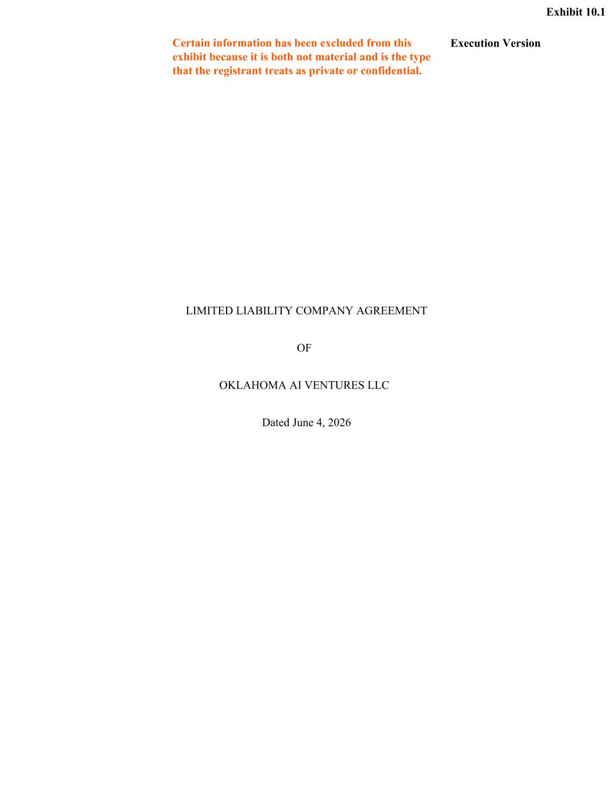
32
Execution Version LIMITED LIABILITY COMPANY AGREEMENT OF OKLAHOMA AI VENTURES LLC Dated June 4, 2026 Certain information has been excluded from this exhibit because it is both not material and is the type that the registrant treats as private or confidential. Exhibit 10.1

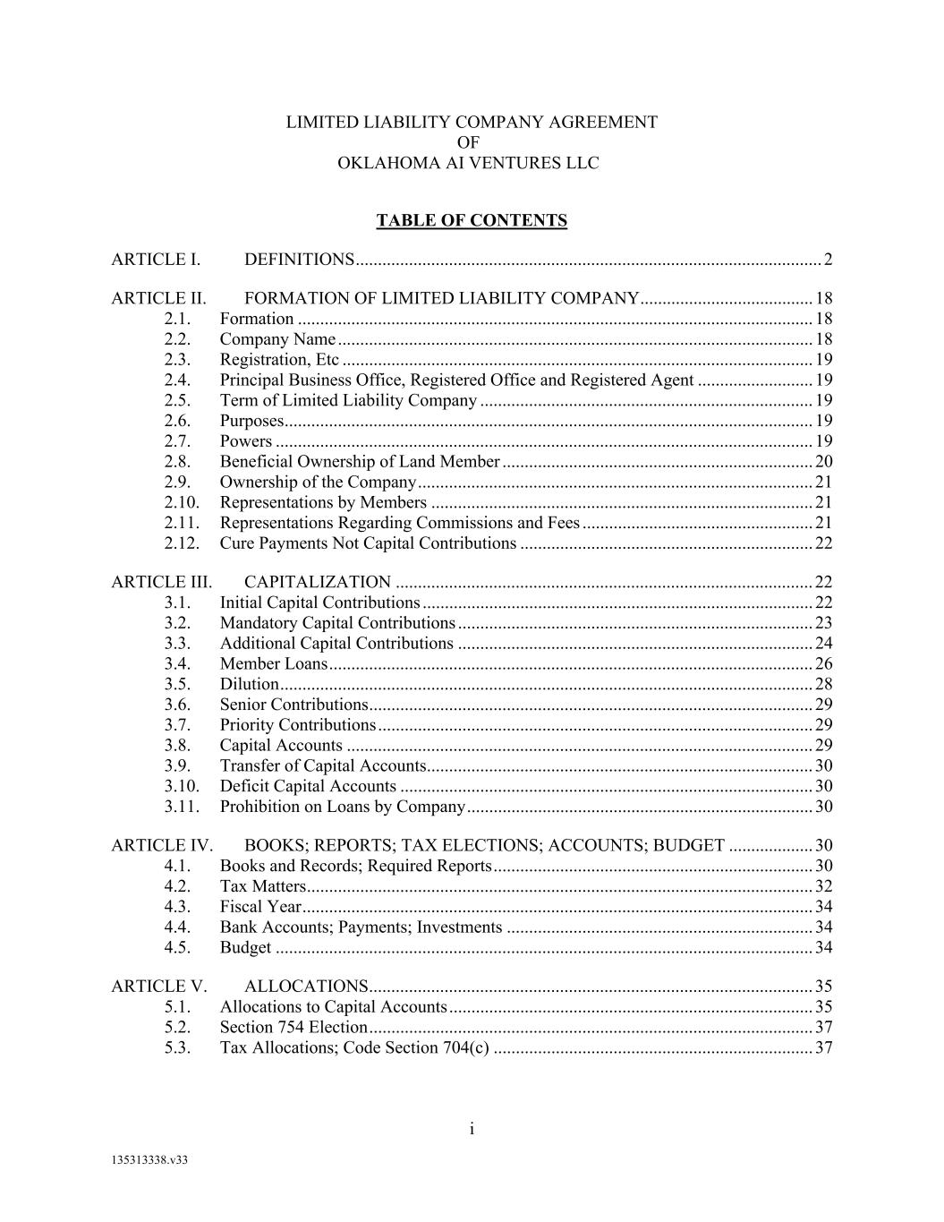
i 135313338.v33 LIMITED LIABILITY COMPANY AGREEMENT OF OKLAHOMA AI VENTURES LLC TABLE OF CONTENTS ARTICLE I. DEFINITIONS ......................................................................................................... 2 ARTICLE II. FORMATION OF LIMITED LIABILITY COMPANY ....................................... 18 2.1. Formation .................................................................................................................... 18 2.2. Company Name ........................................................................................................... 18 2.3. Registration, Etc .......................................................................................................... 19 2.4. Principal Business Office, Registered Office and Registered Agent .......................... 19 2.5. Term of Limited Liability Company ........................................................................... 19 2.6. Purposes ....................................................................................................................... 19 2.7. Powers ......................................................................................................................... 19 2.8. Beneficial Ownership of Land Member ...................................................................... 20 2.9. Ownership of the Company ......................................................................................... 21 2.10. Representations by Members ...................................................................................... 21 2.11. Representations Regarding Commissions and Fees .................................................... 21 2.12. Cure Payments Not Capital Contributions .................................................................. 22 ARTICLE III. CAPITALIZATION .............................................................................................. 22 3.1. Initial Capital Contributions ........................................................................................ 22 3.2. Mandatory Capital Contributions ................................................................................ 23 3.3. Additional Capital Contributions ................................................................................ 24 3.4. Member Loans ............................................................................................................. 26 3.5. Dilution ........................................................................................................................ 28 3.6. Senior Contributions .................................................................................................... 29 3.7. Priority Contributions .................................................................................................. 29 3.8. Capital Accounts ......................................................................................................... 29 3.9. Transfer of Capital Accounts ....................................................................................... 30 3.10. Deficit Capital Accounts ............................................................................................. 30 3.11. Prohibition on Loans by Company .............................................................................. 30 ARTICLE IV. BOOKS; REPORTS; TAX ELECTIONS; ACCOUNTS; BUDGET ................... 30 4.1. Books and Records; Required Reports ........................................................................ 30 4.2. Tax Matters .................................................................................................................. 32 4.3. Fiscal Year ................................................................................................................... 34 4.4. Bank Accounts; Payments; Investments ..................................................................... 34 4.5. Budget ......................................................................................................................... 34 ARTICLE V. ALLOCATIONS .................................................................................................... 35 5.1. Allocations to Capital Accounts .................................................................................. 35 5.2. Section 754 Election .................................................................................................... 37 5.3. Tax Allocations; Code Section 704(c) ........................................................................ 37

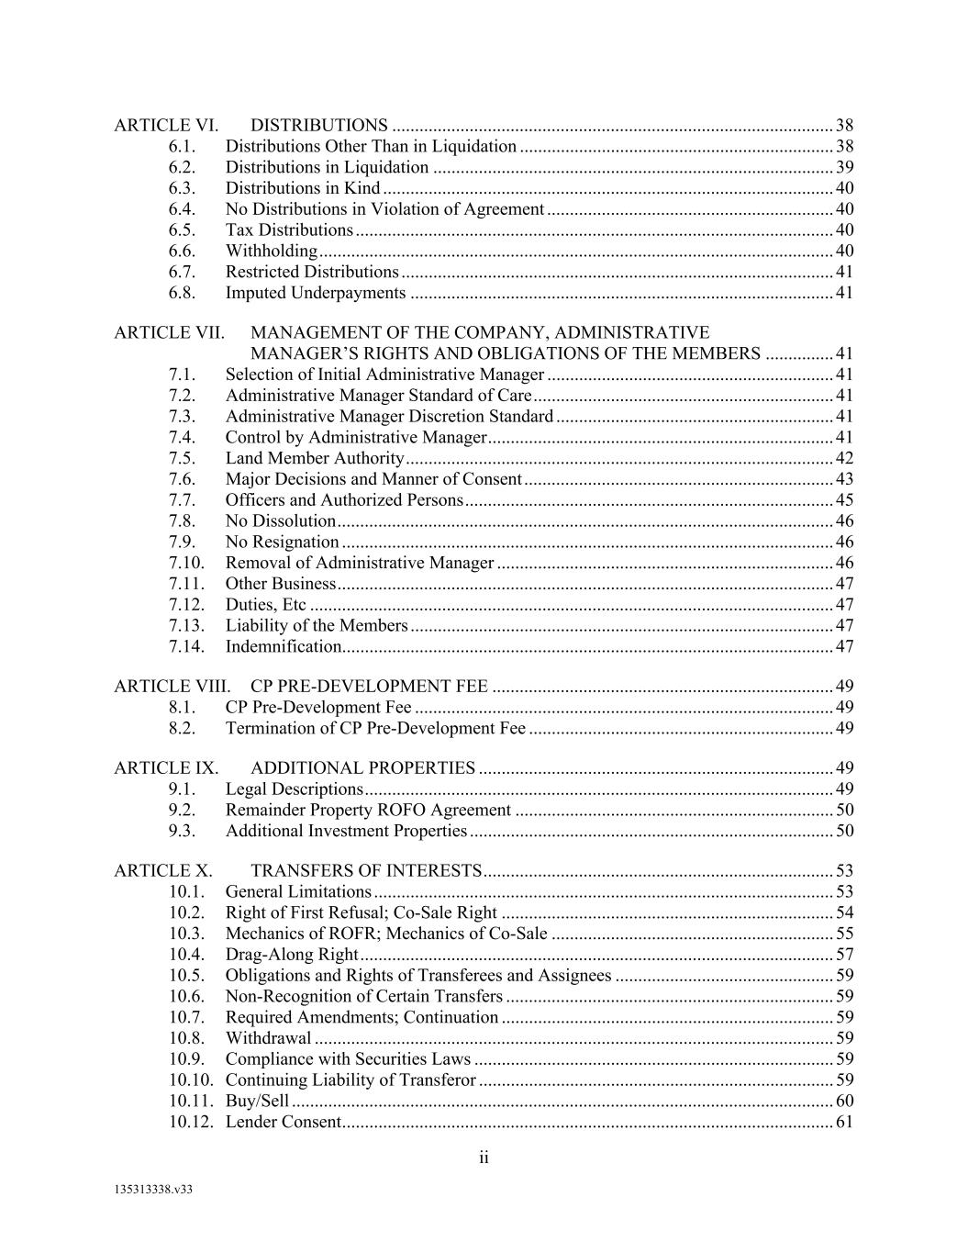
ii 135313338.v33 ARTICLE VI. DISTRIBUTIONS ................................................................................................. 38 6.1. Distributions Other Than in Liquidation ..................................................................... 38 6.2. Distributions in Liquidation ........................................................................................ 39 6.3. Distributions in Kind ................................................................................................... 40 6.4. No Distributions in Violation of Agreement ............................................................... 40 6.5. Tax Distributions ......................................................................................................... 40 6.6. Withholding ................................................................................................................. 40 6.7. Restricted Distributions ............................................................................................... 41 6.8. Imputed Underpayments ............................................................................................. 41 ARTICLE VII. MANAGEMENT OF THE COMPANY, ADMINISTRATIVE MANAGER’S RIGHTS AND OBLIGATIONS OF THE MEMBERS ............... 41 7.1. Selection of Initial Administrative Manager ............................................................... 41 7.2. Administrative Manager Standard of Care .................................................................. 41 7.3. Administrative Manager Discretion Standard ............................................................. 41 7.4. Control by Administrative Manager ............................................................................ 41 7.5. Land Member Authority .............................................................................................. 42 7.6. Major Decisions and Manner of Consent .................................................................... 43 7.7. Officers and Authorized Persons ................................................................................. 45 7.8. No Dissolution ............................................................................................................. 46 7.9. No Resignation ............................................................................................................ 46 7.10. Removal of Administrative Manager .......................................................................... 46 7.11. Other Business ............................................................................................................. 47 7.12. Duties, Etc ................................................................................................................... 47 7.13. Liability of the Members ............................................................................................. 47 7.14. Indemnification............................................................................................................ 47 ARTICLE VIII. CP PRE-DEVELOPMENT FEE ........................................................................... 49 8.1. CP Pre-Development Fee ............................................................................................ 49 8.2. Termination of CP Pre-Development Fee ................................................................... 49 ARTICLE IX. ADDITIONAL PROPERTIES .............................................................................. 49 9.1. Legal Descriptions ....................................................................................................... 49 9.2. Remainder Property ROFO Agreement ...................................................................... 50 9.3. Additional Investment Properties ................................................................................ 50 ARTICLE X. TRANSFERS OF INTERESTS ............................................................................. 53 10.1. General Limitations ..................................................................................................... 53 10.2. Right of First Refusal; Co-Sale Right ......................................................................... 54 10.3. Mechanics of ROFR; Mechanics of Co-Sale .............................................................. 55 10.4. Drag-Along Right ........................................................................................................ 57 10.5. Obligations and Rights of Transferees and Assignees ................................................ 59 10.6. Non-Recognition of Certain Transfers ........................................................................ 59 10.7. Required Amendments; Continuation ......................................................................... 59 10.8. Withdrawal .................................................................................................................. 59 10.9. Compliance with Securities Laws ............................................................................... 59 10.10. Continuing Liability of Transferor .............................................................................. 59 10.11. Buy/Sell ....................................................................................................................... 60 10.12. Lender Consent ............................................................................................................ 61

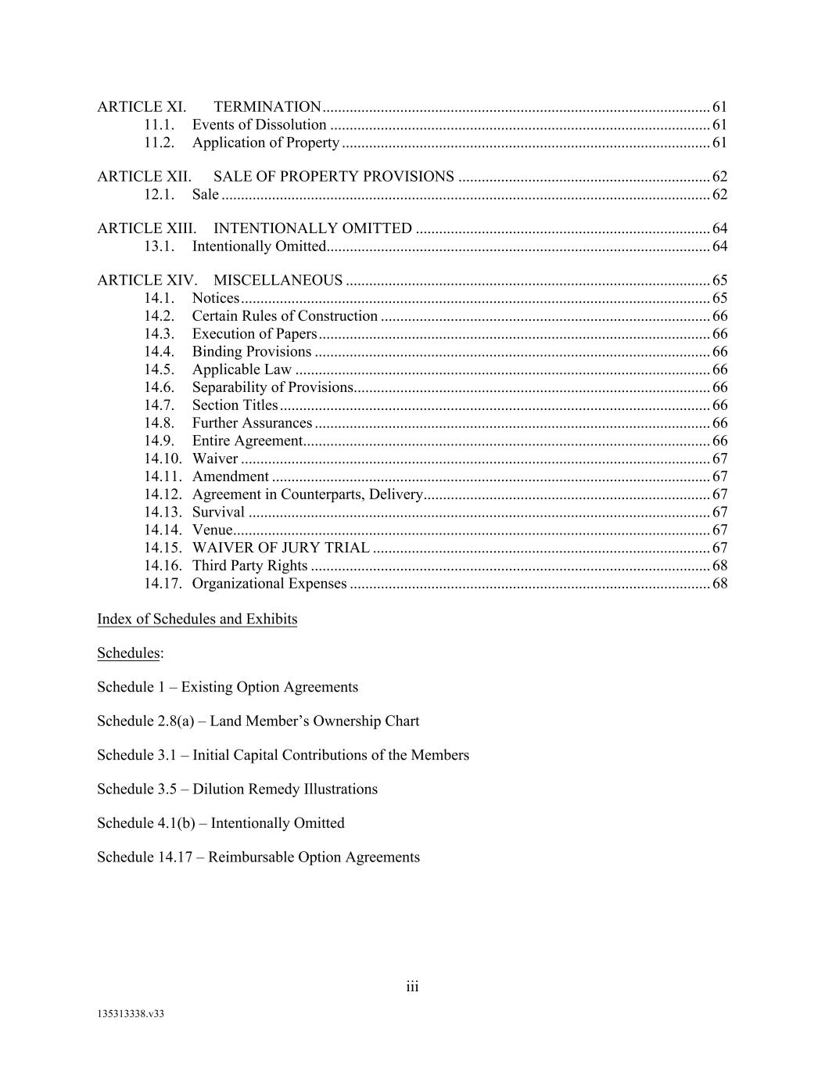
iii 135313338.v33 ARTICLE XI. TERMINATION .................................................................................................... 61 11.1. Events of Dissolution .................................................................................................. 61 11.2. Application of Property ............................................................................................... 61 ARTICLE XII. SALE OF PROPERTY PROVISIONS ................................................................. 62 12.1. Sale .............................................................................................................................. 62 ARTICLE XIII. INTENTIONALLY OMITTED ............................................................................ 64 13.1. Intentionally Omitted ................................................................................................... 64 ARTICLE XIV. MISCELLANEOUS .............................................................................................. 65 14.1. Notices ......................................................................................................................... 65 14.2. Certain Rules of Construction ..................................................................................... 66 14.3. Execution of Papers ..................................................................................................... 66 14.4. Binding Provisions ...................................................................................................... 66 14.5. Applicable Law ........................................................................................................... 66 14.6. Separability of Provisions ............................................................................................ 66 14.7. Section Titles ............................................................................................................... 66 14.8. Further Assurances ...................................................................................................... 66 14.9. Entire Agreement ......................................................................................................... 66 14.10. Waiver ......................................................................................................................... 67 14.11. Amendment ................................................................................................................. 67 14.12. Agreement in Counterparts, Delivery .......................................................................... 67 14.13. Survival ....................................................................................................................... 67 14.14. Venue ........................................................................................................................... 67 14.15. WAIVER OF JURY TRIAL ....................................................................................... 67 14.16. Third Party Rights ....................................................................................................... 68 14.17. Organizational Expenses ............................................................................................. 68 Index of Schedules and Exhibits Schedules: Schedule 1 – Existing Option Agreements Schedule 2.8(a) – Land Member’s Ownership Chart Schedule 3.1 – Initial Capital Contributions of the Members Schedule 3.5 – Dilution Remedy Illustrations Schedule 4.1(b) – Intentionally Omitted Schedule 14.17 – Reimbursable Option Agreements

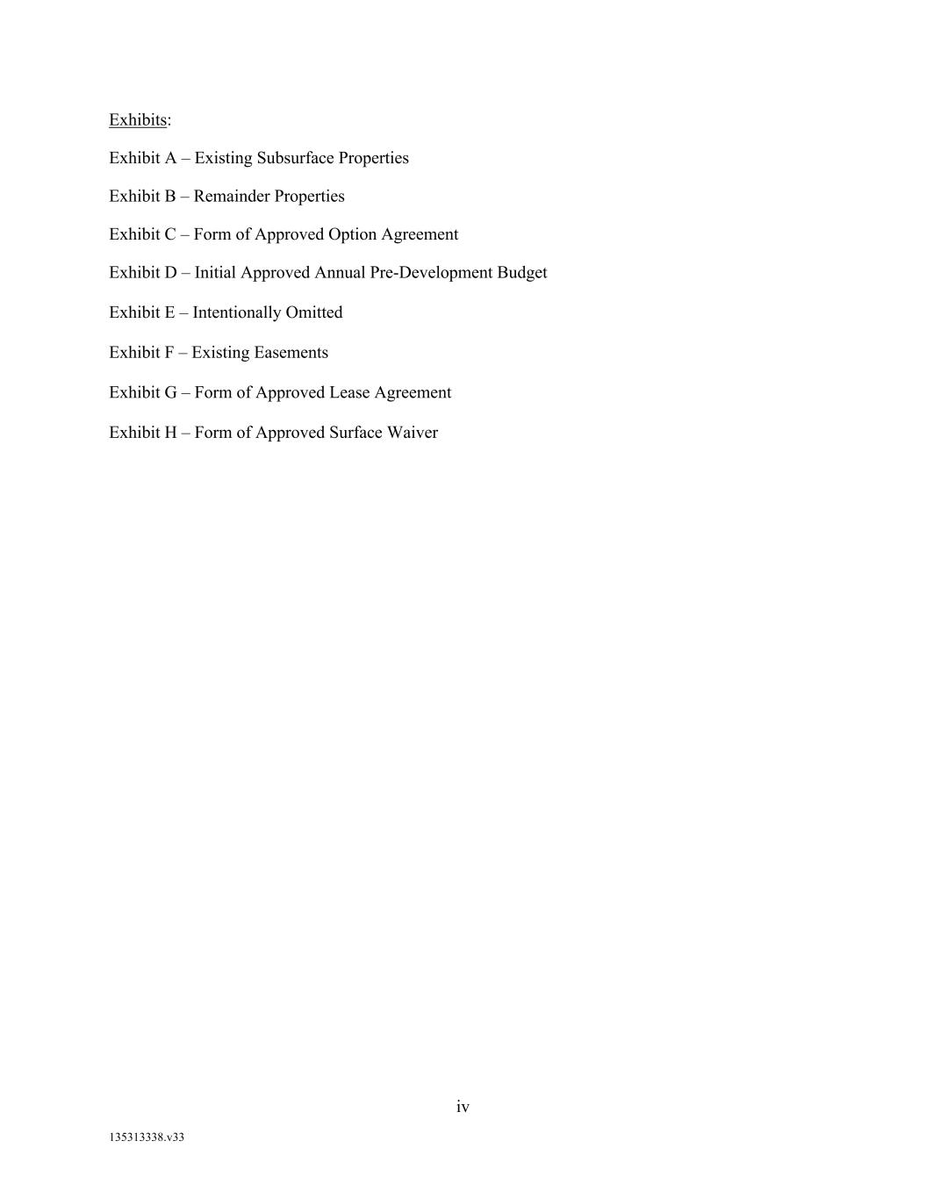
iv 135313338.v33 Exhibits: Exhibit A – Existing Subsurface Properties Exhibit B – Remainder Properties Exhibit C – Form of Approved Option Agreement Exhibit D – Initial Approved Annual Pre-Development Budget Exhibit E – Intentionally Omitted Exhibit F – Existing Easements Exhibit G – Form of Approved Lease Agreement Exhibit H – Form of Approved Surface Waiver

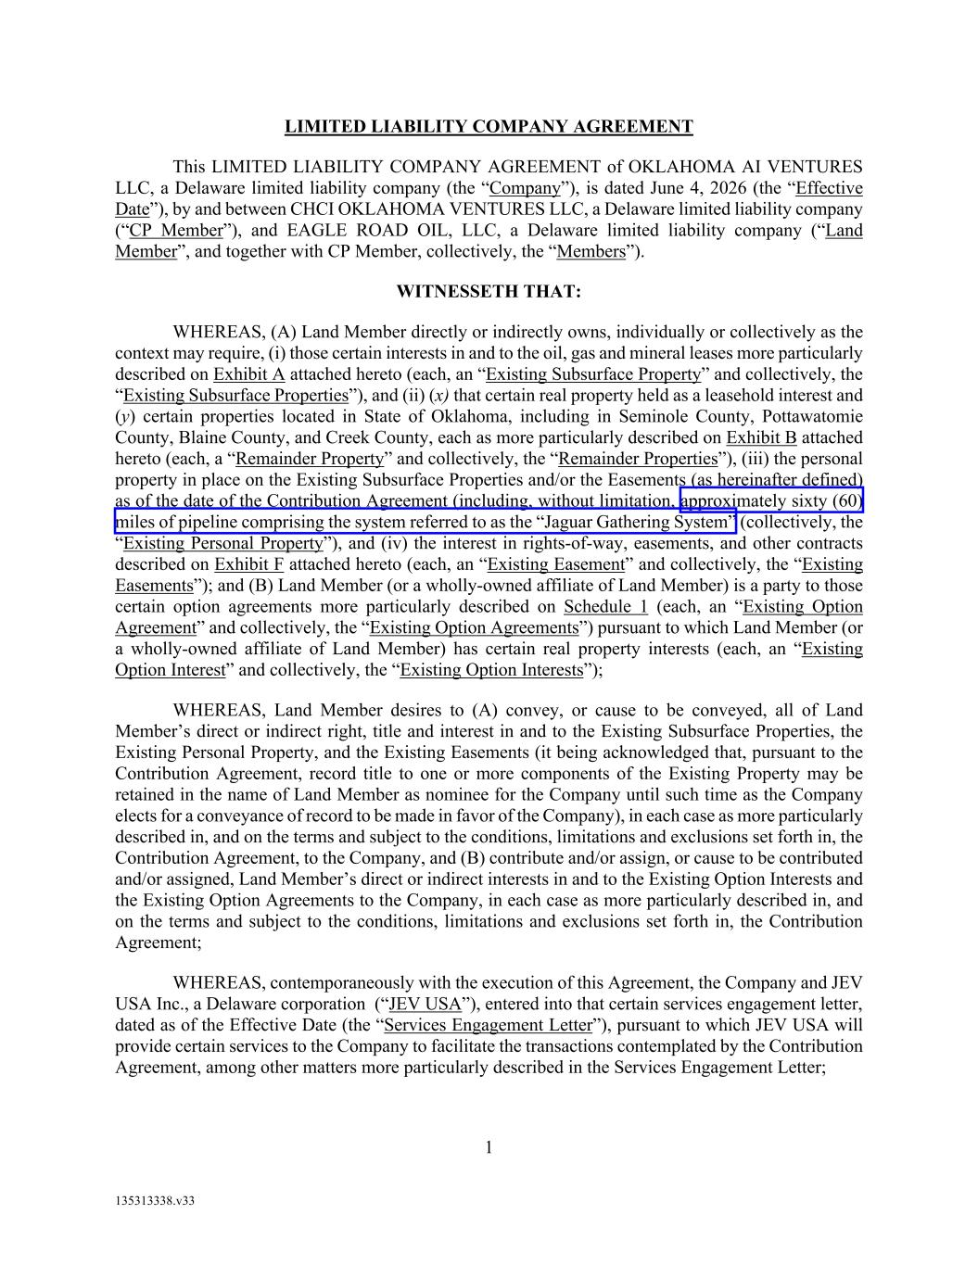
1 135313338.v33 LIMITED LIABILITY COMPANY AGREEMENT This LIMITED LIABILITY COMPANY AGREEMENT of OKLAHOMA AI VENTURES LLC, a Delaware limited liability company (the “Company”), is dated June 4, 2026 (the “Effective Date”), by and between CHCI OKLAHOMA VENTURES LLC, a Delaware limited liability company (“CP Member”), and EAGLE ROAD OIL, LLC, a Delaware limited liability company (“Land Member”, and together with CP Member, collectively, the “Members”). WITNESSETH THAT: WHEREAS, (A) Land Member directly or indirectly owns, individually or collectively as the context may require, (i) those certain interests in and to the oil, gas and mineral leases more particularly described on Exhibit A attached hereto (each, an “Existing Subsurface Property” and collectively, the “Existing Subsurface Properties”), and (ii) (x) that certain real property held as a leasehold interest and (y) certain properties located in State of Oklahoma, including in Seminole County, Pottawatomie County, Blaine County, and Creek County, each as more particularly described on Exhibit B attached hereto (each, a “Remainder Property” and collectively, the “Remainder Properties”), (iii) the personal property in place on the Existing Subsurface Properties and/or the Easements (as hereinafter defined) as of the date of the Contribution Agreement (including, without limitation, approximately sixty (60) miles of pipeline comprising the system referred to as the “Jaguar Gathering System” (collectively, the “Existing Personal Property”), and (iv) the interest in rights-of-way, easements, and other contracts described on Exhibit F attached hereto (each, an “Existing Easement” and collectively, the “Existing Easements”); and (B) Land Member (or a wholly-owned affiliate of Land Member) is a party to those certain option agreements more particularly described on Schedule 1 (each, an “Existing Option Agreement” and collectively, the “Existing Option Agreements”) pursuant to which Land Member (or a wholly-owned affiliate of Land Member) has certain real property interests (each, an “Existing Option Interest” and collectively, the “Existing Option Interests”); WHEREAS, Land Member desires to (A) convey, or cause to be conveyed, all of Land Member’s direct or indirect right, title and interest in and to the Existing Subsurface Properties, the Existing Personal Property, and the Existing Easements (it being acknowledged that, pursuant to the Contribution Agreement, record title to one or more components of the Existing Property may be retained in the name of Land Member as nominee for the Company until such time as the Company elects for a conveyance of record to be made in favor of the Company), in each case as more particularly described in, and on the terms and subject to the conditions, limitations and exclusions set forth in, the Contribution Agreement, to the Company, and (B) contribute and/or assign, or cause to be contributed and/or assigned, Land Member’s direct or indirect interests in and to the Existing Option Interests and the Existing Option Agreements to the Company, in each case as more particularly described in, and on the terms and subject to the conditions, limitations and exclusions set forth in, the Contribution Agreement; WHEREAS, contemporaneously with the execution of this Agreement, the Company and JEV USA Inc., a Delaware corporation (“JEV USA”), entered into that certain services engagement letter, dated as of the Effective Date (the “Services Engagement Letter”), pursuant to which JEV USA will provide certain services to the Company to facilitate the transactions contemplated by the Contribution Agreement, among other matters more particularly described in the Services Engagement Letter;

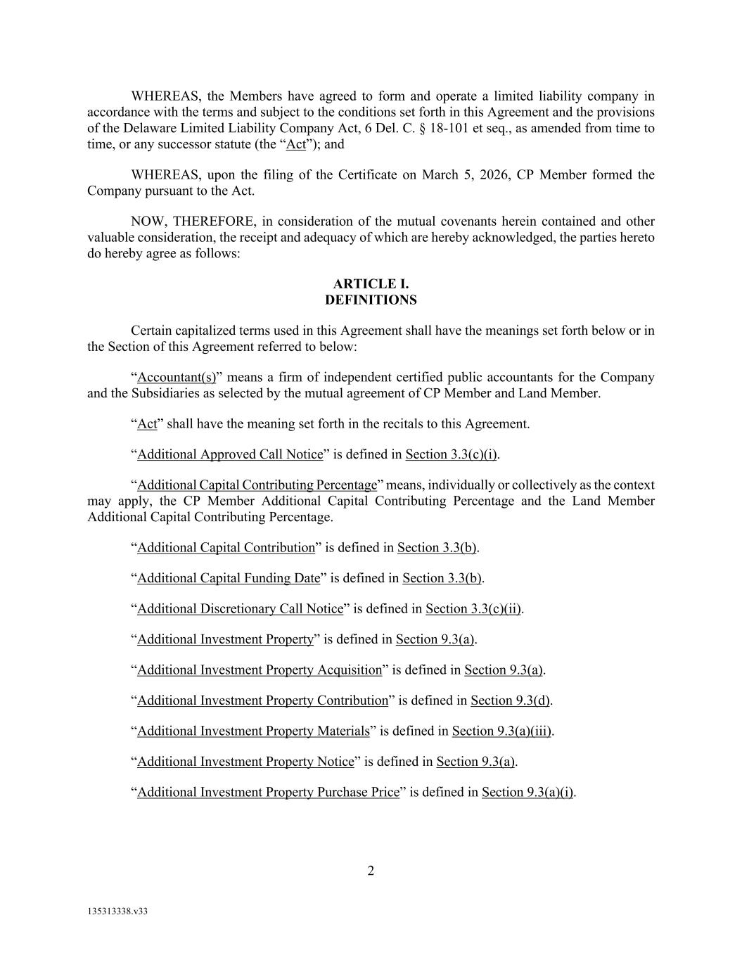
2 135313338.v33 WHEREAS, the Members have agreed to form and operate a limited liability company in accordance with the terms and subject to the conditions set forth in this Agreement and the provisions of the Delaware Limited Liability Company Act, 6 Del. C. § 18-101 et seq., as amended from time to time, or any successor statute (the “Act”); and WHEREAS, upon the filing of the Certificate on March 5, 2026, CP Member formed the Company pursuant to the Act. NOW, THEREFORE, in consideration of the mutual covenants herein contained and other valuable consideration, the receipt and adequacy of which are hereby acknowledged, the parties hereto do hereby agree as follows: ARTICLE I. DEFINITIONS Certain capitalized terms used in this Agreement shall have the meanings set forth below or in the Section of this Agreement referred to below: “Accountant(s)” means a firm of independent certified public accountants for the Company and the Subsidiaries as selected by the mutual agreement of CP Member and Land Member. “Act” shall have the meaning set forth in the recitals to this Agreement. “Additional Approved Call Notice” is defined in Section 3.3(c)(i). “Additional Capital Contributing Percentage” means, individually or collectively as the context may apply, the CP Member Additional Capital Contributing Percentage and the Land Member Additional Capital Contributing Percentage. “Additional Capital Contribution” is defined in Section 3.3(b). “Additional Capital Funding Date” is defined in Section 3.3(b). “Additional Discretionary Call Notice” is defined in Section 3.3(c)(ii). “Additional Investment Property” is defined in Section 9.3(a). “Additional Investment Property Acquisition” is defined in Section 9.3(a). “Additional Investment Property Contribution” is defined in Section 9.3(d). “Additional Investment Property Materials” is defined in Section 9.3(a)(iii). “Additional Investment Property Notice” is defined in Section 9.3(a). “Additional Investment Property Purchase Price” is defined in Section 9.3(a)(i).

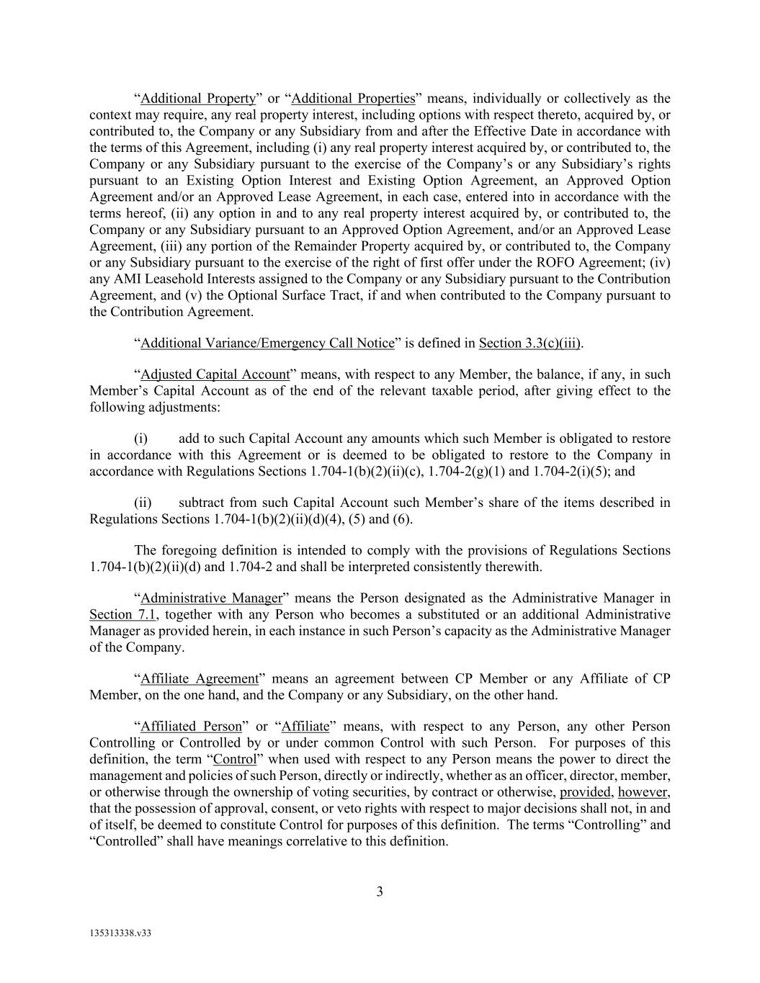
3 135313338.v33 “Additional Property” or “Additional Properties” means, individually or collectively as the context may require, any real property interest, including options with respect thereto, acquired by, or contributed to, the Company or any Subsidiary from and after the Effective Date in accordance with the terms of this Agreement, including (i) any real property interest acquired by, or contributed to, the Company or any Subsidiary pursuant to the exercise of the Company’s or any Subsidiary’s rights pursuant to an Existing Option Interest and Existing Option Agreement, an Approved Option Agreement and/or an Approved Lease Agreement, in each case, entered into in accordance with the terms hereof, (ii) any option in and to any real property interest acquired by, or contributed to, the Company or any Subsidiary pursuant to an Approved Option Agreement, and/or an Approved Lease Agreement, (iii) any portion of the Remainder Property acquired by, or contributed to, the Company or any Subsidiary pursuant to the exercise of the right of first offer under the ROFO Agreement; (iv) any AMI Leasehold Interests assigned to the Company or any Subsidiary pursuant to the Contribution Agreement, and (v) the Optional Surface Tract, if and when contributed to the Company pursuant to the Contribution Agreement. “Additional Variance/Emergency Call Notice” is defined in Section 3.3(c)(iii). “Adjusted Capital Account” means, with respect to any Member, the balance, if any, in such Member’s Capital Account as of the end of the relevant taxable period, after giving effect to the following adjustments: (i) add to such Capital Account any amounts which such Member is obligated to restore in accordance with this Agreement or is deemed to be obligated to restore to the Company in accordance with Regulations Sections 1.704-1(b)(2)(ii)(c), 1.704-2(g)(1) and 1.704-2(i)(5); and (ii) subtract from such Capital Account such Member’s share of the items described in Regulations Sections 1.704-1(b)(2)(ii)(d)(4), (5) and (6). The foregoing definition is intended to comply with the provisions of Regulations Sections 1.704-1(b)(2)(ii)(d) and 1.704-2 and shall be interpreted consistently therewith. “Administrative Manager” means the Person designated as the Administrative Manager in Section 7.1, together with any Person who becomes a substituted or an additional Administrative Manager as provided herein, in each instance in such Person’s capacity as the Administrative Manager of the Company. “Affiliate Agreement” means an agreement between CP Member or any Affiliate of CP Member, on the one hand, and the Company or any Subsidiary, on the other hand. “Affiliated Person” or “Affiliate” means, with respect to any Person, any other Person Controlling or Controlled by or under common Control with such Person. For purposes of this definition, the term “Control” when used with respect to any Person means the power to direct the management and policies of such Person, directly or indirectly, whether as an officer, director, member, or otherwise through the ownership of voting securities, by contract or otherwise, provided, however, that the possession of approval, consent, or veto rights with respect to major decisions shall not, in and of itself, be deemed to constitute Control for purposes of this definition. The terms “Controlling” and “Controlled” shall have meanings correlative to this definition.

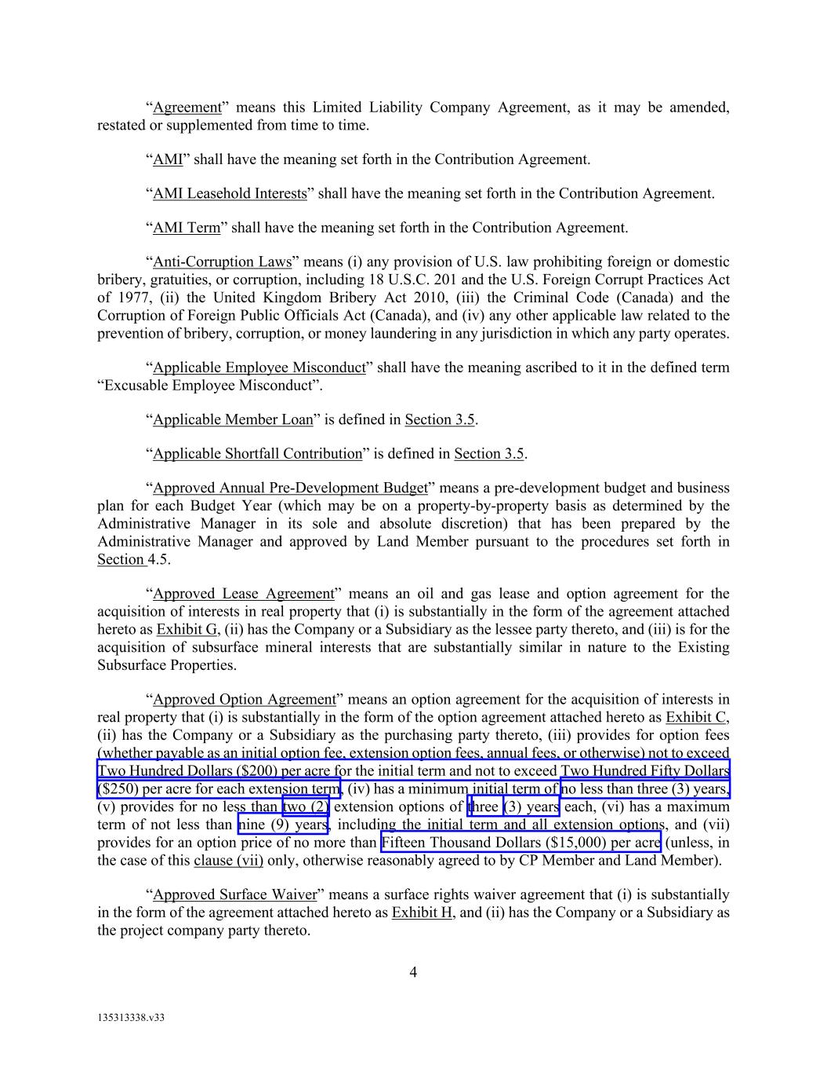
4 135313338.v33 “Agreement” means this Limited Liability Company Agreement, as it may be amended, restated or supplemented from time to time. “AMI” shall have the meaning set forth in the Contribution Agreement. “AMI Leasehold Interests” shall have the meaning set forth in the Contribution Agreement. “AMI Term” shall have the meaning set forth in the Contribution Agreement. “Anti-Corruption Laws” means (i) any provision of U.S. law prohibiting foreign or domestic bribery, gratuities, or corruption, including 18 U.S.C. 201 and the U.S. Foreign Corrupt Practices Act of 1977, (ii) the United Kingdom Bribery Act 2010, (iii) the Criminal Code (Canada) and the Corruption of Foreign Public Officials Act (Canada), and (iv) any other applicable law related to the prevention of bribery, corruption, or money laundering in any jurisdiction in which any party operates. “Applicable Employee Misconduct” shall have the meaning ascribed to it in the defined term “Excusable Employee Misconduct”. “Applicable Member Loan” is defined in Section 3.5. “Applicable Shortfall Contribution” is defined in Section 3.5. “Approved Annual Pre-Development Budget” means a pre-development budget and business plan for each Budget Year (which may be on a property-by-property basis as determined by the Administrative Manager in its sole and absolute discretion) that has been prepared by the Administrative Manager and approved by Land Member pursuant to the procedures set forth in Section 4.5. “Approved Lease Agreement” means an oil and gas lease and option agreement for the acquisition of interests in real property that (i) is substantially in the form of the agreement attached hereto as Exhibit G, (ii) has the Company or a Subsidiary as the lessee party thereto, and (iii) is for the acquisition of subsurface mineral interests that are substantially similar in nature to the Existing Subsurface Properties. “Approved Option Agreement” means an option agreement for the acquisition of interests in real property that (i) is substantially in the form of the option agreement attached hereto as Exhibit C, (ii) has the Company or a Subsidiary as the purchasing party thereto, (iii) provides for option fees (whether payable as an initial option fee, extension option fees, annual fees, or otherwise) not to exceed Two Hundred Dollars ($200) per acre for the initial term and not to exceed Two Hundred Fifty Dollars ($250) per acre for each extension term, (iv) has a minimum initial term of no less than three (3) years, (v) provides for no less than two (2) extension options of three (3) years each, (vi) has a maximum term of not less than nine (9) years, including the initial term and all extension options, and (vii) provides for an option price of no more than Fifteen Thousand Dollars ($15,000) per acre (unless, in the case of this clause (vii) only, otherwise reasonably agreed to by CP Member and Land Member). “Approved Surface Waiver” means a surface rights waiver agreement that (i) is substantially in the form of the agreement attached hereto as Exhibit H, and (ii) has the Company or a Subsidiary as the project company party thereto.

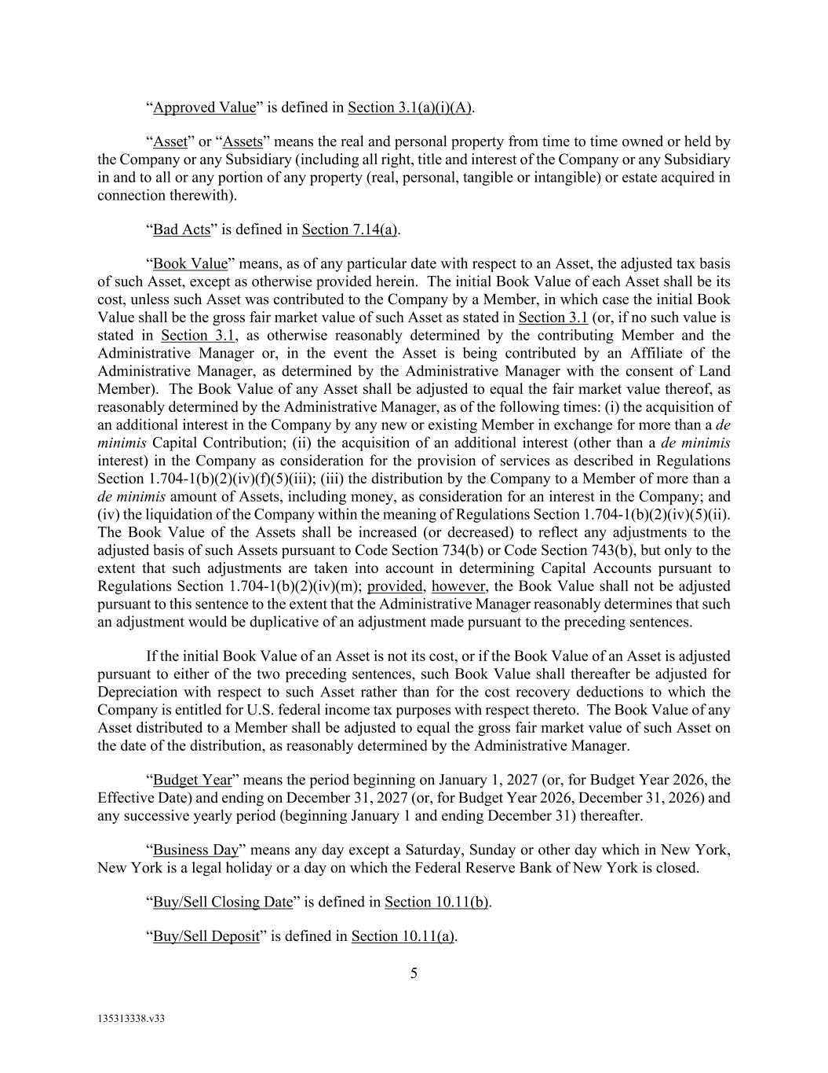
5 135313338.v33 “Approved Value” is defined in Section 3.1(a)(i)(A). “Asset” or “Assets” means the real and personal property from time to time owned or held by the Company or any Subsidiary (including all right, title and interest of the Company or any Subsidiary in and to all or any portion of any property (real, personal, tangible or intangible) or estate acquired in connection therewith). “Bad Acts” is defined in Section 7.14(a). “Book Value” means, as of any particular date with respect to an Asset, the adjusted tax basis of such Asset, except as otherwise provided herein. The initial Book Value of each Asset shall be its cost, unless such Asset was contributed to the Company by a Member, in which case the initial Book Value shall be the gross fair market value of such Asset as stated in Section 3.1 (or, if no such value is stated in Section 3.1, as otherwise reasonably determined by the contributing Member and the Administrative Manager or, in the event the Asset is being contributed by an Affiliate of the Administrative Manager, as determined by the Administrative Manager with the consent of Land Member). The Book Value of any Asset shall be adjusted to equal the fair market value thereof, as reasonably determined by the Administrative Manager, as of the following times: (i) the acquisition of an additional interest in the Company by any new or existing Member in exchange for more than a de minimis Capital Contribution; (ii) the acquisition of an additional interest (other than a de minimis interest) in the Company as consideration for the provision of services as described in Regulations Section 1.704-1(b)(2)(iv)(f)(5)(iii); (iii) the distribution by the Company to a Member of more than a de minimis amount of Assets, including money, as consideration for an interest in the Company; and (iv) the liquidation of the Company within the meaning of Regulations Section 1.704-1(b)(2)(iv)(5)(ii). The Book Value of the Assets shall be increased (or decreased) to reflect any adjustments to the adjusted basis of such Assets pursuant to Code Section 734(b) or Code Section 743(b), but only to the extent that such adjustments are taken into account in determining Capital Accounts pursuant to Regulations Section 1.704-1(b)(2)(iv)(m); provided, however, the Book Value shall not be adjusted pursuant to this sentence to the extent that the Administrative Manager reasonably determines that such an adjustment would be duplicative of an adjustment made pursuant to the preceding sentences. If the initial Book Value of an Asset is not its cost, or if the Book Value of an Asset is adjusted pursuant to either of the two preceding sentences, such Book Value shall thereafter be adjusted for Depreciation with respect to such Asset rather than for the cost recovery deductions to which the Company is entitled for U.S. federal income tax purposes with respect thereto. The Book Value of any Asset distributed to a Member shall be adjusted to equal the gross fair market value of such Asset on the date of the distribution, as reasonably determined by the Administrative Manager. “Budget Year” means the period beginning on January 1, 2027 (or, for Budget Year 2026, the Effective Date) and ending on December 31, 2027 (or, for Budget Year 2026, December 31, 2026) and any successive yearly period (beginning January 1 and ending December 31) thereafter. “Business Day” means any day except a Saturday, Sunday or other day which in New York, New York is a legal holiday or a day on which the Federal Reserve Bank of New York is closed. “Buy/Sell Closing Date” is defined in Section 10.11(b). “Buy/Sell Deposit” is defined in Section 10.11(a).

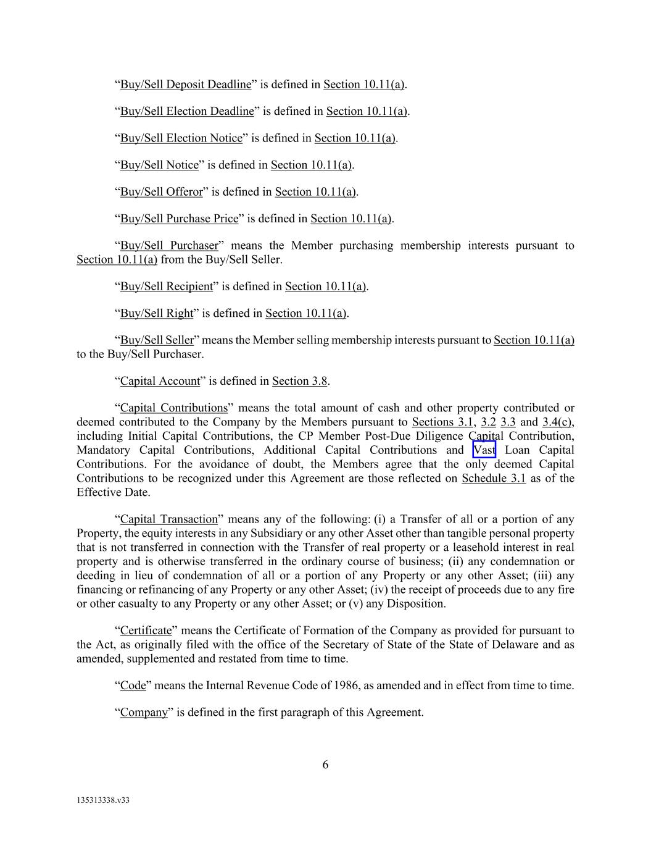
6 135313338.v33 “Buy/Sell Deposit Deadline” is defined in Section 10.11(a). “Buy/Sell Election Deadline” is defined in Section 10.11(a). “Buy/Sell Election Notice” is defined in Section 10.11(a). “Buy/Sell Notice” is defined in Section 10.11(a). “Buy/Sell Offeror” is defined in Section 10.11(a). “Buy/Sell Purchase Price” is defined in Section 10.11(a). “Buy/Sell Purchaser” means the Member purchasing membership interests pursuant to Section 10.11(a) from the Buy/Sell Seller. “Buy/Sell Recipient” is defined in Section 10.11(a). “Buy/Sell Right” is defined in Section 10.11(a). “Buy/Sell Seller” means the Member selling membership interests pursuant to Section 10.11(a) to the Buy/Sell Purchaser. “Capital Account” is defined in Section 3.8. “Capital Contributions” means the total amount of cash and other property contributed or deemed contributed to the Company by the Members pursuant to Sections 3.1, 3.2 3.3 and 3.4(c), including Initial Capital Contributions, the CP Member Post-Due Diligence Capital Contribution, Mandatory Capital Contributions, Additional Capital Contributions and Vast Loan Capital Contributions. For the avoidance of doubt, the Members agree that the only deemed Capital Contributions to be recognized under this Agreement are those reflected on Schedule 3.1 as of the Effective Date. “Capital Transaction” means any of the following: (i) a Transfer of all or a portion of any Property, the equity interests in any Subsidiary or any other Asset other than tangible personal property that is not transferred in connection with the Transfer of real property or a leasehold interest in real property and is otherwise transferred in the ordinary course of business; (ii) any condemnation or deeding in lieu of condemnation of all or a portion of any Property or any other Asset; (iii) any financing or refinancing of any Property or any other Asset; (iv) the receipt of proceeds due to any fire or other casualty to any Property or any other Asset; or (v) any Disposition. “Certificate” means the Certificate of Formation of the Company as provided for pursuant to the Act, as originally filed with the office of the Secretary of State of the State of Delaware and as amended, supplemented and restated from time to time. “Code” means the Internal Revenue Code of 1986, as amended and in effect from time to time. “Company” is defined in the first paragraph of this Agreement.

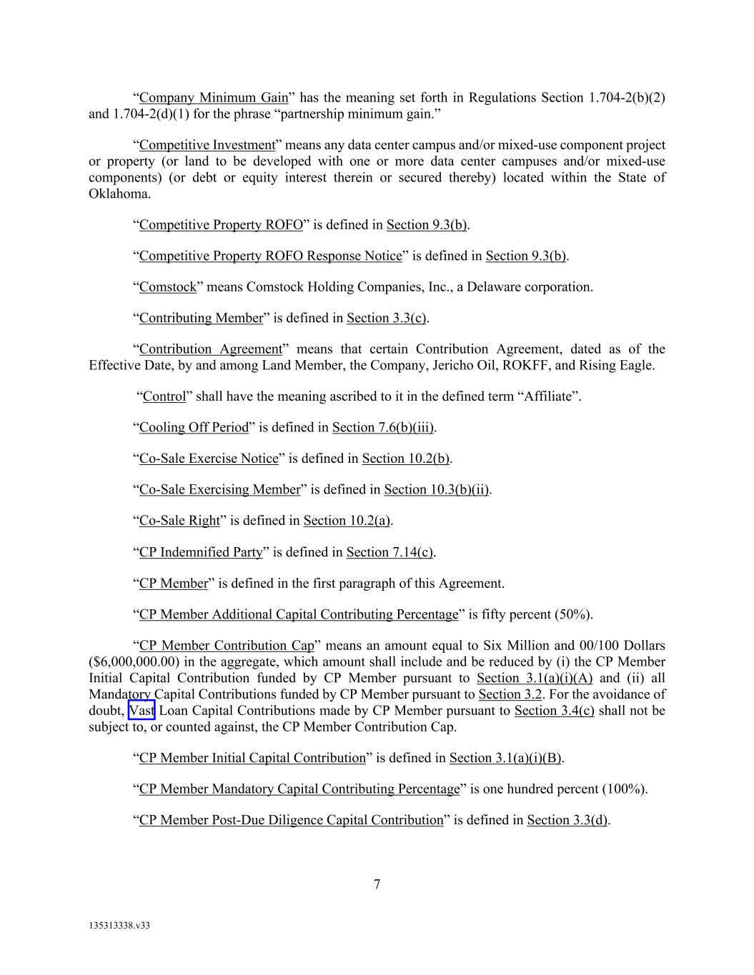
7 135313338.v33 “Company Minimum Gain” has the meaning set forth in Regulations Section 1.704-2(b)(2) and 1.704-2(d)(1) for the phrase “partnership minimum gain.” “Competitive Investment” means any data center campus and/or mixed-use component project or property (or land to be developed with one or more data center campuses and/or mixed-use components) (or debt or equity interest therein or secured thereby) located within the State of Oklahoma. “Competitive Property ROFO” is defined in Section 9.3(b). “Competitive Property ROFO Response Notice” is defined in Section 9.3(b). “Comstock” means Comstock Holding Companies, Inc., a Delaware corporation. “Contributing Member” is defined in Section 3.3(c). “Contribution Agreement” means that certain Contribution Agreement, dated as of the Effective Date, by and among Land Member, the Company, Jericho Oil, ROKFF, and Rising Eagle. “Control” shall have the meaning ascribed to it in the defined term “Affiliate”. “Cooling Off Period” is defined in Section 7.6(b)(iii). “Co-Sale Exercise Notice” is defined in Section 10.2(b). “Co-Sale Exercising Member” is defined in Section 10.3(b)(ii). “Co-Sale Right” is defined in Section 10.2(a). “CP Indemnified Party” is defined in Section 7.14(c). “CP Member” is defined in the first paragraph of this Agreement. “CP Member Additional Capital Contributing Percentage” is fifty percent (50%). “CP Member Contribution Cap” means an amount equal to Six Million and 00/100 Dollars ($6,000,000.00) in the aggregate, which amount shall include and be reduced by (i) the CP Member Initial Capital Contribution funded by CP Member pursuant to Section 3.1(a)(i)(A) and (ii) all Mandatory Capital Contributions funded by CP Member pursuant to Section 3.2. For the avoidance of doubt, Vast Loan Capital Contributions made by CP Member pursuant to Section 3.4(c) shall not be subject to, or counted against, the CP Member Contribution Cap. “CP Member Initial Capital Contribution” is defined in Section 3.1(a)(i)(B). “CP Member Mandatory Capital Contributing Percentage” is one hundred percent (100%). “CP Member Post-Due Diligence Capital Contribution” is defined in Section 3.3(d).

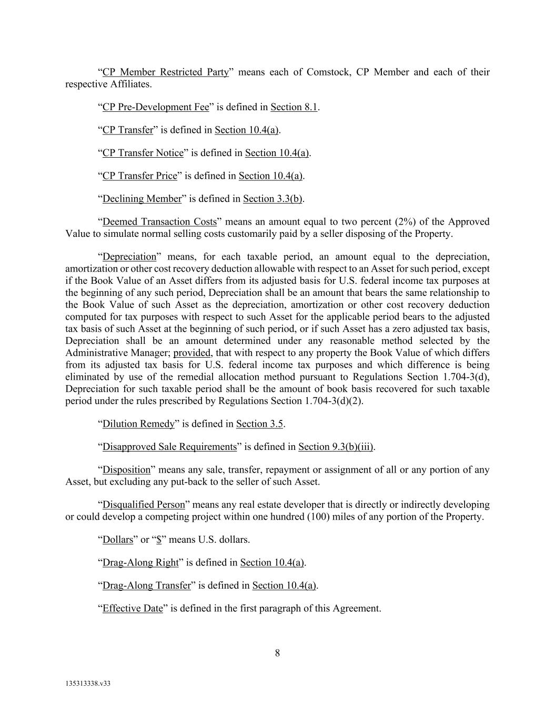
8 135313338.v33 “CP Member Restricted Party” means each of Comstock, CP Member and each of their respective Affiliates. “CP Pre-Development Fee” is defined in Section 8.1. “CP Transfer” is defined in Section 10.4(a). “CP Transfer Notice” is defined in Section 10.4(a). “CP Transfer Price” is defined in Section 10.4(a). “Declining Member” is defined in Section 3.3(b). “Deemed Transaction Costs” means an amount equal to two percent (2%) of the Approved Value to simulate normal selling costs customarily paid by a seller disposing of the Property. “Depreciation” means, for each taxable period, an amount equal to the depreciation, amortization or other cost recovery deduction allowable with respect to an Asset for such period, except if the Book Value of an Asset differs from its adjusted basis for U.S. federal income tax purposes at the beginning of any such period, Depreciation shall be an amount that bears the same relationship to the Book Value of such Asset as the depreciation, amortization or other cost recovery deduction computed for tax purposes with respect to such Asset for the applicable period bears to the adjusted tax basis of such Asset at the beginning of such period, or if such Asset has a zero adjusted tax basis, Depreciation shall be an amount determined under any reasonable method selected by the Administrative Manager; provided, that with respect to any property the Book Value of which differs from its adjusted tax basis for U.S. federal income tax purposes and which difference is being eliminated by use of the remedial allocation method pursuant to Regulations Section 1.704-3(d), Depreciation for such taxable period shall be the amount of book basis recovered for such taxable period under the rules prescribed by Regulations Section 1.704-3(d)(2). “Dilution Remedy” is defined in Section 3.5. “Disapproved Sale Requirements” is defined in Section 9.3(b)(iii). “Disposition” means any sale, transfer, repayment or assignment of all or any portion of any Asset, but excluding any put-back to the seller of such Asset. “Disqualified Person” means any real estate developer that is directly or indirectly developing or could develop a competing project within one hundred (100) miles of any portion of the Property. “Dollars” or “$” means U.S. dollars. “Drag-Along Right” is defined in Section 10.4(a). “Drag-Along Transfer” is defined in Section 10.4(a). “Effective Date” is defined in the first paragraph of this Agreement.

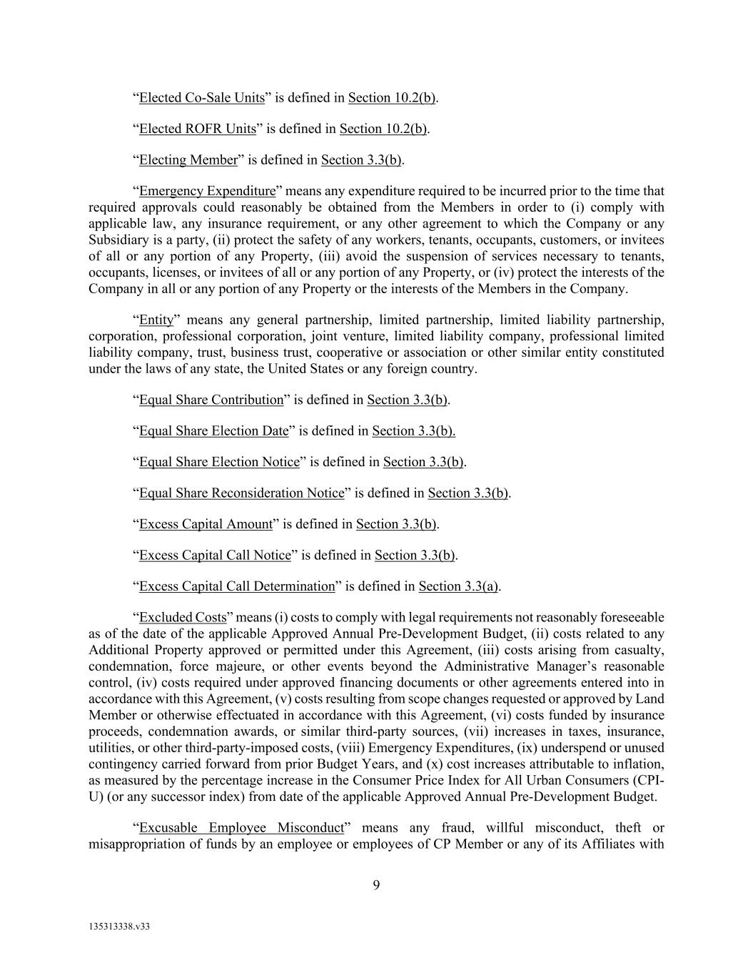
9 135313338.v33 “Elected Co-Sale Units” is defined in Section 10.2(b). “Elected ROFR Units” is defined in Section 10.2(b). “Electing Member” is defined in Section 3.3(b). “Emergency Expenditure” means any expenditure required to be incurred prior to the time that required approvals could reasonably be obtained from the Members in order to (i) comply with applicable law, any insurance requirement, or any other agreement to which the Company or any Subsidiary is a party, (ii) protect the safety of any workers, tenants, occupants, customers, or invitees of all or any portion of any Property, (iii) avoid the suspension of services necessary to tenants, occupants, licenses, or invitees of all or any portion of any Property, or (iv) protect the interests of the Company in all or any portion of any Property or the interests of the Members in the Company. “Entity” means any general partnership, limited partnership, limited liability partnership, corporation, professional corporation, joint venture, limited liability company, professional limited liability company, trust, business trust, cooperative or association or other similar entity constituted under the laws of any state, the United States or any foreign country. “Equal Share Contribution” is defined in Section 3.3(b). “Equal Share Election Date” is defined in Section 3.3(b). “Equal Share Election Notice” is defined in Section 3.3(b). “Equal Share Reconsideration Notice” is defined in Section 3.3(b). “Excess Capital Amount” is defined in Section 3.3(b). “Excess Capital Call Notice” is defined in Section 3.3(b). “Excess Capital Call Determination” is defined in Section 3.3(a). “Excluded Costs” means (i) costs to comply with legal requirements not reasonably foreseeable as of the date of the applicable Approved Annual Pre-Development Budget, (ii) costs related to any Additional Property approved or permitted under this Agreement, (iii) costs arising from casualty, condemnation, force majeure, or other events beyond the Administrative Manager’s reasonable control, (iv) costs required under approved financing documents or other agreements entered into in accordance with this Agreement, (v) costs resulting from scope changes requested or approved by Land Member or otherwise effectuated in accordance with this Agreement, (vi) costs funded by insurance proceeds, condemnation awards, or similar third-party sources, (vii) increases in taxes, insurance, utilities, or other third-party-imposed costs, (viii) Emergency Expenditures, (ix) underspend or unused contingency carried forward from prior Budget Years, and (x) cost increases attributable to inflation, as measured by the percentage increase in the Consumer Price Index for All Urban Consumers (CPI- U) (or any successor index) from date of the applicable Approved Annual Pre-Development Budget. “Excusable Employee Misconduct” means any fraud, willful misconduct, theft or misappropriation of funds by an employee or employees of CP Member or any of its Affiliates with

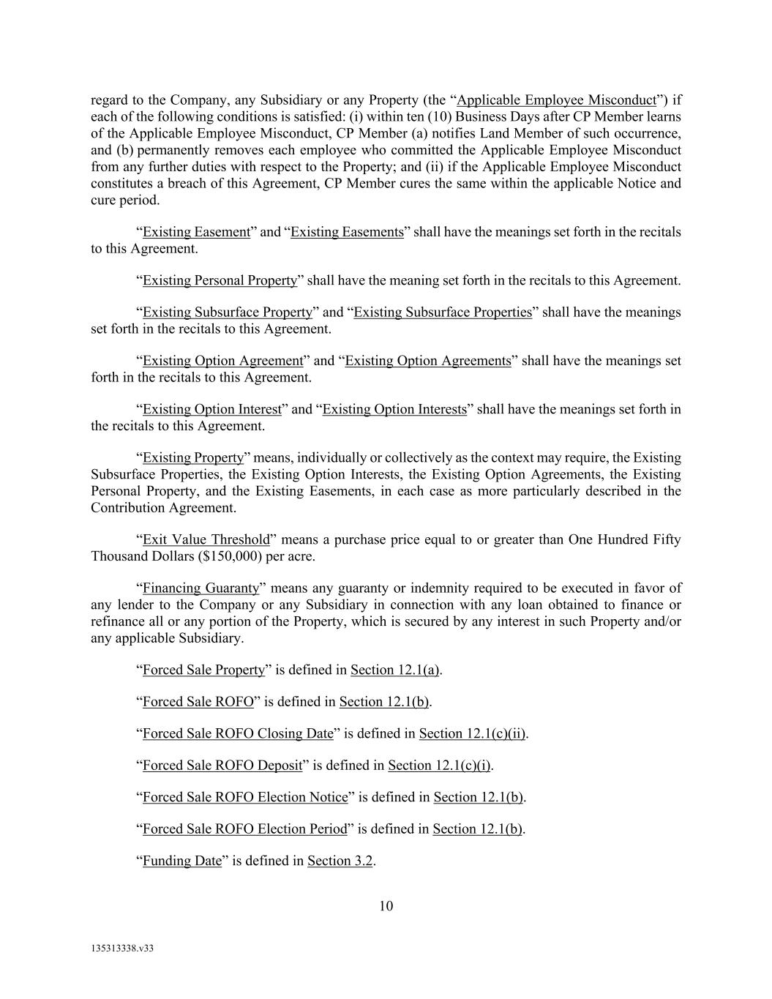
10 135313338.v33 regard to the Company, any Subsidiary or any Property (the “Applicable Employee Misconduct”) if each of the following conditions is satisfied: (i) within ten (10) Business Days after CP Member learns of the Applicable Employee Misconduct, CP Member (a) notifies Land Member of such occurrence, and (b) permanently removes each employee who committed the Applicable Employee Misconduct from any further duties with respect to the Property; and (ii) if the Applicable Employee Misconduct constitutes a breach of this Agreement, CP Member cures the same within the applicable Notice and cure period. “Existing Easement” and “Existing Easements” shall have the meanings set forth in the recitals to this Agreement. “Existing Personal Property” shall have the meaning set forth in the recitals to this Agreement. “Existing Subsurface Property” and “Existing Subsurface Properties” shall have the meanings set forth in the recitals to this Agreement. “Existing Option Agreement” and “Existing Option Agreements” shall have the meanings set forth in the recitals to this Agreement. “Existing Option Interest” and “Existing Option Interests” shall have the meanings set forth in the recitals to this Agreement. “Existing Property” means, individually or collectively as the context may require, the Existing Subsurface Properties, the Existing Option Interests, the Existing Option Agreements, the Existing Personal Property, and the Existing Easements, in each case as more particularly described in the Contribution Agreement. “Exit Value Threshold” means a purchase price equal to or greater than One Hundred Fifty Thousand Dollars ($150,000) per acre. “Financing Guaranty” means any guaranty or indemnity required to be executed in favor of any lender to the Company or any Subsidiary in connection with any loan obtained to finance or refinance all or any portion of the Property, which is secured by any interest in such Property and/or any applicable Subsidiary. “Forced Sale Property” is defined in Section 12.1(a). “Forced Sale ROFO” is defined in Section 12.1(b). “Forced Sale ROFO Closing Date” is defined in Section 12.1(c)(ii). “Forced Sale ROFO Deposit” is defined in Section 12.1(c)(i). “Forced Sale ROFO Election Notice” is defined in Section 12.1(b). “Forced Sale ROFO Election Period” is defined in Section 12.1(b). “Funding Date” is defined in Section 3.2.

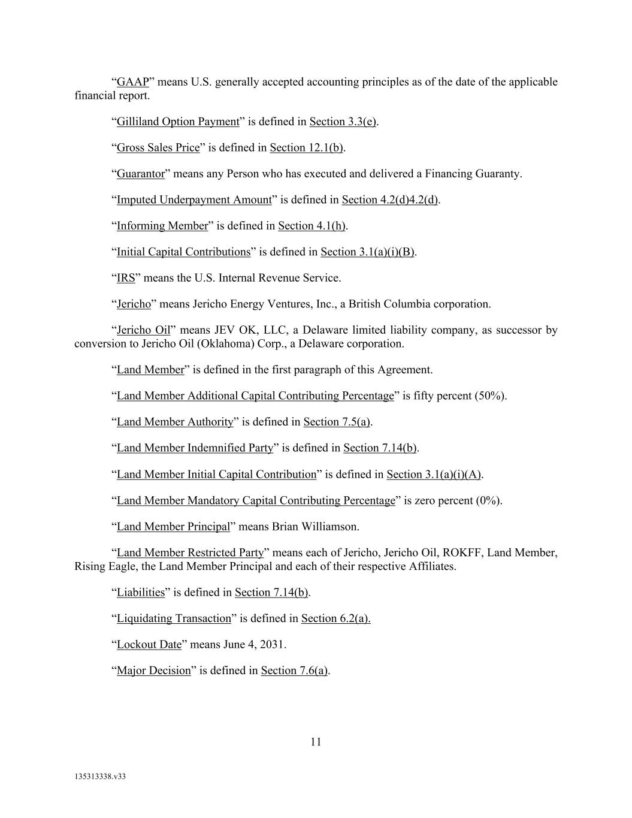
11 135313338.v33 “GAAP” means U.S. generally accepted accounting principles as of the date of the applicable financial report. “Gilliland Option Payment” is defined in Section 3.3(e). “Gross Sales Price” is defined in Section 12.1(b). “Guarantor” means any Person who has executed and delivered a Financing Guaranty. “Imputed Underpayment Amount” is defined in Section 4.2(d)4.2(d). “Informing Member” is defined in Section 4.1(h). “Initial Capital Contributions” is defined in Section 3.1(a)(i)(B). “IRS” means the U.S. Internal Revenue Service. “Jericho” means Jericho Energy Ventures, Inc., a British Columbia corporation. “Jericho Oil” means JEV OK, LLC, a Delaware limited liability company, as successor by conversion to Jericho Oil (Oklahoma) Corp., a Delaware corporation. “Land Member” is defined in the first paragraph of this Agreement. “Land Member Additional Capital Contributing Percentage” is fifty percent (50%). “Land Member Authority” is defined in Section 7.5(a). “Land Member Indemnified Party” is defined in Section 7.14(b). “Land Member Initial Capital Contribution” is defined in Section 3.1(a)(i)(A). “Land Member Mandatory Capital Contributing Percentage” is zero percent (0%). “Land Member Principal” means Brian Williamson. “Land Member Restricted Party” means each of Jericho, Jericho Oil, ROKFF, Land Member, Rising Eagle, the Land Member Principal and each of their respective Affiliates. “Liabilities” is defined in Section 7.14(b). “Liquidating Transaction” is defined in Section 6.2(a). “Lockout Date” means June 4, 2031. “Major Decision” is defined in Section 7.6(a).

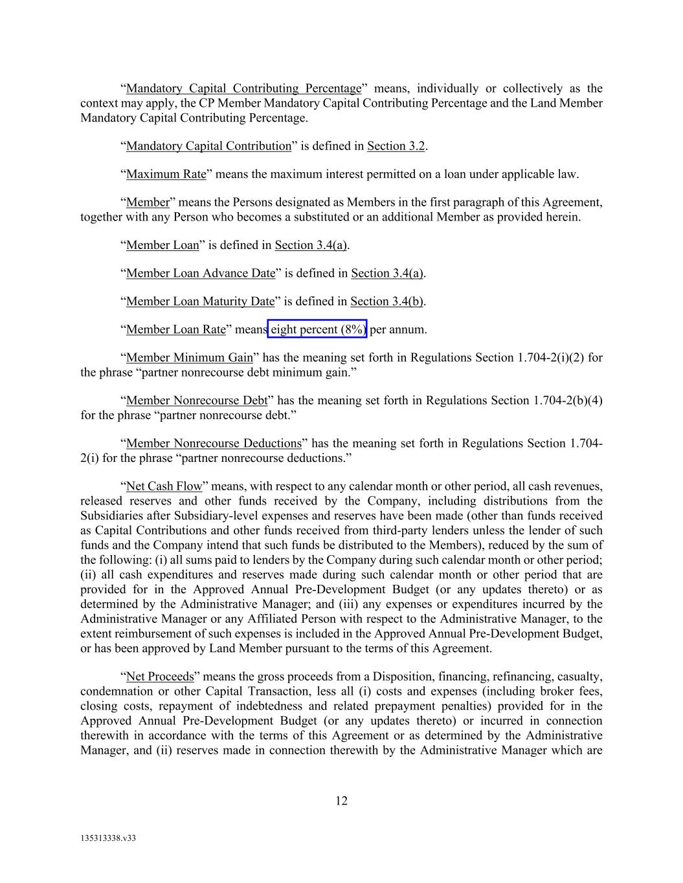
12 135313338.v33 “Mandatory Capital Contributing Percentage” means, individually or collectively as the context may apply, the CP Member Mandatory Capital Contributing Percentage and the Land Member Mandatory Capital Contributing Percentage. “Mandatory Capital Contribution” is defined in Section 3.2. “Maximum Rate” means the maximum interest permitted on a loan under applicable law. “Member” means the Persons designated as Members in the first paragraph of this Agreement, together with any Person who becomes a substituted or an additional Member as provided herein. “Member Loan” is defined in Section 3.4(a). “Member Loan Advance Date” is defined in Section 3.4(a). “Member Loan Maturity Date” is defined in Section 3.4(b). “Member Loan Rate” means eight percent (8%) per annum. “Member Minimum Gain” has the meaning set forth in Regulations Section 1.704-2(i)(2) for the phrase “partner nonrecourse debt minimum gain.” “Member Nonrecourse Debt” has the meaning set forth in Regulations Section 1.704-2(b)(4) for the phrase “partner nonrecourse debt.” “Member Nonrecourse Deductions” has the meaning set forth in Regulations Section 1.704- 2(i) for the phrase “partner nonrecourse deductions.” “Net Cash Flow” means, with respect to any calendar month or other period, all cash revenues, released reserves and other funds received by the Company, including distributions from the Subsidiaries after Subsidiary-level expenses and reserves have been made (other than funds received as Capital Contributions and other funds received from third-party lenders unless the lender of such funds and the Company intend that such funds be distributed to the Members), reduced by the sum of the following: (i) all sums paid to lenders by the Company during such calendar month or other period; (ii) all cash expenditures and reserves made during such calendar month or other period that are provided for in the Approved Annual Pre-Development Budget (or any updates thereto) or as determined by the Administrative Manager; and (iii) any expenses or expenditures incurred by the Administrative Manager or any Affiliated Person with respect to the Administrative Manager, to the extent reimbursement of such expenses is included in the Approved Annual Pre-Development Budget, or has been approved by Land Member pursuant to the terms of this Agreement. “Net Proceeds” means the gross proceeds from a Disposition, financing, refinancing, casualty, condemnation or other Capital Transaction, less all (i) costs and expenses (including broker fees, closing costs, repayment of indebtedness and related prepayment penalties) provided for in the Approved Annual Pre-Development Budget (or any updates thereto) or incurred in connection therewith in accordance with the terms of this Agreement or as determined by the Administrative Manager, and (ii) reserves made in connection therewith by the Administrative Manager which are

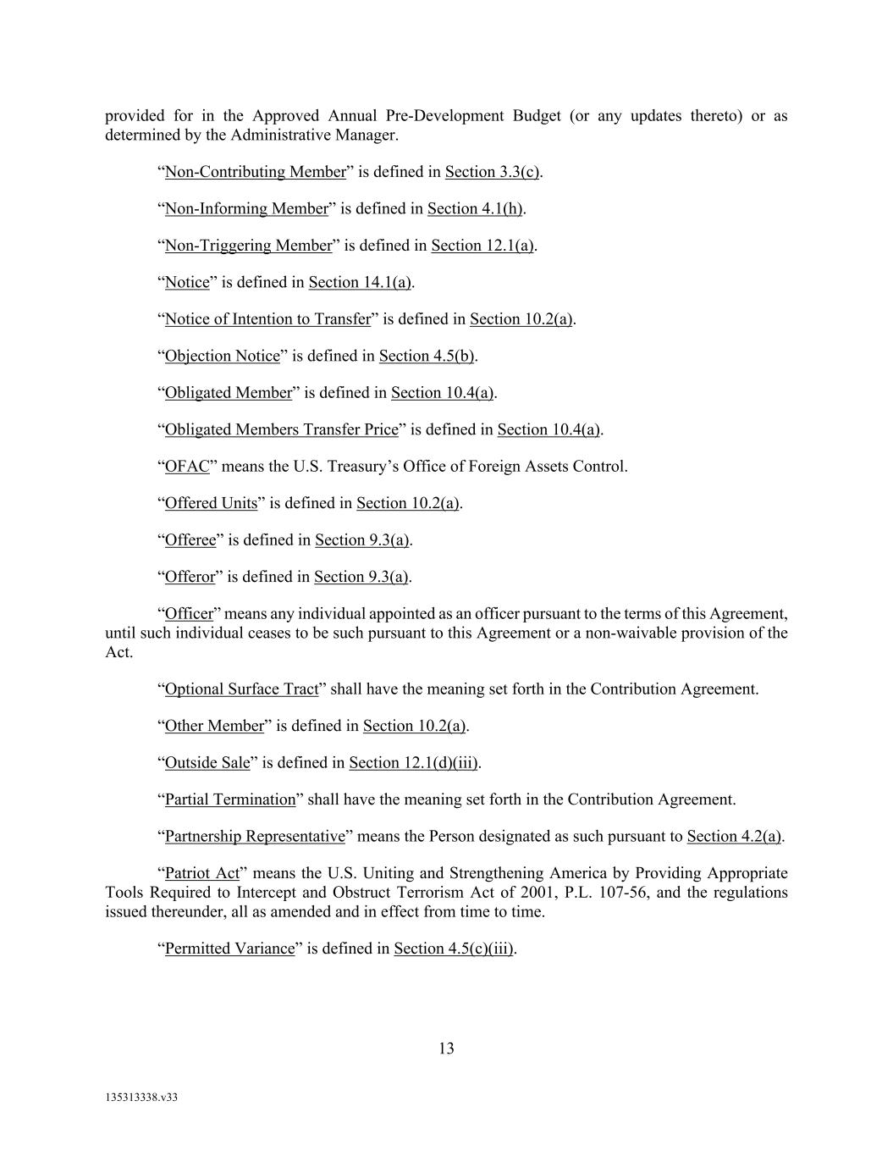
13 135313338.v33 provided for in the Approved Annual Pre-Development Budget (or any updates thereto) or as determined by the Administrative Manager. “Non-Contributing Member” is defined in Section 3.3(c). “Non-Informing Member” is defined in Section 4.1(h). “Non-Triggering Member” is defined in Section 12.1(a). “Notice” is defined in Section 14.1(a). “Notice of Intention to Transfer” is defined in Section 10.2(a). “Objection Notice” is defined in Section 4.5(b). “Obligated Member” is defined in Section 10.4(a). “Obligated Members Transfer Price” is defined in Section 10.4(a). “OFAC” means the U.S. Treasury’s Office of Foreign Assets Control. “Offered Units” is defined in Section 10.2(a). “Offeree” is defined in Section 9.3(a). “Offeror” is defined in Section 9.3(a). “Officer” means any individual appointed as an officer pursuant to the terms of this Agreement, until such individual ceases to be such pursuant to this Agreement or a non-waivable provision of the Act. “Optional Surface Tract” shall have the meaning set forth in the Contribution Agreement. “Other Member” is defined in Section 10.2(a). “Outside Sale” is defined in Section 12.1(d)(iii). “Partial Termination” shall have the meaning set forth in the Contribution Agreement. “Partnership Representative” means the Person designated as such pursuant to Section 4.2(a). “Patriot Act” means the U.S. Uniting and Strengthening America by Providing Appropriate Tools Required to Intercept and Obstruct Terrorism Act of 2001, P.L. 107-56, and the regulations issued thereunder, all as amended and in effect from time to time. “Permitted Variance” is defined in Section 4.5(c)(iii).

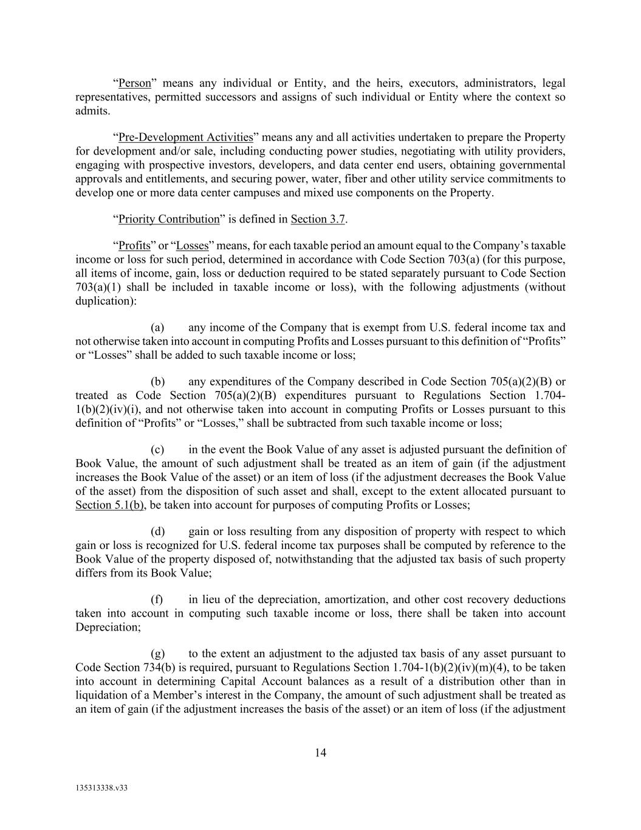
14 135313338.v33 “Person” means any individual or Entity, and the heirs, executors, administrators, legal representatives, permitted successors and assigns of such individual or Entity where the context so admits. “Pre-Development Activities” means any and all activities undertaken to prepare the Property for development and/or sale, including conducting power studies, negotiating with utility providers, engaging with prospective investors, developers, and data center end users, obtaining governmental approvals and entitlements, and securing power, water, fiber and other utility service commitments to develop one or more data center campuses and mixed use components on the Property. “Priority Contribution” is defined in Section 3.7. “Profits” or “Losses” means, for each taxable period an amount equal to the Company’s taxable income or loss for such period, determined in accordance with Code Section 703(a) (for this purpose, all items of income, gain, loss or deduction required to be stated separately pursuant to Code Section 703(a)(1) shall be included in taxable income or loss), with the following adjustments (without duplication): (a) any income of the Company that is exempt from U.S. federal income tax and not otherwise taken into account in computing Profits and Losses pursuant to this definition of “Profits” or “Losses” shall be added to such taxable income or loss; (b) any expenditures of the Company described in Code Section 705(a)(2)(B) or treated as Code Section 705(a)(2)(B) expenditures pursuant to Regulations Section 1.704- 1(b)(2)(iv)(i), and not otherwise taken into account in computing Profits or Losses pursuant to this definition of “Profits” or “Losses,” shall be subtracted from such taxable income or loss; (c) in the event the Book Value of any asset is adjusted pursuant the definition of Book Value, the amount of such adjustment shall be treated as an item of gain (if the adjustment increases the Book Value of the asset) or an item of loss (if the adjustment decreases the Book Value of the asset) from the disposition of such asset and shall, except to the extent allocated pursuant to Section 5.1(b), be taken into account for purposes of computing Profits or Losses; (d) gain or loss resulting from any disposition of property with respect to which gain or loss is recognized for U.S. federal income tax purposes shall be computed by reference to the Book Value of the property disposed of, notwithstanding that the adjusted tax basis of such property differs from its Book Value; (f) in lieu of the depreciation, amortization, and other cost recovery deductions taken into account in computing such taxable income or loss, there shall be taken into account Depreciation; (g) to the extent an adjustment to the adjusted tax basis of any asset pursuant to Code Section 734(b) is required, pursuant to Regulations Section 1.704-1(b)(2)(iv)(m)(4), to be taken into account in determining Capital Account balances as a result of a distribution other than in liquidation of a Member’s interest in the Company, the amount of such adjustment shall be treated as an item of gain (if the adjustment increases the basis of the asset) or an item of loss (if the adjustment

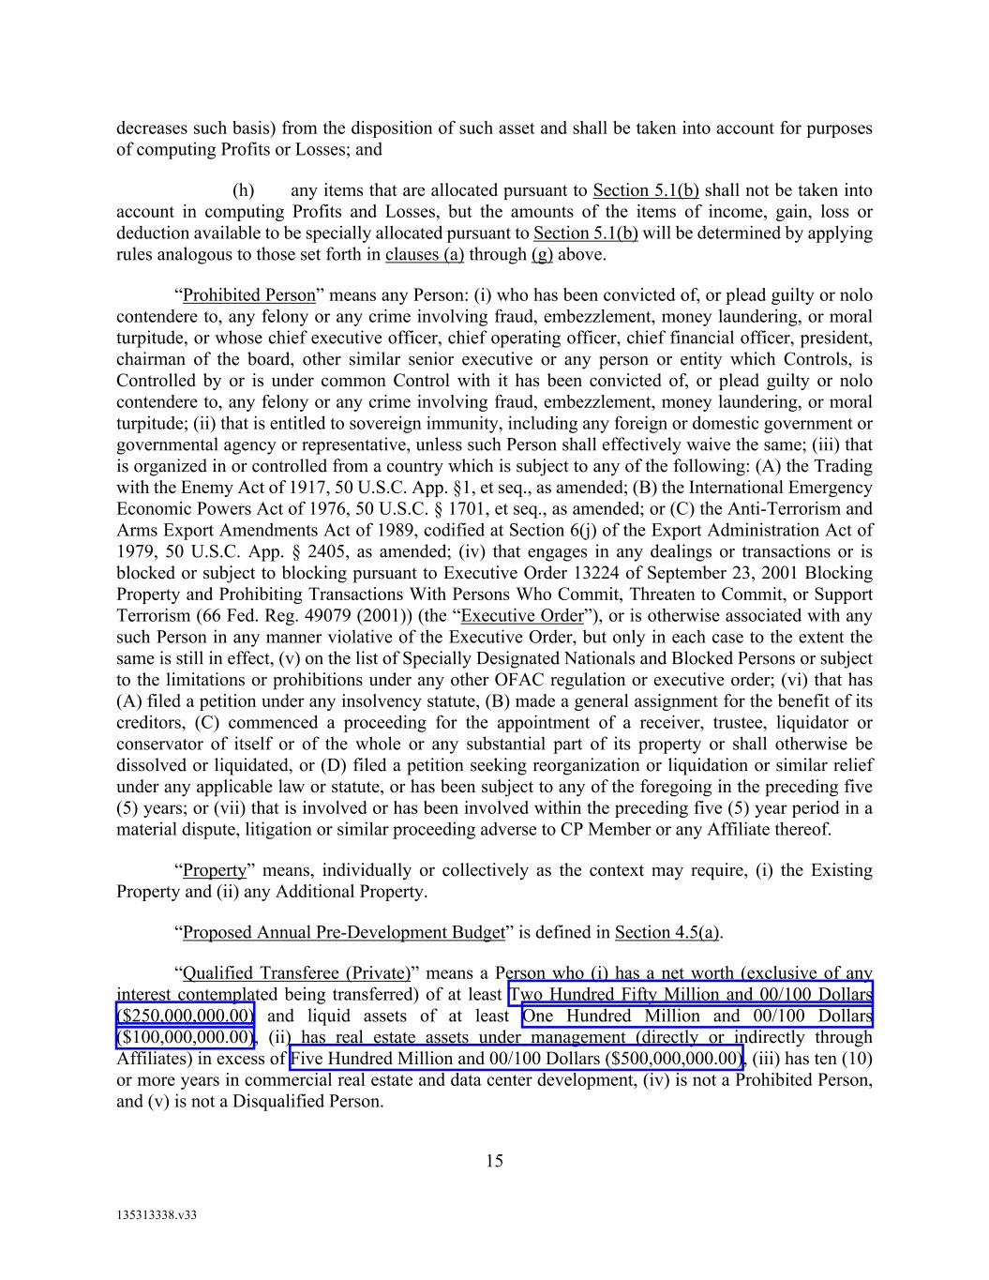
15 135313338.v33 decreases such basis) from the disposition of such asset and shall be taken into account for purposes of computing Profits or Losses; and (h) any items that are allocated pursuant to Section 5.1(b) shall not be taken into account in computing Profits and Losses, but the amounts of the items of income, gain, loss or deduction available to be specially allocated pursuant to Section 5.1(b) will be determined by applying rules analogous to those set forth in clauses (a) through (g) above. “Prohibited Person” means any Person: (i) who has been convicted of, or plead guilty or nolo contendere to, any felony or any crime involving fraud, embezzlement, money laundering, or moral turpitude, or whose chief executive officer, chief operating officer, chief financial officer, president, chairman of the board, other similar senior executive or any person or entity which Controls, is Controlled by or is under common Control with it has been convicted of, or plead guilty or nolo contendere to, any felony or any crime involving fraud, embezzlement, money laundering, or moral turpitude; (ii) that is entitled to sovereign immunity, including any foreign or domestic government or governmental agency or representative, unless such Person shall effectively waive the same; (iii) that is organized in or controlled from a country which is subject to any of the following: (A) the Trading with the Enemy Act of 1917, 50 U.S.C. App. §1, et seq., as amended; (B) the International Emergency Economic Powers Act of 1976, 50 U.S.C. § 1701, et seq., as amended; or (C) the Anti-Terrorism and Arms Export Amendments Act of 1989, codified at Section 6(j) of the Export Administration Act of 1979, 50 U.S.C. App. § 2405, as amended; (iv) that engages in any dealings or transactions or is blocked or subject to blocking pursuant to Executive Order 13224 of September 23, 2001 Blocking Property and Prohibiting Transactions With Persons Who Commit, Threaten to Commit, or Support Terrorism (66 Fed. Reg. 49079 (2001)) (the “Executive Order”), or is otherwise associated with any such Person in any manner violative of the Executive Order, but only in each case to the extent the same is still in effect, (v) on the list of Specially Designated Nationals and Blocked Persons or subject to the limitations or prohibitions under any other OFAC regulation or executive order; (vi) that has (A) filed a petition under any insolvency statute, (B) made a general assignment for the benefit of its creditors, (C) commenced a proceeding for the appointment of a receiver, trustee, liquidator or conservator of itself or of the whole or any substantial part of its property or shall otherwise be dissolved or liquidated, or (D) filed a petition seeking reorganization or liquidation or similar relief under any applicable law or statute, or has been subject to any of the foregoing in the preceding five (5) years; or (vii) that is involved or has been involved within the preceding five (5) year period in a material dispute, litigation or similar proceeding adverse to CP Member or any Affiliate thereof. “Property” means, individually or collectively as the context may require, (i) the Existing Property and (ii) any Additional Property. “Proposed Annual Pre-Development Budget” is defined in Section 4.5(a). “Qualified Transferee (Private)” means a Person who (i) has a net worth (exclusive of any interest contemplated being transferred) of at least Two Hundred Fifty Million and 00/100 Dollars ($250,000,000.00) and liquid assets of at least One Hundred Million and 00/100 Dollars ($100,000,000.00), (ii) has real estate assets under management (directly or indirectly through Affiliates) in excess of Five Hundred Million and 00/100 Dollars ($500,000,000.00), (iii) has ten (10) or more years in commercial real estate and data center development, (iv) is not a Prohibited Person, and (v) is not a Disqualified Person.

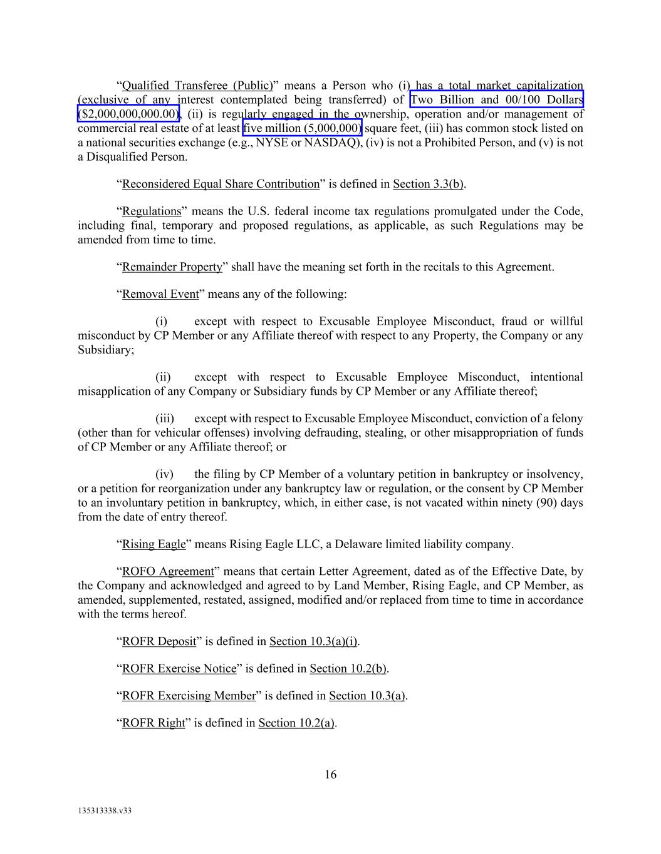
16 135313338.v33 “Qualified Transferee (Public)” means a Person who (i) has a total market capitalization (exclusive of any interest contemplated being transferred) of Two Billion and 00/100 Dollars ($2,000,000,000.00), (ii) is regularly engaged in the ownership, operation and/or management of commercial real estate of at least five million (5,000,000) square feet, (iii) has common stock listed on a national securities exchange (e.g., NYSE or NASDAQ), (iv) is not a Prohibited Person, and (v) is not a Disqualified Person. “Reconsidered Equal Share Contribution” is defined in Section 3.3(b). “Regulations” means the U.S. federal income tax regulations promulgated under the Code, including final, temporary and proposed regulations, as applicable, as such Regulations may be amended from time to time. “Remainder Property” shall have the meaning set forth in the recitals to this Agreement. “Removal Event” means any of the following: (i) except with respect to Excusable Employee Misconduct, fraud or willful misconduct by CP Member or any Affiliate thereof with respect to any Property, the Company or any Subsidiary; (ii) except with respect to Excusable Employee Misconduct, intentional misapplication of any Company or Subsidiary funds by CP Member or any Affiliate thereof; (iii) except with respect to Excusable Employee Misconduct, conviction of a felony (other than for vehicular offenses) involving defrauding, stealing, or other misappropriation of funds of CP Member or any Affiliate thereof; or (iv) the filing by CP Member of a voluntary petition in bankruptcy or insolvency, or a petition for reorganization under any bankruptcy law or regulation, or the consent by CP Member to an involuntary petition in bankruptcy, which, in either case, is not vacated within ninety (90) days from the date of entry thereof. “Rising Eagle” means Rising Eagle LLC, a Delaware limited liability company. “ROFO Agreement” means that certain Letter Agreement, dated as of the Effective Date, by the Company and acknowledged and agreed to by Land Member, Rising Eagle, and CP Member, as amended, supplemented, restated, assigned, modified and/or replaced from time to time in accordance with the terms hereof. “ROFR Deposit” is defined in Section 10.3(a)(i). “ROFR Exercise Notice” is defined in Section 10.2(b). “ROFR Exercising Member” is defined in Section 10.3(a). “ROFR Right” is defined in Section 10.2(a).

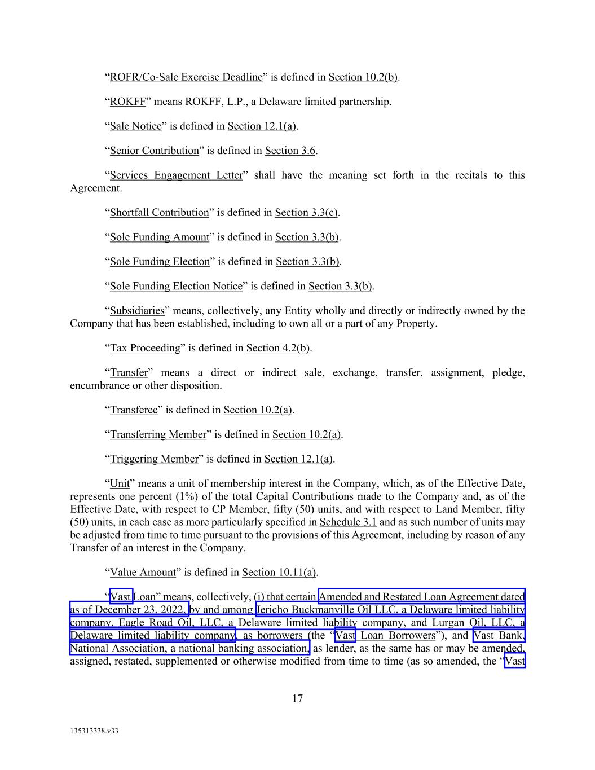
17 135313338.v33 “ROFR/Co-Sale Exercise Deadline” is defined in Section 10.2(b). “ROKFF” means ROKFF, L.P., a Delaware limited partnership. “Sale Notice” is defined in Section 12.1(a). “Senior Contribution” is defined in Section 3.6. “Services Engagement Letter” shall have the meaning set forth in the recitals to this Agreement. “Shortfall Contribution” is defined in Section 3.3(c). “Sole Funding Amount” is defined in Section 3.3(b). “Sole Funding Election” is defined in Section 3.3(b). “Sole Funding Election Notice” is defined in Section 3.3(b). “Subsidiaries” means, collectively, any Entity wholly and directly or indirectly owned by the Company that has been established, including to own all or a part of any Property. “Tax Proceeding” is defined in Section 4.2(b). “Transfer” means a direct or indirect sale, exchange, transfer, assignment, pledge, encumbrance or other disposition. “Transferee” is defined in Section 10.2(a). “Transferring Member” is defined in Section 10.2(a). “Triggering Member” is defined in Section 12.1(a). “Unit” means a unit of membership interest in the Company, which, as of the Effective Date, represents one percent (1%) of the total Capital Contributions made to the Company and, as of the Effective Date, with respect to CP Member, fifty (50) units, and with respect to Land Member, fifty (50) units, in each case as more particularly specified in Schedule 3.1 and as such number of units may be adjusted from time to time pursuant to the provisions of this Agreement, including by reason of any Transfer of an interest in the Company. “Value Amount” is defined in Section 10.11(a). “Vast Loan” means, collectively, (i) that certain Amended and Restated Loan Agreement dated as of December 23, 2022, by and among Jericho Buckmanville Oil LLC, a Delaware limited liability company, Eagle Road Oil, LLC, a Delaware limited liability company, and Lurgan Oil, LLC, a Delaware limited liability company, as borrowers (the “Vast Loan Borrowers”), and Vast Bank, National Association, a national banking association, as lender, as the same has or may be amended, assigned, restated, supplemented or otherwise modified from time to time (as so amended, the “Vast

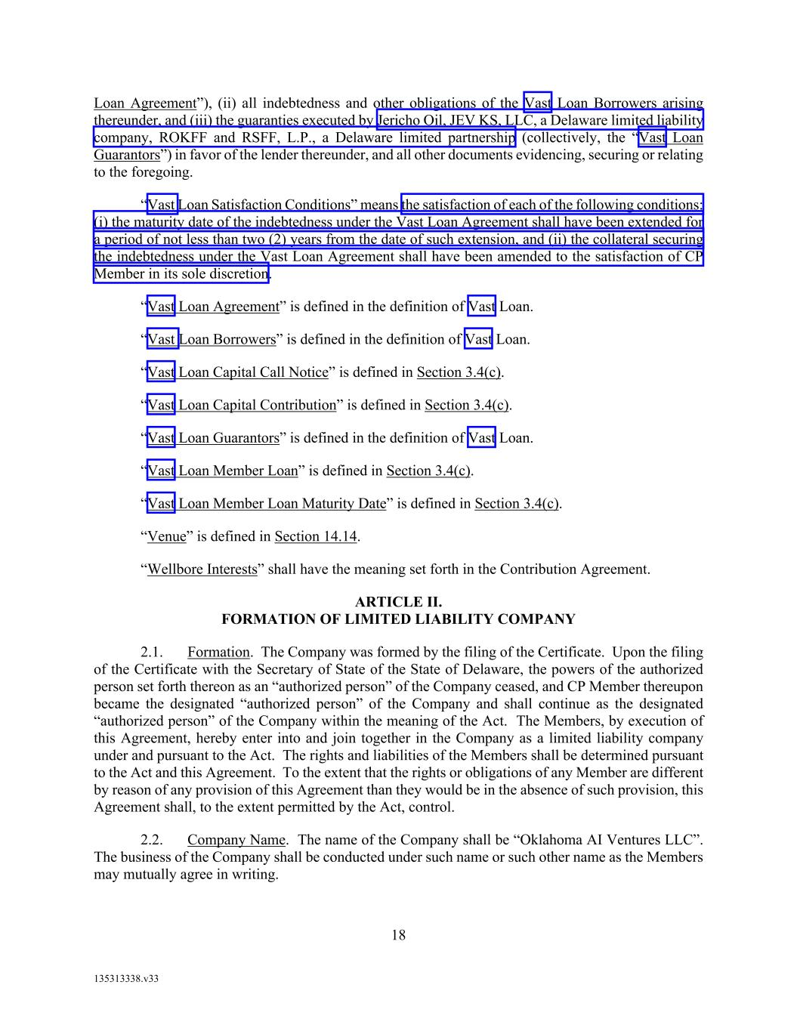
18 135313338.v33 Loan Agreement”), (ii) all indebtedness and other obligations of the Vast Loan Borrowers arising thereunder, and (iii) the guaranties executed by Jericho Oil, JEV KS, LLC, a Delaware limited liability company, ROKFF and RSFF, L.P., a Delaware limited partnership (collectively, the “Vast Loan Guarantors”) in favor of the lender thereunder, and all other documents evidencing, securing or relating to the foregoing. “Vast Loan Satisfaction Conditions” means the satisfaction of each of the following conditions: (i) the maturity date of the indebtedness under the Vast Loan Agreement shall have been extended for a period of not less than two (2) years from the date of such extension, and (ii) the collateral securing the indebtedness under the Vast Loan Agreement shall have been amended to the satisfaction of CP Member in its sole discretion. “Vast Loan Agreement” is defined in the definition of Vast Loan. “Vast Loan Borrowers” is defined in the definition of Vast Loan. “Vast Loan Capital Call Notice” is defined in Section 3.4(c). “Vast Loan Capital Contribution” is defined in Section 3.4(c). “Vast Loan Guarantors” is defined in the definition of Vast Loan. “Vast Loan Member Loan” is defined in Section 3.4(c). “Vast Loan Member Loan Maturity Date” is defined in Section 3.4(c). “Venue” is defined in Section 14.14. “Wellbore Interests” shall have the meaning set forth in the Contribution Agreement. ARTICLE II. FORMATION OF LIMITED LIABILITY COMPANY 2.1. Formation. The Company was formed by the filing of the Certificate. Upon the filing of the Certificate with the Secretary of State of the State of Delaware, the powers of the authorized person set forth thereon as an “authorized person” of the Company ceased, and CP Member thereupon became the designated “authorized person” of the Company and shall continue as the designated “authorized person” of the Company within the meaning of the Act. The Members, by execution of this Agreement, hereby enter into and join together in the Company as a limited liability company under and pursuant to the Act. The rights and liabilities of the Members shall be determined pursuant to the Act and this Agreement. To the extent that the rights or obligations of any Member are different by reason of any provision of this Agreement than they would be in the absence of such provision, this Agreement shall, to the extent permitted by the Act, control. 2.2. Company Name. The name of the Company shall be “Oklahoma AI Ventures LLC”. The business of the Company shall be conducted under such name or such other name as the Members may mutually agree in writing.

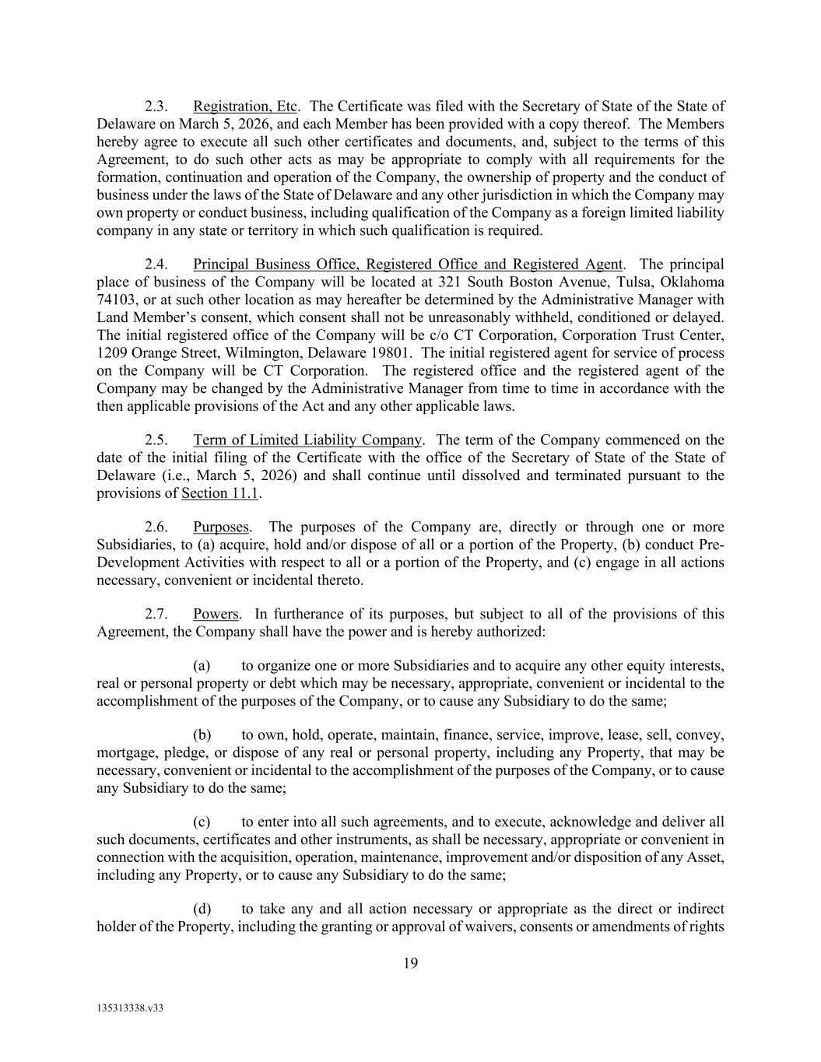
19 135313338.v33 2.3. Registration, Etc. The Certificate was filed with the Secretary of State of the State of Delaware on March 5, 2026, and each Member has been provided with a copy thereof. The Members hereby agree to execute all such other certificates and documents, and, subject to the terms of this Agreement, to do such other acts as may be appropriate to comply with all requirements for the formation, continuation and operation of the Company, the ownership of property and the conduct of business under the laws of the State of Delaware and any other jurisdiction in which the Company may own property or conduct business, including qualification of the Company as a foreign limited liability company in any state or territory in which such qualification is required. 2.4. Principal Business Office, Registered Office and Registered Agent. The principal place of business of the Company will be located at 321 South Boston Avenue, Tulsa, Oklahoma 74103, or at such other location as may hereafter be determined by the Administrative Manager with Land Member’s consent, which consent shall not be unreasonably withheld, conditioned or delayed. The initial registered office of the Company will be c/o CT Corporation, Corporation Trust Center, 1209 Orange Street, Wilmington, Delaware 19801. The initial registered agent for service of process on the Company will be CT Corporation. The registered office and the registered agent of the Company may be changed by the Administrative Manager from time to time in accordance with the then applicable provisions of the Act and any other applicable laws. 2.5. Term of Limited Liability Company. The term of the Company commenced on the date of the initial filing of the Certificate with the office of the Secretary of State of the State of Delaware (i.e., March 5, 2026) and shall continue until dissolved and terminated pursuant to the provisions of Section 11.1. 2.6. Purposes. The purposes of the Company are, directly or through one or more Subsidiaries, to (a) acquire, hold and/or dispose of all or a portion of the Property, (b) conduct Pre- Development Activities with respect to all or a portion of the Property, and (c) engage in all actions necessary, convenient or incidental thereto. 2.7. Powers. In furtherance of its purposes, but subject to all of the provisions of this Agreement, the Company shall have the power and is hereby authorized: (a) to organize one or more Subsidiaries and to acquire any other equity interests, real or personal property or debt which may be necessary, appropriate, convenient or incidental to the accomplishment of the purposes of the Company, or to cause any Subsidiary to do the same; (b) to own, hold, operate, maintain, finance, service, improve, lease, sell, convey, mortgage, pledge, or dispose of any real or personal property, including any Property, that may be necessary, convenient or incidental to the accomplishment of the purposes of the Company, or to cause any Subsidiary to do the same; (c) to enter into all such agreements, and to execute, acknowledge and deliver all such documents, certificates and other instruments, as shall be necessary, appropriate or convenient in connection with the acquisition, operation, maintenance, improvement and/or disposition of any Asset, including any Property, or to cause any Subsidiary to do the same; (d) to take any and all action necessary or appropriate as the direct or indirect holder of the Property, including the granting or approval of waivers, consents or amendments of rights

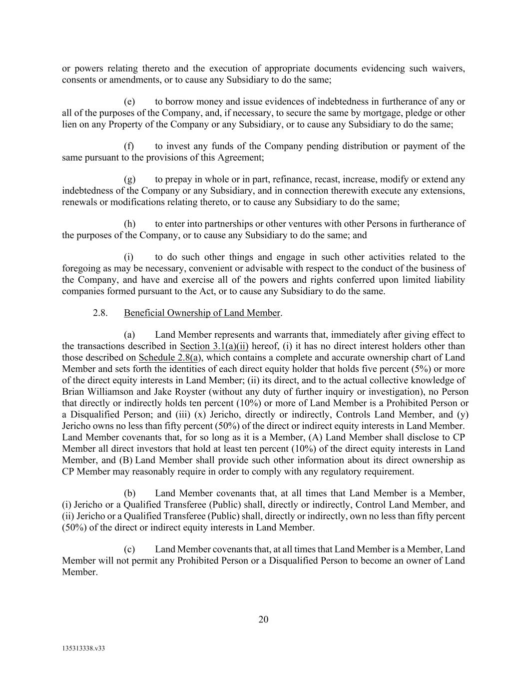
20 135313338.v33 or powers relating thereto and the execution of appropriate documents evidencing such waivers, consents or amendments, or to cause any Subsidiary to do the same; (e) to borrow money and issue evidences of indebtedness in furtherance of any or all of the purposes of the Company, and, if necessary, to secure the same by mortgage, pledge or other lien on any Property of the Company or any Subsidiary, or to cause any Subsidiary to do the same; (f) to invest any funds of the Company pending distribution or payment of the same pursuant to the provisions of this Agreement; (g) to prepay in whole or in part, refinance, recast, increase, modify or extend any indebtedness of the Company or any Subsidiary, and in connection therewith execute any extensions, renewals or modifications relating thereto, or to cause any Subsidiary to do the same; (h) to enter into partnerships or other ventures with other Persons in furtherance of the purposes of the Company, or to cause any Subsidiary to do the same; and (i) to do such other things and engage in such other activities related to the foregoing as may be necessary, convenient or advisable with respect to the conduct of the business of the Company, and have and exercise all of the powers and rights conferred upon limited liability companies formed pursuant to the Act, or to cause any Subsidiary to do the same. 2.8. Beneficial Ownership of Land Member. (a) Land Member represents and warrants that, immediately after giving effect to the transactions described in Section 3.1(a)(ii) hereof, (i) it has no direct interest holders other than those described on Schedule 2.8(a), which contains a complete and accurate ownership chart of Land Member and sets forth the identities of each direct equity holder that holds five percent (5%) or more of the direct equity interests in Land Member; (ii) its direct, and to the actual collective knowledge of Brian Williamson and Jake Royster (without any duty of further inquiry or investigation), no Person that directly or indirectly holds ten percent (10%) or more of Land Member is a Prohibited Person or a Disqualified Person; and (iii) (x) Jericho, directly or indirectly, Controls Land Member, and (y) Jericho owns no less than fifty percent (50%) of the direct or indirect equity interests in Land Member. Land Member covenants that, for so long as it is a Member, (A) Land Member shall disclose to CP Member all direct investors that hold at least ten percent (10%) of the direct equity interests in Land Member, and (B) Land Member shall provide such other information about its direct ownership as CP Member may reasonably require in order to comply with any regulatory requirement. (b) Land Member covenants that, at all times that Land Member is a Member, (i) Jericho or a Qualified Transferee (Public) shall, directly or indirectly, Control Land Member, and (ii) Jericho or a Qualified Transferee (Public) shall, directly or indirectly, own no less than fifty percent (50%) of the direct or indirect equity interests in Land Member. (c) Land Member covenants that, at all times that Land Member is a Member, Land Member will not permit any Prohibited Person or a Disqualified Person to become an owner of Land Member.

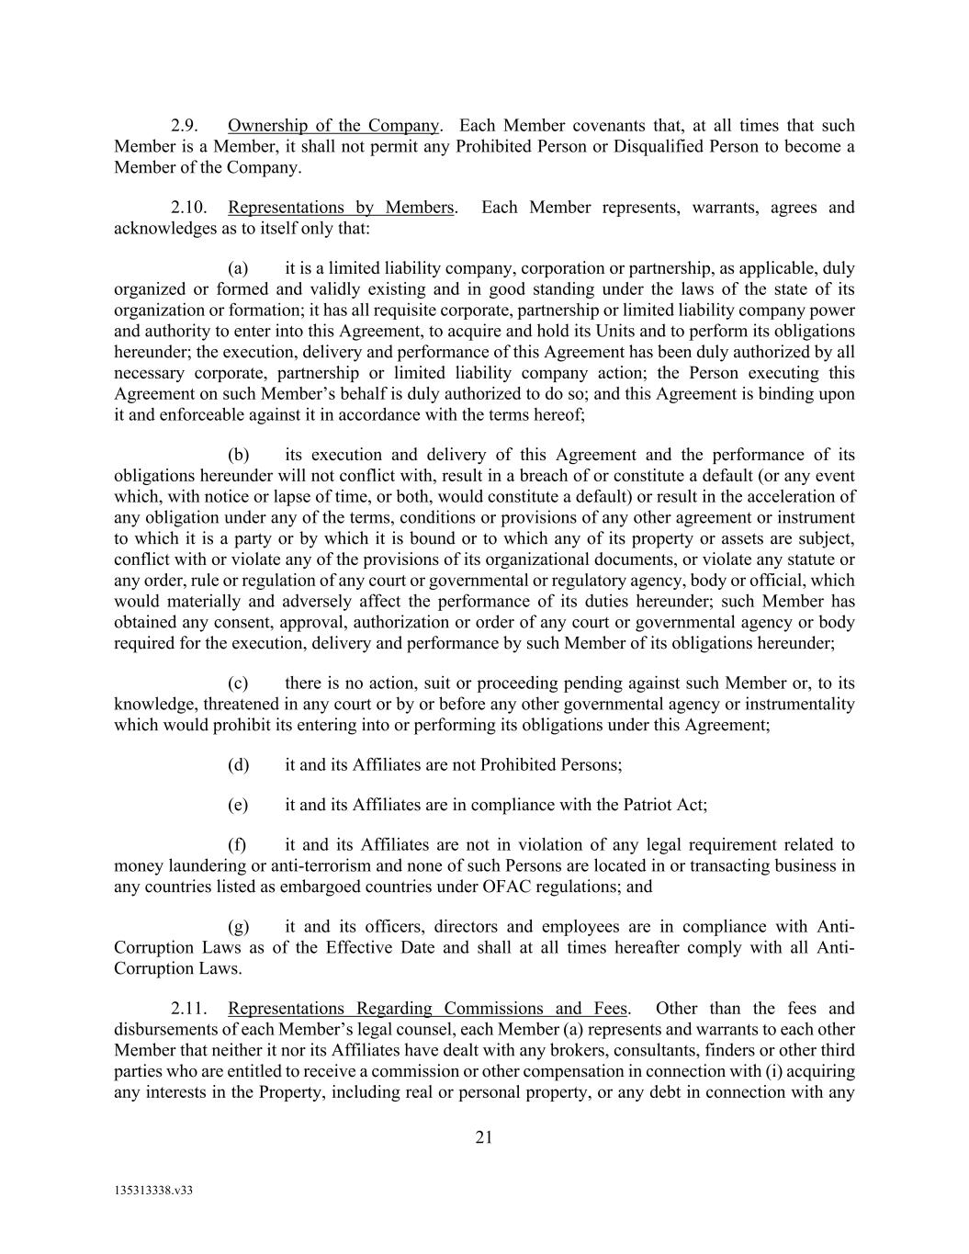
21 135313338.v33 2.9. Ownership of the Company. Each Member covenants that, at all times that such Member is a Member, it shall not permit any Prohibited Person or Disqualified Person to become a Member of the Company. 2.10. Representations by Members. Each Member represents, warrants, agrees and acknowledges as to itself only that: (a) it is a limited liability company, corporation or partnership, as applicable, duly organized or formed and validly existing and in good standing under the laws of the state of its organization or formation; it has all requisite corporate, partnership or limited liability company power and authority to enter into this Agreement, to acquire and hold its Units and to perform its obligations hereunder; the execution, delivery and performance of this Agreement has been duly authorized by all necessary corporate, partnership or limited liability company action; the Person executing this Agreement on such Member’s behalf is duly authorized to do so; and this Agreement is binding upon it and enforceable against it in accordance with the terms hereof; (b) its execution and delivery of this Agreement and the performance of its obligations hereunder will not conflict with, result in a breach of or constitute a default (or any event which, with notice or lapse of time, or both, would constitute a default) or result in the acceleration of any obligation under any of the terms, conditions or provisions of any other agreement or instrument to which it is a party or by which it is bound or to which any of its property or assets are subject, conflict with or violate any of the provisions of its organizational documents, or violate any statute or any order, rule or regulation of any court or governmental or regulatory agency, body or official, which would materially and adversely affect the performance of its duties hereunder; such Member has obtained any consent, approval, authorization or order of any court or governmental agency or body required for the execution, delivery and performance by such Member of its obligations hereunder; (c) there is no action, suit or proceeding pending against such Member or, to its knowledge, threatened in any court or by or before any other governmental agency or instrumentality which would prohibit its entering into or performing its obligations under this Agreement; (d) it and its Affiliates are not Prohibited Persons; (e) it and its Affiliates are in compliance with the Patriot Act; (f) it and its Affiliates are not in violation of any legal requirement related to money laundering or anti-terrorism and none of such Persons are located in or transacting business in any countries listed as embargoed countries under OFAC regulations; and (g) it and its officers, directors and employees are in compliance with Anti- Corruption Laws as of the Effective Date and shall at all times hereafter comply with all Anti- Corruption Laws. 2.11. Representations Regarding Commissions and Fees. Other than the fees and disbursements of each Member’s legal counsel, each Member (a) represents and warrants to each other Member that neither it nor its Affiliates have dealt with any brokers, consultants, finders or other third parties who are entitled to receive a commission or other compensation in connection with (i) acquiring any interests in the Property, including real or personal property, or any debt in connection with any

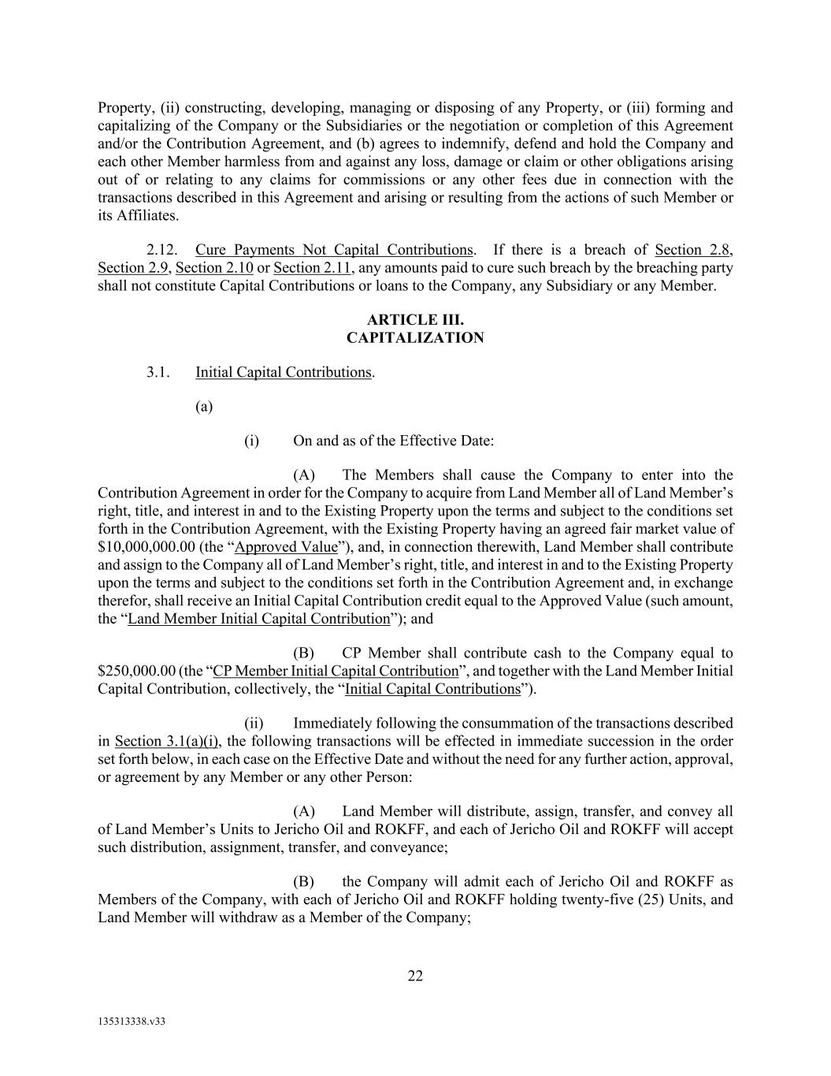
22 135313338.v33 Property, (ii) constructing, developing, managing or disposing of any Property, or (iii) forming and capitalizing of the Company or the Subsidiaries or the negotiation or completion of this Agreement and/or the Contribution Agreement, and (b) agrees to indemnify, defend and hold the Company and each other Member harmless from and against any loss, damage or claim or other obligations arising out of or relating to any claims for commissions or any other fees due in connection with the transactions described in this Agreement and arising or resulting from the actions of such Member or its Affiliates. 2.12. Cure Payments Not Capital Contributions. If there is a breach of Section 2.8, Section 2.9, Section 2.10 or Section 2.11, any amounts paid to cure such breach by the breaching party shall not constitute Capital Contributions or loans to the Company, any Subsidiary or any Member. ARTICLE III. CAPITALIZATION 3.1. Initial Capital Contributions. (a) (i) On and as of the Effective Date: (A) The Members shall cause the Company to enter into the Contribution Agreement in order for the Company to acquire from Land Member all of Land Member’s right, title, and interest in and to the Existing Property upon the terms and subject to the conditions set forth in the Contribution Agreement, with the Existing Property having an agreed fair market value of $10,000,000.00 (the “Approved Value”), and, in connection therewith, Land Member shall contribute and assign to the Company all of Land Member’s right, title, and interest in and to the Existing Property upon the terms and subject to the conditions set forth in the Contribution Agreement and, in exchange therefor, shall receive an Initial Capital Contribution credit equal to the Approved Value (such amount, the “Land Member Initial Capital Contribution”); and (B) CP Member shall contribute cash to the Company equal to $250,000.00 (the “CP Member Initial Capital Contribution”, and together with the Land Member Initial Capital Contribution, collectively, the “Initial Capital Contributions”). (ii) Immediately following the consummation of the transactions described in Section 3.1(a)(i), the following transactions will be effected in immediate succession in the order set forth below, in each case on the Effective Date and without the need for any further action, approval, or agreement by any Member or any other Person: (A) Land Member will distribute, assign, transfer, and convey all of Land Member’s Units to Jericho Oil and ROKFF, and each of Jericho Oil and ROKFF will accept such distribution, assignment, transfer, and conveyance; (B) the Company will admit each of Jericho Oil and ROKFF as Members of the Company, with each of Jericho Oil and ROKFF holding twenty-five (25) Units, and Land Member will withdraw as a Member of the Company;

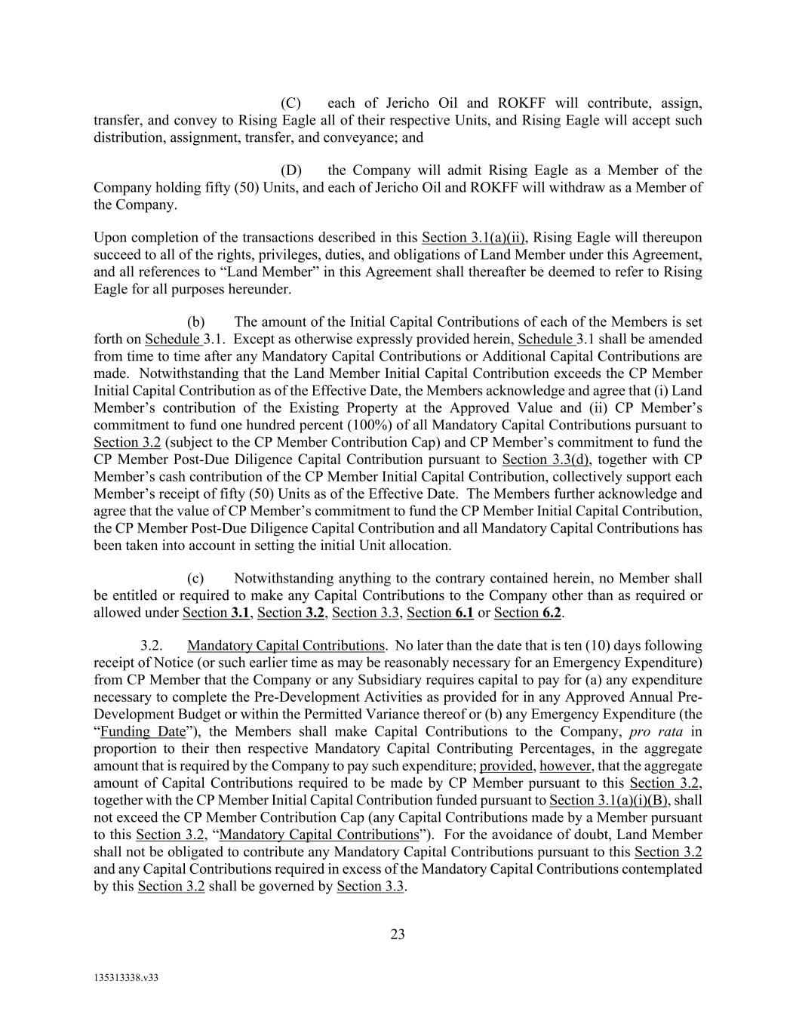
23 135313338.v33 (C) each of Jericho Oil and ROKFF will contribute, assign, transfer, and convey to Rising Eagle all of their respective Units, and Rising Eagle will accept such distribution, assignment, transfer, and conveyance; and (D) the Company will admit Rising Eagle as a Member of the Company holding fifty (50) Units, and each of Jericho Oil and ROKFF will withdraw as a Member of the Company. Upon completion of the transactions described in this Section 3.1(a)(ii), Rising Eagle will thereupon succeed to all of the rights, privileges, duties, and obligations of Land Member under this Agreement, and all references to “Land Member” in this Agreement shall thereafter be deemed to refer to Rising Eagle for all purposes hereunder. (b) The amount of the Initial Capital Contributions of each of the Members is set forth on Schedule 3.1. Except as otherwise expressly provided herein, Schedule 3.1 shall be amended from time to time after any Mandatory Capital Contributions or Additional Capital Contributions are made. Notwithstanding that the Land Member Initial Capital Contribution exceeds the CP Member Initial Capital Contribution as of the Effective Date, the Members acknowledge and agree that (i) Land Member’s contribution of the Existing Property at the Approved Value and (ii) CP Member’s commitment to fund one hundred percent (100%) of all Mandatory Capital Contributions pursuant to Section 3.2 (subject to the CP Member Contribution Cap) and CP Member’s commitment to fund the CP Member Post-Due Diligence Capital Contribution pursuant to Section 3.3(d), together with CP Member’s cash contribution of the CP Member Initial Capital Contribution, collectively support each Member’s receipt of fifty (50) Units as of the Effective Date. The Members further acknowledge and agree that the value of CP Member’s commitment to fund the CP Member Initial Capital Contribution, the CP Member Post-Due Diligence Capital Contribution and all Mandatory Capital Contributions has been taken into account in setting the initial Unit allocation. (c) Notwithstanding anything to the contrary contained herein, no Member shall be entitled or required to make any Capital Contributions to the Company other than as required or allowed under Section 3.1, Section 3.2, Section 3.3, Section 6.1 or Section 6.2. 3.2. Mandatory Capital Contributions. No later than the date that is ten (10) days following receipt of Notice (or such earlier time as may be reasonably necessary for an Emergency Expenditure) from CP Member that the Company or any Subsidiary requires capital to pay for (a) any expenditure necessary to complete the Pre-Development Activities as provided for in any Approved Annual Pre- Development Budget or within the Permitted Variance thereof or (b) any Emergency Expenditure (the “Funding Date”), the Members shall make Capital Contributions to the Company, pro rata in proportion to their then respective Mandatory Capital Contributing Percentages, in the aggregate amount that is required by the Company to pay such expenditure; provided, however, that the aggregate amount of Capital Contributions required to be made by CP Member pursuant to this Section 3.2, together with the CP Member Initial Capital Contribution funded pursuant to Section 3.1(a)(i)(B), shall not exceed the CP Member Contribution Cap (any Capital Contributions made by a Member pursuant to this Section 3.2, “Mandatory Capital Contributions”). For the avoidance of doubt, Land Member shall not be obligated to contribute any Mandatory Capital Contributions pursuant to this Section 3.2 and any Capital Contributions required in excess of the Mandatory Capital Contributions contemplated by this Section 3.2 shall be governed by Section 3.3.

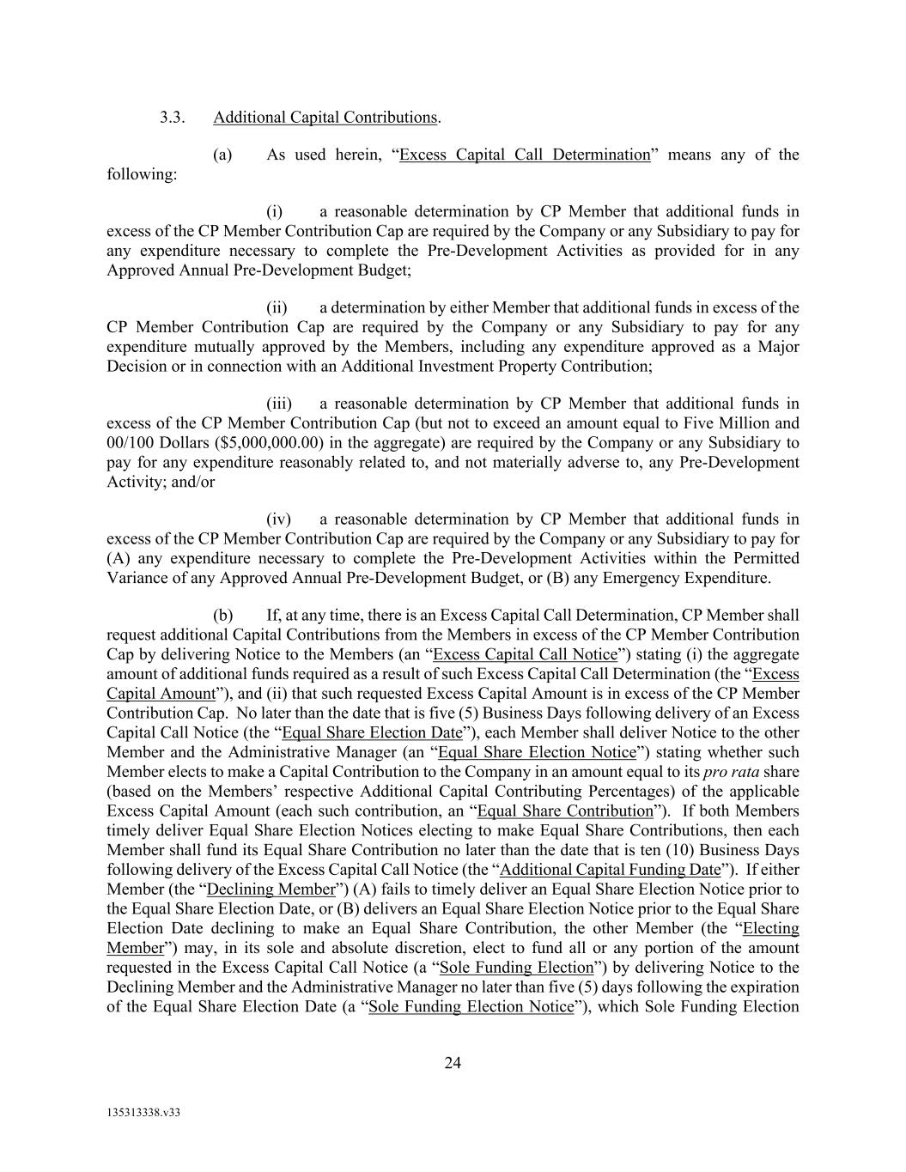
24 135313338.v33 3.3. Additional Capital Contributions. (a) As used herein, “Excess Capital Call Determination” means any of the following: (i) a reasonable determination by CP Member that additional funds in excess of the CP Member Contribution Cap are required by the Company or any Subsidiary to pay for any expenditure necessary to complete the Pre-Development Activities as provided for in any Approved Annual Pre-Development Budget; (ii) a determination by either Member that additional funds in excess of the CP Member Contribution Cap are required by the Company or any Subsidiary to pay for any expenditure mutually approved by the Members, including any expenditure approved as a Major Decision or in connection with an Additional Investment Property Contribution; (iii) a reasonable determination by CP Member that additional funds in excess of the CP Member Contribution Cap (but not to exceed an amount equal to Five Million and 00/100 Dollars ($5,000,000.00) in the aggregate) are required by the Company or any Subsidiary to pay for any expenditure reasonably related to, and not materially adverse to, any Pre-Development Activity; and/or (iv) a reasonable determination by CP Member that additional funds in excess of the CP Member Contribution Cap are required by the Company or any Subsidiary to pay for (A) any expenditure necessary to complete the Pre-Development Activities within the Permitted Variance of any Approved Annual Pre-Development Budget, or (B) any Emergency Expenditure. (b) If, at any time, there is an Excess Capital Call Determination, CP Member shall request additional Capital Contributions from the Members in excess of the CP Member Contribution Cap by delivering Notice to the Members (an “Excess Capital Call Notice”) stating (i) the aggregate amount of additional funds required as a result of such Excess Capital Call Determination (the “Excess Capital Amount”), and (ii) that such requested Excess Capital Amount is in excess of the CP Member Contribution Cap. No later than the date that is five (5) Business Days following delivery of an Excess Capital Call Notice (the “Equal Share Election Date”), each Member shall deliver Notice to the other Member and the Administrative Manager (an “Equal Share Election Notice”) stating whether such Member elects to make a Capital Contribution to the Company in an amount equal to its pro rata share (based on the Members’ respective Additional Capital Contributing Percentages) of the applicable Excess Capital Amount (each such contribution, an “Equal Share Contribution”). If both Members timely deliver Equal Share Election Notices electing to make Equal Share Contributions, then each Member shall fund its Equal Share Contribution no later than the date that is ten (10) Business Days following delivery of the Excess Capital Call Notice (the “Additional Capital Funding Date”). If either Member (the “Declining Member”) (A) fails to timely deliver an Equal Share Election Notice prior to the Equal Share Election Date, or (B) delivers an Equal Share Election Notice prior to the Equal Share Election Date declining to make an Equal Share Contribution, the other Member (the “Electing Member”) may, in its sole and absolute discretion, elect to fund all or any portion of the amount requested in the Excess Capital Call Notice (a “Sole Funding Election”) by delivering Notice to the Declining Member and the Administrative Manager no later than five (5) days following the expiration of the Equal Share Election Date (a “Sole Funding Election Notice”), which Sole Funding Election

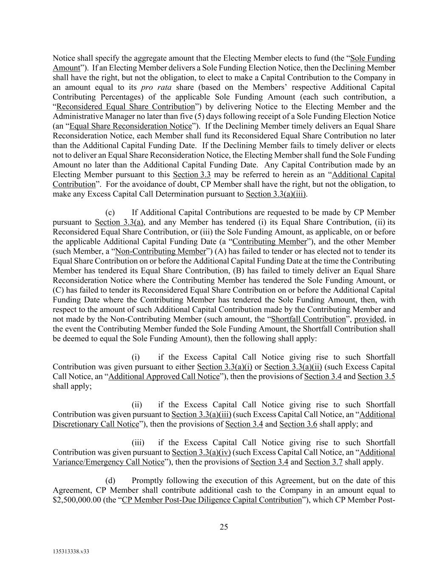
25 135313338.v33 Notice shall specify the aggregate amount that the Electing Member elects to fund (the “Sole Funding Amount”). If an Electing Member delivers a Sole Funding Election Notice, then the Declining Member shall have the right, but not the obligation, to elect to make a Capital Contribution to the Company in an amount equal to its pro rata share (based on the Members’ respective Additional Capital Contributing Percentages) of the applicable Sole Funding Amount (each such contribution, a “Reconsidered Equal Share Contribution”) by delivering Notice to the Electing Member and the Administrative Manager no later than five (5) days following receipt of a Sole Funding Election Notice (an “Equal Share Reconsideration Notice”). If the Declining Member timely delivers an Equal Share Reconsideration Notice, each Member shall fund its Reconsidered Equal Share Contribution no later than the Additional Capital Funding Date. If the Declining Member fails to timely deliver or elects not to deliver an Equal Share Reconsideration Notice, the Electing Member shall fund the Sole Funding Amount no later than the Additional Capital Funding Date. Any Capital Contribution made by an Electing Member pursuant to this Section 3.3 may be referred to herein as an “Additional Capital Contribution”. For the avoidance of doubt, CP Member shall have the right, but not the obligation, to make any Excess Capital Call Determination pursuant to Section 3.3(a)(iii). (c) If Additional Capital Contributions are requested to be made by CP Member pursuant to Section 3.3(a), and any Member has tendered (i) its Equal Share Contribution, (ii) its Reconsidered Equal Share Contribution, or (iii) the Sole Funding Amount, as applicable, on or before the applicable Additional Capital Funding Date (a “Contributing Member”), and the other Member (such Member, a “Non-Contributing Member”) (A) has failed to tender or has elected not to tender its Equal Share Contribution on or before the Additional Capital Funding Date at the time the Contributing Member has tendered its Equal Share Contribution, (B) has failed to timely deliver an Equal Share Reconsideration Notice where the Contributing Member has tendered the Sole Funding Amount, or (C) has failed to tender its Reconsidered Equal Share Contribution on or before the Additional Capital Funding Date where the Contributing Member has tendered the Sole Funding Amount, then, with respect to the amount of such Additional Capital Contribution made by the Contributing Member and not made by the Non-Contributing Member (such amount, the “Shortfall Contribution”, provided, in the event the Contributing Member funded the Sole Funding Amount, the Shortfall Contribution shall be deemed to equal the Sole Funding Amount), then the following shall apply: (i) if the Excess Capital Call Notice giving rise to such Shortfall Contribution was given pursuant to either Section 3.3(a)(i) or Section 3.3(a)(ii) (such Excess Capital Call Notice, an “Additional Approved Call Notice”), then the provisions of Section 3.4 and Section 3.5 shall apply; (ii) if the Excess Capital Call Notice giving rise to such Shortfall Contribution was given pursuant to Section 3.3(a)(iii) (such Excess Capital Call Notice, an “Additional Discretionary Call Notice”), then the provisions of Section 3.4 and Section 3.6 shall apply; and (iii) if the Excess Capital Call Notice giving rise to such Shortfall Contribution was given pursuant to Section 3.3(a)(iv) (such Excess Capital Call Notice, an “Additional Variance/Emergency Call Notice”), then the provisions of Section 3.4 and Section 3.7 shall apply. (d) Promptly following the execution of this Agreement, but on the date of this Agreement, CP Member shall contribute additional cash to the Company in an amount equal to $2,500,000.00 (the “CP Member Post-Due Diligence Capital Contribution”), which CP Member Post-

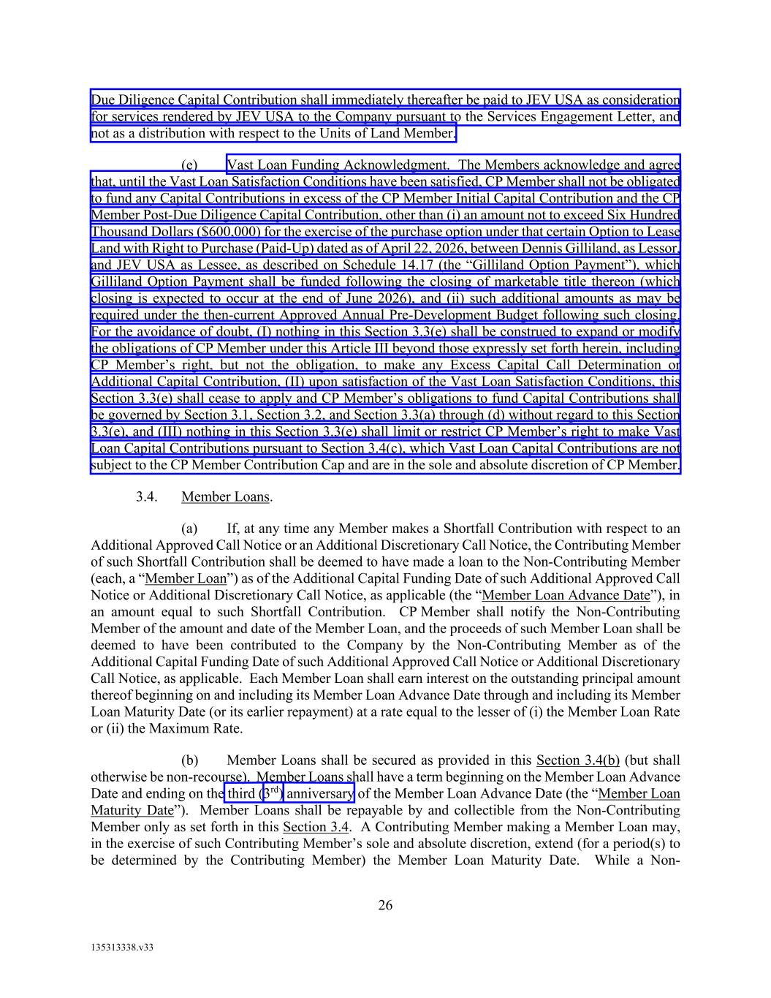
26 135313338.v33 Due Diligence Capital Contribution shall immediately thereafter be paid to JEV USA as consideration for services rendered by JEV USA to the Company pursuant to the Services Engagement Letter, and not as a distribution with respect to the Units of Land Member. (e) Vast Loan Funding Acknowledgment. The Members acknowledge and agree that, until the Vast Loan Satisfaction Conditions have been satisfied, CP Member shall not be obligated to fund any Capital Contributions in excess of the CP Member Initial Capital Contribution and the CP Member Post-Due Diligence Capital Contribution, other than (i) an amount not to exceed Six Hundred Thousand Dollars ($600,000) for the exercise of the purchase option under that certain Option to Lease Land with Right to Purchase (Paid-Up) dated as of April 22, 2026, between Dennis Gilliland, as Lessor, and JEV USA as Lessee, as described on Schedule 14.17 (the “Gilliland Option Payment”), which Gilliland Option Payment shall be funded following the closing of marketable title thereon (which closing is expected to occur at the end of June 2026), and (ii) such additional amounts as may be required under the then-current Approved Annual Pre-Development Budget following such closing. For the avoidance of doubt, (I) nothing in this Section 3.3(e) shall be construed to expand or modify the obligations of CP Member under this Article III beyond those expressly set forth herein, including CP Member’s right, but not the obligation, to make any Excess Capital Call Determination or Additional Capital Contribution, (II) upon satisfaction of the Vast Loan Satisfaction Conditions, this Section 3.3(e) shall cease to apply and CP Member’s obligations to fund Capital Contributions shall be governed by Section 3.1, Section 3.2, and Section 3.3(a) through (d) without regard to this Section 3.3(e), and (III) nothing in this Section 3.3(e) shall limit or restrict CP Member’s right to make Vast Loan Capital Contributions pursuant to Section 3.4(c), which Vast Loan Capital Contributions are not subject to the CP Member Contribution Cap and are in the sole and absolute discretion of CP Member. 3.4. Member Loans. (a) If, at any time any Member makes a Shortfall Contribution with respect to an Additional Approved Call Notice or an Additional Discretionary Call Notice, the Contributing Member of such Shortfall Contribution shall be deemed to have made a loan to the Non-Contributing Member (each, a “Member Loan”) as of the Additional Capital Funding Date of such Additional Approved Call Notice or Additional Discretionary Call Notice, as applicable (the “Member Loan Advance Date”), in an amount equal to such Shortfall Contribution. CP Member shall notify the Non-Contributing Member of the amount and date of the Member Loan, and the proceeds of such Member Loan shall be deemed to have been contributed to the Company by the Non-Contributing Member as of the Additional Capital Funding Date of such Additional Approved Call Notice or Additional Discretionary Call Notice, as applicable. Each Member Loan shall earn interest on the outstanding principal amount thereof beginning on and including its Member Loan Advance Date through and including its Member Loan Maturity Date (or its earlier repayment) at a rate equal to the lesser of (i) the Member Loan Rate or (ii) the Maximum Rate. (b) Member Loans shall be secured as provided in this Section 3.4(b) (but shall otherwise be non-recourse). Member Loans shall have a term beginning on the Member Loan Advance Date and ending on the third (3rd) anniversary of the Member Loan Advance Date (the “Member Loan Maturity Date”). Member Loans shall be repayable by and collectible from the Non-Contributing Member only as set forth in this Section 3.4. A Contributing Member making a Member Loan may, in the exercise of such Contributing Member’s sole and absolute discretion, extend (for a period(s) to be determined by the Contributing Member) the Member Loan Maturity Date. While a Non-

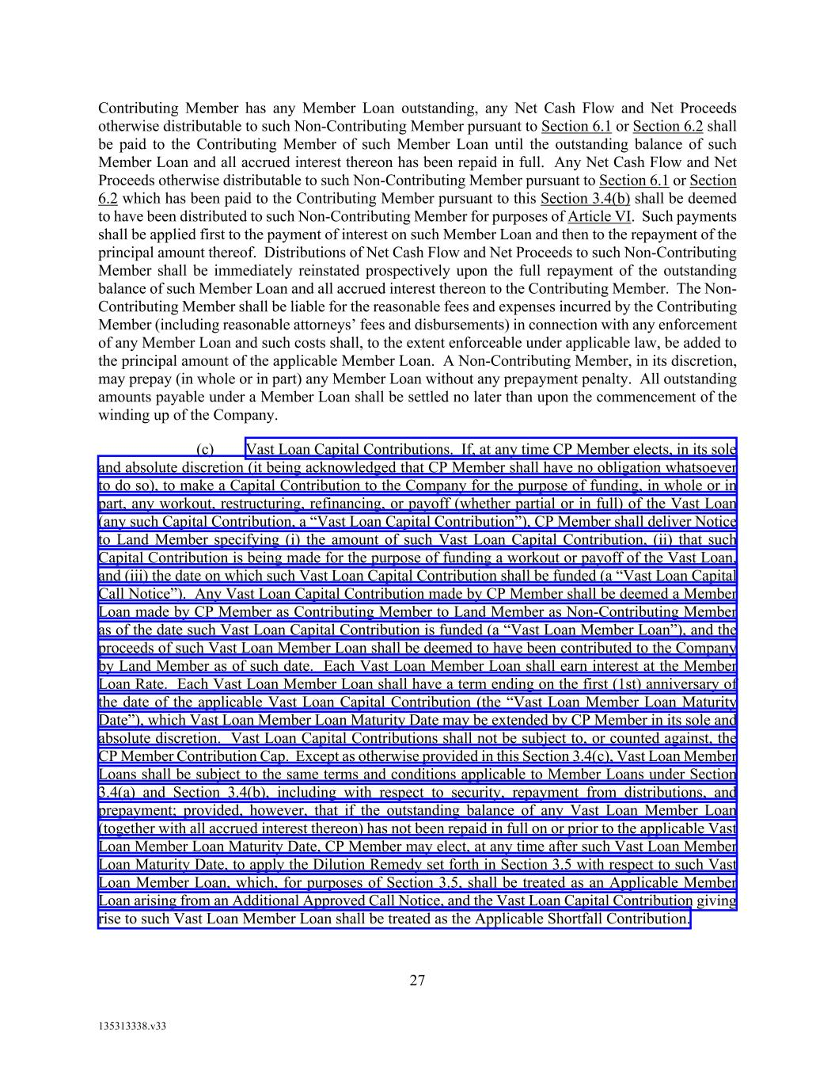
27 135313338.v33 Contributing Member has any Member Loan outstanding, any Net Cash Flow and Net Proceeds otherwise distributable to such Non-Contributing Member pursuant to Section 6.1 or Section 6.2 shall be paid to the Contributing Member of such Member Loan until the outstanding balance of such Member Loan and all accrued interest thereon has been repaid in full. Any Net Cash Flow and Net Proceeds otherwise distributable to such Non-Contributing Member pursuant to Section 6.1 or Section 6.2 which has been paid to the Contributing Member pursuant to this Section 3.4(b) shall be deemed to have been distributed to such Non-Contributing Member for purposes of Article VI. Such payments shall be applied first to the payment of interest on such Member Loan and then to the repayment of the principal amount thereof. Distributions of Net Cash Flow and Net Proceeds to such Non-Contributing Member shall be immediately reinstated prospectively upon the full repayment of the outstanding balance of such Member Loan and all accrued interest thereon to the Contributing Member. The Non- Contributing Member shall be liable for the reasonable fees and expenses incurred by the Contributing Member (including reasonable attorneys’ fees and disbursements) in connection with any enforcement of any Member Loan and such costs shall, to the extent enforceable under applicable law, be added to the principal amount of the applicable Member Loan. A Non-Contributing Member, in its discretion, may prepay (in whole or in part) any Member Loan without any prepayment penalty. All outstanding amounts payable under a Member Loan shall be settled no later than upon the commencement of the winding up of the Company. (c) Vast Loan Capital Contributions. If, at any time CP Member elects, in its sole and absolute discretion (it being acknowledged that CP Member shall have no obligation whatsoever to do so), to make a Capital Contribution to the Company for the purpose of funding, in whole or in part, any workout, restructuring, refinancing, or payoff (whether partial or in full) of the Vast Loan (any such Capital Contribution, a “Vast Loan Capital Contribution”), CP Member shall deliver Notice to Land Member specifying (i) the amount of such Vast Loan Capital Contribution, (ii) that such Capital Contribution is being made for the purpose of funding a workout or payoff of the Vast Loan, and (iii) the date on which such Vast Loan Capital Contribution shall be funded (a “Vast Loan Capital Call Notice”). Any Vast Loan Capital Contribution made by CP Member shall be deemed a Member Loan made by CP Member as Contributing Member to Land Member as Non-Contributing Member as of the date such Vast Loan Capital Contribution is funded (a “Vast Loan Member Loan”), and the proceeds of such Vast Loan Member Loan shall be deemed to have been contributed to the Company by Land Member as of such date. Each Vast Loan Member Loan shall earn interest at the Member Loan Rate. Each Vast Loan Member Loan shall have a term ending on the first (1st) anniversary of the date of the applicable Vast Loan Capital Contribution (the “Vast Loan Member Loan Maturity Date”), which Vast Loan Member Loan Maturity Date may be extended by CP Member in its sole and absolute discretion. Vast Loan Capital Contributions shall not be subject to, or counted against, the CP Member Contribution Cap. Except as otherwise provided in this Section 3.4(c), Vast Loan Member Loans shall be subject to the same terms and conditions applicable to Member Loans under Section 3.4(a) and Section 3.4(b), including with respect to security, repayment from distributions, and prepayment; provided, however, that if the outstanding balance of any Vast Loan Member Loan (together with all accrued interest thereon) has not been repaid in full on or prior to the applicable Vast Loan Member Loan Maturity Date, CP Member may elect, at any time after such Vast Loan Member Loan Maturity Date, to apply the Dilution Remedy set forth in Section 3.5 with respect to such Vast Loan Member Loan, which, for purposes of Section 3.5, shall be treated as an Applicable Member Loan arising from an Additional Approved Call Notice, and the Vast Loan Capital Contribution giving rise to such Vast Loan Member Loan shall be treated as the Applicable Shortfall Contribution.


28 135313338.v33 3.5. Dilution. If the outstanding balance of a Member Loan (together with all accrued interest thereon) arising from an Additional Approved Call Notice (or treated as arising from an Additional Approved Call Notice pursuant to Section 3.4(c)) has not been repaid in full on or prior to its Member Loan Maturity Date (or, in the case of a Vast Loan Member Loan, its Vast Loan Member Loan Maturity Date), the Contributing Member may elect, at any time after such Member Loan Maturity Date (or Vast Loan Member Loan Maturity Date, as applicable), to apply the provisions of this Section 3.5 with respect to such Member Loan (such Member Loan, the “Applicable Member Loan”, and the Shortfall Contribution (or Vast Loan Capital Contribution, as applicable) giving rise to such Applicable Member Loan, the “Applicable Shortfall Contribution”), in which case, subject to the terms of provisions of this Section 3.5, the number of Units of such Contributing Member shall be recalculated to be the number determined by (x) dividing (a) the sum of (i) the aggregate Capital Contributions actually made by such Contributing Member as of such recalculation date that have not previously been withdrawn by the Contributing Member (excluding the Applicable Shortfall Contribution but including, for the avoidance of doubt, any Shortfall Contribution for which the Dilution Remedy has theretofore been applied and the Units of the Contributing Member have theretofore been adjusted pursuant to this Section 3.5), plus (ii) the full amount of the Applicable Shortfall Contribution contributed by the Contributing Member on behalf of the Non-Contributing Member, by (b) the sum of all of Capital Contributions actually made by the Members as of such recalculation date (excluding the Applicable Shortfall Contribution but including, for the avoidance of doubt, any Shortfall Contribution for which the Dilution Remedy has theretofore been applied and the Units of the Contributing Member have theretofore been adjusted pursuant to this Section 3.5)), and (y) multiplying such amount by one hundred percent (100%); provided, however, if CP Member is the Contributing Member, in no event shall the application of the foregoing recalculation result in CP Member holding fewer Units than the number of Units held by CP Member immediately prior to such recalculation. If there is any increase in the number of Units of the Contributing Member pursuant to this Section 3.5, the number of Units of the Non-Contributing Member shall be reduced by the amount of the increase in the Units held by the Contributing Member (any such increase in the number of Units of the Contributing Member and corresponding decrease in the number of Units of the Non- Contributing Member (the provisions of this Section 3.5, the “Dilution Remedy”); provided, however, such increase and decrease shall not exceed the amount of Units held by the Non-Contributing Member prior to such Applicable Shortfall Contribution. Upon application of the Dilution Remedy with respect to any Applicable Shortfall Contribution, such Applicable Shortfall Contribution shall thereafter be deemed a Capital Contribution of the Contributing Member (and not of the Non-Contributing Member) for all purposes of this Agreement, including for purposes of any subsequent application of this Section 3.5. For the avoidance of doubt, (I) any Shortfall Contribution for which the Member Loan Maturity Date (or Vast Loan Member Loan Maturity Date, as applicable) for the related Member Loan has not occurred shall be deemed a Capital Contribution of the Non-Contributing Member (and not of the Contributing Member) for purposes of this Section 3.5 until such time, if ever, as the Dilution Remedy is applied with respect thereto, (II) any Shortfall Contribution for which the Member Loan Maturity Date (or Vast Loan Member Loan Maturity Date, as applicable), for the related Member Loan has occurred but for which the Contributing Member has not yet elected to apply the Dilution Remedy shall continue to be deemed a Capital Contribution of the Non-Contributing Member for purposes of this Section 3.5 until such time, if ever, as the Contributing Member makes such election, and (III) Senior Contributions and Priority Contributions shall not constitute Capital Contributions and shall be excluded from all calculations under this Section 3.5. Illustrative examples of the application of the Dilution Remedy under this Section 3.5 are set forth on Schedule 3.5 attached hereto, which

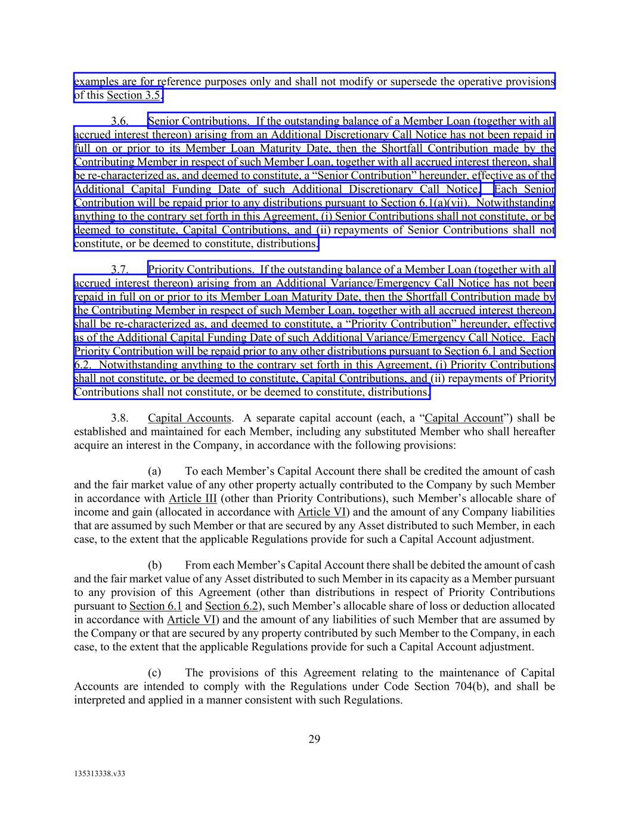
29 135313338.v33 examples are for reference purposes only and shall not modify or supersede the operative provisions of this Section 3.5. 3.6. Senior Contributions. If the outstanding balance of a Member Loan (together with all accrued interest thereon) arising from an Additional Discretionary Call Notice has not been repaid in full on or prior to its Member Loan Maturity Date, then the Shortfall Contribution made by the Contributing Member in respect of such Member Loan, together with all accrued interest thereon, shall be re-characterized as, and deemed to constitute, a “Senior Contribution” hereunder, effective as of the Additional Capital Funding Date of such Additional Discretionary Call Notice. Each Senior Contribution will be repaid prior to any distributions pursuant to Section 6.1(a)(vii). Notwithstanding anything to the contrary set forth in this Agreement, (i) Senior Contributions shall not constitute, or be deemed to constitute, Capital Contributions, and (ii) repayments of Senior Contributions shall not constitute, or be deemed to constitute, distributions. 3.7. Priority Contributions. If the outstanding balance of a Member Loan (together with all accrued interest thereon) arising from an Additional Variance/Emergency Call Notice has not been repaid in full on or prior to its Member Loan Maturity Date, then the Shortfall Contribution made by the Contributing Member in respect of such Member Loan, together with all accrued interest thereon, shall be re-characterized as, and deemed to constitute, a “Priority Contribution” hereunder, effective as of the Additional Capital Funding Date of such Additional Variance/Emergency Call Notice. Each Priority Contribution will be repaid prior to any other distributions pursuant to Section 6.1 and Section 6.2. Notwithstanding anything to the contrary set forth in this Agreement, (i) Priority Contributions shall not constitute, or be deemed to constitute, Capital Contributions, and (ii) repayments of Priority Contributions shall not constitute, or be deemed to constitute, distributions. 3.8. Capital Accounts. A separate capital account (each, a “Capital Account”) shall be established and maintained for each Member, including any substituted Member who shall hereafter acquire an interest in the Company, in accordance with the following provisions: (a) To each Member’s Capital Account there shall be credited the amount of cash and the fair market value of any other property actually contributed to the Company by such Member in accordance with Article III (other than Priority Contributions), such Member’s allocable share of income and gain (allocated in accordance with Article VI) and the amount of any Company liabilities that are assumed by such Member or that are secured by any Asset distributed to such Member, in each case, to the extent that the applicable Regulations provide for such a Capital Account adjustment. (b) From each Member’s Capital Account there shall be debited the amount of cash and the fair market value of any Asset distributed to such Member in its capacity as a Member pursuant to any provision of this Agreement (other than distributions in respect of Priority Contributions pursuant to Section 6.1 and Section 6.2), such Member’s allocable share of loss or deduction allocated in accordance with Article VI) and the amount of any liabilities of such Member that are assumed by the Company or that are secured by any property contributed by such Member to the Company, in each case, to the extent that the applicable Regulations provide for such a Capital Account adjustment. (c) The provisions of this Agreement relating to the maintenance of Capital Accounts are intended to comply with the Regulations under Code Section 704(b), and shall be interpreted and applied in a manner consistent with such Regulations.

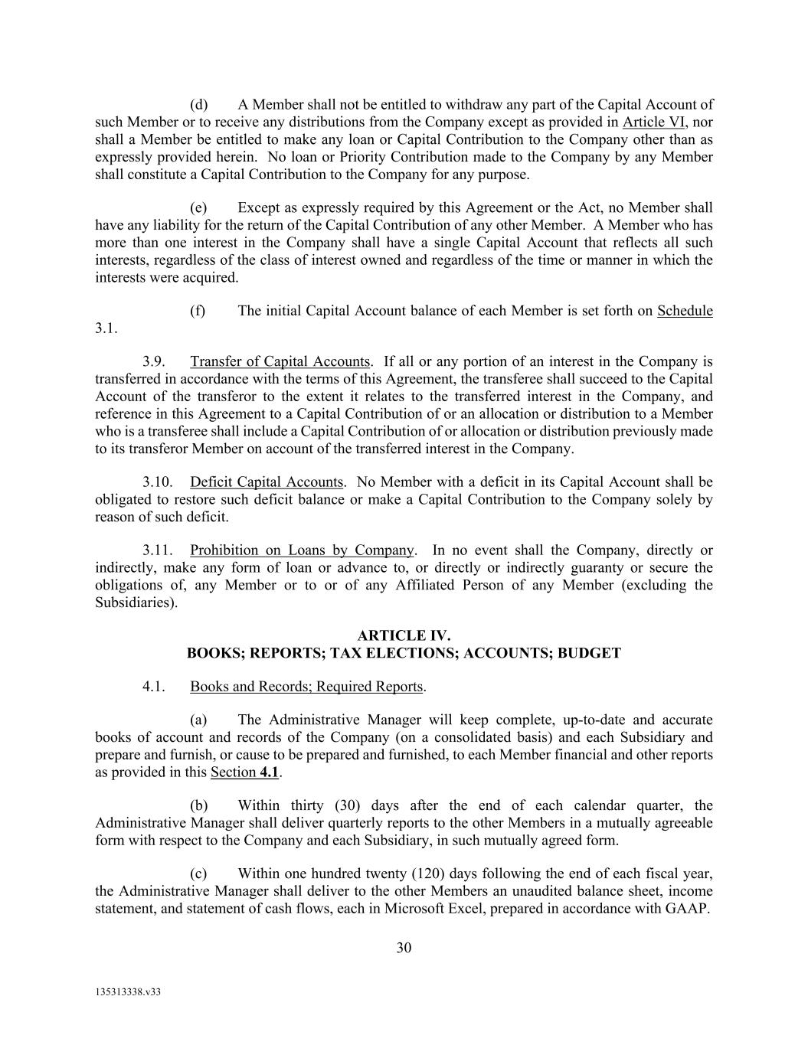
30 135313338.v33 (d) A Member shall not be entitled to withdraw any part of the Capital Account of such Member or to receive any distributions from the Company except as provided in Article VI, nor shall a Member be entitled to make any loan or Capital Contribution to the Company other than as expressly provided herein. No loan or Priority Contribution made to the Company by any Member shall constitute a Capital Contribution to the Company for any purpose. (e) Except as expressly required by this Agreement or the Act, no Member shall have any liability for the return of the Capital Contribution of any other Member. A Member who has more than one interest in the Company shall have a single Capital Account that reflects all such interests, regardless of the class of interest owned and regardless of the time or manner in which the interests were acquired. (f) The initial Capital Account balance of each Member is set forth on Schedule 3.1. 3.9. Transfer of Capital Accounts. If all or any portion of an interest in the Company is transferred in accordance with the terms of this Agreement, the transferee shall succeed to the Capital Account of the transferor to the extent it relates to the transferred interest in the Company, and reference in this Agreement to a Capital Contribution of or an allocation or distribution to a Member who is a transferee shall include a Capital Contribution of or allocation or distribution previously made to its transferor Member on account of the transferred interest in the Company. 3.10. Deficit Capital Accounts. No Member with a deficit in its Capital Account shall be obligated to restore such deficit balance or make a Capital Contribution to the Company solely by reason of such deficit. 3.11. Prohibition on Loans by Company. In no event shall the Company, directly or indirectly, make any form of loan or advance to, or directly or indirectly guaranty or secure the obligations of, any Member or to or of any Affiliated Person of any Member (excluding the Subsidiaries). ARTICLE IV. BOOKS; REPORTS; TAX ELECTIONS; ACCOUNTS; BUDGET 4.1. Books and Records; Required Reports. (a) The Administrative Manager will keep complete, up-to-date and accurate books of account and records of the Company (on a consolidated basis) and each Subsidiary and prepare and furnish, or cause to be prepared and furnished, to each Member financial and other reports as provided in this Section 4.1. (b) Within thirty (30) days after the end of each calendar quarter, the Administrative Manager shall deliver quarterly reports to the other Members in a mutually agreeable form with respect to the Company and each Subsidiary, in such mutually agreed form. (c) Within one hundred twenty (120) days following the end of each fiscal year, the Administrative Manager shall deliver to the other Members an unaudited balance sheet, income statement, and statement of cash flows, each in Microsoft Excel, prepared in accordance with GAAP.

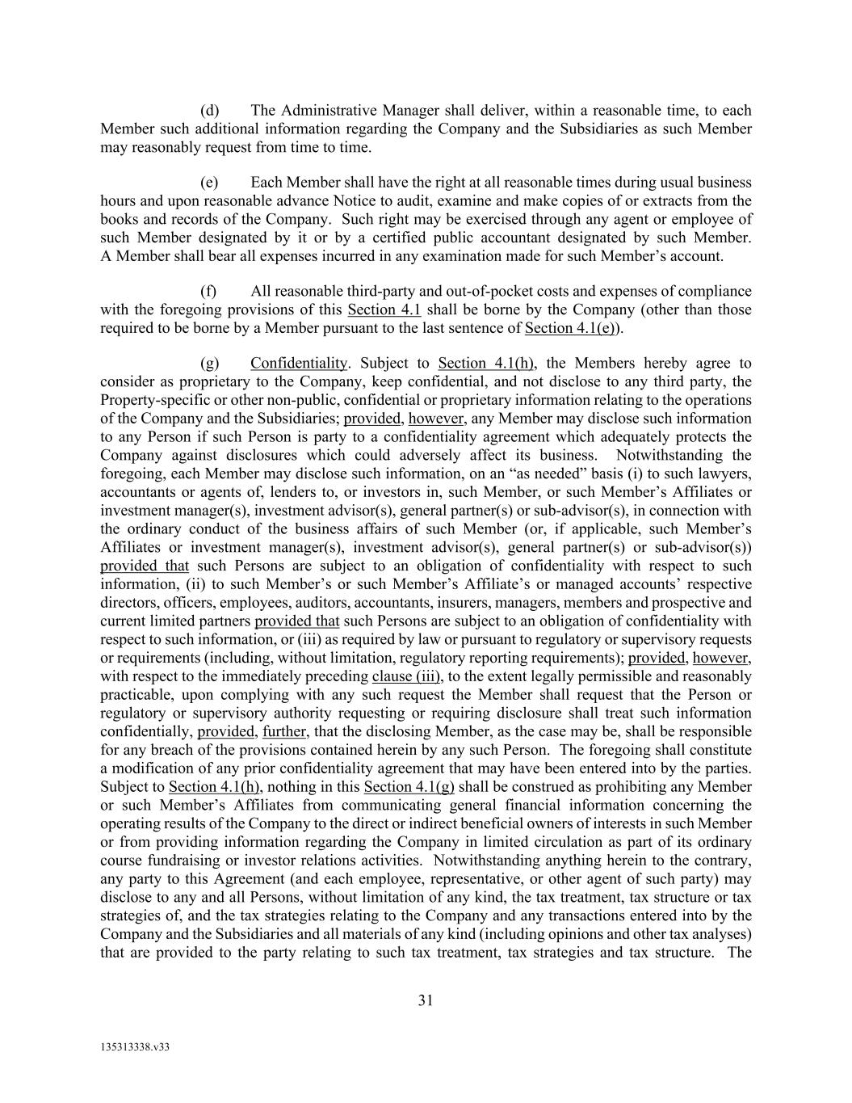
31 135313338.v33 (d) The Administrative Manager shall deliver, within a reasonable time, to each Member such additional information regarding the Company and the Subsidiaries as such Member may reasonably request from time to time. (e) Each Member shall have the right at all reasonable times during usual business hours and upon reasonable advance Notice to audit, examine and make copies of or extracts from the books and records of the Company. Such right may be exercised through any agent or employee of such Member designated by it or by a certified public accountant designated by such Member. A Member shall bear all expenses incurred in any examination made for such Member’s account. (f) All reasonable third-party and out-of-pocket costs and expenses of compliance with the foregoing provisions of this Section 4.1 shall be borne by the Company (other than those required to be borne by a Member pursuant to the last sentence of Section 4.1(e)). (g) Confidentiality. Subject to Section 4.1(h), the Members hereby agree to consider as proprietary to the Company, keep confidential, and not disclose to any third party, the Property-specific or other non-public, confidential or proprietary information relating to the operations of the Company and the Subsidiaries; provided, however, any Member may disclose such information to any Person if such Person is party to a confidentiality agreement which adequately protects the Company against disclosures which could adversely affect its business. Notwithstanding the foregoing, each Member may disclose such information, on an “as needed” basis (i) to such lawyers, accountants or agents of, lenders to, or investors in, such Member, or such Member’s Affiliates or investment manager(s), investment advisor(s), general partner(s) or sub-advisor(s), in connection with the ordinary conduct of the business affairs of such Member (or, if applicable, such Member’s Affiliates or investment manager(s), investment advisor(s), general partner(s) or sub-advisor(s)) provided that such Persons are subject to an obligation of confidentiality with respect to such information, (ii) to such Member’s or such Member’s Affiliate’s or managed accounts’ respective directors, officers, employees, auditors, accountants, insurers, managers, members and prospective and current limited partners provided that such Persons are subject to an obligation of confidentiality with respect to such information, or (iii) as required by law or pursuant to regulatory or supervisory requests or requirements (including, without limitation, regulatory reporting requirements); provided, however, with respect to the immediately preceding clause (iii), to the extent legally permissible and reasonably practicable, upon complying with any such request the Member shall request that the Person or regulatory or supervisory authority requesting or requiring disclosure shall treat such information confidentially, provided, further, that the disclosing Member, as the case may be, shall be responsible for any breach of the provisions contained herein by any such Person. The foregoing shall constitute a modification of any prior confidentiality agreement that may have been entered into by the parties. Subject to Section 4.1(h), nothing in this Section 4.1(g) shall be construed as prohibiting any Member or such Member’s Affiliates from communicating general financial information concerning the operating results of the Company to the direct or indirect beneficial owners of interests in such Member or from providing information regarding the Company in limited circulation as part of its ordinary course fundraising or investor relations activities. Notwithstanding anything herein to the contrary, any party to this Agreement (and each employee, representative, or other agent of such party) may disclose to any and all Persons, without limitation of any kind, the tax treatment, tax structure or tax strategies of, and the tax strategies relating to the Company and any transactions entered into by the Company and the Subsidiaries and all materials of any kind (including opinions and other tax analyses) that are provided to the party relating to such tax treatment, tax strategies and tax structure. The

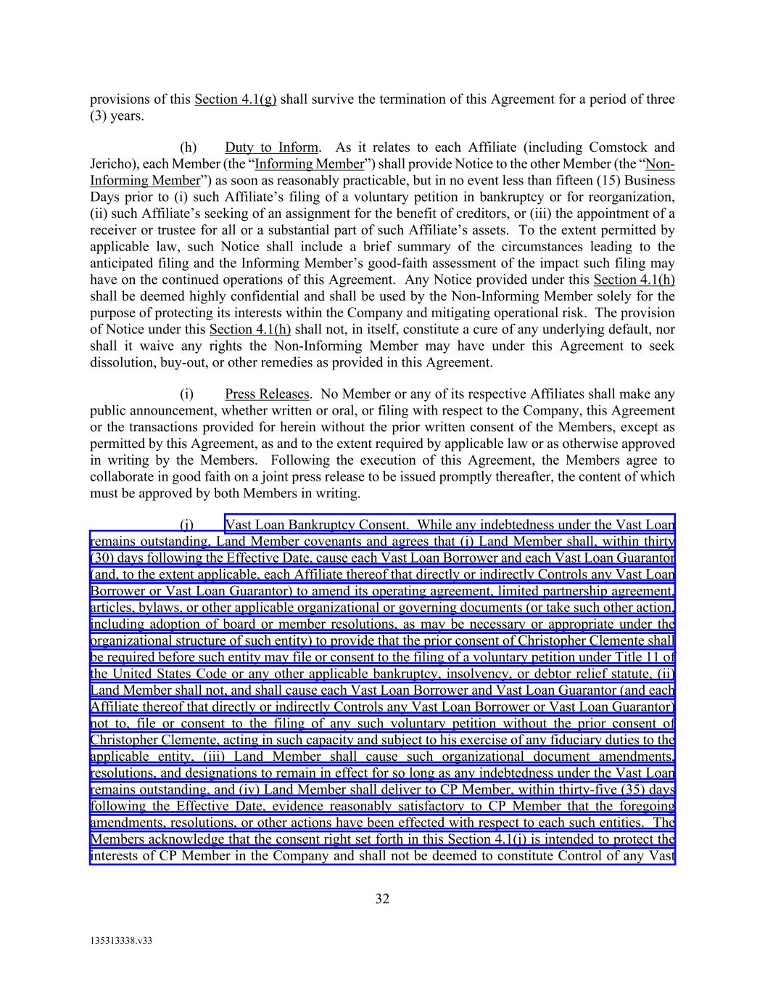
32 135313338.v33 provisions of this Section 4.1(g) shall survive the termination of this Agreement for a period of three (3) years. (h) Duty to Inform. As it relates to each Affiliate (including Comstock and Jericho), each Member (the “Informing Member”) shall provide Notice to the other Member (the “Non- Informing Member”) as soon as reasonably practicable, but in no event less than fifteen (15) Business Days prior to (i) such Affiliate’s filing of a voluntary petition in bankruptcy or for reorganization, (ii) such Affiliate’s seeking of an assignment for the benefit of creditors, or (iii) the appointment of a receiver or trustee for all or a substantial part of such Affiliate’s assets. To the extent permitted by applicable law, such Notice shall include a brief summary of the circumstances leading to the anticipated filing and the Informing Member’s good-faith assessment of the impact such filing may have on the continued operations of this Agreement. Any Notice provided under this Section 4.1(h) shall be deemed highly confidential and shall be used by the Non-Informing Member solely for the purpose of protecting its interests within the Company and mitigating operational risk. The provision of Notice under this Section 4.1(h) shall not, in itself, constitute a cure of any underlying default, nor shall it waive any rights the Non-Informing Member may have under this Agreement to seek dissolution, buy-out, or other remedies as provided in this Agreement. (i) Press Releases. No Member or any of its respective Affiliates shall make any public announcement, whether written or oral, or filing with respect to the Company, this Agreement or the transactions provided for herein without the prior written consent of the Members, except as permitted by this Agreement, as and to the extent required by applicable law or as otherwise approved in writing by the Members. Following the execution of this Agreement, the Members agree to collaborate in good faith on a joint press release to be issued promptly thereafter, the content of which must be approved by both Members in writing. (j) Vast Loan Bankruptcy Consent. While any indebtedness under the Vast Loan remains outstanding, Land Member covenants and agrees that (i) Land Member shall, within thirty (30) days following the Effective Date, cause each Vast Loan Borrower and each Vast Loan Guarantor (and, to the extent applicable, each Affiliate thereof that directly or indirectly Controls any Vast Loan Borrower or Vast Loan Guarantor) to amend its operating agreement, limited partnership agreement, articles, bylaws, or other applicable organizational or governing documents (or take such other action, including adoption of board or member resolutions, as may be necessary or appropriate under the organizational structure of such entity) to provide that the prior consent of Christopher Clemente shall be required before such entity may file or consent to the filing of a voluntary petition under Title 11 of the United States Code or any other applicable bankruptcy, insolvency, or debtor relief statute, (ii) Land Member shall not, and shall cause each Vast Loan Borrower and Vast Loan Guarantor (and each Affiliate thereof that directly or indirectly Controls any Vast Loan Borrower or Vast Loan Guarantor) not to, file or consent to the filing of any such voluntary petition without the prior consent of Christopher Clemente, acting in such capacity and subject to his exercise of any fiduciary duties to the applicable entity, (iii) Land Member shall cause such organizational document amendments, resolutions, and designations to remain in effect for so long as any indebtedness under the Vast Loan remains outstanding, and (iv) Land Member shall deliver to CP Member, within thirty-five (35) days following the Effective Date, evidence reasonably satisfactory to CP Member that the foregoing amendments, resolutions, or other actions have been effected with respect to each such entities. The Members acknowledge that the consent right set forth in this Section 4.1(j) is intended to protect the interests of CP Member in the Company and shall not be deemed to constitute Control of any Vast

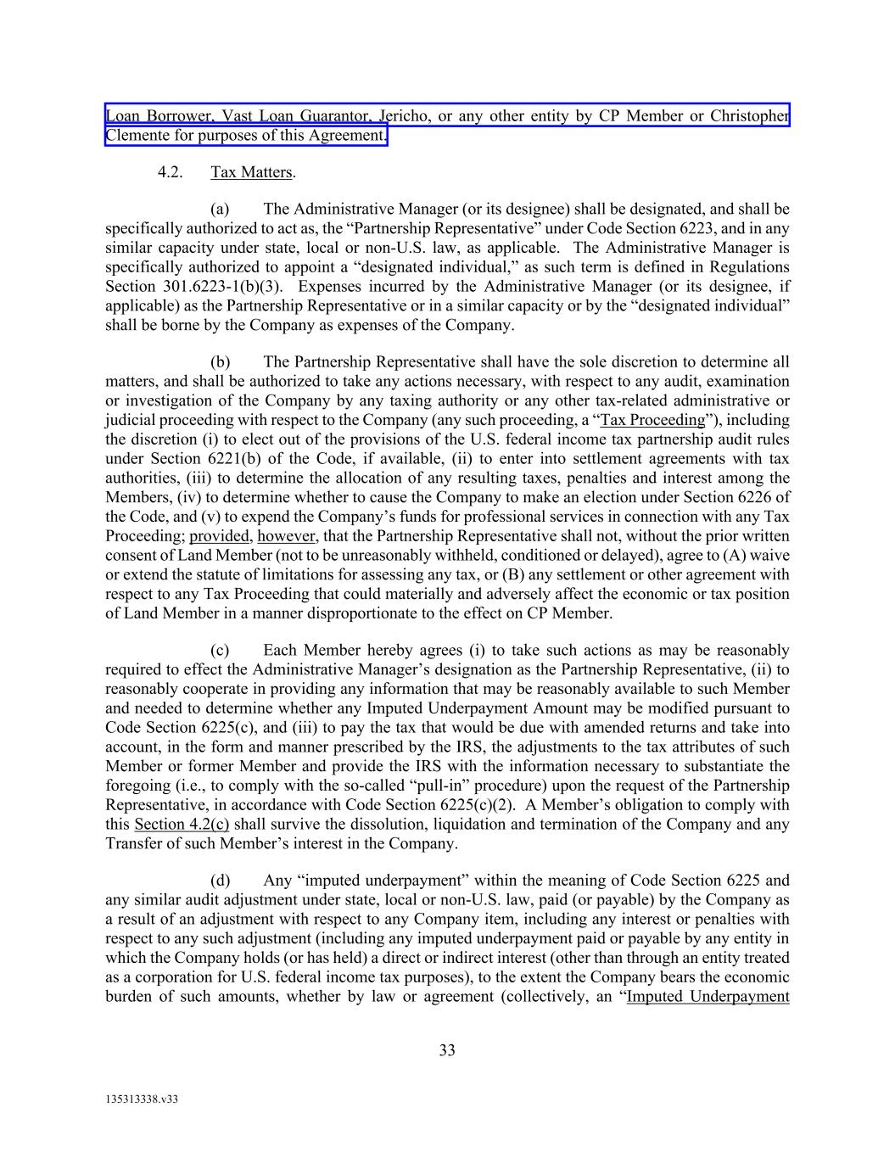
33 135313338.v33 Loan Borrower, Vast Loan Guarantor, Jericho, or any other entity by CP Member or Christopher Clemente for purposes of this Agreement. 4.2. Tax Matters. (a) The Administrative Manager (or its designee) shall be designated, and shall be specifically authorized to act as, the “Partnership Representative” under Code Section 6223, and in any similar capacity under state, local or non-U.S. law, as applicable. The Administrative Manager is specifically authorized to appoint a “designated individual,” as such term is defined in Regulations Section 301.6223-1(b)(3). Expenses incurred by the Administrative Manager (or its designee, if applicable) as the Partnership Representative or in a similar capacity or by the “designated individual” shall be borne by the Company as expenses of the Company. (b) The Partnership Representative shall have the sole discretion to determine all matters, and shall be authorized to take any actions necessary, with respect to any audit, examination or investigation of the Company by any taxing authority or any other tax-related administrative or judicial proceeding with respect to the Company (any such proceeding, a “Tax Proceeding”), including the discretion (i) to elect out of the provisions of the U.S. federal income tax partnership audit rules under Section 6221(b) of the Code, if available, (ii) to enter into settlement agreements with tax authorities, (iii) to determine the allocation of any resulting taxes, penalties and interest among the Members, (iv) to determine whether to cause the Company to make an election under Section 6226 of the Code, and (v) to expend the Company’s funds for professional services in connection with any Tax Proceeding; provided, however, that the Partnership Representative shall not, without the prior written consent of Land Member (not to be unreasonably withheld, conditioned or delayed), agree to (A) waive or extend the statute of limitations for assessing any tax, or (B) any settlement or other agreement with respect to any Tax Proceeding that could materially and adversely affect the economic or tax position of Land Member in a manner disproportionate to the effect on CP Member. (c) Each Member hereby agrees (i) to take such actions as may be reasonably required to effect the Administrative Manager’s designation as the Partnership Representative, (ii) to reasonably cooperate in providing any information that may be reasonably available to such Member and needed to determine whether any Imputed Underpayment Amount may be modified pursuant to Code Section 6225(c), and (iii) to pay the tax that would be due with amended returns and take into account, in the form and manner prescribed by the IRS, the adjustments to the tax attributes of such Member or former Member and provide the IRS with the information necessary to substantiate the foregoing (i.e., to comply with the so-called “pull-in” procedure) upon the request of the Partnership Representative, in accordance with Code Section 6225(c)(2). A Member’s obligation to comply with this Section 4.2(c) shall survive the dissolution, liquidation and termination of the Company and any Transfer of such Member’s interest in the Company. (d) Any “imputed underpayment” within the meaning of Code Section 6225 and any similar audit adjustment under state, local or non-U.S. law, paid (or payable) by the Company as a result of an adjustment with respect to any Company item, including any interest or penalties with respect to any such adjustment (including any imputed underpayment paid or payable by any entity in which the Company holds (or has held) a direct or indirect interest (other than through an entity treated as a corporation for U.S. federal income tax purposes), to the extent the Company bears the economic burden of such amounts, whether by law or agreement (collectively, an “Imputed Underpayment

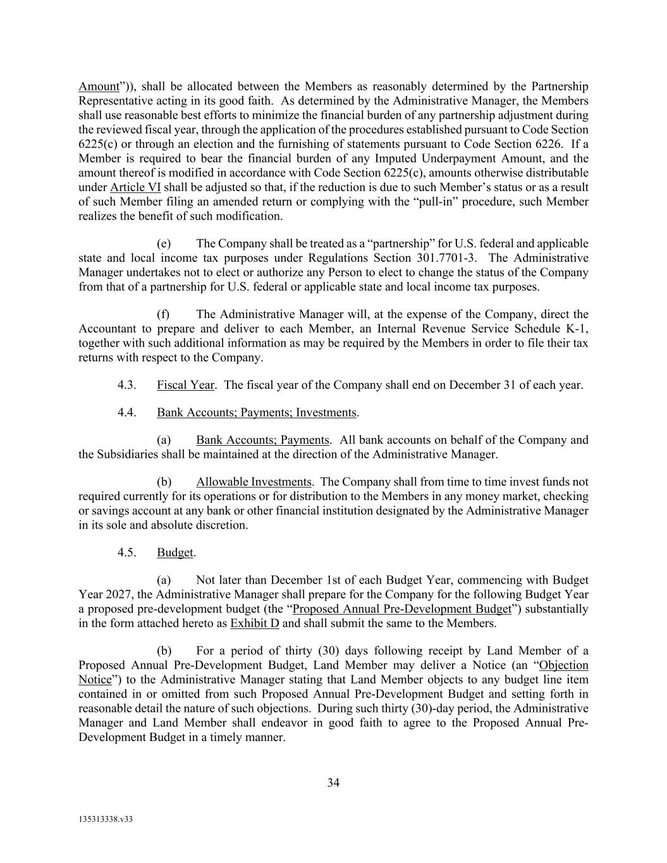
34 135313338.v33 Amount”)), shall be allocated between the Members as reasonably determined by the Partnership Representative acting in its good faith. As determined by the Administrative Manager, the Members shall use reasonable best efforts to minimize the financial burden of any partnership adjustment during the reviewed fiscal year, through the application of the procedures established pursuant to Code Section 6225(c) or through an election and the furnishing of statements pursuant to Code Section 6226. If a Member is required to bear the financial burden of any Imputed Underpayment Amount, and the amount thereof is modified in accordance with Code Section 6225(c), amounts otherwise distributable under Article VI shall be adjusted so that, if the reduction is due to such Member’s status or as a result of such Member filing an amended return or complying with the “pull-in” procedure, such Member realizes the benefit of such modification. (e) The Company shall be treated as a “partnership” for U.S. federal and applicable state and local income tax purposes under Regulations Section 301.7701-3. The Administrative Manager undertakes not to elect or authorize any Person to elect to change the status of the Company from that of a partnership for U.S. federal or applicable state and local income tax purposes. (f) The Administrative Manager will, at the expense of the Company, direct the Accountant to prepare and deliver to each Member, an Internal Revenue Service Schedule K-1, together with such additional information as may be required by the Members in order to file their tax returns with respect to the Company. 4.3. Fiscal Year. The fiscal year of the Company shall end on December 31 of each year. 4.4. Bank Accounts; Payments; Investments. (a) Bank Accounts; Payments. All bank accounts on behalf of the Company and the Subsidiaries shall be maintained at the direction of the Administrative Manager. (b) Allowable Investments. The Company shall from time to time invest funds not required currently for its operations or for distribution to the Members in any money market, checking or savings account at any bank or other financial institution designated by the Administrative Manager in its sole and absolute discretion. 4.5. Budget. (a) Not later than December 1st of each Budget Year, commencing with Budget Year 2027, the Administrative Manager shall prepare for the Company for the following Budget Year a proposed pre-development budget (the “Proposed Annual Pre-Development Budget”) substantially in the form attached hereto as Exhibit D and shall submit the same to the Members. (b) For a period of thirty (30) days following receipt by Land Member of a Proposed Annual Pre-Development Budget, Land Member may deliver a Notice (an “Objection Notice”) to the Administrative Manager stating that Land Member objects to any budget line item contained in or omitted from such Proposed Annual Pre-Development Budget and setting forth in reasonable detail the nature of such objections. During such thirty (30)-day period, the Administrative Manager and Land Member shall endeavor in good faith to agree to the Proposed Annual Pre- Development Budget in a timely manner.

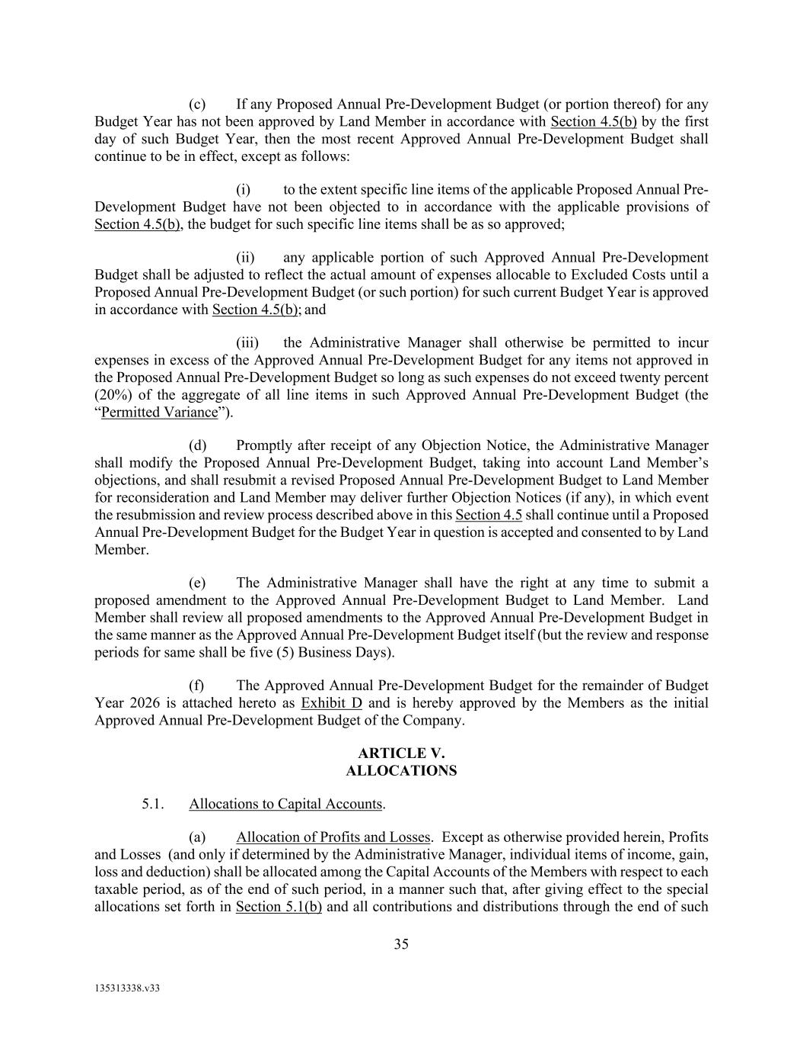
35 135313338.v33 (c) If any Proposed Annual Pre-Development Budget (or portion thereof) for any Budget Year has not been approved by Land Member in accordance with Section 4.5(b) by the first day of such Budget Year, then the most recent Approved Annual Pre-Development Budget shall continue to be in effect, except as follows: (i) to the extent specific line items of the applicable Proposed Annual Pre- Development Budget have not been objected to in accordance with the applicable provisions of Section 4.5(b), the budget for such specific line items shall be as so approved; (ii) any applicable portion of such Approved Annual Pre-Development Budget shall be adjusted to reflect the actual amount of expenses allocable to Excluded Costs until a Proposed Annual Pre-Development Budget (or such portion) for such current Budget Year is approved in accordance with Section 4.5(b); and (iii) the Administrative Manager shall otherwise be permitted to incur expenses in excess of the Approved Annual Pre-Development Budget for any items not approved in the Proposed Annual Pre-Development Budget so long as such expenses do not exceed twenty percent (20%) of the aggregate of all line items in such Approved Annual Pre-Development Budget (the “Permitted Variance”). (d) Promptly after receipt of any Objection Notice, the Administrative Manager shall modify the Proposed Annual Pre-Development Budget, taking into account Land Member’s objections, and shall resubmit a revised Proposed Annual Pre-Development Budget to Land Member for reconsideration and Land Member may deliver further Objection Notices (if any), in which event the resubmission and review process described above in this Section 4.5 shall continue until a Proposed Annual Pre-Development Budget for the Budget Year in question is accepted and consented to by Land Member. (e) The Administrative Manager shall have the right at any time to submit a proposed amendment to the Approved Annual Pre-Development Budget to Land Member. Land Member shall review all proposed amendments to the Approved Annual Pre-Development Budget in the same manner as the Approved Annual Pre-Development Budget itself (but the review and response periods for same shall be five (5) Business Days). (f) The Approved Annual Pre-Development Budget for the remainder of Budget Year 2026 is attached hereto as Exhibit D and is hereby approved by the Members as the initial Approved Annual Pre-Development Budget of the Company. ARTICLE V. ALLOCATIONS 5.1. Allocations to Capital Accounts. (a) Allocation of Profits and Losses. Except as otherwise provided herein, Profits and Losses (and only if determined by the Administrative Manager, individual items of income, gain, loss and deduction) shall be allocated among the Capital Accounts of the Members with respect to each taxable period, as of the end of such period, in a manner such that, after giving effect to the special allocations set forth in Section 5.1(b) and all contributions and distributions through the end of such

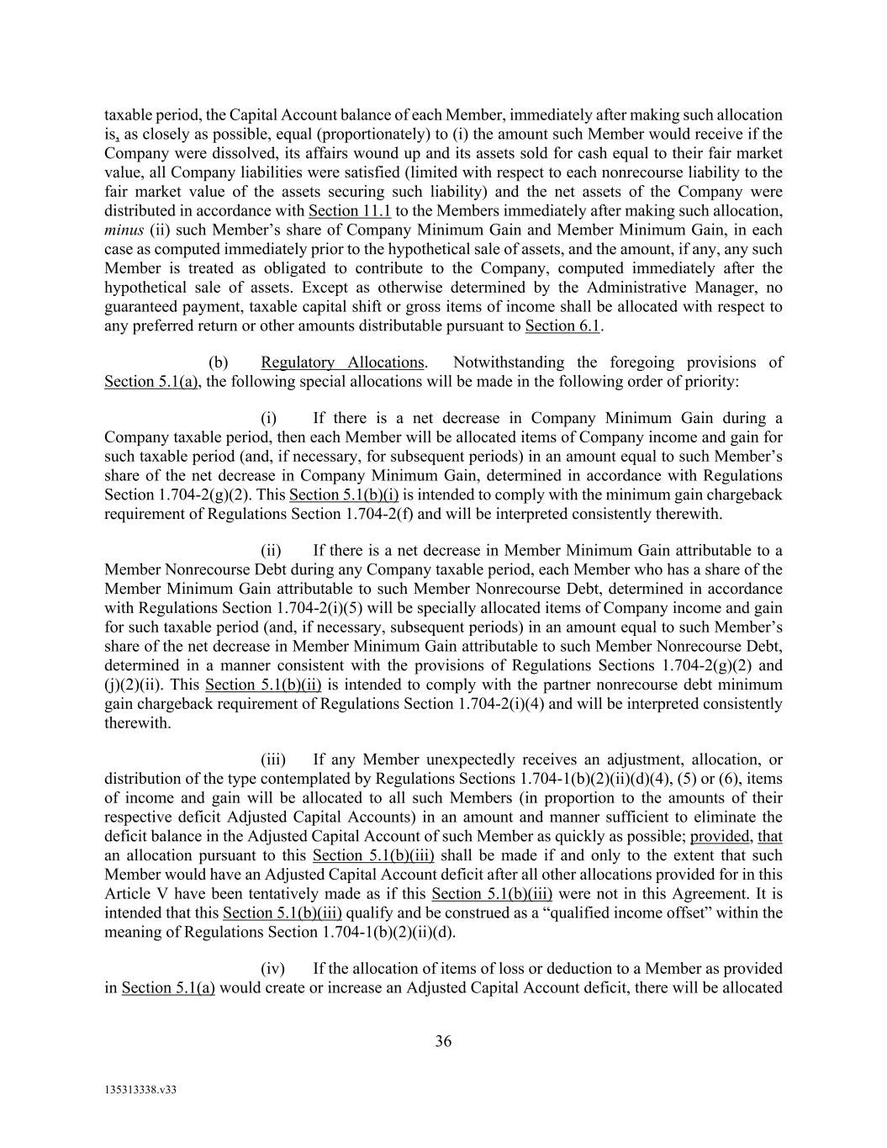
36 135313338.v33 taxable period, the Capital Account balance of each Member, immediately after making such allocation is, as closely as possible, equal (proportionately) to (i) the amount such Member would receive if the Company were dissolved, its affairs wound up and its assets sold for cash equal to their fair market value, all Company liabilities were satisfied (limited with respect to each nonrecourse liability to the fair market value of the assets securing such liability) and the net assets of the Company were distributed in accordance with Section 11.1 to the Members immediately after making such allocation, minus (ii) such Member’s share of Company Minimum Gain and Member Minimum Gain, in each case as computed immediately prior to the hypothetical sale of assets, and the amount, if any, any such Member is treated as obligated to contribute to the Company, computed immediately after the hypothetical sale of assets. Except as otherwise determined by the Administrative Manager, no guaranteed payment, taxable capital shift or gross items of income shall be allocated with respect to any preferred return or other amounts distributable pursuant to Section 6.1. (b) Regulatory Allocations. Notwithstanding the foregoing provisions of Section 5.1(a), the following special allocations will be made in the following order of priority: (i) If there is a net decrease in Company Minimum Gain during a Company taxable period, then each Member will be allocated items of Company income and gain for such taxable period (and, if necessary, for subsequent periods) in an amount equal to such Member’s share of the net decrease in Company Minimum Gain, determined in accordance with Regulations Section 1.704-2(g)(2). This Section 5.1(b)(i) is intended to comply with the minimum gain chargeback requirement of Regulations Section 1.704-2(f) and will be interpreted consistently therewith. (ii) If there is a net decrease in Member Minimum Gain attributable to a Member Nonrecourse Debt during any Company taxable period, each Member who has a share of the Member Minimum Gain attributable to such Member Nonrecourse Debt, determined in accordance with Regulations Section 1.704-2(i)(5) will be specially allocated items of Company income and gain for such taxable period (and, if necessary, subsequent periods) in an amount equal to such Member’s share of the net decrease in Member Minimum Gain attributable to such Member Nonrecourse Debt, determined in a manner consistent with the provisions of Regulations Sections 1.704-2(g)(2) and (j)(2)(ii). This Section 5.1(b)(ii) is intended to comply with the partner nonrecourse debt minimum gain chargeback requirement of Regulations Section 1.704-2(i)(4) and will be interpreted consistently therewith. (iii) If any Member unexpectedly receives an adjustment, allocation, or distribution of the type contemplated by Regulations Sections 1.704-1(b)(2)(ii)(d)(4), (5) or (6), items of income and gain will be allocated to all such Members (in proportion to the amounts of their respective deficit Adjusted Capital Accounts) in an amount and manner sufficient to eliminate the deficit balance in the Adjusted Capital Account of such Member as quickly as possible; provided, that an allocation pursuant to this Section 5.1(b)(iii) shall be made if and only to the extent that such Member would have an Adjusted Capital Account deficit after all other allocations provided for in this Article V have been tentatively made as if this Section 5.1(b)(iii) were not in this Agreement. It is intended that this Section 5.1(b)(iii) qualify and be construed as a “qualified income offset” within the meaning of Regulations Section 1.704-1(b)(2)(ii)(d). (iv) If the allocation of items of loss or deduction to a Member as provided in Section 5.1(a) would create or increase an Adjusted Capital Account deficit, there will be allocated

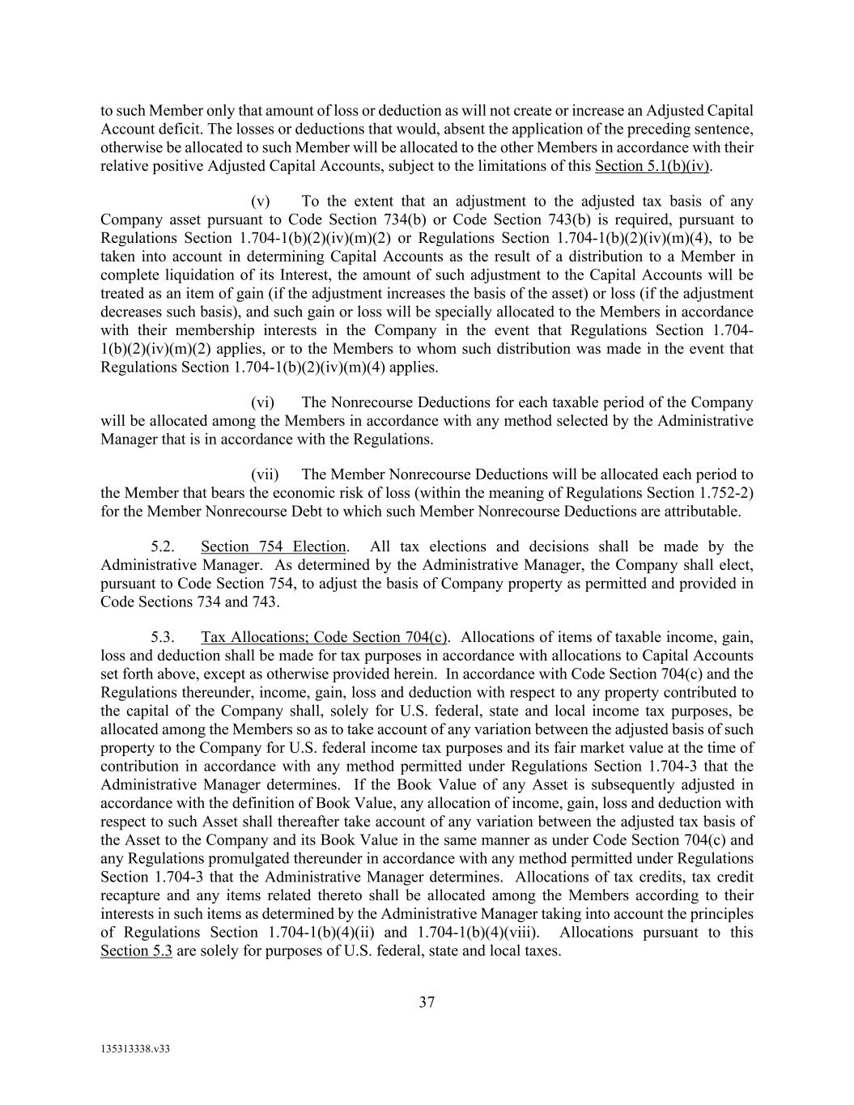
37 135313338.v33 to such Member only that amount of loss or deduction as will not create or increase an Adjusted Capital Account deficit. The losses or deductions that would, absent the application of the preceding sentence, otherwise be allocated to such Member will be allocated to the other Members in accordance with their relative positive Adjusted Capital Accounts, subject to the limitations of this Section 5.1(b)(iv). (v) To the extent that an adjustment to the adjusted tax basis of any Company asset pursuant to Code Section 734(b) or Code Section 743(b) is required, pursuant to Regulations Section 1.704-1(b)(2)(iv)(m)(2) or Regulations Section 1.704-1(b)(2)(iv)(m)(4), to be taken into account in determining Capital Accounts as the result of a distribution to a Member in complete liquidation of its Interest, the amount of such adjustment to the Capital Accounts will be treated as an item of gain (if the adjustment increases the basis of the asset) or loss (if the adjustment decreases such basis), and such gain or loss will be specially allocated to the Members in accordance with their membership interests in the Company in the event that Regulations Section 1.704- 1(b)(2)(iv)(m)(2) applies, or to the Members to whom such distribution was made in the event that Regulations Section 1.704-1(b)(2)(iv)(m)(4) applies. (vi) The Nonrecourse Deductions for each taxable period of the Company will be allocated among the Members in accordance with any method selected by the Administrative Manager that is in accordance with the Regulations. (vii) The Member Nonrecourse Deductions will be allocated each period to the Member that bears the economic risk of loss (within the meaning of Regulations Section 1.752-2) for the Member Nonrecourse Debt to which such Member Nonrecourse Deductions are attributable. 5.2. Section 754 Election. All tax elections and decisions shall be made by the Administrative Manager. As determined by the Administrative Manager, the Company shall elect, pursuant to Code Section 754, to adjust the basis of Company property as permitted and provided in Code Sections 734 and 743. 5.3. Tax Allocations; Code Section 704(c). Allocations of items of taxable income, gain, loss and deduction shall be made for tax purposes in accordance with allocations to Capital Accounts set forth above, except as otherwise provided herein. In accordance with Code Section 704(c) and the Regulations thereunder, income, gain, loss and deduction with respect to any property contributed to the capital of the Company shall, solely for U.S. federal, state and local income tax purposes, be allocated among the Members so as to take account of any variation between the adjusted basis of such property to the Company for U.S. federal income tax purposes and its fair market value at the time of contribution in accordance with any method permitted under Regulations Section 1.704-3 that the Administrative Manager determines. If the Book Value of any Asset is subsequently adjusted in accordance with the definition of Book Value, any allocation of income, gain, loss and deduction with respect to such Asset shall thereafter take account of any variation between the adjusted tax basis of the Asset to the Company and its Book Value in the same manner as under Code Section 704(c) and any Regulations promulgated thereunder in accordance with any method permitted under Regulations Section 1.704-3 that the Administrative Manager determines. Allocations of tax credits, tax credit recapture and any items related thereto shall be allocated among the Members according to their interests in such items as determined by the Administrative Manager taking into account the principles of Regulations Section 1.704-1(b)(4)(ii) and 1.704-1(b)(4)(viii). Allocations pursuant to this Section 5.3 are solely for purposes of U.S. federal, state and local taxes.

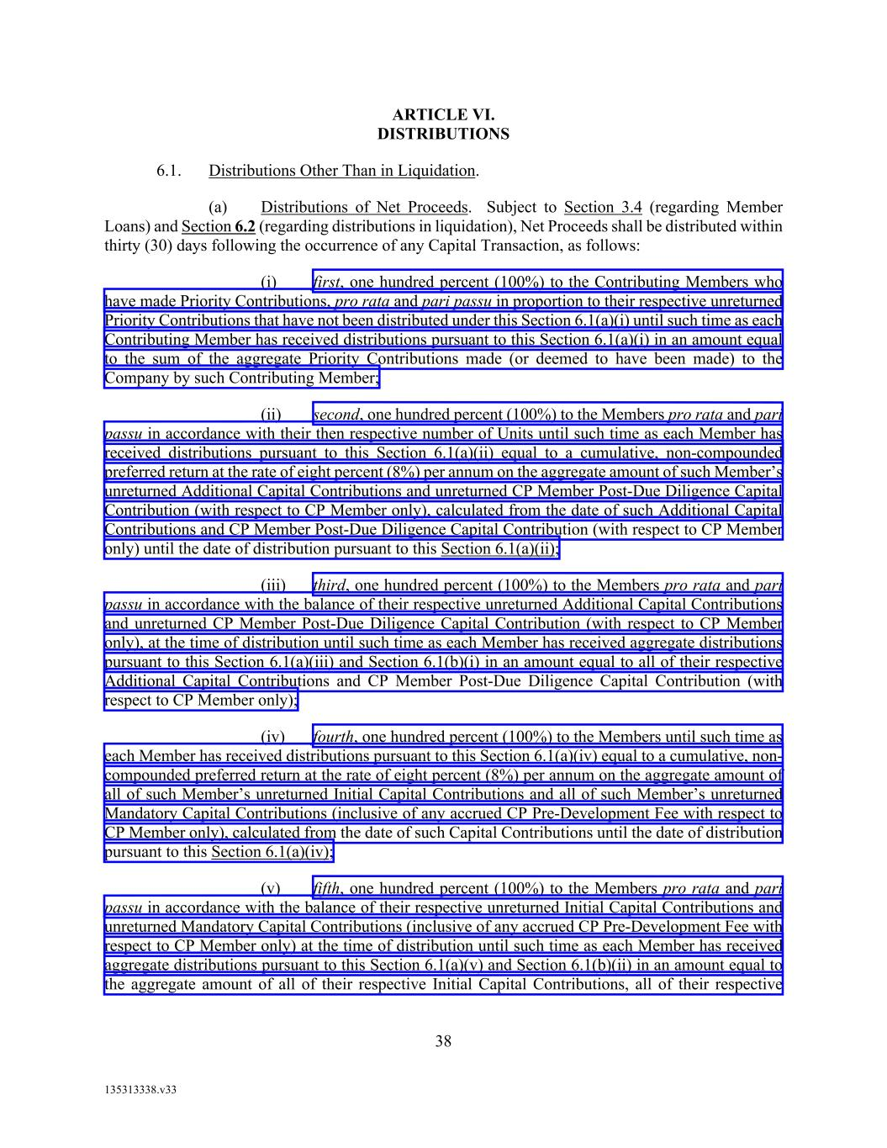
38 135313338.v33 ARTICLE VI. DISTRIBUTIONS 6.1. Distributions Other Than in Liquidation. (a) Distributions of Net Proceeds. Subject to Section 3.4 (regarding Member Loans) and Section 6.2 (regarding distributions in liquidation), Net Proceeds shall be distributed within thirty (30) days following the occurrence of any Capital Transaction, as follows: (i) first, one hundred percent (100%) to the Contributing Members who have made Priority Contributions, pro rata and pari passu in proportion to their respective unreturned Priority Contributions that have not been distributed under this Section 6.1(a)(i) until such time as each Contributing Member has received distributions pursuant to this Section 6.1(a)(i) in an amount equal to the sum of the aggregate Priority Contributions made (or deemed to have been made) to the Company by such Contributing Member; (ii) second, one hundred percent (100%) to the Members pro rata and pari passu in accordance with their then respective number of Units until such time as each Member has received distributions pursuant to this Section 6.1(a)(ii) equal to a cumulative, non-compounded preferred return at the rate of eight percent (8%) per annum on the aggregate amount of such Member’s unreturned Additional Capital Contributions and unreturned CP Member Post-Due Diligence Capital Contribution (with respect to CP Member only), calculated from the date of such Additional Capital Contributions and CP Member Post-Due Diligence Capital Contribution (with respect to CP Member only) until the date of distribution pursuant to this Section 6.1(a)(ii); (iii) third, one hundred percent (100%) to the Members pro rata and pari passu in accordance with the balance of their respective unreturned Additional Capital Contributions and unreturned CP Member Post-Due Diligence Capital Contribution (with respect to CP Member only), at the time of distribution until such time as each Member has received aggregate distributions pursuant to this Section 6.1(a)(iii) and Section 6.1(b)(i) in an amount equal to all of their respective Additional Capital Contributions and CP Member Post-Due Diligence Capital Contribution (with respect to CP Member only); (iv) fourth, one hundred percent (100%) to the Members until such time as each Member has received distributions pursuant to this Section 6.1(a)(iv) equal to a cumulative, non- compounded preferred return at the rate of eight percent (8%) per annum on the aggregate amount of all of such Member’s unreturned Initial Capital Contributions and all of such Member’s unreturned Mandatory Capital Contributions (inclusive of any accrued CP Pre-Development Fee with respect to CP Member only), calculated from the date of such Capital Contributions until the date of distribution pursuant to this Section 6.1(a)(iv); (v) fifth, one hundred percent (100%) to the Members pro rata and pari passu in accordance with the balance of their respective unreturned Initial Capital Contributions and unreturned Mandatory Capital Contributions (inclusive of any accrued CP Pre-Development Fee with respect to CP Member only) at the time of distribution until such time as each Member has received aggregate distributions pursuant to this Section 6.1(a)(v) and Section 6.1(b)(ii) in an amount equal to the aggregate amount of all of their respective Initial Capital Contributions, all of their respective

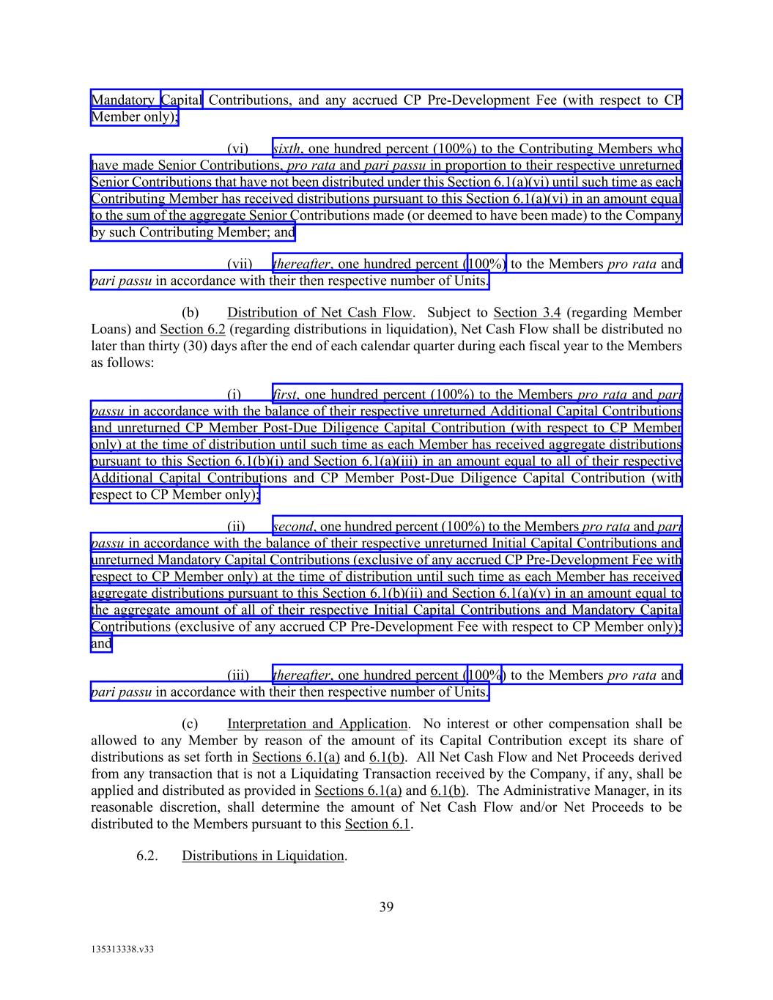
39 135313338.v33 Mandatory Capital Contributions, and any accrued CP Pre-Development Fee (with respect to CP Member only); (vi) sixth, one hundred percent (100%) to the Contributing Members who have made Senior Contributions, pro rata and pari passu in proportion to their respective unreturned Senior Contributions that have not been distributed under this Section 6.1(a)(vi) until such time as each Contributing Member has received distributions pursuant to this Section 6.1(a)(vi) in an amount equal to the sum of the aggregate Senior Contributions made (or deemed to have been made) to the Company by such Contributing Member; and (vii) thereafter, one hundred percent (100%) to the Members pro rata and pari passu in accordance with their then respective number of Units. (b) Distribution of Net Cash Flow. Subject to Section 3.4 (regarding Member Loans) and Section 6.2 (regarding distributions in liquidation), Net Cash Flow shall be distributed no later than thirty (30) days after the end of each calendar quarter during each fiscal year to the Members as follows: (i) first, one hundred percent (100%) to the Members pro rata and pari passu in accordance with the balance of their respective unreturned Additional Capital Contributions and unreturned CP Member Post-Due Diligence Capital Contribution (with respect to CP Member only) at the time of distribution until such time as each Member has received aggregate distributions pursuant to this Section 6.1(b)(i) and Section 6.1(a)(iii) in an amount equal to all of their respective Additional Capital Contributions and CP Member Post-Due Diligence Capital Contribution (with respect to CP Member only); (ii) second, one hundred percent (100%) to the Members pro rata and pari passu in accordance with the balance of their respective unreturned Initial Capital Contributions and unreturned Mandatory Capital Contributions (exclusive of any accrued CP Pre-Development Fee with respect to CP Member only) at the time of distribution until such time as each Member has received aggregate distributions pursuant to this Section 6.1(b)(ii) and Section 6.1(a)(v) in an amount equal to the aggregate amount of all of their respective Initial Capital Contributions and Mandatory Capital Contributions (exclusive of any accrued CP Pre-Development Fee with respect to CP Member only); and (iii) thereafter, one hundred percent (100%) to the Members pro rata and pari passu in accordance with their then respective number of Units. (c) Interpretation and Application. No interest or other compensation shall be allowed to any Member by reason of the amount of its Capital Contribution except its share of distributions as set forth in Sections 6.1(a) and 6.1(b). All Net Cash Flow and Net Proceeds derived from any transaction that is not a Liquidating Transaction received by the Company, if any, shall be applied and distributed as provided in Sections 6.1(a) and 6.1(b). The Administrative Manager, in its reasonable discretion, shall determine the amount of Net Cash Flow and/or Net Proceeds to be distributed to the Members pursuant to this Section 6.1. 6.2. Distributions in Liquidation.

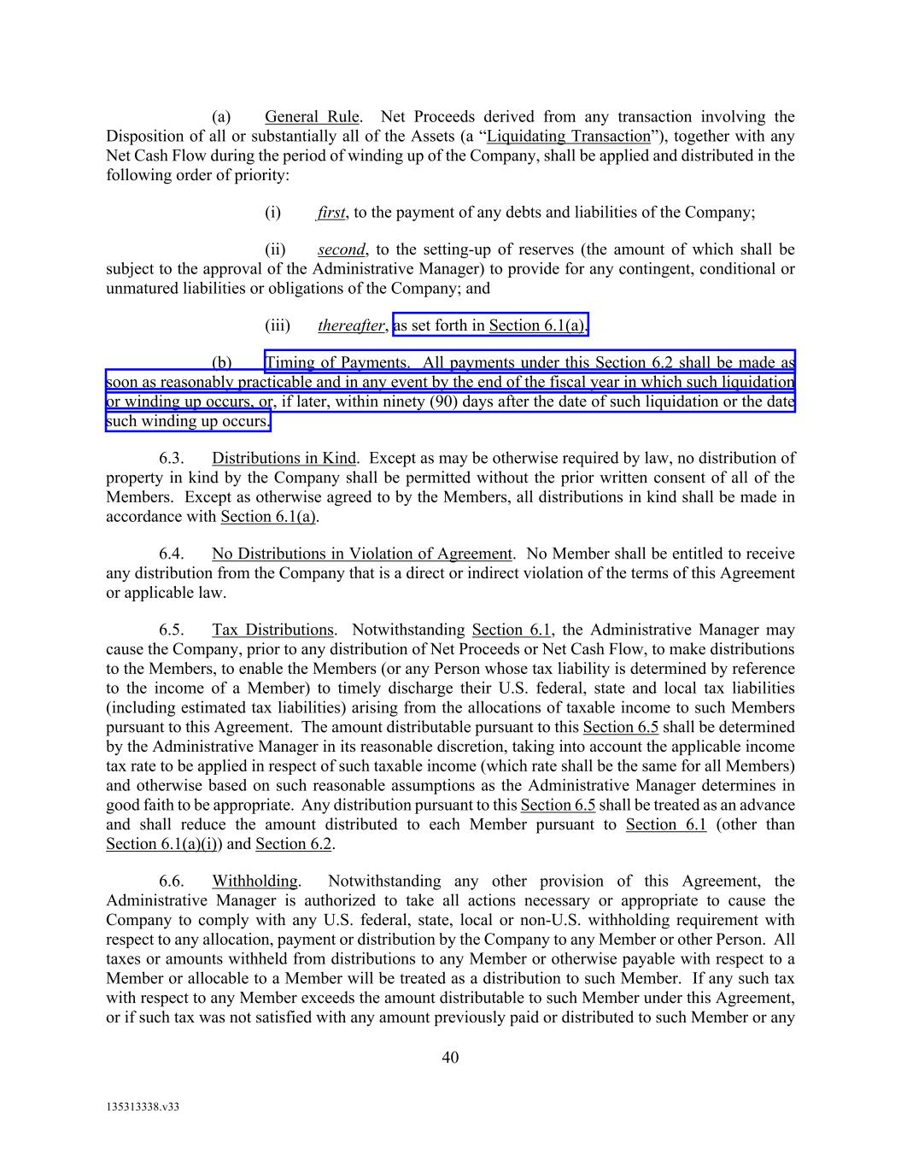
40 135313338.v33 (a) General Rule. Net Proceeds derived from any transaction involving the Disposition of all or substantially all of the Assets (a “Liquidating Transaction”), together with any Net Cash Flow during the period of winding up of the Company, shall be applied and distributed in the following order of priority: (i) first, to the payment of any debts and liabilities of the Company; (ii) second, to the setting-up of reserves (the amount of which shall be subject to the approval of the Administrative Manager) to provide for any contingent, conditional or unmatured liabilities or obligations of the Company; and (iii) thereafter, as set forth in Section 6.1(a). (b) Timing of Payments. All payments under this Section 6.2 shall be made as soon as reasonably practicable and in any event by the end of the fiscal year in which such liquidation or winding up occurs, or, if later, within ninety (90) days after the date of such liquidation or the date such winding up occurs. 6.3. Distributions in Kind. Except as may be otherwise required by law, no distribution of property in kind by the Company shall be permitted without the prior written consent of all of the Members. Except as otherwise agreed to by the Members, all distributions in kind shall be made in accordance with Section 6.1(a). 6.4. No Distributions in Violation of Agreement. No Member shall be entitled to receive any distribution from the Company that is a direct or indirect violation of the terms of this Agreement or applicable law. 6.5. Tax Distributions. Notwithstanding Section 6.1, the Administrative Manager may cause the Company, prior to any distribution of Net Proceeds or Net Cash Flow, to make distributions to the Members, to enable the Members (or any Person whose tax liability is determined by reference to the income of a Member) to timely discharge their U.S. federal, state and local tax liabilities (including estimated tax liabilities) arising from the allocations of taxable income to such Members pursuant to this Agreement. The amount distributable pursuant to this Section 6.5 shall be determined by the Administrative Manager in its reasonable discretion, taking into account the applicable income tax rate to be applied in respect of such taxable income (which rate shall be the same for all Members) and otherwise based on such reasonable assumptions as the Administrative Manager determines in good faith to be appropriate. Any distribution pursuant to this Section 6.5 shall be treated as an advance and shall reduce the amount distributed to each Member pursuant to Section 6.1 (other than Section 6.1(a)(i)) and Section 6.2. 6.6. Withholding. Notwithstanding any other provision of this Agreement, the Administrative Manager is authorized to take all actions necessary or appropriate to cause the Company to comply with any U.S. federal, state, local or non-U.S. withholding requirement with respect to any allocation, payment or distribution by the Company to any Member or other Person. All taxes or amounts withheld from distributions to any Member or otherwise payable with respect to a Member or allocable to a Member will be treated as a distribution to such Member. If any such tax with respect to any Member exceeds the amount distributable to such Member under this Agreement, or if such tax was not satisfied with any amount previously paid or distributed to such Member or any

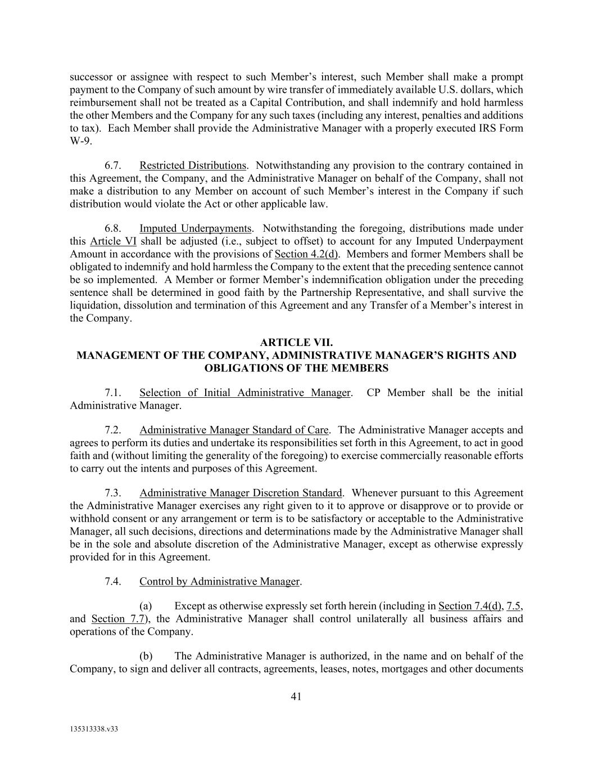
41 135313338.v33 successor or assignee with respect to such Member’s interest, such Member shall make a prompt payment to the Company of such amount by wire transfer of immediately available U.S. dollars, which reimbursement shall not be treated as a Capital Contribution, and shall indemnify and hold harmless the other Members and the Company for any such taxes (including any interest, penalties and additions to tax). Each Member shall provide the Administrative Manager with a properly executed IRS Form W-9. 6.7. Restricted Distributions. Notwithstanding any provision to the contrary contained in this Agreement, the Company, and the Administrative Manager on behalf of the Company, shall not make a distribution to any Member on account of such Member’s interest in the Company if such distribution would violate the Act or other applicable law. 6.8. Imputed Underpayments. Notwithstanding the foregoing, distributions made under this Article VI shall be adjusted (i.e., subject to offset) to account for any Imputed Underpayment Amount in accordance with the provisions of Section 4.2(d). Members and former Members shall be obligated to indemnify and hold harmless the Company to the extent that the preceding sentence cannot be so implemented. A Member or former Member’s indemnification obligation under the preceding sentence shall be determined in good faith by the Partnership Representative, and shall survive the liquidation, dissolution and termination of this Agreement and any Transfer of a Member’s interest in the Company. ARTICLE VII. MANAGEMENT OF THE COMPANY, ADMINISTRATIVE MANAGER’S RIGHTS AND OBLIGATIONS OF THE MEMBERS 7.1. Selection of Initial Administrative Manager. CP Member shall be the initial Administrative Manager. 7.2. Administrative Manager Standard of Care. The Administrative Manager accepts and agrees to perform its duties and undertake its responsibilities set forth in this Agreement, to act in good faith and (without limiting the generality of the foregoing) to exercise commercially reasonable efforts to carry out the intents and purposes of this Agreement. 7.3. Administrative Manager Discretion Standard. Whenever pursuant to this Agreement the Administrative Manager exercises any right given to it to approve or disapprove or to provide or withhold consent or any arrangement or term is to be satisfactory or acceptable to the Administrative Manager, all such decisions, directions and determinations made by the Administrative Manager shall be in the sole and absolute discretion of the Administrative Manager, except as otherwise expressly provided for in this Agreement. 7.4. Control by Administrative Manager. (a) Except as otherwise expressly set forth herein (including in Section 7.4(d), 7.5, and Section 7.7), the Administrative Manager shall control unilaterally all business affairs and operations of the Company. (b) The Administrative Manager is authorized, in the name and on behalf of the Company, to sign and deliver all contracts, agreements, leases, notes, mortgages and other documents

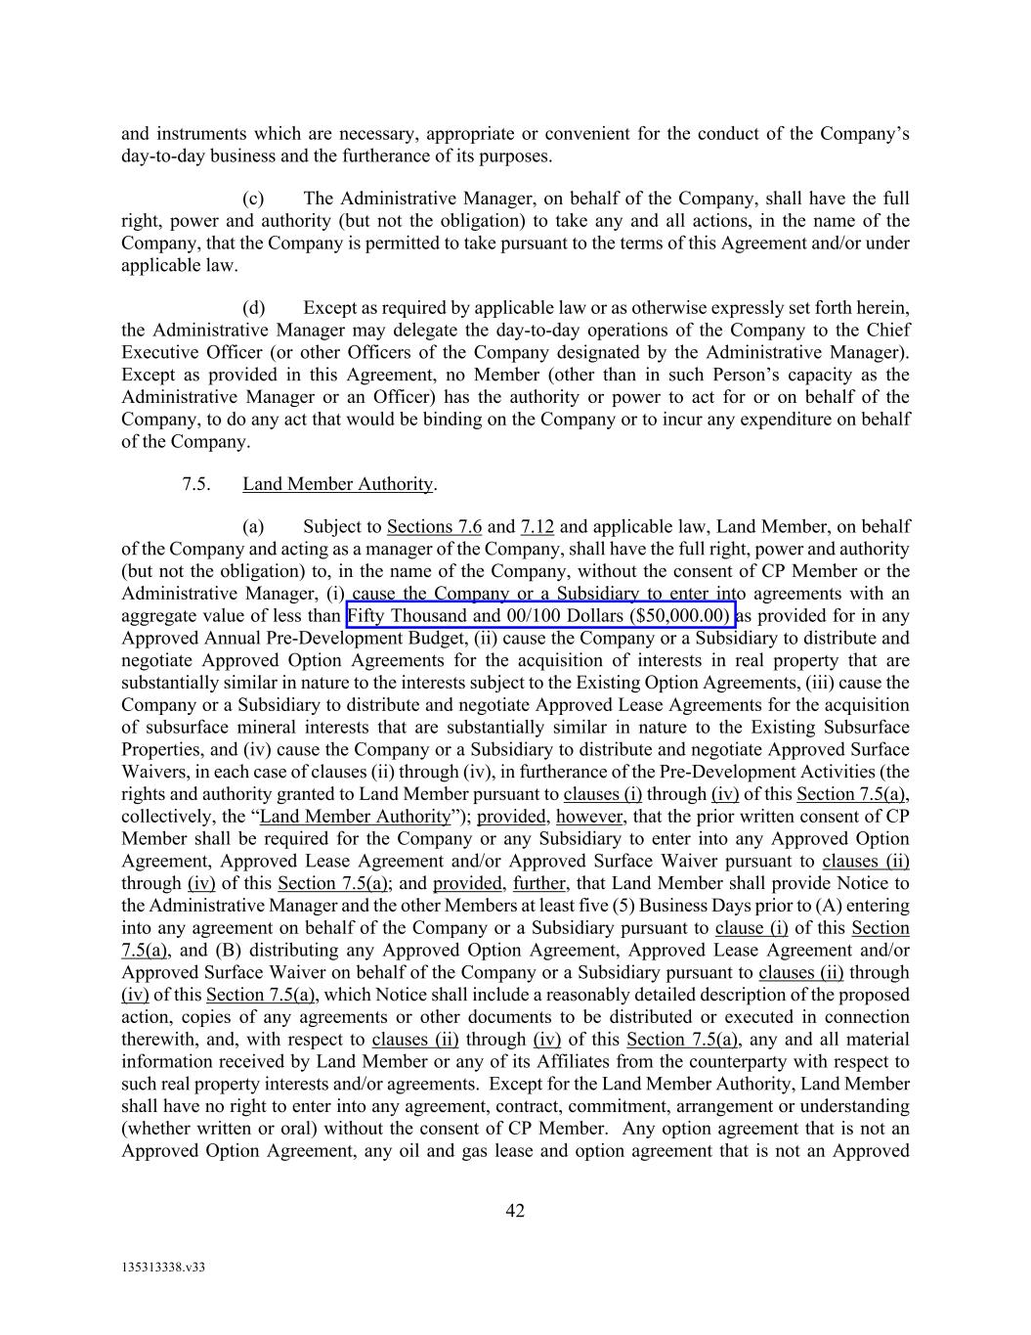
42 135313338.v33 and instruments which are necessary, appropriate or convenient for the conduct of the Company’s day-to-day business and the furtherance of its purposes. (c) The Administrative Manager, on behalf of the Company, shall have the full right, power and authority (but not the obligation) to take any and all actions, in the name of the Company, that the Company is permitted to take pursuant to the terms of this Agreement and/or under applicable law. (d) Except as required by applicable law or as otherwise expressly set forth herein, the Administrative Manager may delegate the day-to-day operations of the Company to the Chief Executive Officer (or other Officers of the Company designated by the Administrative Manager). Except as provided in this Agreement, no Member (other than in such Person’s capacity as the Administrative Manager or an Officer) has the authority or power to act for or on behalf of the Company, to do any act that would be binding on the Company or to incur any expenditure on behalf of the Company. 7.5. Land Member Authority. (a) Subject to Sections 7.6 and 7.12 and applicable law, Land Member, on behalf of the Company and acting as a manager of the Company, shall have the full right, power and authority (but not the obligation) to, in the name of the Company, without the consent of CP Member or the Administrative Manager, (i) cause the Company or a Subsidiary to enter into agreements with an aggregate value of less than Fifty Thousand and 00/100 Dollars ($50,000.00) as provided for in any Approved Annual Pre-Development Budget, (ii) cause the Company or a Subsidiary to distribute and negotiate Approved Option Agreements for the acquisition of interests in real property that are substantially similar in nature to the interests subject to the Existing Option Agreements, (iii) cause the Company or a Subsidiary to distribute and negotiate Approved Lease Agreements for the acquisition of subsurface mineral interests that are substantially similar in nature to the Existing Subsurface Properties, and (iv) cause the Company or a Subsidiary to distribute and negotiate Approved Surface Waivers, in each case of clauses (ii) through (iv), in furtherance of the Pre-Development Activities (the rights and authority granted to Land Member pursuant to clauses (i) through (iv) of this Section 7.5(a), collectively, the “Land Member Authority”); provided, however, that the prior written consent of CP Member shall be required for the Company or any Subsidiary to enter into any Approved Option Agreement, Approved Lease Agreement and/or Approved Surface Waiver pursuant to clauses (ii) through (iv) of this Section 7.5(a); and provided, further, that Land Member shall provide Notice to the Administrative Manager and the other Members at least five (5) Business Days prior to (A) entering into any agreement on behalf of the Company or a Subsidiary pursuant to clause (i) of this Section 7.5(a), and (B) distributing any Approved Option Agreement, Approved Lease Agreement and/or Approved Surface Waiver on behalf of the Company or a Subsidiary pursuant to clauses (ii) through (iv) of this Section 7.5(a), which Notice shall include a reasonably detailed description of the proposed action, copies of any agreements or other documents to be distributed or executed in connection therewith, and, with respect to clauses (ii) through (iv) of this Section 7.5(a), any and all material information received by Land Member or any of its Affiliates from the counterparty with respect to such real property interests and/or agreements. Except for the Land Member Authority, Land Member shall have no right to enter into any agreement, contract, commitment, arrangement or understanding (whether written or oral) without the consent of CP Member. Any option agreement that is not an Approved Option Agreement, any oil and gas lease and option agreement that is not an Approved

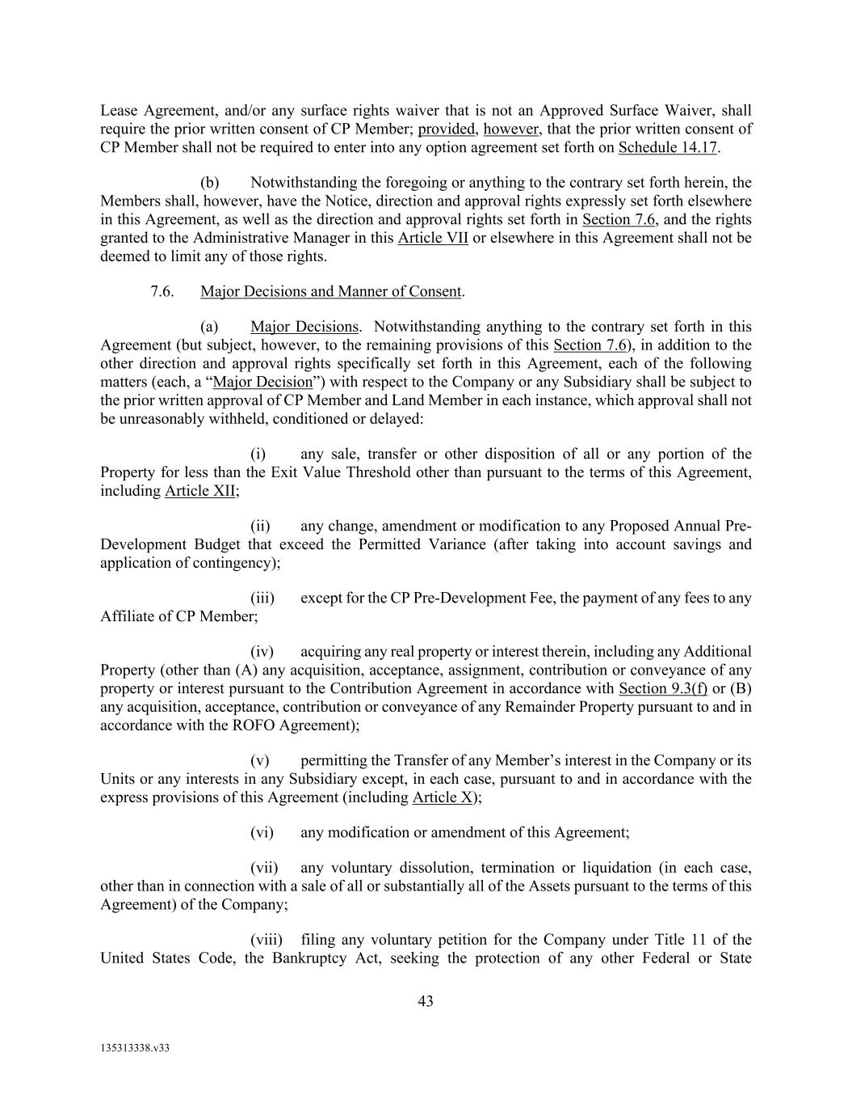
43 135313338.v33 Lease Agreement, and/or any surface rights waiver that is not an Approved Surface Waiver, shall require the prior written consent of CP Member; provided, however, that the prior written consent of CP Member shall not be required to enter into any option agreement set forth on Schedule 14.17. (b) Notwithstanding the foregoing or anything to the contrary set forth herein, the Members shall, however, have the Notice, direction and approval rights expressly set forth elsewhere in this Agreement, as well as the direction and approval rights set forth in Section 7.6, and the rights granted to the Administrative Manager in this Article VII or elsewhere in this Agreement shall not be deemed to limit any of those rights. 7.6. Major Decisions and Manner of Consent. (a) Major Decisions. Notwithstanding anything to the contrary set forth in this Agreement (but subject, however, to the remaining provisions of this Section 7.6), in addition to the other direction and approval rights specifically set forth in this Agreement, each of the following matters (each, a “Major Decision”) with respect to the Company or any Subsidiary shall be subject to the prior written approval of CP Member and Land Member in each instance, which approval shall not be unreasonably withheld, conditioned or delayed: (i) any sale, transfer or other disposition of all or any portion of the Property for less than the Exit Value Threshold other than pursuant to the terms of this Agreement, including Article XII; (ii) any change, amendment or modification to any Proposed Annual Pre- Development Budget that exceed the Permitted Variance (after taking into account savings and application of contingency); (iii) except for the CP Pre-Development Fee, the payment of any fees to any Affiliate of CP Member; (iv) acquiring any real property or interest therein, including any Additional Property (other than (A) any acquisition, acceptance, assignment, contribution or conveyance of any property or interest pursuant to the Contribution Agreement in accordance with Section 9.3(f) or (B) any acquisition, acceptance, contribution or conveyance of any Remainder Property pursuant to and in accordance with the ROFO Agreement); (v) permitting the Transfer of any Member’s interest in the Company or its Units or any interests in any Subsidiary except, in each case, pursuant to and in accordance with the express provisions of this Agreement (including Article X); (vi) any modification or amendment of this Agreement; (vii) any voluntary dissolution, termination or liquidation (in each case, other than in connection with a sale of all or substantially all of the Assets pursuant to the terms of this Agreement) of the Company; (viii) filing any voluntary petition for the Company under Title 11 of the United States Code, the Bankruptcy Act, seeking the protection of any other Federal or State

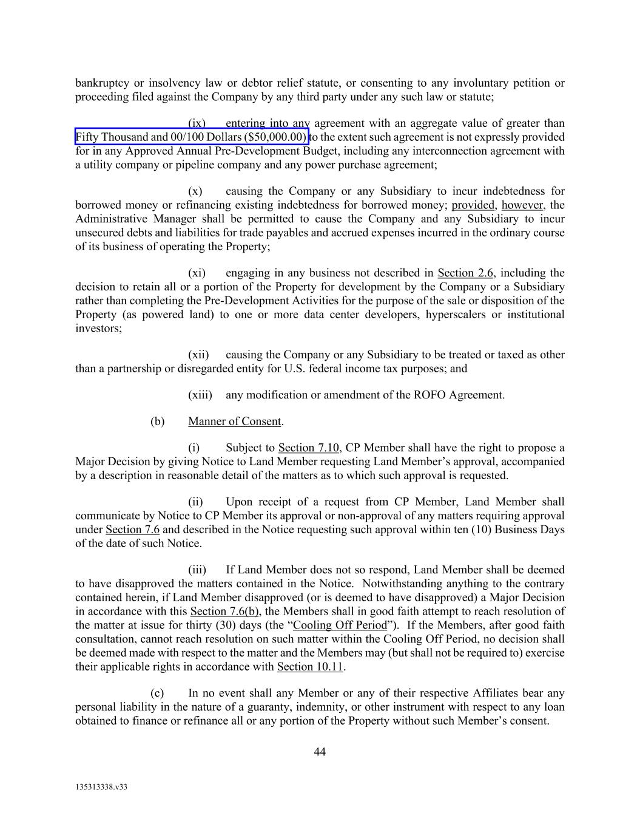
44 135313338.v33 bankruptcy or insolvency law or debtor relief statute, or consenting to any involuntary petition or proceeding filed against the Company by any third party under any such law or statute; (ix) entering into any agreement with an aggregate value of greater than Fifty Thousand and 00/100 Dollars ($50,000.00) to the extent such agreement is not expressly provided for in any Approved Annual Pre-Development Budget, including any interconnection agreement with a utility company or pipeline company and any power purchase agreement; (x) causing the Company or any Subsidiary to incur indebtedness for borrowed money or refinancing existing indebtedness for borrowed money; provided, however, the Administrative Manager shall be permitted to cause the Company and any Subsidiary to incur unsecured debts and liabilities for trade payables and accrued expenses incurred in the ordinary course of its business of operating the Property; (xi) engaging in any business not described in Section 2.6, including the decision to retain all or a portion of the Property for development by the Company or a Subsidiary rather than completing the Pre-Development Activities for the purpose of the sale or disposition of the Property (as powered land) to one or more data center developers, hyperscalers or institutional investors; (xii) causing the Company or any Subsidiary to be treated or taxed as other than a partnership or disregarded entity for U.S. federal income tax purposes; and (xiii) any modification or amendment of the ROFO Agreement. (b) Manner of Consent. (i) Subject to Section 7.10, CP Member shall have the right to propose a Major Decision by giving Notice to Land Member requesting Land Member’s approval, accompanied by a description in reasonable detail of the matters as to which such approval is requested. (ii) Upon receipt of a request from CP Member, Land Member shall communicate by Notice to CP Member its approval or non-approval of any matters requiring approval under Section 7.6 and described in the Notice requesting such approval within ten (10) Business Days of the date of such Notice. (iii) If Land Member does not so respond, Land Member shall be deemed to have disapproved the matters contained in the Notice. Notwithstanding anything to the contrary contained herein, if Land Member disapproved (or is deemed to have disapproved) a Major Decision in accordance with this Section 7.6(b), the Members shall in good faith attempt to reach resolution of the matter at issue for thirty (30) days (the “Cooling Off Period”). If the Members, after good faith consultation, cannot reach resolution on such matter within the Cooling Off Period, no decision shall be deemed made with respect to the matter and the Members may (but shall not be required to) exercise their applicable rights in accordance with Section 10.11. (c) In no event shall any Member or any of their respective Affiliates bear any personal liability in the nature of a guaranty, indemnity, or other instrument with respect to any loan obtained to finance or refinance all or any portion of the Property without such Member’s consent.

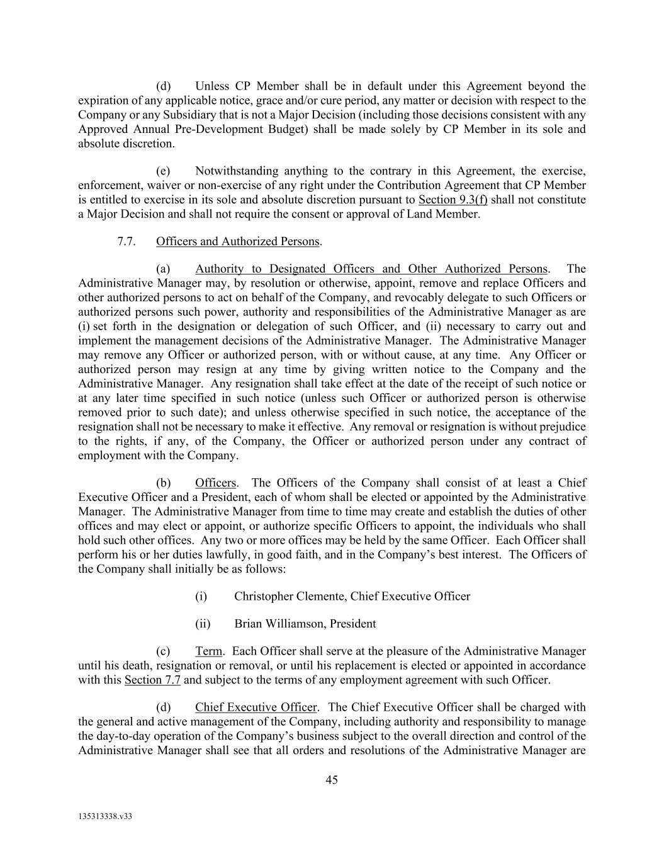
45 135313338.v33 (d) Unless CP Member shall be in default under this Agreement beyond the expiration of any applicable notice, grace and/or cure period, any matter or decision with respect to the Company or any Subsidiary that is not a Major Decision (including those decisions consistent with any Approved Annual Pre-Development Budget) shall be made solely by CP Member in its sole and absolute discretion. (e) Notwithstanding anything to the contrary in this Agreement, the exercise, enforcement, waiver or non-exercise of any right under the Contribution Agreement that CP Member is entitled to exercise in its sole and absolute discretion pursuant to Section 9.3(f) shall not constitute a Major Decision and shall not require the consent or approval of Land Member. 7.7. Officers and Authorized Persons. (a) Authority to Designated Officers and Other Authorized Persons. The Administrative Manager may, by resolution or otherwise, appoint, remove and replace Officers and other authorized persons to act on behalf of the Company, and revocably delegate to such Officers or authorized persons such power, authority and responsibilities of the Administrative Manager as are (i) set forth in the designation or delegation of such Officer, and (ii) necessary to carry out and implement the management decisions of the Administrative Manager. The Administrative Manager may remove any Officer or authorized person, with or without cause, at any time. Any Officer or authorized person may resign at any time by giving written notice to the Company and the Administrative Manager. Any resignation shall take effect at the date of the receipt of such notice or at any later time specified in such notice (unless such Officer or authorized person is otherwise removed prior to such date); and unless otherwise specified in such notice, the acceptance of the resignation shall not be necessary to make it effective. Any removal or resignation is without prejudice to the rights, if any, of the Company, the Officer or authorized person under any contract of employment with the Company. (b) Officers. The Officers of the Company shall consist of at least a Chief Executive Officer and a President, each of whom shall be elected or appointed by the Administrative Manager. The Administrative Manager from time to time may create and establish the duties of other offices and may elect or appoint, or authorize specific Officers to appoint, the individuals who shall hold such other offices. Any two or more offices may be held by the same Officer. Each Officer shall perform his or her duties lawfully, in good faith, and in the Company’s best interest. The Officers of the Company shall initially be as follows: (i) Christopher Clemente, Chief Executive Officer (ii) Brian Williamson, President (c) Term. Each Officer shall serve at the pleasure of the Administrative Manager until his death, resignation or removal, or until his replacement is elected or appointed in accordance with this Section 7.7 and subject to the terms of any employment agreement with such Officer. (d) Chief Executive Officer. The Chief Executive Officer shall be charged with the general and active management of the Company, including authority and responsibility to manage the day-to-day operation of the Company’s business subject to the overall direction and control of the Administrative Manager shall see that all orders and resolutions of the Administrative Manager are

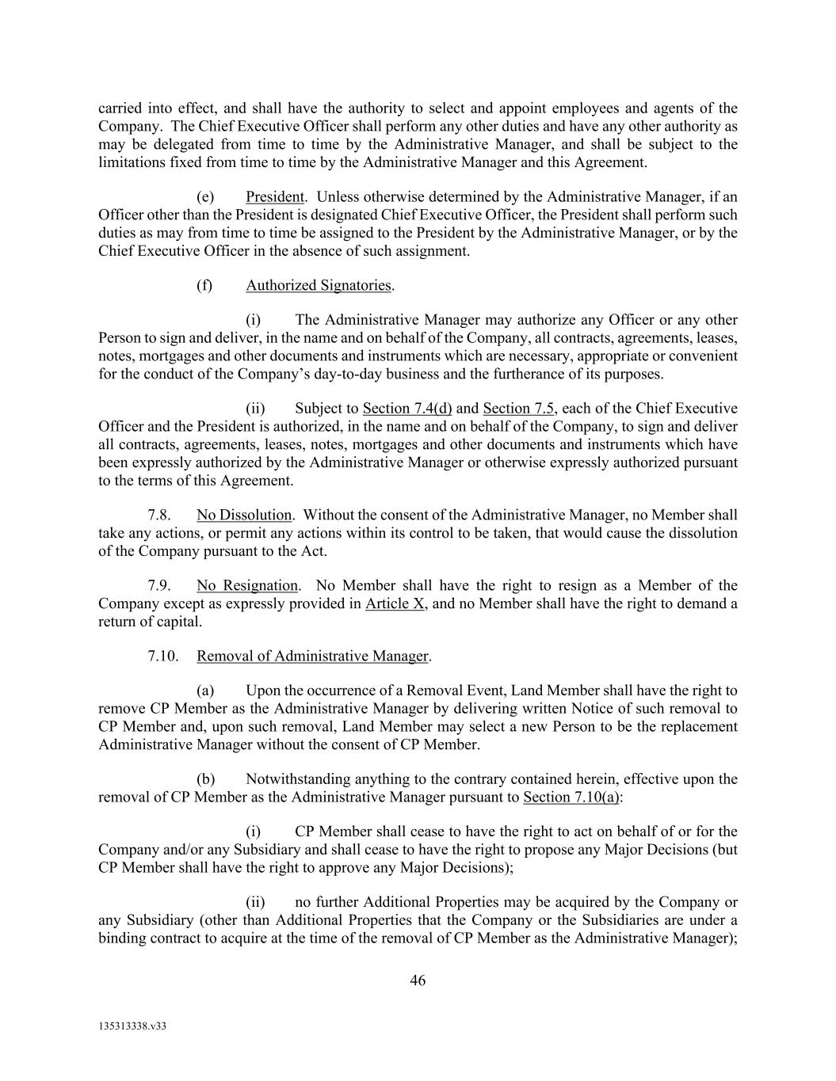
46 135313338.v33 carried into effect, and shall have the authority to select and appoint employees and agents of the Company. The Chief Executive Officer shall perform any other duties and have any other authority as may be delegated from time to time by the Administrative Manager, and shall be subject to the limitations fixed from time to time by the Administrative Manager and this Agreement. (e) President. Unless otherwise determined by the Administrative Manager, if an Officer other than the President is designated Chief Executive Officer, the President shall perform such duties as may from time to time be assigned to the President by the Administrative Manager, or by the Chief Executive Officer in the absence of such assignment. (f) Authorized Signatories. (i) The Administrative Manager may authorize any Officer or any other Person to sign and deliver, in the name and on behalf of the Company, all contracts, agreements, leases, notes, mortgages and other documents and instruments which are necessary, appropriate or convenient for the conduct of the Company’s day-to-day business and the furtherance of its purposes. (ii) Subject to Section 7.4(d) and Section 7.5, each of the Chief Executive Officer and the President is authorized, in the name and on behalf of the Company, to sign and deliver all contracts, agreements, leases, notes, mortgages and other documents and instruments which have been expressly authorized by the Administrative Manager or otherwise expressly authorized pursuant to the terms of this Agreement. 7.8. No Dissolution. Without the consent of the Administrative Manager, no Member shall take any actions, or permit any actions within its control to be taken, that would cause the dissolution of the Company pursuant to the Act. 7.9. No Resignation. No Member shall have the right to resign as a Member of the Company except as expressly provided in Article X, and no Member shall have the right to demand a return of capital. 7.10. Removal of Administrative Manager. (a) Upon the occurrence of a Removal Event, Land Member shall have the right to remove CP Member as the Administrative Manager by delivering written Notice of such removal to CP Member and, upon such removal, Land Member may select a new Person to be the replacement Administrative Manager without the consent of CP Member. (b) Notwithstanding anything to the contrary contained herein, effective upon the removal of CP Member as the Administrative Manager pursuant to Section 7.10(a): (i) CP Member shall cease to have the right to act on behalf of or for the Company and/or any Subsidiary and shall cease to have the right to propose any Major Decisions (but CP Member shall have the right to approve any Major Decisions); (ii) no further Additional Properties may be acquired by the Company or any Subsidiary (other than Additional Properties that the Company or the Subsidiaries are under a binding contract to acquire at the time of the removal of CP Member as the Administrative Manager);

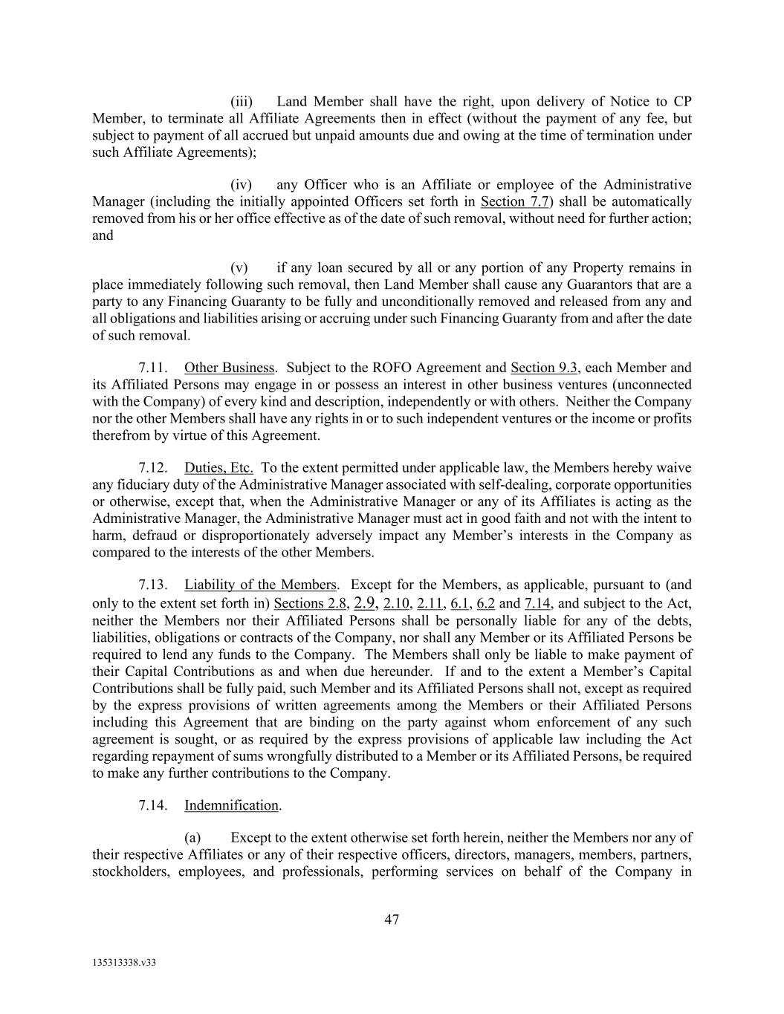
47 135313338.v33 (iii) Land Member shall have the right, upon delivery of Notice to CP Member, to terminate all Affiliate Agreements then in effect (without the payment of any fee, but subject to payment of all accrued but unpaid amounts due and owing at the time of termination under such Affiliate Agreements); (iv) any Officer who is an Affiliate or employee of the Administrative Manager (including the initially appointed Officers set forth in Section 7.7) shall be automatically removed from his or her office effective as of the date of such removal, without need for further action; and (v) if any loan secured by all or any portion of any Property remains in place immediately following such removal, then Land Member shall cause any Guarantors that are a party to any Financing Guaranty to be fully and unconditionally removed and released from any and all obligations and liabilities arising or accruing under such Financing Guaranty from and after the date of such removal. 7.11. Other Business. Subject to the ROFO Agreement and Section 9.3, each Member and its Affiliated Persons may engage in or possess an interest in other business ventures (unconnected with the Company) of every kind and description, independently or with others. Neither the Company nor the other Members shall have any rights in or to such independent ventures or the income or profits therefrom by virtue of this Agreement. 7.12. Duties, Etc. To the extent permitted under applicable law, the Members hereby waive any fiduciary duty of the Administrative Manager associated with self-dealing, corporate opportunities or otherwise, except that, when the Administrative Manager or any of its Affiliates is acting as the Administrative Manager, the Administrative Manager must act in good faith and not with the intent to harm, defraud or disproportionately adversely impact any Member’s interests in the Company as compared to the interests of the other Members. 7.13. Liability of the Members. Except for the Members, as applicable, pursuant to (and only to the extent set forth in) Sections 2.8, 2.9, 2.10, 2.11, 6.1, 6.2 and 7.14, and subject to the Act, neither the Members nor their Affiliated Persons shall be personally liable for any of the debts, liabilities, obligations or contracts of the Company, nor shall any Member or its Affiliated Persons be required to lend any funds to the Company. The Members shall only be liable to make payment of their Capital Contributions as and when due hereunder. If and to the extent a Member’s Capital Contributions shall be fully paid, such Member and its Affiliated Persons shall not, except as required by the express provisions of written agreements among the Members or their Affiliated Persons including this Agreement that are binding on the party against whom enforcement of any such agreement is sought, or as required by the express provisions of applicable law including the Act regarding repayment of sums wrongfully distributed to a Member or its Affiliated Persons, be required to make any further contributions to the Company. 7.14. Indemnification. (a) Except to the extent otherwise set forth herein, neither the Members nor any of their respective Affiliates or any of their respective officers, directors, managers, members, partners, stockholders, employees, and professionals, performing services on behalf of the Company in

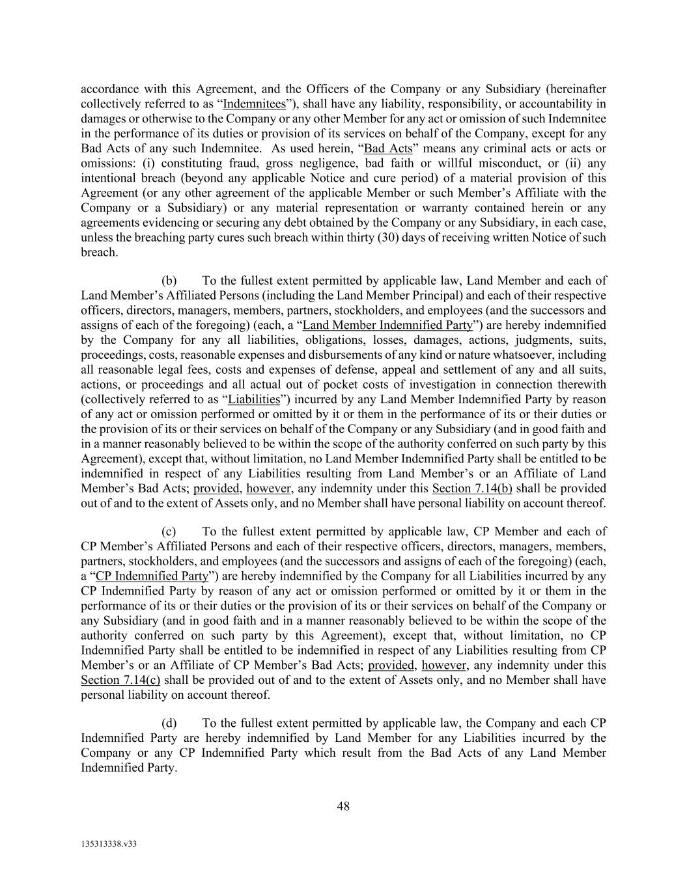
48 135313338.v33 accordance with this Agreement, and the Officers of the Company or any Subsidiary (hereinafter collectively referred to as “Indemnitees”), shall have any liability, responsibility, or accountability in damages or otherwise to the Company or any other Member for any act or omission of such Indemnitee in the performance of its duties or provision of its services on behalf of the Company, except for any Bad Acts of any such Indemnitee. As used herein, “Bad Acts” means any criminal acts or acts or omissions: (i) constituting fraud, gross negligence, bad faith or willful misconduct, or (ii) any intentional breach (beyond any applicable Notice and cure period) of a material provision of this Agreement (or any other agreement of the applicable Member or such Member’s Affiliate with the Company or a Subsidiary) or any material representation or warranty contained herein or any agreements evidencing or securing any debt obtained by the Company or any Subsidiary, in each case, unless the breaching party cures such breach within thirty (30) days of receiving written Notice of such breach. (b) To the fullest extent permitted by applicable law, Land Member and each of Land Member’s Affiliated Persons (including the Land Member Principal) and each of their respective officers, directors, managers, members, partners, stockholders, and employees (and the successors and assigns of each of the foregoing) (each, a “Land Member Indemnified Party”) are hereby indemnified by the Company for any all liabilities, obligations, losses, damages, actions, judgments, suits, proceedings, costs, reasonable expenses and disbursements of any kind or nature whatsoever, including all reasonable legal fees, costs and expenses of defense, appeal and settlement of any and all suits, actions, or proceedings and all actual out of pocket costs of investigation in connection therewith (collectively referred to as “Liabilities”) incurred by any Land Member Indemnified Party by reason of any act or omission performed or omitted by it or them in the performance of its or their duties or the provision of its or their services on behalf of the Company or any Subsidiary (and in good faith and in a manner reasonably believed to be within the scope of the authority conferred on such party by this Agreement), except that, without limitation, no Land Member Indemnified Party shall be entitled to be indemnified in respect of any Liabilities resulting from Land Member’s or an Affiliate of Land Member’s Bad Acts; provided, however, any indemnity under this Section 7.14(b) shall be provided out of and to the extent of Assets only, and no Member shall have personal liability on account thereof. (c) To the fullest extent permitted by applicable law, CP Member and each of CP Member’s Affiliated Persons and each of their respective officers, directors, managers, members, partners, stockholders, and employees (and the successors and assigns of each of the foregoing) (each, a “CP Indemnified Party”) are hereby indemnified by the Company for all Liabilities incurred by any CP Indemnified Party by reason of any act or omission performed or omitted by it or them in the performance of its or their duties or the provision of its or their services on behalf of the Company or any Subsidiary (and in good faith and in a manner reasonably believed to be within the scope of the authority conferred on such party by this Agreement), except that, without limitation, no CP Indemnified Party shall be entitled to be indemnified in respect of any Liabilities resulting from CP Member’s or an Affiliate of CP Member’s Bad Acts; provided, however, any indemnity under this Section 7.14(c) shall be provided out of and to the extent of Assets only, and no Member shall have personal liability on account thereof. (d) To the fullest extent permitted by applicable law, the Company and each CP Indemnified Party are hereby indemnified by Land Member for any Liabilities incurred by the Company or any CP Indemnified Party which result from the Bad Acts of any Land Member Indemnified Party.

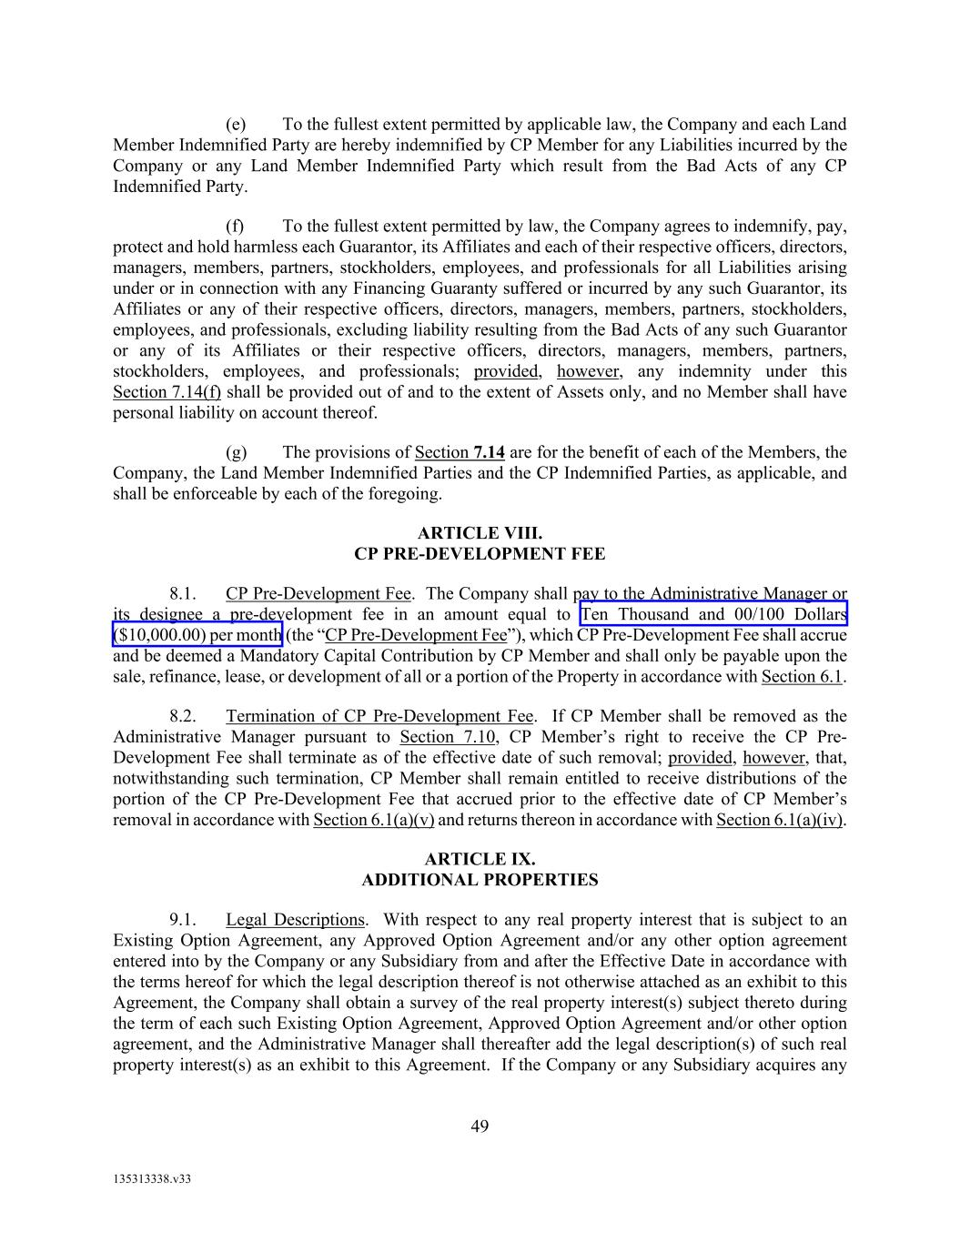
49 135313338.v33 (e) To the fullest extent permitted by applicable law, the Company and each Land Member Indemnified Party are hereby indemnified by CP Member for any Liabilities incurred by the Company or any Land Member Indemnified Party which result from the Bad Acts of any CP Indemnified Party. (f) To the fullest extent permitted by law, the Company agrees to indemnify, pay, protect and hold harmless each Guarantor, its Affiliates and each of their respective officers, directors, managers, members, partners, stockholders, employees, and professionals for all Liabilities arising under or in connection with any Financing Guaranty suffered or incurred by any such Guarantor, its Affiliates or any of their respective officers, directors, managers, members, partners, stockholders, employees, and professionals, excluding liability resulting from the Bad Acts of any such Guarantor or any of its Affiliates or their respective officers, directors, managers, members, partners, stockholders, employees, and professionals; provided, however, any indemnity under this Section 7.14(f) shall be provided out of and to the extent of Assets only, and no Member shall have personal liability on account thereof. (g) The provisions of Section 7.14 are for the benefit of each of the Members, the Company, the Land Member Indemnified Parties and the CP Indemnified Parties, as applicable, and shall be enforceable by each of the foregoing. ARTICLE VIII. CP PRE-DEVELOPMENT FEE 8.1. CP Pre-Development Fee. The Company shall pay to the Administrative Manager or its designee a pre-development fee in an amount equal to Ten Thousand and 00/100 Dollars ($10,000.00) per month (the “CP Pre-Development Fee”), which CP Pre-Development Fee shall accrue and be deemed a Mandatory Capital Contribution by CP Member and shall only be payable upon the sale, refinance, lease, or development of all or a portion of the Property in accordance with Section 6.1. 8.2. Termination of CP Pre-Development Fee. If CP Member shall be removed as the Administrative Manager pursuant to Section 7.10, CP Member’s right to receive the CP Pre- Development Fee shall terminate as of the effective date of such removal; provided, however, that, notwithstanding such termination, CP Member shall remain entitled to receive distributions of the portion of the CP Pre-Development Fee that accrued prior to the effective date of CP Member’s removal in accordance with Section 6.1(a)(v) and returns thereon in accordance with Section 6.1(a)(iv). ARTICLE IX. ADDITIONAL PROPERTIES 9.1. Legal Descriptions. With respect to any real property interest that is subject to an Existing Option Agreement, any Approved Option Agreement and/or any other option agreement entered into by the Company or any Subsidiary from and after the Effective Date in accordance with the terms hereof for which the legal description thereof is not otherwise attached as an exhibit to this Agreement, the Company shall obtain a survey of the real property interest(s) subject thereto during the term of each such Existing Option Agreement, Approved Option Agreement and/or other option agreement, and the Administrative Manager shall thereafter add the legal description(s) of such real property interest(s) as an exhibit to this Agreement. If the Company or any Subsidiary acquires any

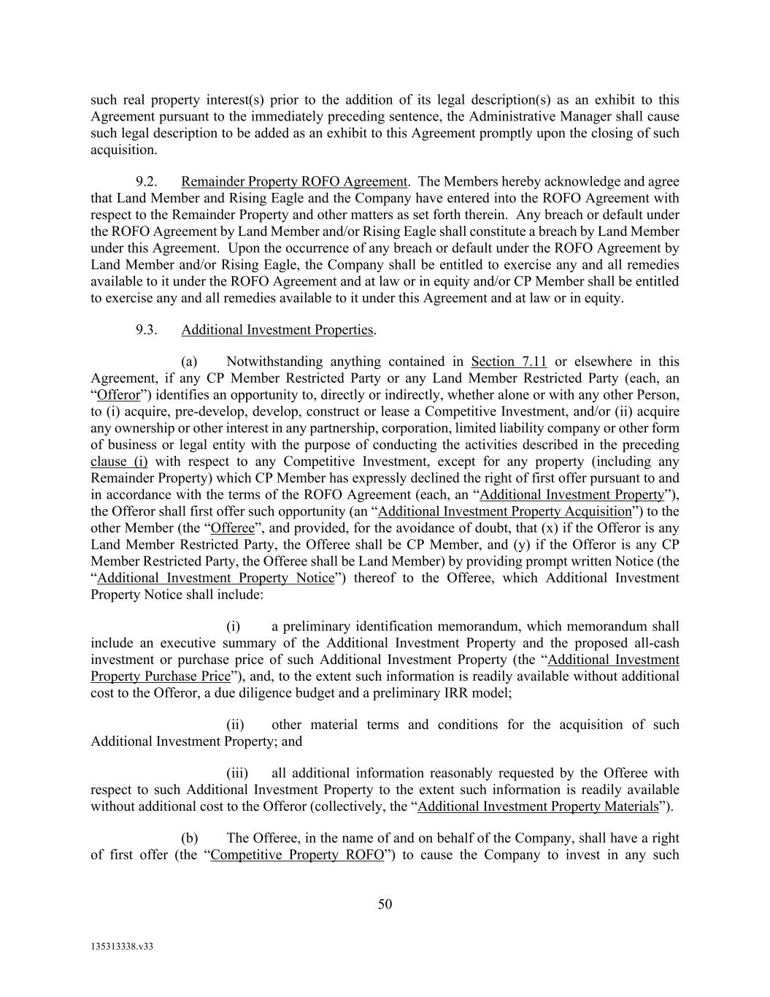
50 135313338.v33 such real property interest(s) prior to the addition of its legal description(s) as an exhibit to this Agreement pursuant to the immediately preceding sentence, the Administrative Manager shall cause such legal description to be added as an exhibit to this Agreement promptly upon the closing of such acquisition. 9.2. Remainder Property ROFO Agreement. The Members hereby acknowledge and agree that Land Member and Rising Eagle and the Company have entered into the ROFO Agreement with respect to the Remainder Property and other matters as set forth therein. Any breach or default under the ROFO Agreement by Land Member and/or Rising Eagle shall constitute a breach by Land Member under this Agreement. Upon the occurrence of any breach or default under the ROFO Agreement by Land Member and/or Rising Eagle, the Company shall be entitled to exercise any and all remedies available to it under the ROFO Agreement and at law or in equity and/or CP Member shall be entitled to exercise any and all remedies available to it under this Agreement and at law or in equity. 9.3. Additional Investment Properties. (a) Notwithstanding anything contained in Section 7.11 or elsewhere in this Agreement, if any CP Member Restricted Party or any Land Member Restricted Party (each, an “Offeror”) identifies an opportunity to, directly or indirectly, whether alone or with any other Person, to (i) acquire, pre-develop, develop, construct or lease a Competitive Investment, and/or (ii) acquire any ownership or other interest in any partnership, corporation, limited liability company or other form of business or legal entity with the purpose of conducting the activities described in the preceding clause (i) with respect to any Competitive Investment, except for any property (including any Remainder Property) which CP Member has expressly declined the right of first offer pursuant to and in accordance with the terms of the ROFO Agreement (each, an “Additional Investment Property”), the Offeror shall first offer such opportunity (an “Additional Investment Property Acquisition”) to the other Member (the “Offeree”, and provided, for the avoidance of doubt, that (x) if the Offeror is any Land Member Restricted Party, the Offeree shall be CP Member, and (y) if the Offeror is any CP Member Restricted Party, the Offeree shall be Land Member) by providing prompt written Notice (the “Additional Investment Property Notice”) thereof to the Offeree, which Additional Investment Property Notice shall include: (i) a preliminary identification memorandum, which memorandum shall include an executive summary of the Additional Investment Property and the proposed all-cash investment or purchase price of such Additional Investment Property (the “Additional Investment Property Purchase Price”), and, to the extent such information is readily available without additional cost to the Offeror, a due diligence budget and a preliminary IRR model; (ii) other material terms and conditions for the acquisition of such Additional Investment Property; and (iii) all additional information reasonably requested by the Offeree with respect to such Additional Investment Property to the extent such information is readily available without additional cost to the Offeror (collectively, the “Additional Investment Property Materials”). (b) The Offeree, in the name of and on behalf of the Company, shall have a right of first offer (the “Competitive Property ROFO”) to cause the Company to invest in any such

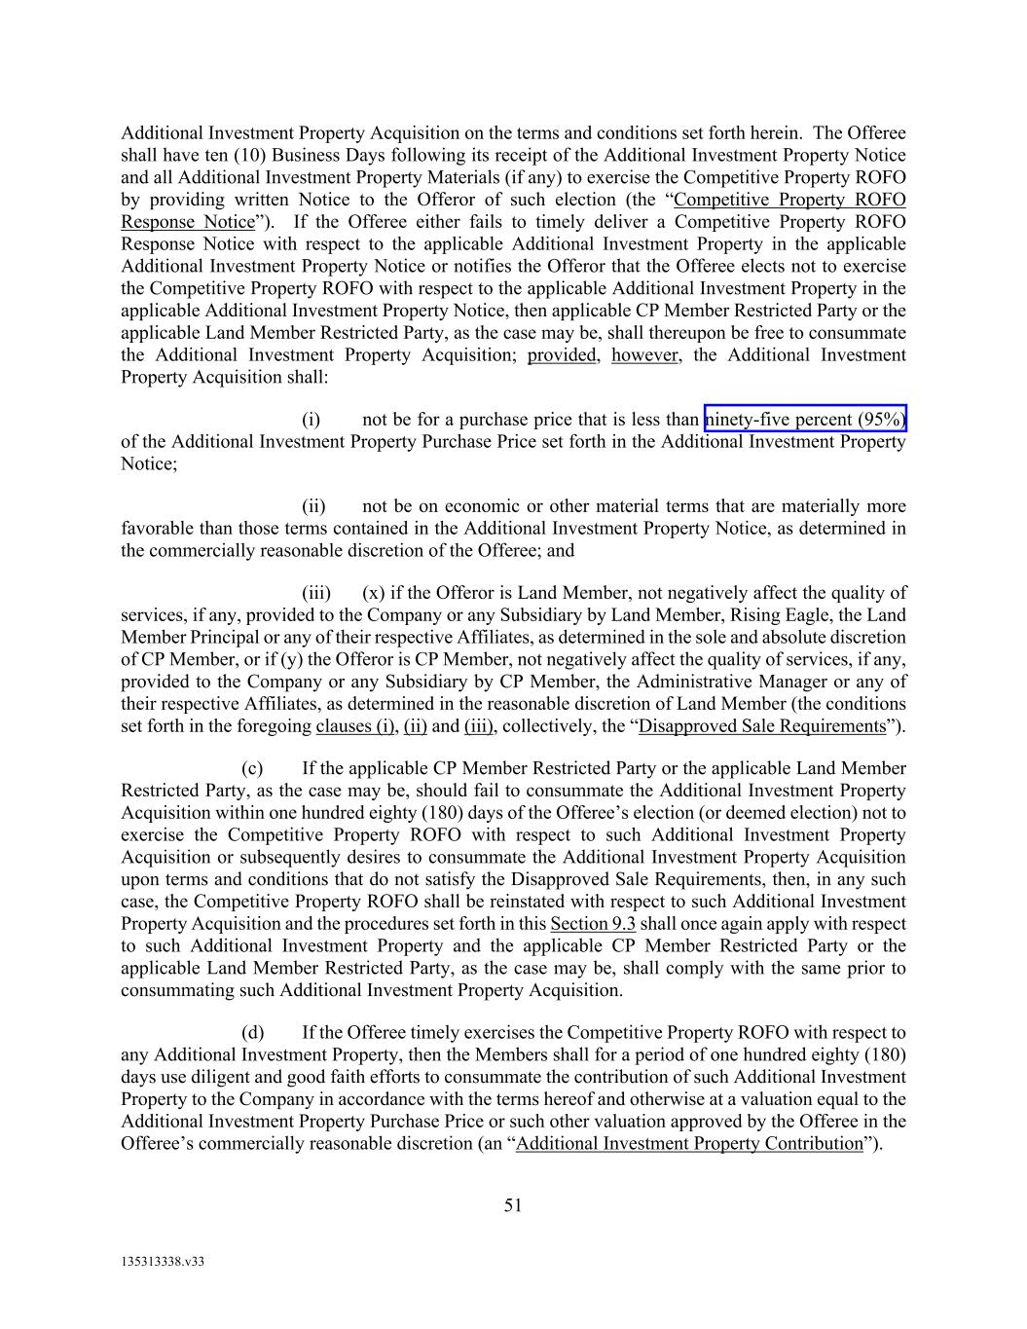
51 135313338.v33 Additional Investment Property Acquisition on the terms and conditions set forth herein. The Offeree shall have ten (10) Business Days following its receipt of the Additional Investment Property Notice and all Additional Investment Property Materials (if any) to exercise the Competitive Property ROFO by providing written Notice to the Offeror of such election (the “Competitive Property ROFO Response Notice”). If the Offeree either fails to timely deliver a Competitive Property ROFO Response Notice with respect to the applicable Additional Investment Property in the applicable Additional Investment Property Notice or notifies the Offeror that the Offeree elects not to exercise the Competitive Property ROFO with respect to the applicable Additional Investment Property in the applicable Additional Investment Property Notice, then applicable CP Member Restricted Party or the applicable Land Member Restricted Party, as the case may be, shall thereupon be free to consummate the Additional Investment Property Acquisition; provided, however, the Additional Investment Property Acquisition shall: (i) not be for a purchase price that is less than ninety-five percent (95%) of the Additional Investment Property Purchase Price set forth in the Additional Investment Property Notice; (ii) not be on economic or other material terms that are materially more favorable than those terms contained in the Additional Investment Property Notice, as determined in the commercially reasonable discretion of the Offeree; and (iii) (x) if the Offeror is Land Member, not negatively affect the quality of services, if any, provided to the Company or any Subsidiary by Land Member, Rising Eagle, the Land Member Principal or any of their respective Affiliates, as determined in the sole and absolute discretion of CP Member, or if (y) the Offeror is CP Member, not negatively affect the quality of services, if any, provided to the Company or any Subsidiary by CP Member, the Administrative Manager or any of their respective Affiliates, as determined in the reasonable discretion of Land Member (the conditions set forth in the foregoing clauses (i), (ii) and (iii), collectively, the “Disapproved Sale Requirements”). (c) If the applicable CP Member Restricted Party or the applicable Land Member Restricted Party, as the case may be, should fail to consummate the Additional Investment Property Acquisition within one hundred eighty (180) days of the Offeree’s election (or deemed election) not to exercise the Competitive Property ROFO with respect to such Additional Investment Property Acquisition or subsequently desires to consummate the Additional Investment Property Acquisition upon terms and conditions that do not satisfy the Disapproved Sale Requirements, then, in any such case, the Competitive Property ROFO shall be reinstated with respect to such Additional Investment Property Acquisition and the procedures set forth in this Section 9.3 shall once again apply with respect to such Additional Investment Property and the applicable CP Member Restricted Party or the applicable Land Member Restricted Party, as the case may be, shall comply with the same prior to consummating such Additional Investment Property Acquisition. (d) If the Offeree timely exercises the Competitive Property ROFO with respect to any Additional Investment Property, then the Members shall for a period of one hundred eighty (180) days use diligent and good faith efforts to consummate the contribution of such Additional Investment Property to the Company in accordance with the terms hereof and otherwise at a valuation equal to the Additional Investment Property Purchase Price or such other valuation approved by the Offeree in the Offeree’s commercially reasonable discretion (an “Additional Investment Property Contribution”).

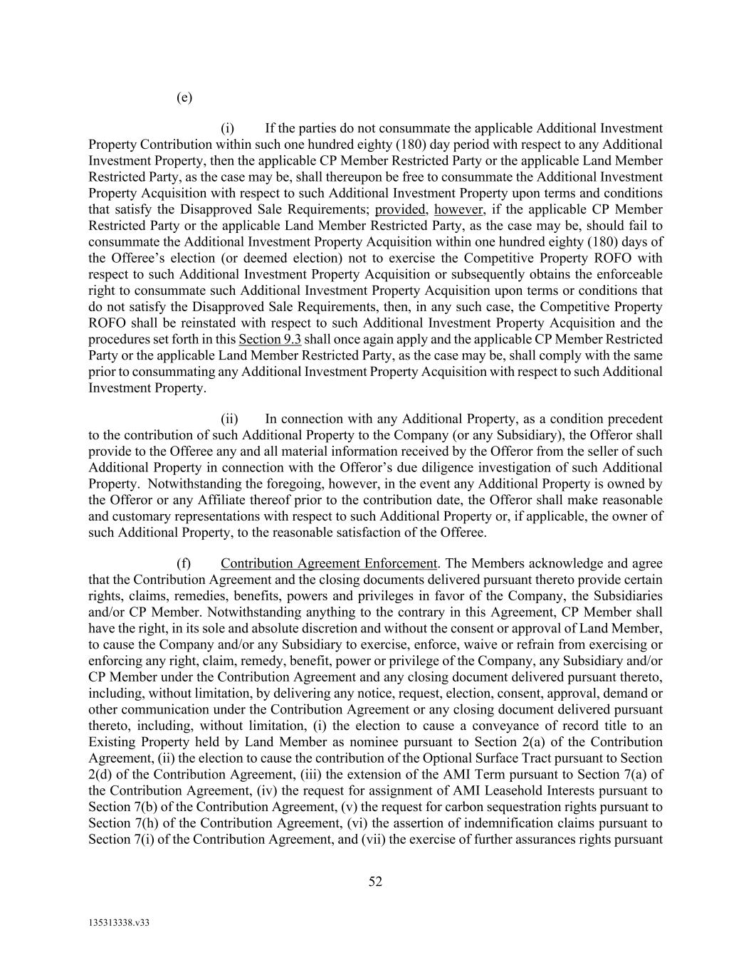
52 135313338.v33 (e) (i) If the parties do not consummate the applicable Additional Investment Property Contribution within such one hundred eighty (180) day period with respect to any Additional Investment Property, then the applicable CP Member Restricted Party or the applicable Land Member Restricted Party, as the case may be, shall thereupon be free to consummate the Additional Investment Property Acquisition with respect to such Additional Investment Property upon terms and conditions that satisfy the Disapproved Sale Requirements; provided, however, if the applicable CP Member Restricted Party or the applicable Land Member Restricted Party, as the case may be, should fail to consummate the Additional Investment Property Acquisition within one hundred eighty (180) days of the Offeree’s election (or deemed election) not to exercise the Competitive Property ROFO with respect to such Additional Investment Property Acquisition or subsequently obtains the enforceable right to consummate such Additional Investment Property Acquisition upon terms or conditions that do not satisfy the Disapproved Sale Requirements, then, in any such case, the Competitive Property ROFO shall be reinstated with respect to such Additional Investment Property Acquisition and the procedures set forth in this Section 9.3 shall once again apply and the applicable CP Member Restricted Party or the applicable Land Member Restricted Party, as the case may be, shall comply with the same prior to consummating any Additional Investment Property Acquisition with respect to such Additional Investment Property. (ii) In connection with any Additional Property, as a condition precedent to the contribution of such Additional Property to the Company (or any Subsidiary), the Offeror shall provide to the Offeree any and all material information received by the Offeror from the seller of such Additional Property in connection with the Offeror’s due diligence investigation of such Additional Property. Notwithstanding the foregoing, however, in the event any Additional Property is owned by the Offeror or any Affiliate thereof prior to the contribution date, the Offeror shall make reasonable and customary representations with respect to such Additional Property or, if applicable, the owner of such Additional Property, to the reasonable satisfaction of the Offeree. (f) Contribution Agreement Enforcement. The Members acknowledge and agree that the Contribution Agreement and the closing documents delivered pursuant thereto provide certain rights, claims, remedies, benefits, powers and privileges in favor of the Company, the Subsidiaries and/or CP Member. Notwithstanding anything to the contrary in this Agreement, CP Member shall have the right, in its sole and absolute discretion and without the consent or approval of Land Member, to cause the Company and/or any Subsidiary to exercise, enforce, waive or refrain from exercising or enforcing any right, claim, remedy, benefit, power or privilege of the Company, any Subsidiary and/or CP Member under the Contribution Agreement and any closing document delivered pursuant thereto, including, without limitation, by delivering any notice, request, election, consent, approval, demand or other communication under the Contribution Agreement or any closing document delivered pursuant thereto, including, without limitation, (i) the election to cause a conveyance of record title to an Existing Property held by Land Member as nominee pursuant to Section 2(a) of the Contribution Agreement, (ii) the election to cause the contribution of the Optional Surface Tract pursuant to Section 2(d) of the Contribution Agreement, (iii) the extension of the AMI Term pursuant to Section 7(a) of the Contribution Agreement, (iv) the request for assignment of AMI Leasehold Interests pursuant to Section 7(b) of the Contribution Agreement, (v) the request for carbon sequestration rights pursuant to Section 7(h) of the Contribution Agreement, (vi) the assertion of indemnification claims pursuant to Section 7(i) of the Contribution Agreement, and (vii) the exercise of further assurances rights pursuant

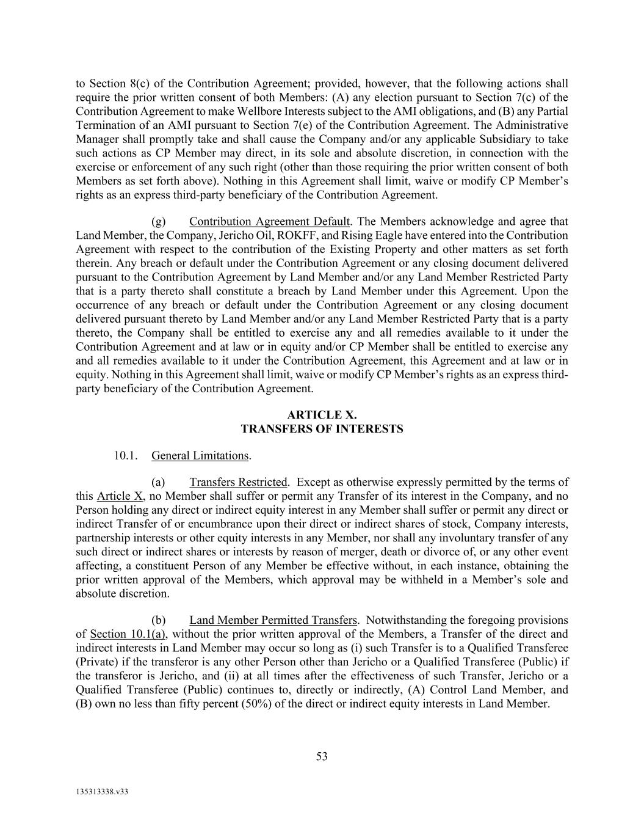
53 135313338.v33 to Section 8(c) of the Contribution Agreement; provided, however, that the following actions shall require the prior written consent of both Members: (A) any election pursuant to Section 7(c) of the Contribution Agreement to make Wellbore Interests subject to the AMI obligations, and (B) any Partial Termination of an AMI pursuant to Section 7(e) of the Contribution Agreement. The Administrative Manager shall promptly take and shall cause the Company and/or any applicable Subsidiary to take such actions as CP Member may direct, in its sole and absolute discretion, in connection with the exercise or enforcement of any such right (other than those requiring the prior written consent of both Members as set forth above). Nothing in this Agreement shall limit, waive or modify CP Member’s rights as an express third-party beneficiary of the Contribution Agreement. (g) Contribution Agreement Default. The Members acknowledge and agree that Land Member, the Company, Jericho Oil, ROKFF, and Rising Eagle have entered into the Contribution Agreement with respect to the contribution of the Existing Property and other matters as set forth therein. Any breach or default under the Contribution Agreement or any closing document delivered pursuant to the Contribution Agreement by Land Member and/or any Land Member Restricted Party that is a party thereto shall constitute a breach by Land Member under this Agreement. Upon the occurrence of any breach or default under the Contribution Agreement or any closing document delivered pursuant thereto by Land Member and/or any Land Member Restricted Party that is a party thereto, the Company shall be entitled to exercise any and all remedies available to it under the Contribution Agreement and at law or in equity and/or CP Member shall be entitled to exercise any and all remedies available to it under the Contribution Agreement, this Agreement and at law or in equity. Nothing in this Agreement shall limit, waive or modify CP Member’s rights as an express third- party beneficiary of the Contribution Agreement. ARTICLE X. TRANSFERS OF INTERESTS 10.1. General Limitations. (a) Transfers Restricted. Except as otherwise expressly permitted by the terms of this Article X, no Member shall suffer or permit any Transfer of its interest in the Company, and no Person holding any direct or indirect equity interest in any Member shall suffer or permit any direct or indirect Transfer of or encumbrance upon their direct or indirect shares of stock, Company interests, partnership interests or other equity interests in any Member, nor shall any involuntary transfer of any such direct or indirect shares or interests by reason of merger, death or divorce of, or any other event affecting, a constituent Person of any Member be effective without, in each instance, obtaining the prior written approval of the Members, which approval may be withheld in a Member’s sole and absolute discretion. (b) Land Member Permitted Transfers. Notwithstanding the foregoing provisions of Section 10.1(a), without the prior written approval of the Members, a Transfer of the direct and indirect interests in Land Member may occur so long as (i) such Transfer is to a Qualified Transferee (Private) if the transferor is any other Person other than Jericho or a Qualified Transferee (Public) if the transferor is Jericho, and (ii) at all times after the effectiveness of such Transfer, Jericho or a Qualified Transferee (Public) continues to, directly or indirectly, (A) Control Land Member, and (B) own no less than fifty percent (50%) of the direct or indirect equity interests in Land Member.

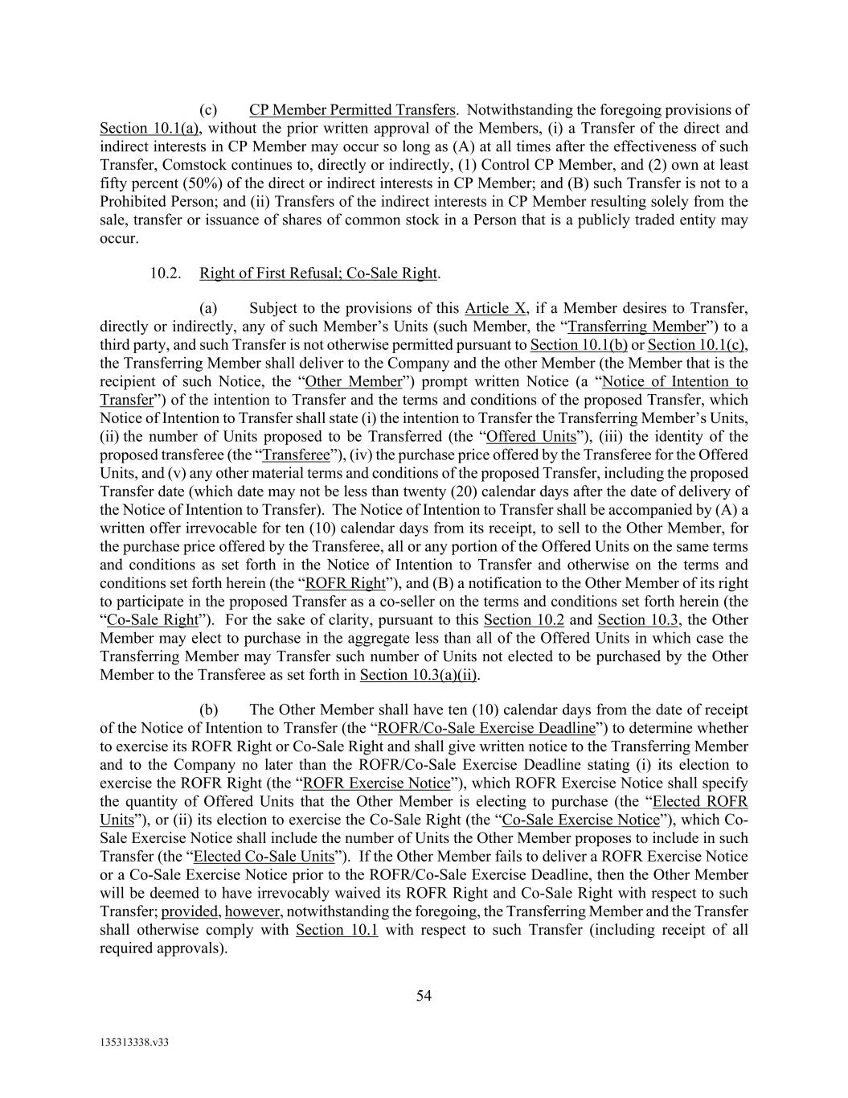
54 135313338.v33 (c) CP Member Permitted Transfers. Notwithstanding the foregoing provisions of Section 10.1(a), without the prior written approval of the Members, (i) a Transfer of the direct and indirect interests in CP Member may occur so long as (A) at all times after the effectiveness of such Transfer, Comstock continues to, directly or indirectly, (1) Control CP Member, and (2) own at least fifty percent (50%) of the direct or indirect interests in CP Member; and (B) such Transfer is not to a Prohibited Person; and (ii) Transfers of the indirect interests in CP Member resulting solely from the sale, transfer or issuance of shares of common stock in a Person that is a publicly traded entity may occur. 10.2. Right of First Refusal; Co-Sale Right. (a) Subject to the provisions of this Article X, if a Member desires to Transfer, directly or indirectly, any of such Member’s Units (such Member, the “Transferring Member”) to a third party, and such Transfer is not otherwise permitted pursuant to Section 10.1(b) or Section 10.1(c), the Transferring Member shall deliver to the Company and the other Member (the Member that is the recipient of such Notice, the “Other Member”) prompt written Notice (a “Notice of Intention to Transfer”) of the intention to Transfer and the terms and conditions of the proposed Transfer, which Notice of Intention to Transfer shall state (i) the intention to Transfer the Transferring Member’s Units, (ii) the number of Units proposed to be Transferred (the “Offered Units”), (iii) the identity of the proposed transferee (the “Transferee”), (iv) the purchase price offered by the Transferee for the Offered Units, and (v) any other material terms and conditions of the proposed Transfer, including the proposed Transfer date (which date may not be less than twenty (20) calendar days after the date of delivery of the Notice of Intention to Transfer). The Notice of Intention to Transfer shall be accompanied by (A) a written offer irrevocable for ten (10) calendar days from its receipt, to sell to the Other Member, for the purchase price offered by the Transferee, all or any portion of the Offered Units on the same terms and conditions as set forth in the Notice of Intention to Transfer and otherwise on the terms and conditions set forth herein (the “ROFR Right”), and (B) a notification to the Other Member of its right to participate in the proposed Transfer as a co-seller on the terms and conditions set forth herein (the “Co-Sale Right”). For the sake of clarity, pursuant to this Section 10.2 and Section 10.3, the Other Member may elect to purchase in the aggregate less than all of the Offered Units in which case the Transferring Member may Transfer such number of Units not elected to be purchased by the Other Member to the Transferee as set forth in Section 10.3(a)(ii). (b) The Other Member shall have ten (10) calendar days from the date of receipt of the Notice of Intention to Transfer (the “ROFR/Co-Sale Exercise Deadline”) to determine whether to exercise its ROFR Right or Co-Sale Right and shall give written notice to the Transferring Member and to the Company no later than the ROFR/Co-Sale Exercise Deadline stating (i) its election to exercise the ROFR Right (the “ROFR Exercise Notice”), which ROFR Exercise Notice shall specify the quantity of Offered Units that the Other Member is electing to purchase (the “Elected ROFR Units”), or (ii) its election to exercise the Co-Sale Right (the “Co-Sale Exercise Notice”), which Co- Sale Exercise Notice shall include the number of Units the Other Member proposes to include in such Transfer (the “Elected Co-Sale Units”). If the Other Member fails to deliver a ROFR Exercise Notice or a Co-Sale Exercise Notice prior to the ROFR/Co-Sale Exercise Deadline, then the Other Member will be deemed to have irrevocably waived its ROFR Right and Co-Sale Right with respect to such Transfer; provided, however, notwithstanding the foregoing, the Transferring Member and the Transfer shall otherwise comply with Section 10.1 with respect to such Transfer (including receipt of all required approvals).

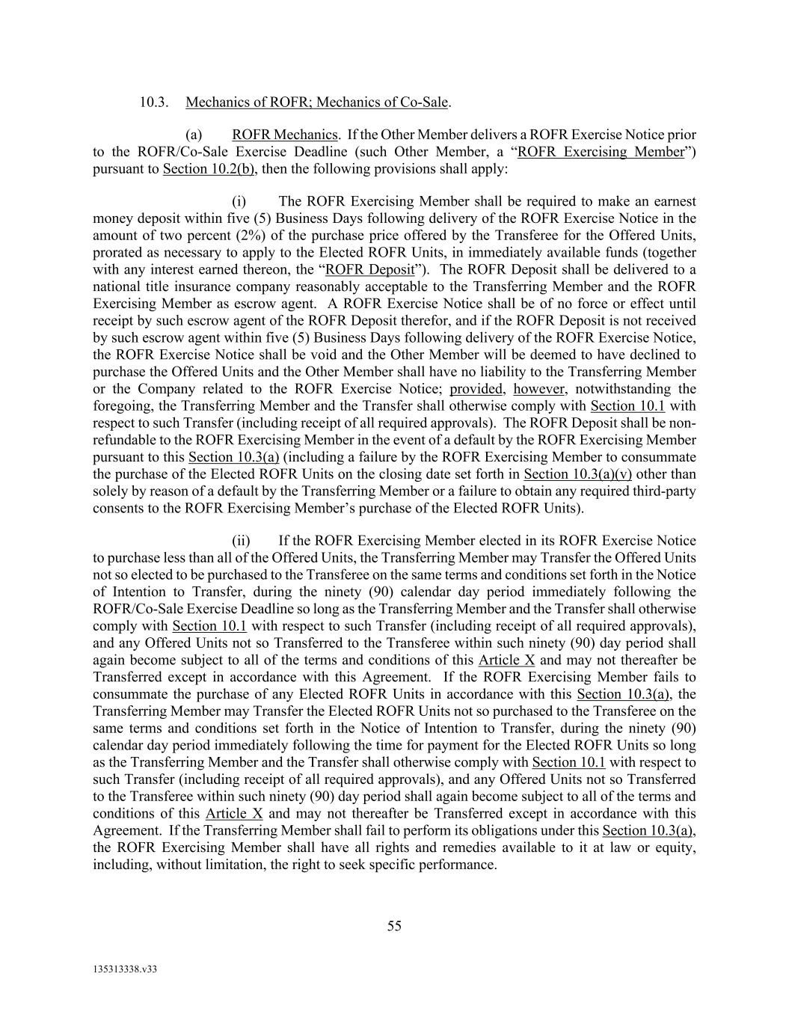
55 135313338.v33 10.3. Mechanics of ROFR; Mechanics of Co-Sale. (a) ROFR Mechanics. If the Other Member delivers a ROFR Exercise Notice prior to the ROFR/Co-Sale Exercise Deadline (such Other Member, a “ROFR Exercising Member”) pursuant to Section 10.2(b), then the following provisions shall apply: (i) The ROFR Exercising Member shall be required to make an earnest money deposit within five (5) Business Days following delivery of the ROFR Exercise Notice in the amount of two percent (2%) of the purchase price offered by the Transferee for the Offered Units, prorated as necessary to apply to the Elected ROFR Units, in immediately available funds (together with any interest earned thereon, the “ROFR Deposit”). The ROFR Deposit shall be delivered to a national title insurance company reasonably acceptable to the Transferring Member and the ROFR Exercising Member as escrow agent. A ROFR Exercise Notice shall be of no force or effect until receipt by such escrow agent of the ROFR Deposit therefor, and if the ROFR Deposit is not received by such escrow agent within five (5) Business Days following delivery of the ROFR Exercise Notice, the ROFR Exercise Notice shall be void and the Other Member will be deemed to have declined to purchase the Offered Units and the Other Member shall have no liability to the Transferring Member or the Company related to the ROFR Exercise Notice; provided, however, notwithstanding the foregoing, the Transferring Member and the Transfer shall otherwise comply with Section 10.1 with respect to such Transfer (including receipt of all required approvals). The ROFR Deposit shall be non- refundable to the ROFR Exercising Member in the event of a default by the ROFR Exercising Member pursuant to this Section 10.3(a) (including a failure by the ROFR Exercising Member to consummate the purchase of the Elected ROFR Units on the closing date set forth in Section 10.3(a)(v) other than solely by reason of a default by the Transferring Member or a failure to obtain any required third-party consents to the ROFR Exercising Member’s purchase of the Elected ROFR Units). (ii) If the ROFR Exercising Member elected in its ROFR Exercise Notice to purchase less than all of the Offered Units, the Transferring Member may Transfer the Offered Units not so elected to be purchased to the Transferee on the same terms and conditions set forth in the Notice of Intention to Transfer, during the ninety (90) calendar day period immediately following the ROFR/Co-Sale Exercise Deadline so long as the Transferring Member and the Transfer shall otherwise comply with Section 10.1 with respect to such Transfer (including receipt of all required approvals), and any Offered Units not so Transferred to the Transferee within such ninety (90) day period shall again become subject to all of the terms and conditions of this Article X and may not thereafter be Transferred except in accordance with this Agreement. If the ROFR Exercising Member fails to consummate the purchase of any Elected ROFR Units in accordance with this Section 10.3(a), the Transferring Member may Transfer the Elected ROFR Units not so purchased to the Transferee on the same terms and conditions set forth in the Notice of Intention to Transfer, during the ninety (90) calendar day period immediately following the time for payment for the Elected ROFR Units so long as the Transferring Member and the Transfer shall otherwise comply with Section 10.1 with respect to such Transfer (including receipt of all required approvals), and any Offered Units not so Transferred to the Transferee within such ninety (90) day period shall again become subject to all of the terms and conditions of this Article X and may not thereafter be Transferred except in accordance with this Agreement. If the Transferring Member shall fail to perform its obligations under this Section 10.3(a), the ROFR Exercising Member shall have all rights and remedies available to it at law or equity, including, without limitation, the right to seek specific performance.

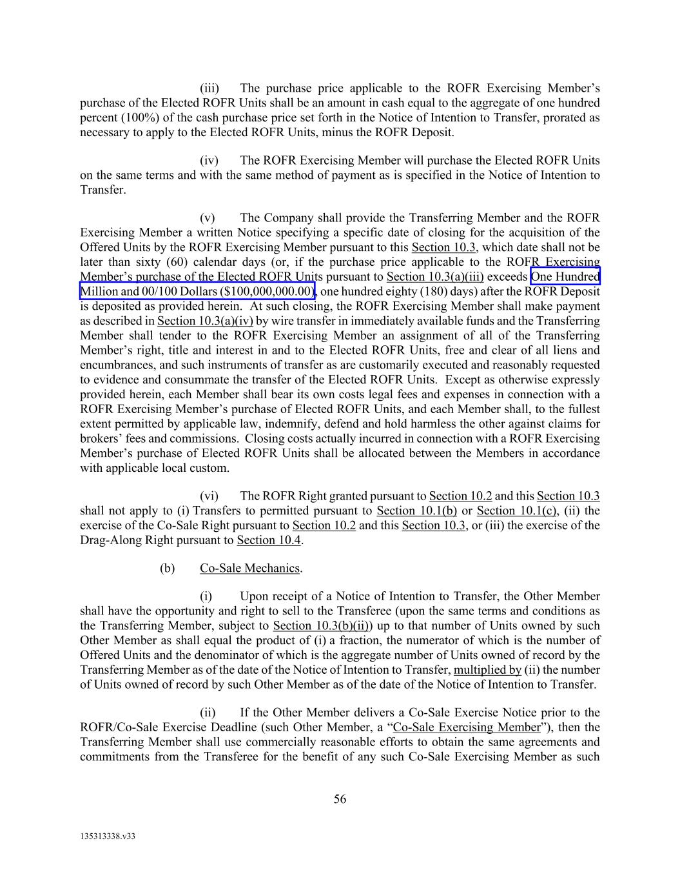
56 135313338.v33 (iii) The purchase price applicable to the ROFR Exercising Member’s purchase of the Elected ROFR Units shall be an amount in cash equal to the aggregate of one hundred percent (100%) of the cash purchase price set forth in the Notice of Intention to Transfer, prorated as necessary to apply to the Elected ROFR Units, minus the ROFR Deposit. (iv) The ROFR Exercising Member will purchase the Elected ROFR Units on the same terms and with the same method of payment as is specified in the Notice of Intention to Transfer. (v) The Company shall provide the Transferring Member and the ROFR Exercising Member a written Notice specifying a specific date of closing for the acquisition of the Offered Units by the ROFR Exercising Member pursuant to this Section 10.3, which date shall not be later than sixty (60) calendar days (or, if the purchase price applicable to the ROFR Exercising Member’s purchase of the Elected ROFR Units pursuant to Section 10.3(a)(iii) exceeds One Hundred Million and 00/100 Dollars ($100,000,000.00), one hundred eighty (180) days) after the ROFR Deposit is deposited as provided herein. At such closing, the ROFR Exercising Member shall make payment as described in Section 10.3(a)(iv) by wire transfer in immediately available funds and the Transferring Member shall tender to the ROFR Exercising Member an assignment of all of the Transferring Member’s right, title and interest in and to the Elected ROFR Units, free and clear of all liens and encumbrances, and such instruments of transfer as are customarily executed and reasonably requested to evidence and consummate the transfer of the Elected ROFR Units. Except as otherwise expressly provided herein, each Member shall bear its own costs legal fees and expenses in connection with a ROFR Exercising Member’s purchase of Elected ROFR Units, and each Member shall, to the fullest extent permitted by applicable law, indemnify, defend and hold harmless the other against claims for brokers’ fees and commissions. Closing costs actually incurred in connection with a ROFR Exercising Member’s purchase of Elected ROFR Units shall be allocated between the Members in accordance with applicable local custom. (vi) The ROFR Right granted pursuant to Section 10.2 and this Section 10.3 shall not apply to (i) Transfers to permitted pursuant to Section 10.1(b) or Section 10.1(c), (ii) the exercise of the Co-Sale Right pursuant to Section 10.2 and this Section 10.3, or (iii) the exercise of the Drag-Along Right pursuant to Section 10.4. (b) Co-Sale Mechanics. (i) Upon receipt of a Notice of Intention to Transfer, the Other Member shall have the opportunity and right to sell to the Transferee (upon the same terms and conditions as the Transferring Member, subject to Section 10.3(b)(ii)) up to that number of Units owned by such Other Member as shall equal the product of (i) a fraction, the numerator of which is the number of Offered Units and the denominator of which is the aggregate number of Units owned of record by the Transferring Member as of the date of the Notice of Intention to Transfer, multiplied by (ii) the number of Units owned of record by such Other Member as of the date of the Notice of Intention to Transfer. (ii) If the Other Member delivers a Co-Sale Exercise Notice prior to the ROFR/Co-Sale Exercise Deadline (such Other Member, a “Co-Sale Exercising Member”), then the Transferring Member shall use commercially reasonable efforts to obtain the same agreements and commitments from the Transferee for the benefit of any such Co-Sale Exercising Member as such

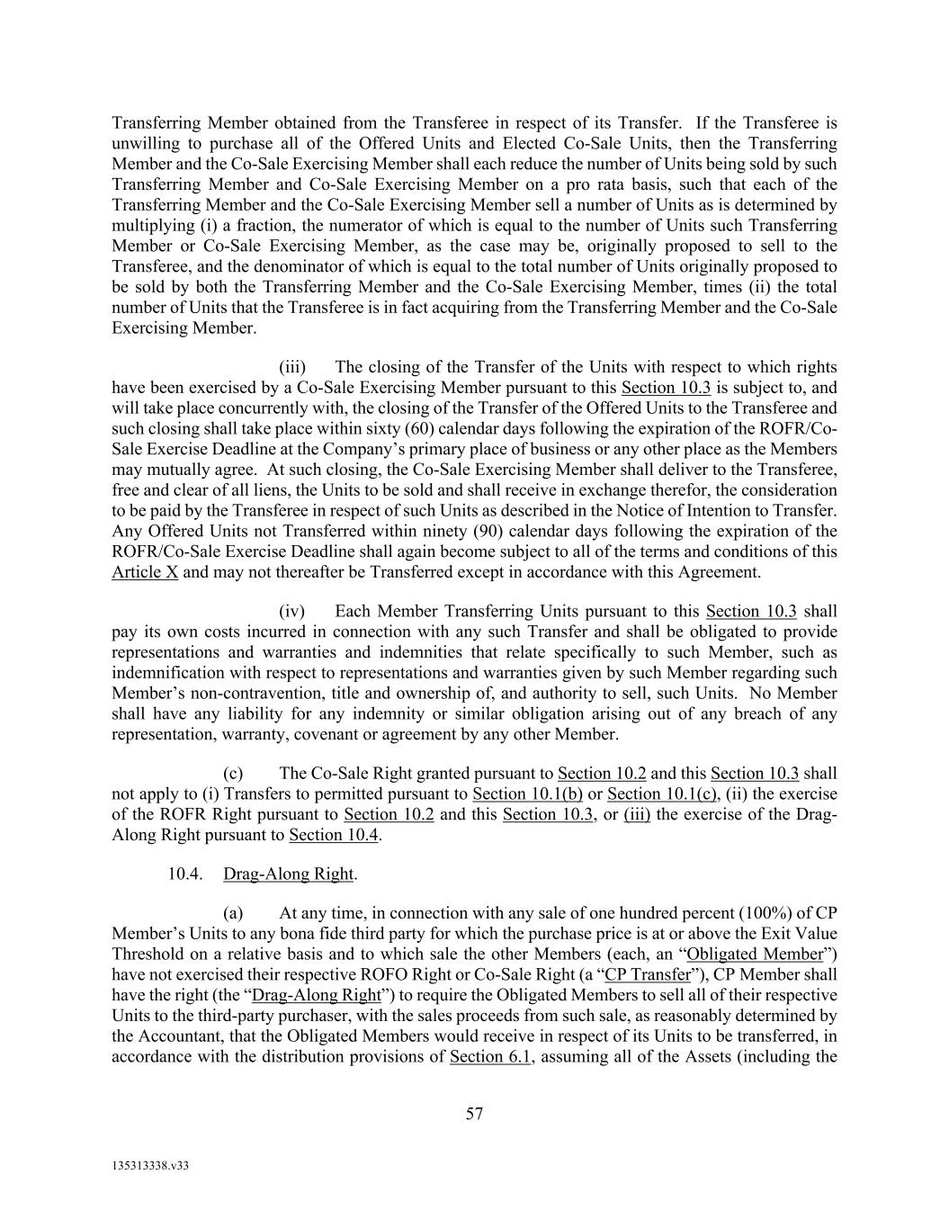
57 135313338.v33 Transferring Member obtained from the Transferee in respect of its Transfer. If the Transferee is unwilling to purchase all of the Offered Units and Elected Co-Sale Units, then the Transferring Member and the Co-Sale Exercising Member shall each reduce the number of Units being sold by such Transferring Member and Co-Sale Exercising Member on a pro rata basis, such that each of the Transferring Member and the Co-Sale Exercising Member sell a number of Units as is determined by multiplying (i) a fraction, the numerator of which is equal to the number of Units such Transferring Member or Co-Sale Exercising Member, as the case may be, originally proposed to sell to the Transferee, and the denominator of which is equal to the total number of Units originally proposed to be sold by both the Transferring Member and the Co-Sale Exercising Member, times (ii) the total number of Units that the Transferee is in fact acquiring from the Transferring Member and the Co-Sale Exercising Member. (iii) The closing of the Transfer of the Units with respect to which rights have been exercised by a Co-Sale Exercising Member pursuant to this Section 10.3 is subject to, and will take place concurrently with, the closing of the Transfer of the Offered Units to the Transferee and such closing shall take place within sixty (60) calendar days following the expiration of the ROFR/Co- Sale Exercise Deadline at the Company’s primary place of business or any other place as the Members may mutually agree. At such closing, the Co-Sale Exercising Member shall deliver to the Transferee, free and clear of all liens, the Units to be sold and shall receive in exchange therefor, the consideration to be paid by the Transferee in respect of such Units as described in the Notice of Intention to Transfer. Any Offered Units not Transferred within ninety (90) calendar days following the expiration of the ROFR/Co-Sale Exercise Deadline shall again become subject to all of the terms and conditions of this Article X and may not thereafter be Transferred except in accordance with this Agreement. (iv) Each Member Transferring Units pursuant to this Section 10.3 shall pay its own costs incurred in connection with any such Transfer and shall be obligated to provide representations and warranties and indemnities that relate specifically to such Member, such as indemnification with respect to representations and warranties given by such Member regarding such Member’s non-contravention, title and ownership of, and authority to sell, such Units. No Member shall have any liability for any indemnity or similar obligation arising out of any breach of any representation, warranty, covenant or agreement by any other Member. (c) The Co-Sale Right granted pursuant to Section 10.2 and this Section 10.3 shall not apply to (i) Transfers to permitted pursuant to Section 10.1(b) or Section 10.1(c), (ii) the exercise of the ROFR Right pursuant to Section 10.2 and this Section 10.3, or (iii) the exercise of the Drag- Along Right pursuant to Section 10.4. 10.4. Drag-Along Right. (a) At any time, in connection with any sale of one hundred percent (100%) of CP Member’s Units to any bona fide third party for which the purchase price is at or above the Exit Value Threshold on a relative basis and to which sale the other Members (each, an “Obligated Member”) have not exercised their respective ROFO Right or Co-Sale Right (a “CP Transfer”), CP Member shall have the right (the “Drag-Along Right”) to require the Obligated Members to sell all of their respective Units to the third-party purchaser, with the sales proceeds from such sale, as reasonably determined by the Accountant, that the Obligated Members would receive in respect of its Units to be transferred, in accordance with the distribution provisions of Section 6.1, assuming all of the Assets (including the

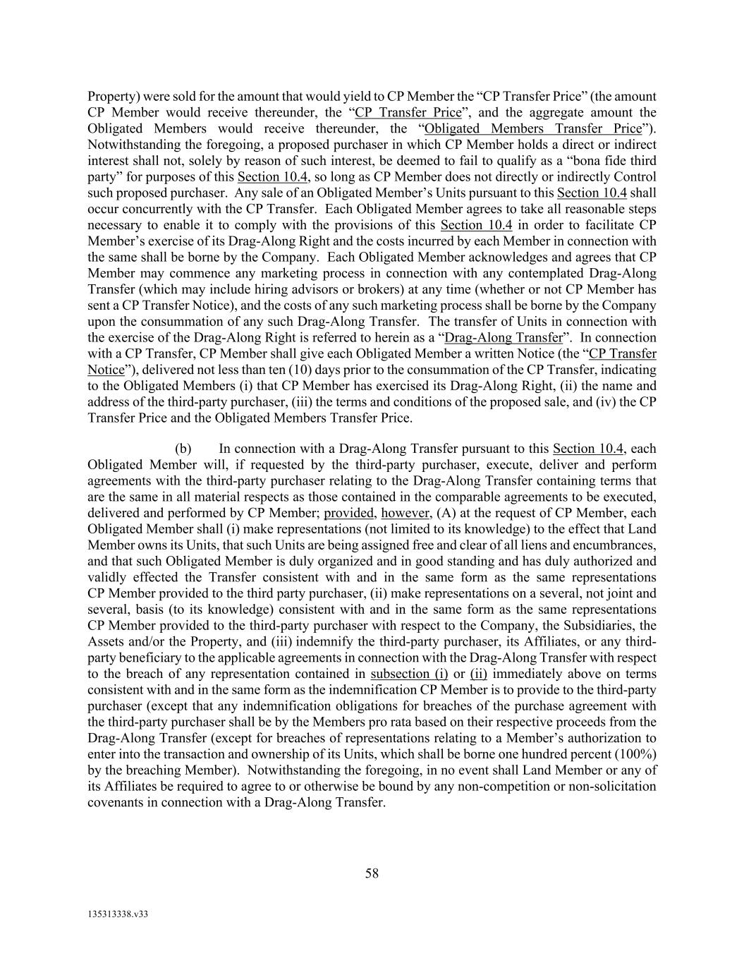
58 135313338.v33 Property) were sold for the amount that would yield to CP Member the “CP Transfer Price” (the amount CP Member would receive thereunder, the “CP Transfer Price”, and the aggregate amount the Obligated Members would receive thereunder, the “Obligated Members Transfer Price”). Notwithstanding the foregoing, a proposed purchaser in which CP Member holds a direct or indirect interest shall not, solely by reason of such interest, be deemed to fail to qualify as a “bona fide third party” for purposes of this Section 10.4, so long as CP Member does not directly or indirectly Control such proposed purchaser. Any sale of an Obligated Member’s Units pursuant to this Section 10.4 shall occur concurrently with the CP Transfer. Each Obligated Member agrees to take all reasonable steps necessary to enable it to comply with the provisions of this Section 10.4 in order to facilitate CP Member’s exercise of its Drag-Along Right and the costs incurred by each Member in connection with the same shall be borne by the Company. Each Obligated Member acknowledges and agrees that CP Member may commence any marketing process in connection with any contemplated Drag-Along Transfer (which may include hiring advisors or brokers) at any time (whether or not CP Member has sent a CP Transfer Notice), and the costs of any such marketing process shall be borne by the Company upon the consummation of any such Drag-Along Transfer. The transfer of Units in connection with the exercise of the Drag-Along Right is referred to herein as a “Drag-Along Transfer”. In connection with a CP Transfer, CP Member shall give each Obligated Member a written Notice (the “CP Transfer Notice”), delivered not less than ten (10) days prior to the consummation of the CP Transfer, indicating to the Obligated Members (i) that CP Member has exercised its Drag-Along Right, (ii) the name and address of the third-party purchaser, (iii) the terms and conditions of the proposed sale, and (iv) the CP Transfer Price and the Obligated Members Transfer Price. (b) In connection with a Drag-Along Transfer pursuant to this Section 10.4, each Obligated Member will, if requested by the third-party purchaser, execute, deliver and perform agreements with the third-party purchaser relating to the Drag-Along Transfer containing terms that are the same in all material respects as those contained in the comparable agreements to be executed, delivered and performed by CP Member; provided, however, (A) at the request of CP Member, each Obligated Member shall (i) make representations (not limited to its knowledge) to the effect that Land Member owns its Units, that such Units are being assigned free and clear of all liens and encumbrances, and that such Obligated Member is duly organized and in good standing and has duly authorized and validly effected the Transfer consistent with and in the same form as the same representations CP Member provided to the third party purchaser, (ii) make representations on a several, not joint and several, basis (to its knowledge) consistent with and in the same form as the same representations CP Member provided to the third-party purchaser with respect to the Company, the Subsidiaries, the Assets and/or the Property, and (iii) indemnify the third-party purchaser, its Affiliates, or any third- party beneficiary to the applicable agreements in connection with the Drag-Along Transfer with respect to the breach of any representation contained in subsection (i) or (ii) immediately above on terms consistent with and in the same form as the indemnification CP Member is to provide to the third-party purchaser (except that any indemnification obligations for breaches of the purchase agreement with the third-party purchaser shall be by the Members pro rata based on their respective proceeds from the Drag-Along Transfer (except for breaches of representations relating to a Member’s authorization to enter into the transaction and ownership of its Units, which shall be borne one hundred percent (100%) by the breaching Member). Notwithstanding the foregoing, in no event shall Land Member or any of its Affiliates be required to agree to or otherwise be bound by any non-competition or non-solicitation covenants in connection with a Drag-Along Transfer.

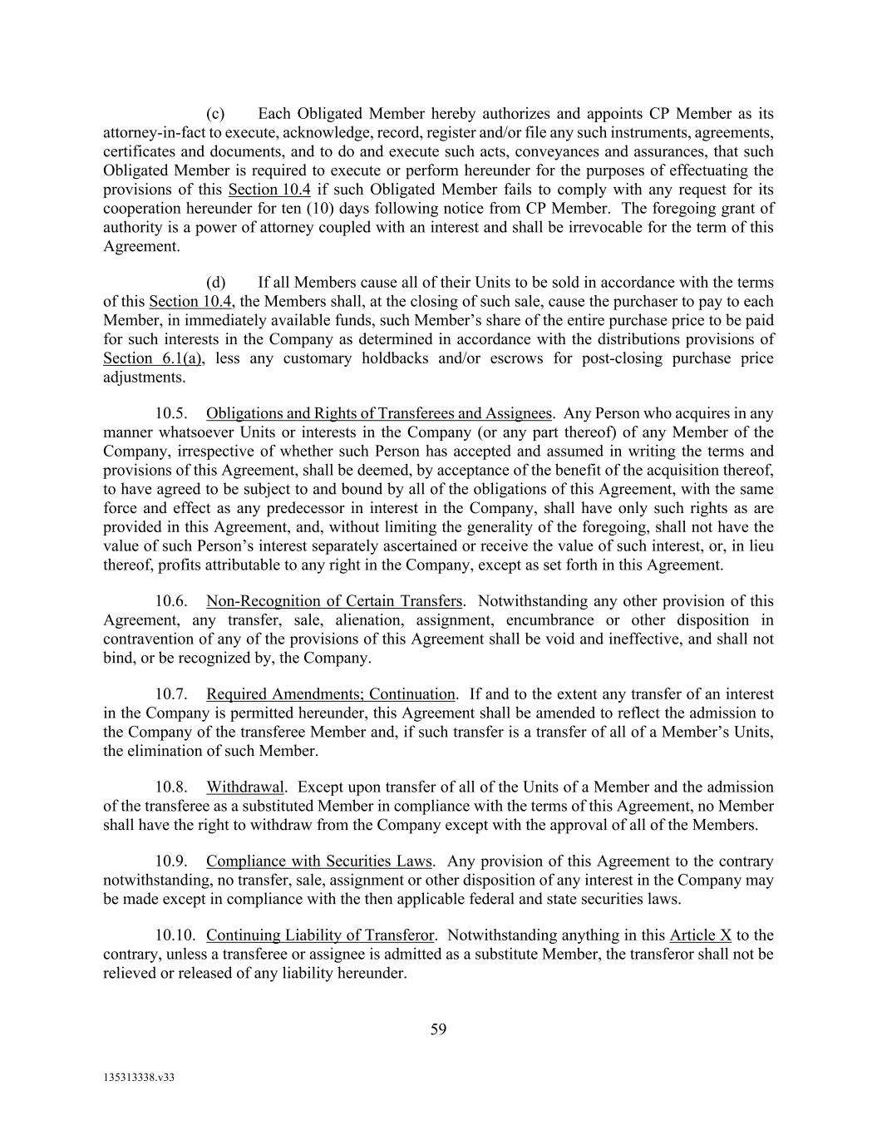
59 135313338.v33 (c) Each Obligated Member hereby authorizes and appoints CP Member as its attorney-in-fact to execute, acknowledge, record, register and/or file any such instruments, agreements, certificates and documents, and to do and execute such acts, conveyances and assurances, that such Obligated Member is required to execute or perform hereunder for the purposes of effectuating the provisions of this Section 10.4 if such Obligated Member fails to comply with any request for its cooperation hereunder for ten (10) days following notice from CP Member. The foregoing grant of authority is a power of attorney coupled with an interest and shall be irrevocable for the term of this Agreement. (d) If all Members cause all of their Units to be sold in accordance with the terms of this Section 10.4, the Members shall, at the closing of such sale, cause the purchaser to pay to each Member, in immediately available funds, such Member’s share of the entire purchase price to be paid for such interests in the Company as determined in accordance with the distributions provisions of Section 6.1(a), less any customary holdbacks and/or escrows for post-closing purchase price adjustments. 10.5. Obligations and Rights of Transferees and Assignees. Any Person who acquires in any manner whatsoever Units or interests in the Company (or any part thereof) of any Member of the Company, irrespective of whether such Person has accepted and assumed in writing the terms and provisions of this Agreement, shall be deemed, by acceptance of the benefit of the acquisition thereof, to have agreed to be subject to and bound by all of the obligations of this Agreement, with the same force and effect as any predecessor in interest in the Company, shall have only such rights as are provided in this Agreement, and, without limiting the generality of the foregoing, shall not have the value of such Person’s interest separately ascertained or receive the value of such interest, or, in lieu thereof, profits attributable to any right in the Company, except as set forth in this Agreement. 10.6. Non-Recognition of Certain Transfers. Notwithstanding any other provision of this Agreement, any transfer, sale, alienation, assignment, encumbrance or other disposition in contravention of any of the provisions of this Agreement shall be void and ineffective, and shall not bind, or be recognized by, the Company. 10.7. Required Amendments; Continuation. If and to the extent any transfer of an interest in the Company is permitted hereunder, this Agreement shall be amended to reflect the admission to the Company of the transferee Member and, if such transfer is a transfer of all of a Member’s Units, the elimination of such Member. 10.8. Withdrawal. Except upon transfer of all of the Units of a Member and the admission of the transferee as a substituted Member in compliance with the terms of this Agreement, no Member shall have the right to withdraw from the Company except with the approval of all of the Members. 10.9. Compliance with Securities Laws. Any provision of this Agreement to the contrary notwithstanding, no transfer, sale, assignment or other disposition of any interest in the Company may be made except in compliance with the then applicable federal and state securities laws. 10.10. Continuing Liability of Transferor. Notwithstanding anything in this Article X to the contrary, unless a transferee or assignee is admitted as a substitute Member, the transferor shall not be relieved or released of any liability hereunder.

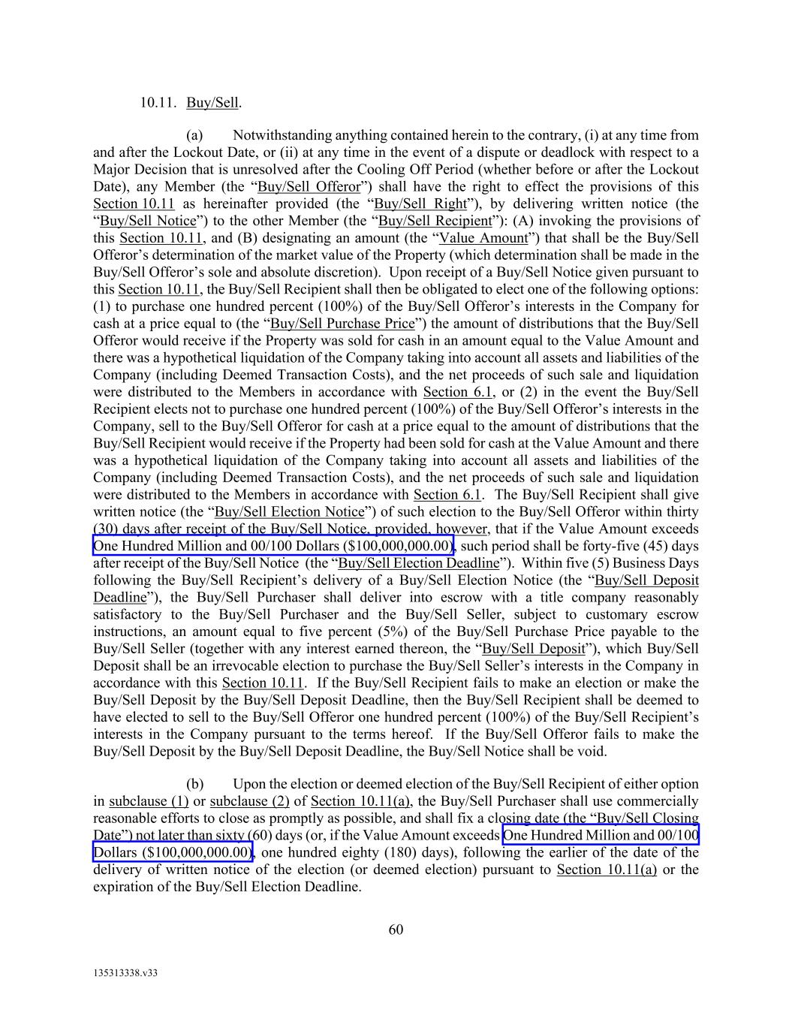
60 135313338.v33 10.11. Buy/Sell. (a) Notwithstanding anything contained herein to the contrary, (i) at any time from and after the Lockout Date, or (ii) at any time in the event of a dispute or deadlock with respect to a Major Decision that is unresolved after the Cooling Off Period (whether before or after the Lockout Date), any Member (the “Buy/Sell Offeror”) shall have the right to effect the provisions of this Section 10.11 as hereinafter provided (the “Buy/Sell Right”), by delivering written notice (the “Buy/Sell Notice”) to the other Member (the “Buy/Sell Recipient”): (A) invoking the provisions of this Section 10.11, and (B) designating an amount (the “Value Amount”) that shall be the Buy/Sell Offeror’s determination of the market value of the Property (which determination shall be made in the Buy/Sell Offeror’s sole and absolute discretion). Upon receipt of a Buy/Sell Notice given pursuant to this Section 10.11, the Buy/Sell Recipient shall then be obligated to elect one of the following options: (1) to purchase one hundred percent (100%) of the Buy/Sell Offeror’s interests in the Company for cash at a price equal to (the “Buy/Sell Purchase Price”) the amount of distributions that the Buy/Sell Offeror would receive if the Property was sold for cash in an amount equal to the Value Amount and there was a hypothetical liquidation of the Company taking into account all assets and liabilities of the Company (including Deemed Transaction Costs), and the net proceeds of such sale and liquidation were distributed to the Members in accordance with Section 6.1, or (2) in the event the Buy/Sell Recipient elects not to purchase one hundred percent (100%) of the Buy/Sell Offeror’s interests in the Company, sell to the Buy/Sell Offeror for cash at a price equal to the amount of distributions that the Buy/Sell Recipient would receive if the Property had been sold for cash at the Value Amount and there was a hypothetical liquidation of the Company taking into account all assets and liabilities of the Company (including Deemed Transaction Costs), and the net proceeds of such sale and liquidation were distributed to the Members in accordance with Section 6.1. The Buy/Sell Recipient shall give written notice (the “Buy/Sell Election Notice”) of such election to the Buy/Sell Offeror within thirty (30) days after receipt of the Buy/Sell Notice, provided, however, that if the Value Amount exceeds One Hundred Million and 00/100 Dollars ($100,000,000.00), such period shall be forty-five (45) days after receipt of the Buy/Sell Notice (the “Buy/Sell Election Deadline”). Within five (5) Business Days following the Buy/Sell Recipient’s delivery of a Buy/Sell Election Notice (the “Buy/Sell Deposit Deadline”), the Buy/Sell Purchaser shall deliver into escrow with a title company reasonably satisfactory to the Buy/Sell Purchaser and the Buy/Sell Seller, subject to customary escrow instructions, an amount equal to five percent (5%) of the Buy/Sell Purchase Price payable to the Buy/Sell Seller (together with any interest earned thereon, the “Buy/Sell Deposit”), which Buy/Sell Deposit shall be an irrevocable election to purchase the Buy/Sell Seller’s interests in the Company in accordance with this Section 10.11. If the Buy/Sell Recipient fails to make an election or make the Buy/Sell Deposit by the Buy/Sell Deposit Deadline, then the Buy/Sell Recipient shall be deemed to have elected to sell to the Buy/Sell Offeror one hundred percent (100%) of the Buy/Sell Recipient’s interests in the Company pursuant to the terms hereof. If the Buy/Sell Offeror fails to make the Buy/Sell Deposit by the Buy/Sell Deposit Deadline, the Buy/Sell Notice shall be void. (b) Upon the election or deemed election of the Buy/Sell Recipient of either option in subclause (1) or subclause (2) of Section 10.11(a), the Buy/Sell Purchaser shall use commercially reasonable efforts to close as promptly as possible, and shall fix a closing date (the “Buy/Sell Closing Date”) not later than sixty (60) days (or, if the Value Amount exceeds One Hundred Million and 00/100 Dollars ($100,000,000.00), one hundred eighty (180) days), following the earlier of the date of the delivery of written notice of the election (or deemed election) pursuant to Section 10.11(a) or the expiration of the Buy/Sell Election Deadline.

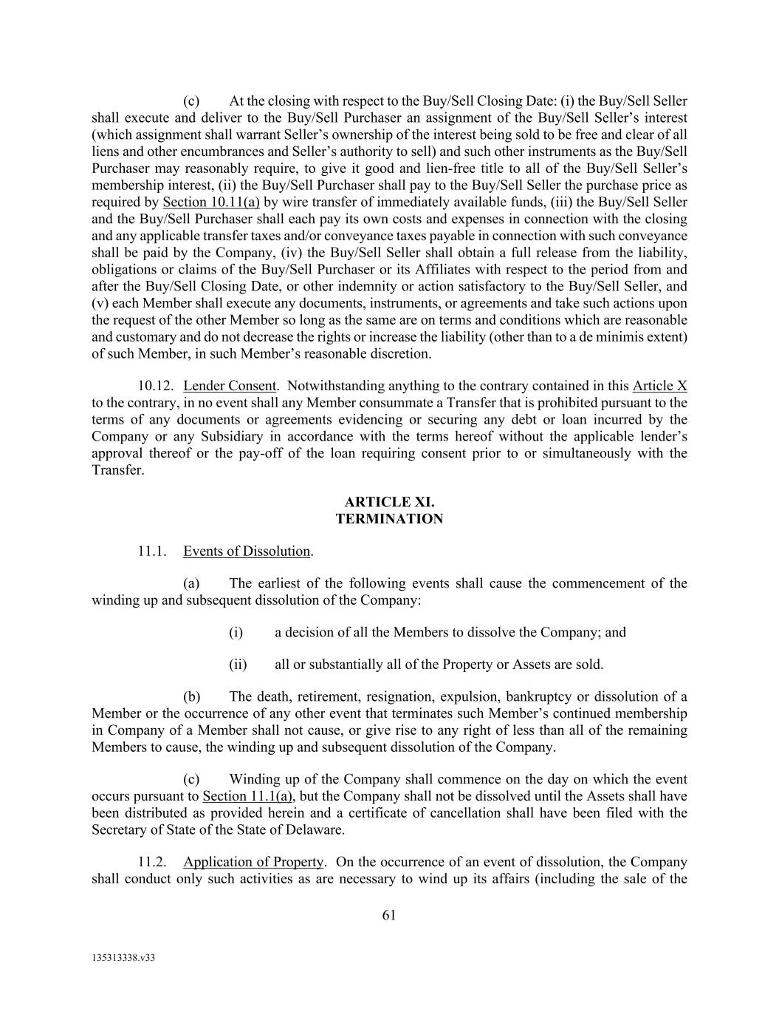
61 135313338.v33 (c) At the closing with respect to the Buy/Sell Closing Date: (i) the Buy/Sell Seller shall execute and deliver to the Buy/Sell Purchaser an assignment of the Buy/Sell Seller’s interest (which assignment shall warrant Seller’s ownership of the interest being sold to be free and clear of all liens and other encumbrances and Seller’s authority to sell) and such other instruments as the Buy/Sell Purchaser may reasonably require, to give it good and lien-free title to all of the Buy/Sell Seller’s membership interest, (ii) the Buy/Sell Purchaser shall pay to the Buy/Sell Seller the purchase price as required by Section 10.11(a) by wire transfer of immediately available funds, (iii) the Buy/Sell Seller and the Buy/Sell Purchaser shall each pay its own costs and expenses in connection with the closing and any applicable transfer taxes and/or conveyance taxes payable in connection with such conveyance shall be paid by the Company, (iv) the Buy/Sell Seller shall obtain a full release from the liability, obligations or claims of the Buy/Sell Purchaser or its Affiliates with respect to the period from and after the Buy/Sell Closing Date, or other indemnity or action satisfactory to the Buy/Sell Seller, and (v) each Member shall execute any documents, instruments, or agreements and take such actions upon the request of the other Member so long as the same are on terms and conditions which are reasonable and customary and do not decrease the rights or increase the liability (other than to a de minimis extent) of such Member, in such Member’s reasonable discretion. 10.12. Lender Consent. Notwithstanding anything to the contrary contained in this Article X to the contrary, in no event shall any Member consummate a Transfer that is prohibited pursuant to the terms of any documents or agreements evidencing or securing any debt or loan incurred by the Company or any Subsidiary in accordance with the terms hereof without the applicable lender’s approval thereof or the pay-off of the loan requiring consent prior to or simultaneously with the Transfer. ARTICLE XI. TERMINATION 11.1. Events of Dissolution. (a) The earliest of the following events shall cause the commencement of the winding up and subsequent dissolution of the Company: (i) a decision of all the Members to dissolve the Company; and (ii) all or substantially all of the Property or Assets are sold. (b) The death, retirement, resignation, expulsion, bankruptcy or dissolution of a Member or the occurrence of any other event that terminates such Member’s continued membership in Company of a Member shall not cause, or give rise to any right of less than all of the remaining Members to cause, the winding up and subsequent dissolution of the Company. (c) Winding up of the Company shall commence on the day on which the event occurs pursuant to Section 11.1(a), but the Company shall not be dissolved until the Assets shall have been distributed as provided herein and a certificate of cancellation shall have been filed with the Secretary of State of the State of Delaware. 11.2. Application of Property. On the occurrence of an event of dissolution, the Company shall conduct only such activities as are necessary to wind up its affairs (including the sale of the

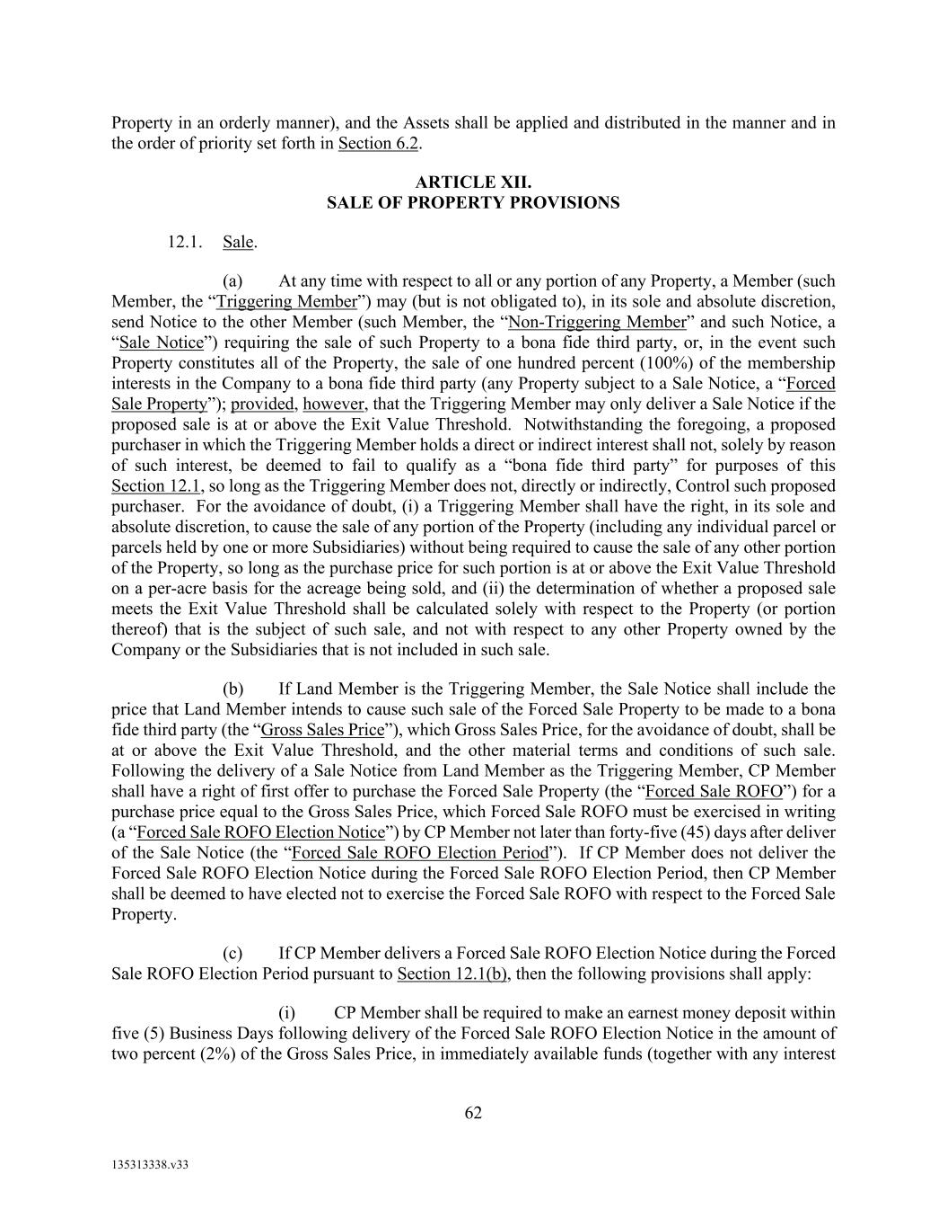
62 135313338.v33 Property in an orderly manner), and the Assets shall be applied and distributed in the manner and in the order of priority set forth in Section 6.2. ARTICLE XII. SALE OF PROPERTY PROVISIONS 12.1. Sale. (a) At any time with respect to all or any portion of any Property, a Member (such Member, the “Triggering Member”) may (but is not obligated to), in its sole and absolute discretion, send Notice to the other Member (such Member, the “Non-Triggering Member” and such Notice, a “Sale Notice”) requiring the sale of such Property to a bona fide third party, or, in the event such Property constitutes all of the Property, the sale of one hundred percent (100%) of the membership interests in the Company to a bona fide third party (any Property subject to a Sale Notice, a “Forced Sale Property”); provided, however, that the Triggering Member may only deliver a Sale Notice if the proposed sale is at or above the Exit Value Threshold. Notwithstanding the foregoing, a proposed purchaser in which the Triggering Member holds a direct or indirect interest shall not, solely by reason of such interest, be deemed to fail to qualify as a “bona fide third party” for purposes of this Section 12.1, so long as the Triggering Member does not, directly or indirectly, Control such proposed purchaser. For the avoidance of doubt, (i) a Triggering Member shall have the right, in its sole and absolute discretion, to cause the sale of any portion of the Property (including any individual parcel or parcels held by one or more Subsidiaries) without being required to cause the sale of any other portion of the Property, so long as the purchase price for such portion is at or above the Exit Value Threshold on a per-acre basis for the acreage being sold, and (ii) the determination of whether a proposed sale meets the Exit Value Threshold shall be calculated solely with respect to the Property (or portion thereof) that is the subject of such sale, and not with respect to any other Property owned by the Company or the Subsidiaries that is not included in such sale. (b) If Land Member is the Triggering Member, the Sale Notice shall include the price that Land Member intends to cause such sale of the Forced Sale Property to be made to a bona fide third party (the “Gross Sales Price”), which Gross Sales Price, for the avoidance of doubt, shall be at or above the Exit Value Threshold, and the other material terms and conditions of such sale. Following the delivery of a Sale Notice from Land Member as the Triggering Member, CP Member shall have a right of first offer to purchase the Forced Sale Property (the “Forced Sale ROFO”) for a purchase price equal to the Gross Sales Price, which Forced Sale ROFO must be exercised in writing (a “Forced Sale ROFO Election Notice”) by CP Member not later than forty-five (45) days after deliver of the Sale Notice (the “Forced Sale ROFO Election Period”). If CP Member does not deliver the Forced Sale ROFO Election Notice during the Forced Sale ROFO Election Period, then CP Member shall be deemed to have elected not to exercise the Forced Sale ROFO with respect to the Forced Sale Property. (c) If CP Member delivers a Forced Sale ROFO Election Notice during the Forced Sale ROFO Election Period pursuant to Section 12.1(b), then the following provisions shall apply: (i) CP Member shall be required to make an earnest money deposit within five (5) Business Days following delivery of the Forced Sale ROFO Election Notice in the amount of two percent (2%) of the Gross Sales Price, in immediately available funds (together with any interest

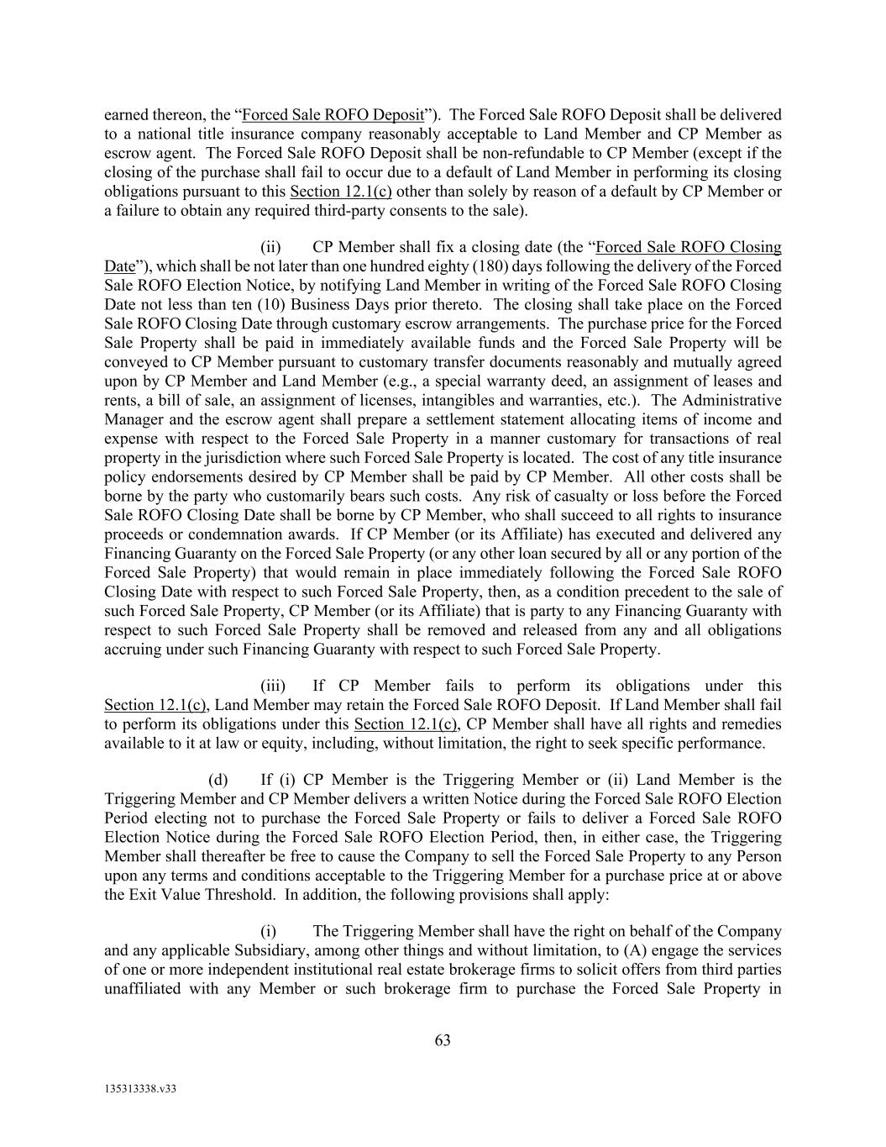
63 135313338.v33 earned thereon, the “Forced Sale ROFO Deposit”). The Forced Sale ROFO Deposit shall be delivered to a national title insurance company reasonably acceptable to Land Member and CP Member as escrow agent. The Forced Sale ROFO Deposit shall be non-refundable to CP Member (except if the closing of the purchase shall fail to occur due to a default of Land Member in performing its closing obligations pursuant to this Section 12.1(c) other than solely by reason of a default by CP Member or a failure to obtain any required third-party consents to the sale). (ii) CP Member shall fix a closing date (the “Forced Sale ROFO Closing Date”), which shall be not later than one hundred eighty (180) days following the delivery of the Forced Sale ROFO Election Notice, by notifying Land Member in writing of the Forced Sale ROFO Closing Date not less than ten (10) Business Days prior thereto. The closing shall take place on the Forced Sale ROFO Closing Date through customary escrow arrangements. The purchase price for the Forced Sale Property shall be paid in immediately available funds and the Forced Sale Property will be conveyed to CP Member pursuant to customary transfer documents reasonably and mutually agreed upon by CP Member and Land Member (e.g., a special warranty deed, an assignment of leases and rents, a bill of sale, an assignment of licenses, intangibles and warranties, etc.). The Administrative Manager and the escrow agent shall prepare a settlement statement allocating items of income and expense with respect to the Forced Sale Property in a manner customary for transactions of real property in the jurisdiction where such Forced Sale Property is located. The cost of any title insurance policy endorsements desired by CP Member shall be paid by CP Member. All other costs shall be borne by the party who customarily bears such costs. Any risk of casualty or loss before the Forced Sale ROFO Closing Date shall be borne by CP Member, who shall succeed to all rights to insurance proceeds or condemnation awards. If CP Member (or its Affiliate) has executed and delivered any Financing Guaranty on the Forced Sale Property (or any other loan secured by all or any portion of the Forced Sale Property) that would remain in place immediately following the Forced Sale ROFO Closing Date with respect to such Forced Sale Property, then, as a condition precedent to the sale of such Forced Sale Property, CP Member (or its Affiliate) that is party to any Financing Guaranty with respect to such Forced Sale Property shall be removed and released from any and all obligations accruing under such Financing Guaranty with respect to such Forced Sale Property. (iii) If CP Member fails to perform its obligations under this Section 12.1(c), Land Member may retain the Forced Sale ROFO Deposit. If Land Member shall fail to perform its obligations under this Section 12.1(c), CP Member shall have all rights and remedies available to it at law or equity, including, without limitation, the right to seek specific performance. (d) If (i) CP Member is the Triggering Member or (ii) Land Member is the Triggering Member and CP Member delivers a written Notice during the Forced Sale ROFO Election Period electing not to purchase the Forced Sale Property or fails to deliver a Forced Sale ROFO Election Notice during the Forced Sale ROFO Election Period, then, in either case, the Triggering Member shall thereafter be free to cause the Company to sell the Forced Sale Property to any Person upon any terms and conditions acceptable to the Triggering Member for a purchase price at or above the Exit Value Threshold. In addition, the following provisions shall apply: (i) The Triggering Member shall have the right on behalf of the Company and any applicable Subsidiary, among other things and without limitation, to (A) engage the services of one or more independent institutional real estate brokerage firms to solicit offers from third parties unaffiliated with any Member or such brokerage firm to purchase the Forced Sale Property in

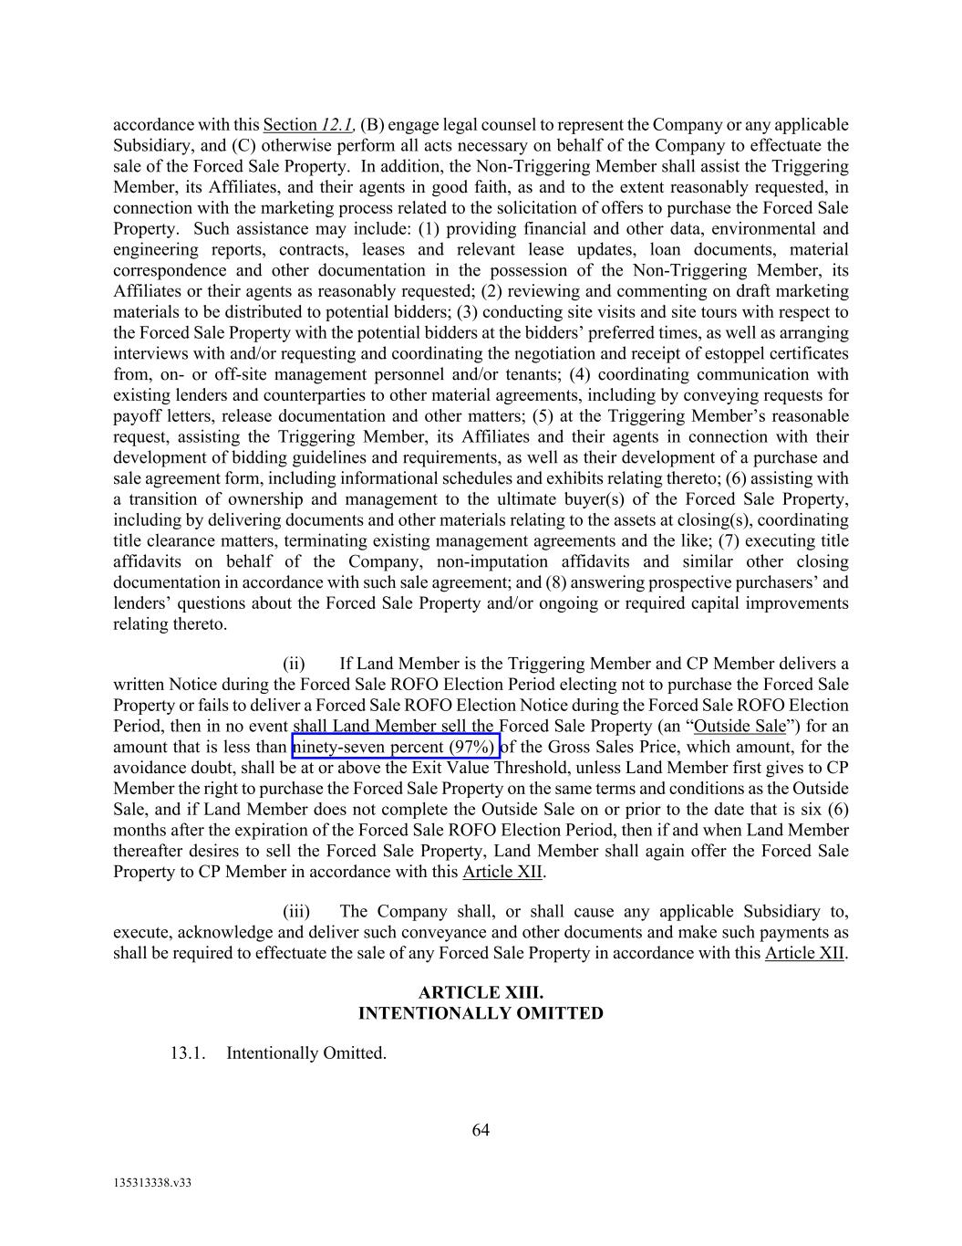
64 135313338.v33 accordance with this Section 12.1, (B) engage legal counsel to represent the Company or any applicable Subsidiary, and (C) otherwise perform all acts necessary on behalf of the Company to effectuate the sale of the Forced Sale Property. In addition, the Non-Triggering Member shall assist the Triggering Member, its Affiliates, and their agents in good faith, as and to the extent reasonably requested, in connection with the marketing process related to the solicitation of offers to purchase the Forced Sale Property. Such assistance may include: (1) providing financial and other data, environmental and engineering reports, contracts, leases and relevant lease updates, loan documents, material correspondence and other documentation in the possession of the Non-Triggering Member, its Affiliates or their agents as reasonably requested; (2) reviewing and commenting on draft marketing materials to be distributed to potential bidders; (3) conducting site visits and site tours with respect to the Forced Sale Property with the potential bidders at the bidders’ preferred times, as well as arranging interviews with and/or requesting and coordinating the negotiation and receipt of estoppel certificates from, on- or off-site management personnel and/or tenants; (4) coordinating communication with existing lenders and counterparties to other material agreements, including by conveying requests for payoff letters, release documentation and other matters; (5) at the Triggering Member’s reasonable request, assisting the Triggering Member, its Affiliates and their agents in connection with their development of bidding guidelines and requirements, as well as their development of a purchase and sale agreement form, including informational schedules and exhibits relating thereto; (6) assisting with a transition of ownership and management to the ultimate buyer(s) of the Forced Sale Property, including by delivering documents and other materials relating to the assets at closing(s), coordinating title clearance matters, terminating existing management agreements and the like; (7) executing title affidavits on behalf of the Company, non-imputation affidavits and similar other closing documentation in accordance with such sale agreement; and (8) answering prospective purchasers’ and lenders’ questions about the Forced Sale Property and/or ongoing or required capital improvements relating thereto. (ii) If Land Member is the Triggering Member and CP Member delivers a written Notice during the Forced Sale ROFO Election Period electing not to purchase the Forced Sale Property or fails to deliver a Forced Sale ROFO Election Notice during the Forced Sale ROFO Election Period, then in no event shall Land Member sell the Forced Sale Property (an “Outside Sale”) for an amount that is less than ninety-seven percent (97%) of the Gross Sales Price, which amount, for the avoidance doubt, shall be at or above the Exit Value Threshold, unless Land Member first gives to CP Member the right to purchase the Forced Sale Property on the same terms and conditions as the Outside Sale, and if Land Member does not complete the Outside Sale on or prior to the date that is six (6) months after the expiration of the Forced Sale ROFO Election Period, then if and when Land Member thereafter desires to sell the Forced Sale Property, Land Member shall again offer the Forced Sale Property to CP Member in accordance with this Article XII. (iii) The Company shall, or shall cause any applicable Subsidiary to, execute, acknowledge and deliver such conveyance and other documents and make such payments as shall be required to effectuate the sale of any Forced Sale Property in accordance with this Article XII. ARTICLE XIII. INTENTIONALLY OMITTED 13.1. Intentionally Omitted.

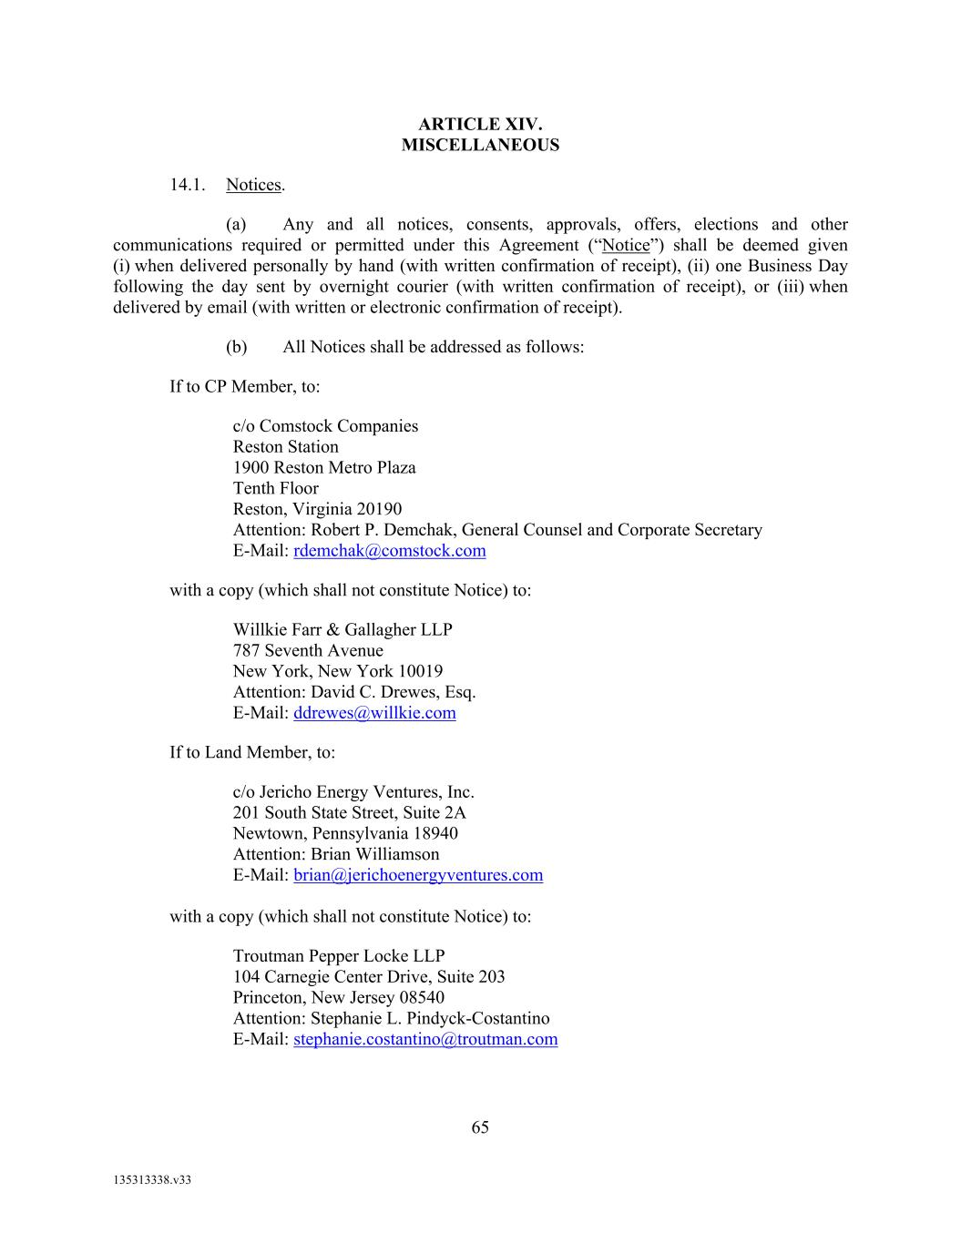
65 135313338.v33 ARTICLE XIV. MISCELLANEOUS 14.1. Notices. (a) Any and all notices, consents, approvals, offers, elections and other communications required or permitted under this Agreement (“Notice”) shall be deemed given (i) when delivered personally by hand (with written confirmation of receipt), (ii) one Business Day following the day sent by overnight courier (with written confirmation of receipt), or (iii) when delivered by email (with written or electronic confirmation of receipt). (b) All Notices shall be addressed as follows: If to CP Member, to: c/o Comstock Companies Reston Station 1900 Reston Metro Plaza Tenth Floor Reston, Virginia 20190 Attention: Robert P. Demchak, General Counsel and Corporate Secretary E-Mail: rdemchak@comstock.com with a copy (which shall not constitute Notice) to: Willkie Farr & Gallagher LLP 787 Seventh Avenue New York, New York 10019 Attention: David C. Drewes, Esq. E-Mail: ddrewes@willkie.com If to Land Member, to: c/o Jericho Energy Ventures, Inc. 201 South State Street, Suite 2A Newtown, Pennsylvania 18940 Attention: Brian Williamson E-Mail: brian@jerichoenergyventures.com with a copy (which shall not constitute Notice) to: Troutman Pepper Locke LLP 104 Carnegie Center Drive, Suite 203 Princeton, New Jersey 08540 Attention: Stephanie L. Pindyck-Costantino E-Mail: stephanie.costantino@troutman.com

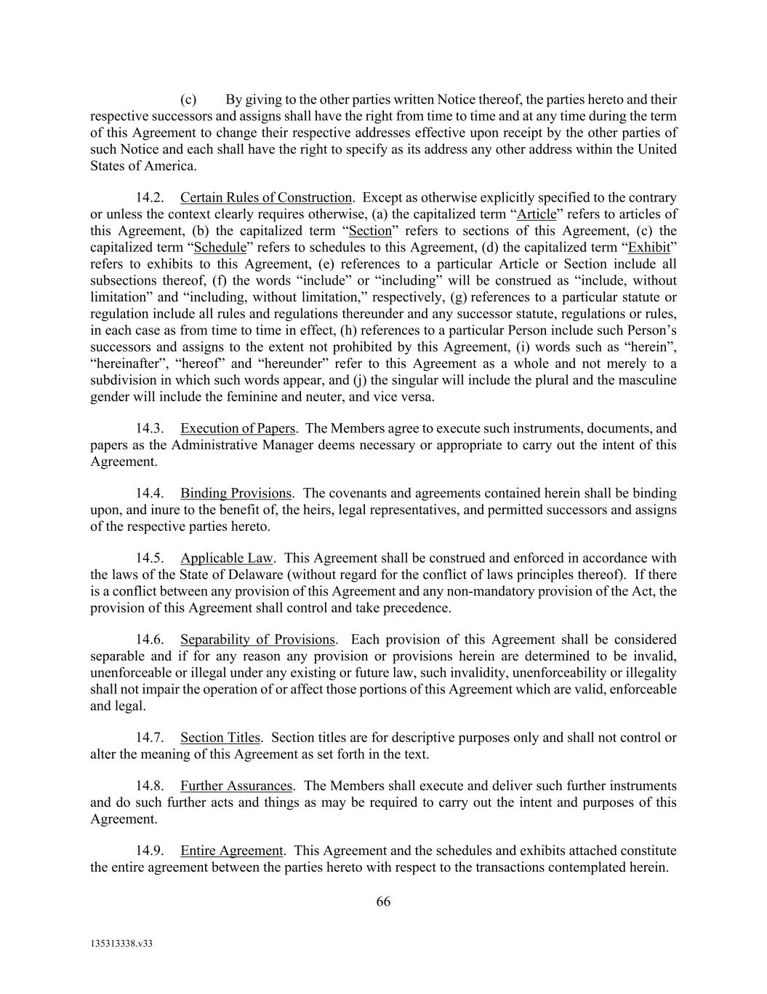
66 135313338.v33 (c) By giving to the other parties written Notice thereof, the parties hereto and their respective successors and assigns shall have the right from time to time and at any time during the term of this Agreement to change their respective addresses effective upon receipt by the other parties of such Notice and each shall have the right to specify as its address any other address within the United States of America. 14.2. Certain Rules of Construction. Except as otherwise explicitly specified to the contrary or unless the context clearly requires otherwise, (a) the capitalized term “Article” refers to articles of this Agreement, (b) the capitalized term “Section” refers to sections of this Agreement, (c) the capitalized term “Schedule” refers to schedules to this Agreement, (d) the capitalized term “Exhibit” refers to exhibits to this Agreement, (e) references to a particular Article or Section include all subsections thereof, (f) the words “include” or “including” will be construed as “include, without limitation” and “including, without limitation,” respectively, (g) references to a particular statute or regulation include all rules and regulations thereunder and any successor statute, regulations or rules, in each case as from time to time in effect, (h) references to a particular Person include such Person’s successors and assigns to the extent not prohibited by this Agreement, (i) words such as “herein”, “hereinafter”, “hereof” and “hereunder” refer to this Agreement as a whole and not merely to a subdivision in which such words appear, and (j) the singular will include the plural and the masculine gender will include the feminine and neuter, and vice versa. 14.3. Execution of Papers. The Members agree to execute such instruments, documents, and papers as the Administrative Manager deems necessary or appropriate to carry out the intent of this Agreement. 14.4. Binding Provisions. The covenants and agreements contained herein shall be binding upon, and inure to the benefit of, the heirs, legal representatives, and permitted successors and assigns of the respective parties hereto. 14.5. Applicable Law. This Agreement shall be construed and enforced in accordance with the laws of the State of Delaware (without regard for the conflict of laws principles thereof). If there is a conflict between any provision of this Agreement and any non-mandatory provision of the Act, the provision of this Agreement shall control and take precedence. 14.6. Separability of Provisions. Each provision of this Agreement shall be considered separable and if for any reason any provision or provisions herein are determined to be invalid, unenforceable or illegal under any existing or future law, such invalidity, unenforceability or illegality shall not impair the operation of or affect those portions of this Agreement which are valid, enforceable and legal. 14.7. Section Titles. Section titles are for descriptive purposes only and shall not control or alter the meaning of this Agreement as set forth in the text. 14.8. Further Assurances. The Members shall execute and deliver such further instruments and do such further acts and things as may be required to carry out the intent and purposes of this Agreement. 14.9. Entire Agreement. This Agreement and the schedules and exhibits attached constitute the entire agreement between the parties hereto with respect to the transactions contemplated herein.

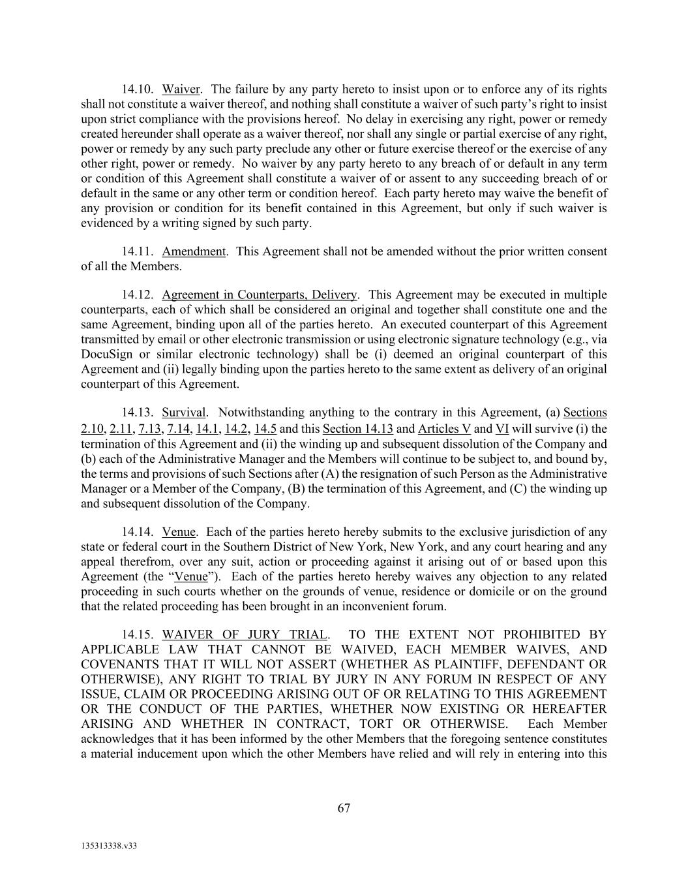
67 135313338.v33 14.10. Waiver. The failure by any party hereto to insist upon or to enforce any of its rights shall not constitute a waiver thereof, and nothing shall constitute a waiver of such party’s right to insist upon strict compliance with the provisions hereof. No delay in exercising any right, power or remedy created hereunder shall operate as a waiver thereof, nor shall any single or partial exercise of any right, power or remedy by any such party preclude any other or future exercise thereof or the exercise of any other right, power or remedy. No waiver by any party hereto to any breach of or default in any term or condition of this Agreement shall constitute a waiver of or assent to any succeeding breach of or default in the same or any other term or condition hereof. Each party hereto may waive the benefit of any provision or condition for its benefit contained in this Agreement, but only if such waiver is evidenced by a writing signed by such party. 14.11. Amendment. This Agreement shall not be amended without the prior written consent of all the Members. 14.12. Agreement in Counterparts, Delivery. This Agreement may be executed in multiple counterparts, each of which shall be considered an original and together shall constitute one and the same Agreement, binding upon all of the parties hereto. An executed counterpart of this Agreement transmitted by email or other electronic transmission or using electronic signature technology (e.g., via DocuSign or similar electronic technology) shall be (i) deemed an original counterpart of this Agreement and (ii) legally binding upon the parties hereto to the same extent as delivery of an original counterpart of this Agreement. 14.13. Survival. Notwithstanding anything to the contrary in this Agreement, (a) Sections 2.10, 2.11, 7.13, 7.14, 14.1, 14.2, 14.5 and this Section 14.13 and Articles V and VI will survive (i) the termination of this Agreement and (ii) the winding up and subsequent dissolution of the Company and (b) each of the Administrative Manager and the Members will continue to be subject to, and bound by, the terms and provisions of such Sections after (A) the resignation of such Person as the Administrative Manager or a Member of the Company, (B) the termination of this Agreement, and (C) the winding up and subsequent dissolution of the Company. 14.14. Venue. Each of the parties hereto hereby submits to the exclusive jurisdiction of any state or federal court in the Southern District of New York, New York, and any court hearing and any appeal therefrom, over any suit, action or proceeding against it arising out of or based upon this Agreement (the “Venue”). Each of the parties hereto hereby waives any objection to any related proceeding in such courts whether on the grounds of venue, residence or domicile or on the ground that the related proceeding has been brought in an inconvenient forum. 14.15. WAIVER OF JURY TRIAL. TO THE EXTENT NOT PROHIBITED BY APPLICABLE LAW THAT CANNOT BE WAIVED, EACH MEMBER WAIVES, AND COVENANTS THAT IT WILL NOT ASSERT (WHETHER AS PLAINTIFF, DEFENDANT OR OTHERWISE), ANY RIGHT TO TRIAL BY JURY IN ANY FORUM IN RESPECT OF ANY ISSUE, CLAIM OR PROCEEDING ARISING OUT OF OR RELATING TO THIS AGREEMENT OR THE CONDUCT OF THE PARTIES, WHETHER NOW EXISTING OR HEREAFTER ARISING AND WHETHER IN CONTRACT, TORT OR OTHERWISE. Each Member acknowledges that it has been informed by the other Members that the foregoing sentence constitutes a material inducement upon which the other Members have relied and will rely in entering into this

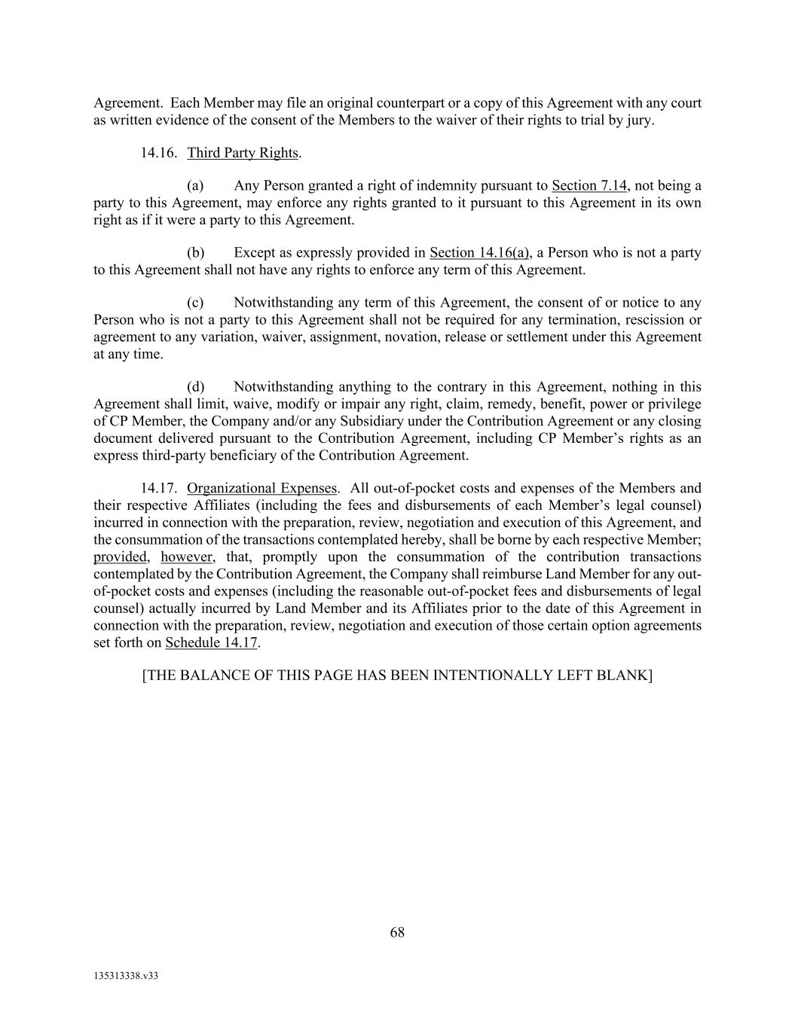
68 135313338.v33 Agreement. Each Member may file an original counterpart or a copy of this Agreement with any court as written evidence of the consent of the Members to the waiver of their rights to trial by jury. 14.16. Third Party Rights. (a) Any Person granted a right of indemnity pursuant to Section 7.14, not being a party to this Agreement, may enforce any rights granted to it pursuant to this Agreement in its own right as if it were a party to this Agreement. (b) Except as expressly provided in Section 14.16(a), a Person who is not a party to this Agreement shall not have any rights to enforce any term of this Agreement. (c) Notwithstanding any term of this Agreement, the consent of or notice to any Person who is not a party to this Agreement shall not be required for any termination, rescission or agreement to any variation, waiver, assignment, novation, release or settlement under this Agreement at any time. (d) Notwithstanding anything to the contrary in this Agreement, nothing in this Agreement shall limit, waive, modify or impair any right, claim, remedy, benefit, power or privilege of CP Member, the Company and/or any Subsidiary under the Contribution Agreement or any closing document delivered pursuant to the Contribution Agreement, including CP Member’s rights as an express third-party beneficiary of the Contribution Agreement. 14.17. Organizational Expenses. All out-of-pocket costs and expenses of the Members and their respective Affiliates (including the fees and disbursements of each Member’s legal counsel) incurred in connection with the preparation, review, negotiation and execution of this Agreement, and the consummation of the transactions contemplated hereby, shall be borne by each respective Member; provided, however, that, promptly upon the consummation of the contribution transactions contemplated by the Contribution Agreement, the Company shall reimburse Land Member for any out- of-pocket costs and expenses (including the reasonable out-of-pocket fees and disbursements of legal counsel) actually incurred by Land Member and its Affiliates prior to the date of this Agreement in connection with the preparation, review, negotiation and execution of those certain option agreements set forth on Schedule 14.17. [THE BALANCE OF THIS PAGE HAS BEEN INTENTIONALLY LEFT BLANK]

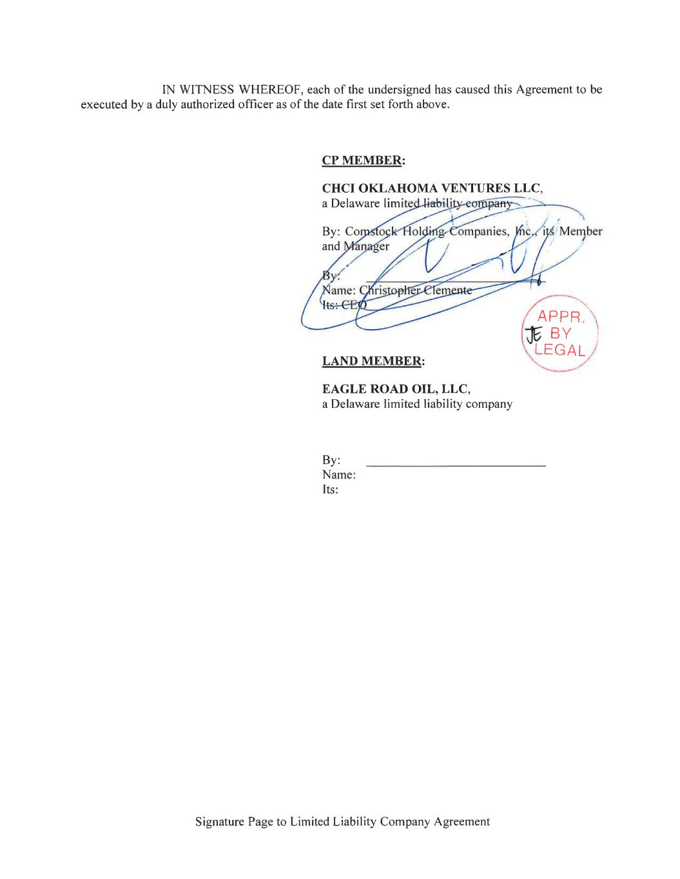

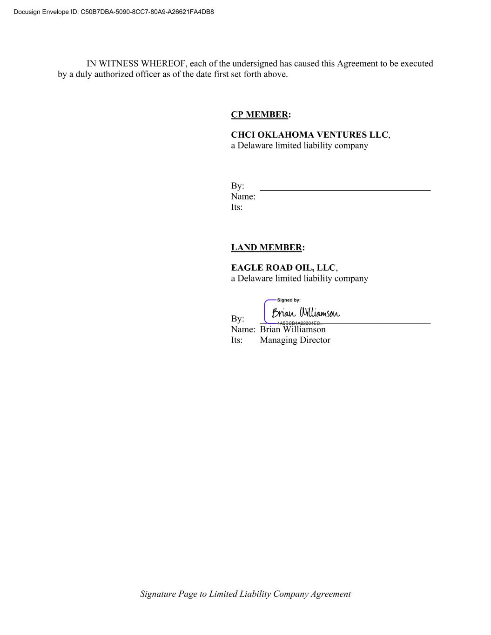
Signature Page to Limited Liability Company Agreement IN WITNESS WHEREOF, each of the undersigned has caused this Agreement to be executed by a duly authorized officer as of the date first set forth above. CP MEMBER: CHCI OKLAHOMA VENTURES LLC, a Delaware limited liability company By: _____________________________________ Name: Its: LAND MEMBER: EAGLE ROAD OIL, LLC, a Delaware limited liability company By: _____________________________________ Name: Brian Williamson Its: Managing Director Docusign Envelope ID: C50B7DBA-5090-8CC7-80A9-A26621FA4DB8

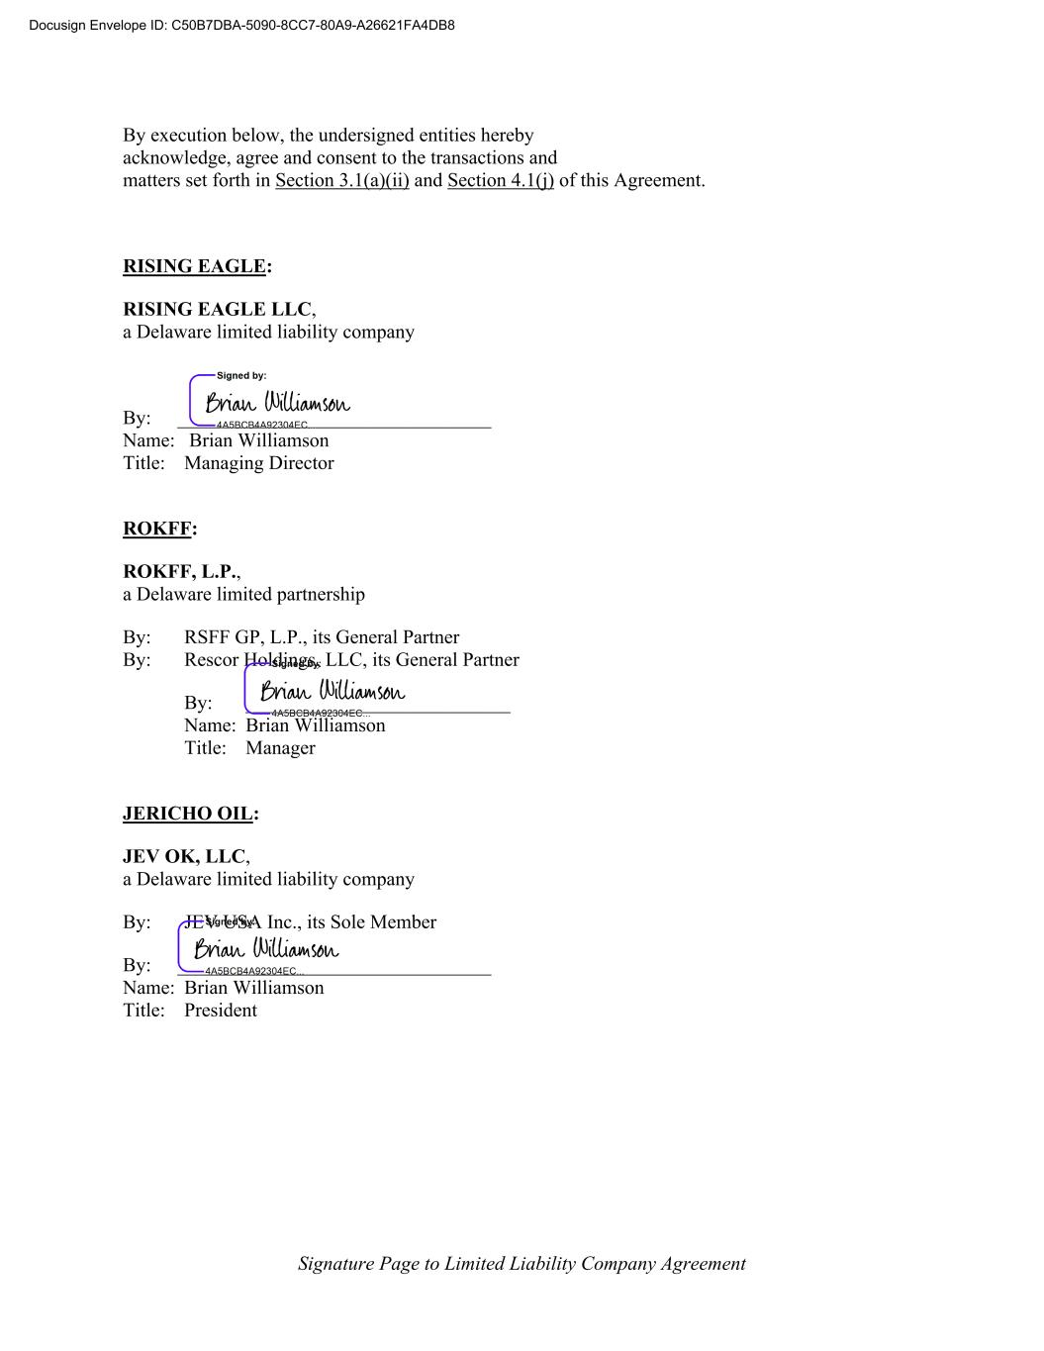
Signature Page to Limited Liability Company Agreement By execution below, the undersigned entities hereby acknowledge, agree and consent to the transactions and matters set forth in Section 3.1(a)(ii) and Section 4.1(j) of this Agreement. RISING EAGLE: RISING EAGLE LLC, a Delaware limited liability company By: ________________________________ Name: Brian Williamson Title: Managing Director ROKFF: ROKFF, L.P., a Delaware limited partnership By: RSFF GP, L.P., its General Partner By: Rescor Holdings, LLC, its General Partner By: ___________________________ Name: Brian Williamson Title: Manager JERICHO OIL: JEV OK, LLC, a Delaware limited liability company By: JEV USA Inc., its Sole Member By: ________________________________ Name: Brian Williamson Title: President Docusign Envelope ID: C50B7DBA-5090-8CC7-80A9-A26621FA4DB8

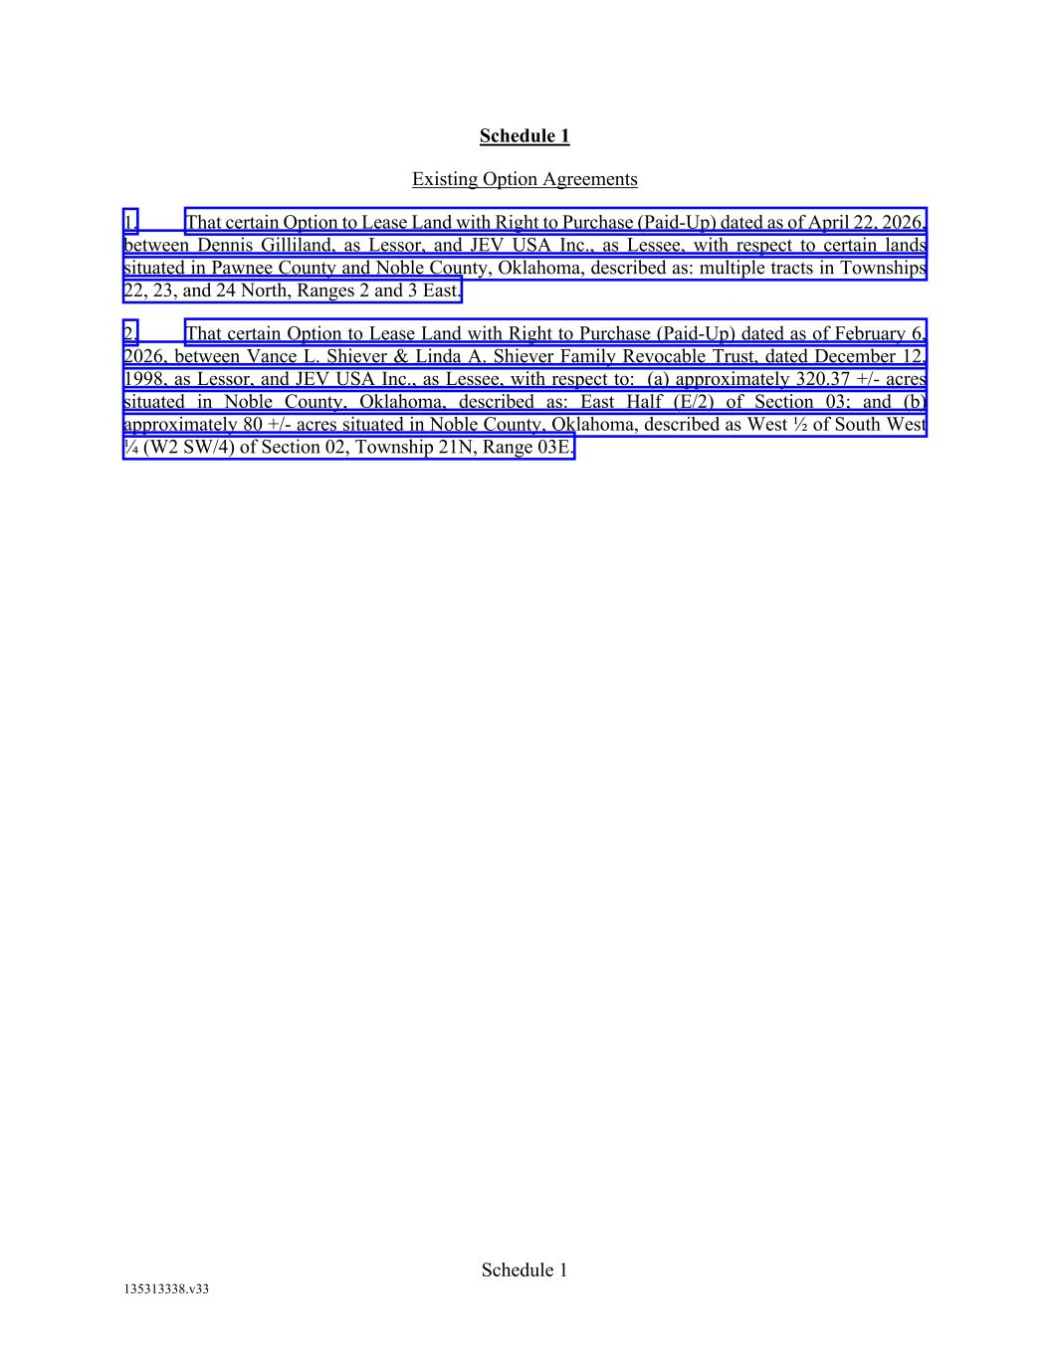
Schedule 1 135313338.v33 Schedule 1 Existing Option Agreements 1. That certain Option to Lease Land with Right to Purchase (Paid-Up) dated as of April 22, 2026, between Dennis Gilliland, as Lessor, and JEV USA Inc., as Lessee, with respect to certain lands situated in Pawnee County and Noble County, Oklahoma, described as: multiple tracts in Townships 22, 23, and 24 North, Ranges 2 and 3 East. 2. That certain Option to Lease Land with Right to Purchase (Paid-Up) dated as of February 6, 2026, between Vance L. Shiever & Linda A. Shiever Family Revocable Trust, dated December 12, 1998, as Lessor, and JEV USA Inc., as Lessee, with respect to: (a) approximately 320.37 +/- acres situated in Noble County, Oklahoma, described as: East Half (E/2) of Section 03; and (b) approximately 80 +/- acres situated in Noble County, Oklahoma, described as West ½ of South West ¼ (W2 SW/4) of Section 02, Township 21N, Range 03E.


Schedule 2.8(a) 135313338.v33 Schedule 2.8(a) Land Member’s Ownership Chart (See Attached)

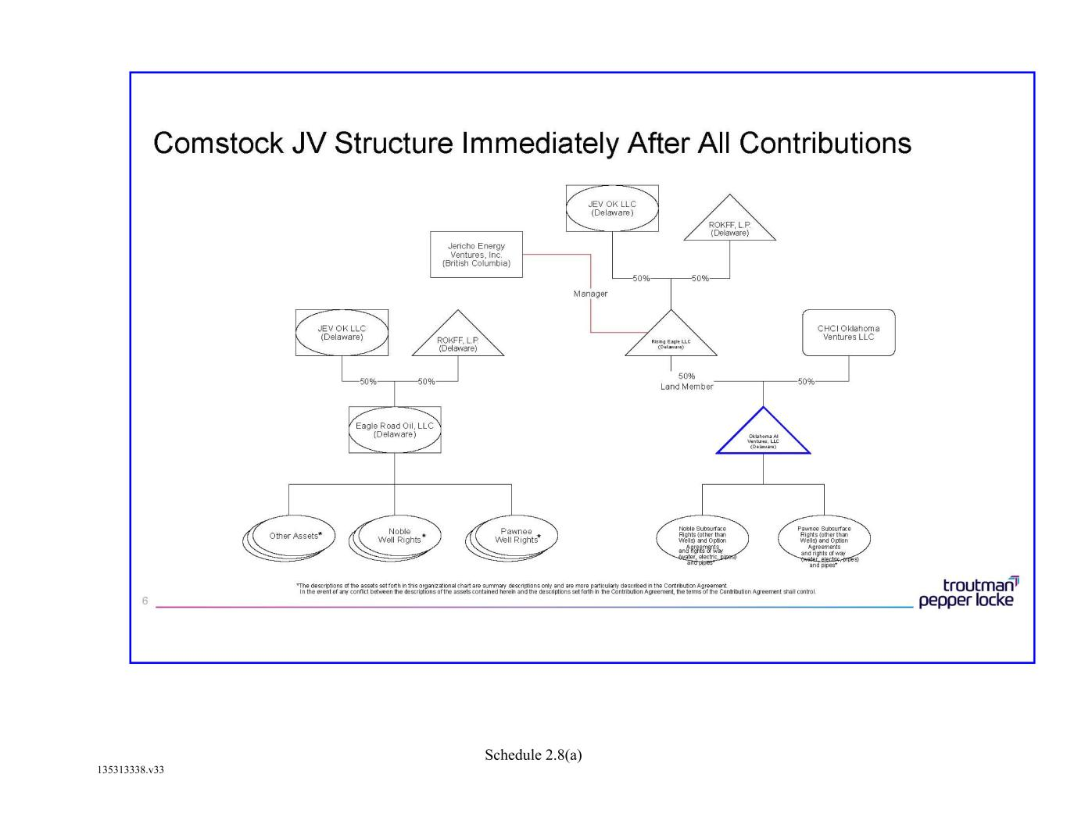
Schedule 2.8(a) 135313338.v33

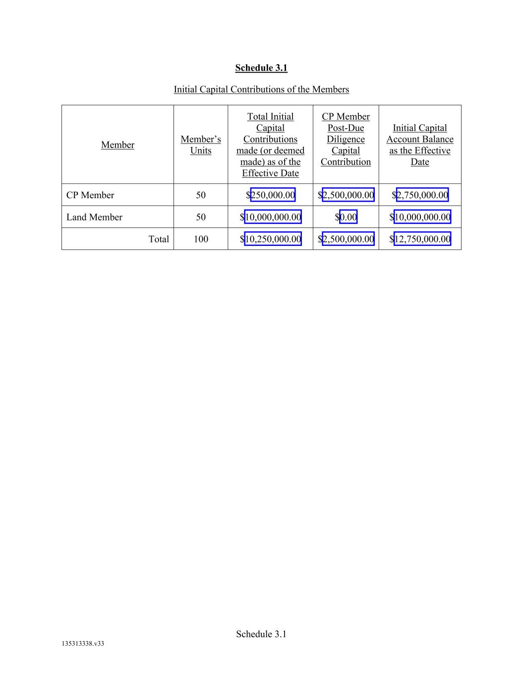
Schedule 3.1 135313338.v33 Schedule 3.1 Initial Capital Contributions of the Members Member Member’s Units Total Initial Capital Contributions made (or deemed made) as of the Effective Date CP Member Post-Due Diligence Capital Contribution Initial Capital Account Balance as the Effective Date CP Member 50 $250,000.00 $2,500,000.00 $2,750,000.00 Land Member 50 $10,000,000.00 $0.00 $10,000,000.00 Total 100 $10,250,000.00 $2,500,000.00 $12,750,000.00


Schedule 2.8(a) 135313338.v33 Schedule 3.5 Dilution Remedy Illustrations (See Attached)


Schedule 4.1(b) Omitted 135313338.v33 Schedule Error! Reference source not found. Intentionally Omitted

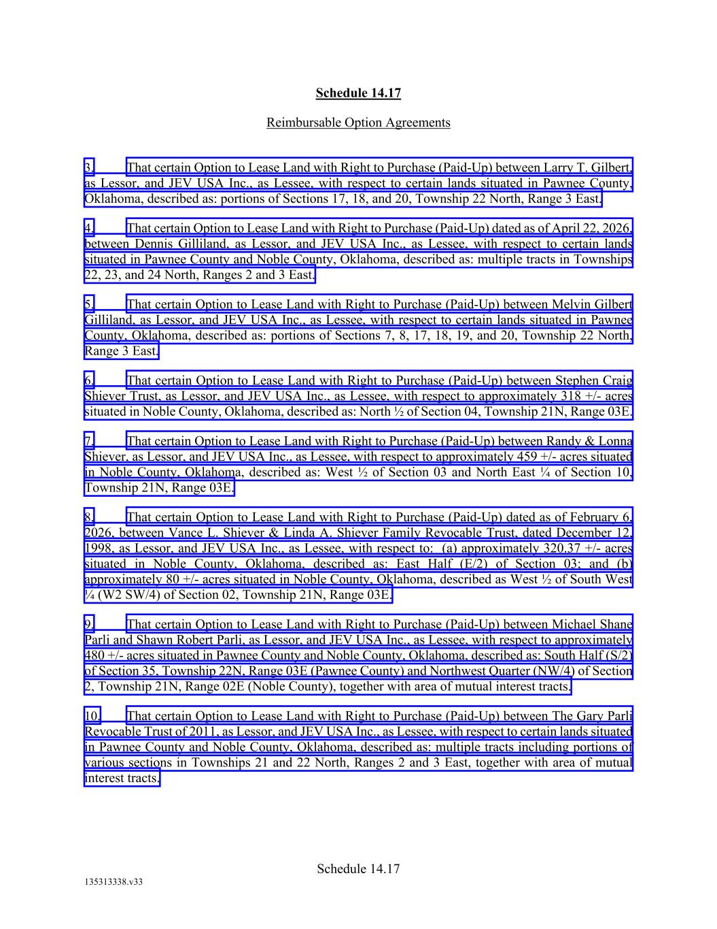
Schedule 14.17 135313338.v33 Schedule 14.17 Reimbursable Option Agreements 3. That certain Option to Lease Land with Right to Purchase (Paid-Up) between Larry T. Gilbert, as Lessor, and JEV USA Inc., as Lessee, with respect to certain lands situated in Pawnee County, Oklahoma, described as: portions of Sections 17, 18, and 20, Township 22 North, Range 3 East. 4. That certain Option to Lease Land with Right to Purchase (Paid-Up) dated as of April 22, 2026, between Dennis Gilliland, as Lessor, and JEV USA Inc., as Lessee, with respect to certain lands situated in Pawnee County and Noble County, Oklahoma, described as: multiple tracts in Townships 22, 23, and 24 North, Ranges 2 and 3 East. 5. That certain Option to Lease Land with Right to Purchase (Paid-Up) between Melvin Gilbert Gilliland, as Lessor, and JEV USA Inc., as Lessee, with respect to certain lands situated in Pawnee County, Oklahoma, described as: portions of Sections 7, 8, 17, 18, 19, and 20, Township 22 North, Range 3 East. 6. That certain Option to Lease Land with Right to Purchase (Paid-Up) between Stephen Craig Shiever Trust, as Lessor, and JEV USA Inc., as Lessee, with respect to approximately 318 +/- acres situated in Noble County, Oklahoma, described as: North ½ of Section 04, Township 21N, Range 03E. 7. That certain Option to Lease Land with Right to Purchase (Paid-Up) between Randy & Lonna Shiever, as Lessor, and JEV USA Inc., as Lessee, with respect to approximately 459 +/- acres situated in Noble County, Oklahoma, described as: West ½ of Section 03 and North East ¼ of Section 10, Township 21N, Range 03E. 8. That certain Option to Lease Land with Right to Purchase (Paid-Up) dated as of February 6, 2026, between Vance L. Shiever & Linda A. Shiever Family Revocable Trust, dated December 12, 1998, as Lessor, and JEV USA Inc., as Lessee, with respect to: (a) approximately 320.37 +/- acres situated in Noble County, Oklahoma, described as: East Half (E/2) of Section 03; and (b) approximately 80 +/- acres situated in Noble County, Oklahoma, described as West ½ of South West ¼ (W2 SW/4) of Section 02, Township 21N, Range 03E. 9. That certain Option to Lease Land with Right to Purchase (Paid-Up) between Michael Shane Parli and Shawn Robert Parli, as Lessor, and JEV USA Inc., as Lessee, with respect to approximately 480 +/- acres situated in Pawnee County and Noble County, Oklahoma, described as: South Half (S/2) of Section 35, Township 22N, Range 03E (Pawnee County) and Northwest Quarter (NW/4) of Section 2, Township 21N, Range 02E (Noble County), together with area of mutual interest tracts. 10. That certain Option to Lease Land with Right to Purchase (Paid-Up) between The Gary Parli Revocable Trust of 2011, as Lessor, and JEV USA Inc., as Lessee, with respect to certain lands situated in Pawnee County and Noble County, Oklahoma, described as: multiple tracts including portions of various sections in Townships 21 and 22 North, Ranges 2 and 3 East, together with area of mutual interest tracts.

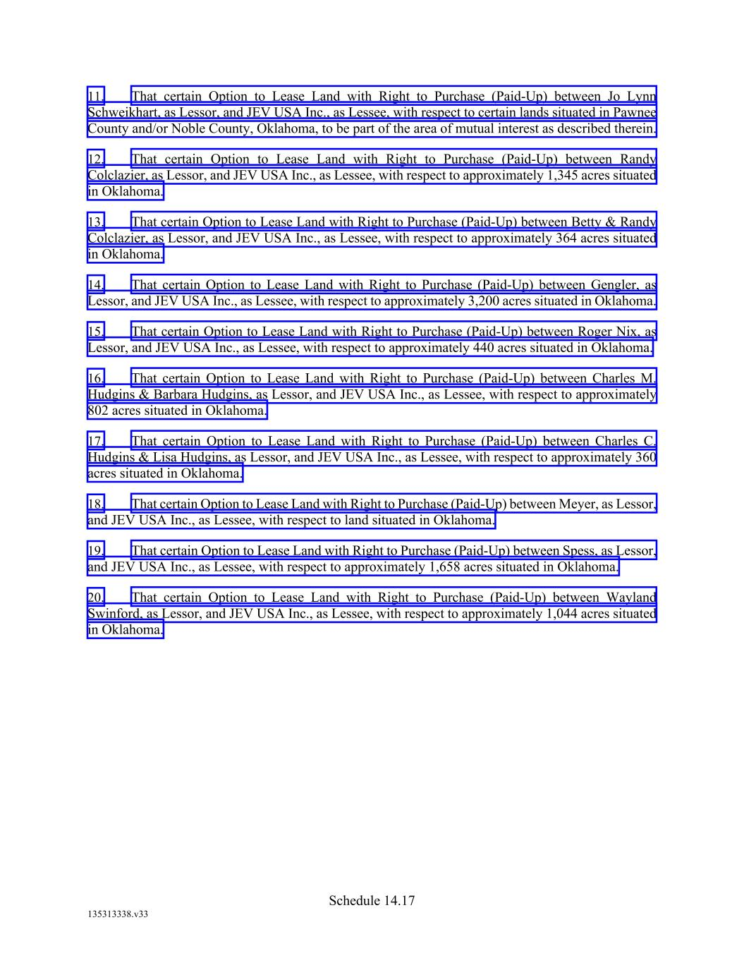
Schedule 14.17 135313338.v33 11. That certain Option to Lease Land with Right to Purchase (Paid-Up) between Jo Lynn Schweikhart, as Lessor, and JEV USA Inc., as Lessee, with respect to certain lands situated in Pawnee County and/or Noble County, Oklahoma, to be part of the area of mutual interest as described therein. 12. That certain Option to Lease Land with Right to Purchase (Paid-Up) between Randy Colclazier, as Lessor, and JEV USA Inc., as Lessee, with respect to approximately 1,345 acres situated in Oklahoma. 13. That certain Option to Lease Land with Right to Purchase (Paid-Up) between Betty & Randy Colclazier, as Lessor, and JEV USA Inc., as Lessee, with respect to approximately 364 acres situated in Oklahoma. 14. That certain Option to Lease Land with Right to Purchase (Paid-Up) between Gengler, as Lessor, and JEV USA Inc., as Lessee, with respect to approximately 3,200 acres situated in Oklahoma. 15. That certain Option to Lease Land with Right to Purchase (Paid-Up) between Roger Nix, as Lessor, and JEV USA Inc., as Lessee, with respect to approximately 440 acres situated in Oklahoma. 16. That certain Option to Lease Land with Right to Purchase (Paid-Up) between Charles M. Hudgins & Barbara Hudgins, as Lessor, and JEV USA Inc., as Lessee, with respect to approximately 802 acres situated in Oklahoma. 17. That certain Option to Lease Land with Right to Purchase (Paid-Up) between Charles C. Hudgins & Lisa Hudgins, as Lessor, and JEV USA Inc., as Lessee, with respect to approximately 360 acres situated in Oklahoma. 18. That certain Option to Lease Land with Right to Purchase (Paid-Up) between Meyer, as Lessor, and JEV USA Inc., as Lessee, with respect to land situated in Oklahoma. 19. That certain Option to Lease Land with Right to Purchase (Paid-Up) between Spess, as Lessor, and JEV USA Inc., as Lessee, with respect to approximately 1,658 acres situated in Oklahoma. 20. That certain Option to Lease Land with Right to Purchase (Paid-Up) between Wayland Swinford, as Lessor, and JEV USA Inc., as Lessee, with respect to approximately 1,044 acres situated in Oklahoma.


Exhibit A-1 135313338.v33 Exhibit A Existing Subsurface Properties

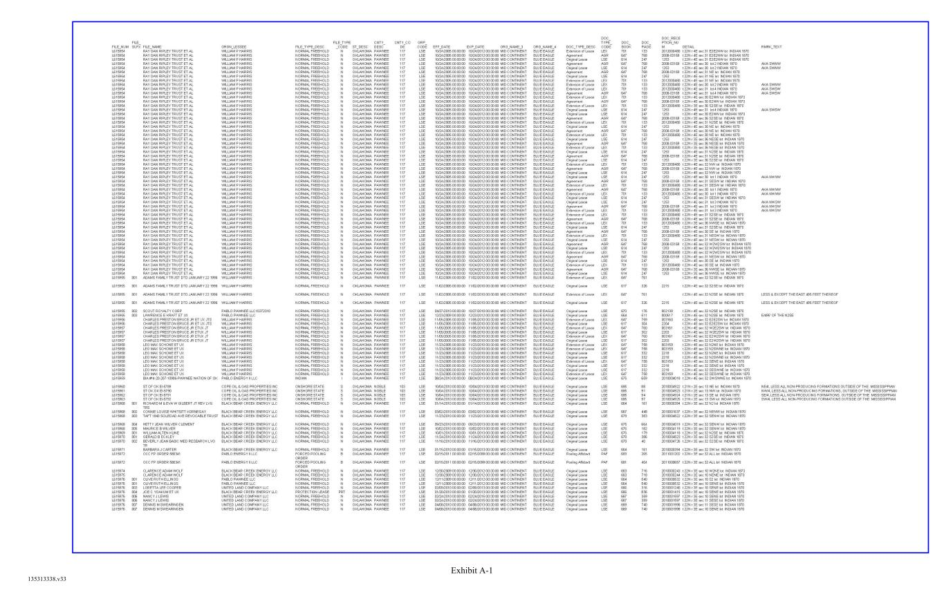
Exhibit A-1 135313338.v33

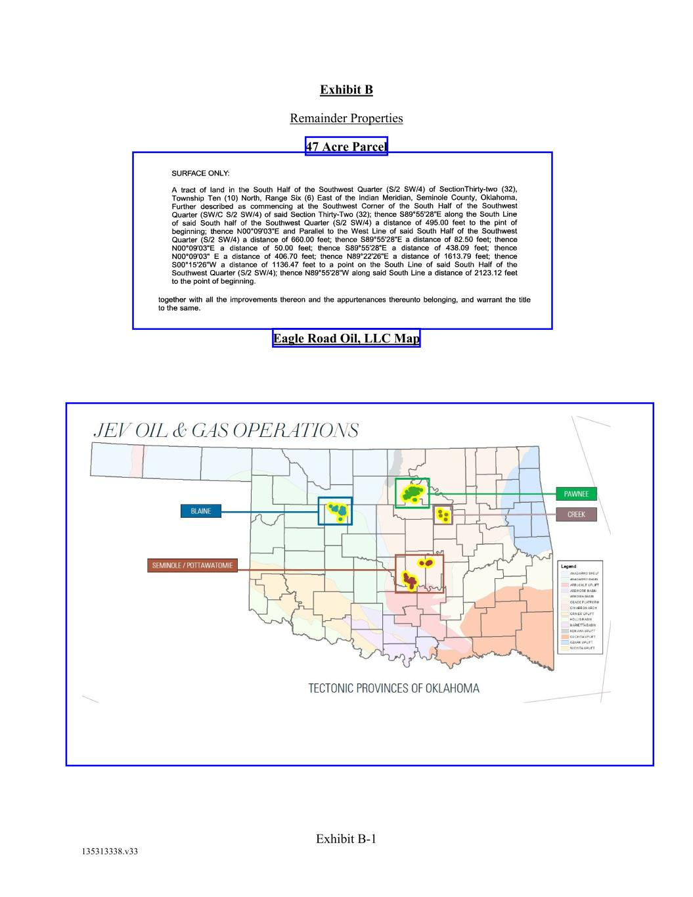
Exhibit B-1 135313338.v33 Exhibit B Remainder Properties 47 Acre Parcel Eagle Road Oil, LLC Map


Exhibit C 135313338.v33 Exhibit C Form of Approved Option Agreement (See Attached)


Exhibit D 135313338.v33 Exhibit D Initial Approved Annual Pre-Development Budget (See Attached)


Exhibit E 135313338.v33 Exhibit E Intentionally Omitted (See Attached)


Exhibit F 135313338.v33 Exhibit F Existing Easements (See Attached)


Exhibit G 135313338.v33 Exhibit G Form of Approved Lease Agreement (See Attached)


Exhibit H 135313338.v33 Exhibit H Form of Approved Surface Waiver (See Attached

Exhibit 31.1
CERTIFICATION
Pursuant to Exchange Act Rules 13a-14(a) and 15d-14(a),
as Adopted Pursuant to Section 302 of the Sarbanes-Oxley Act of 2002
I, Christopher Clemente, certify that:
1.I have reviewed this Quarterly Report on Form 10-Q of Comstock Holding Companies, Inc.;
2.Based on my knowledge, this report does not contain any untrue statement of a material fact or omit to state a material fact necessary to make the statements made, in light of the circumstances under which such statements were made, not misleading with respect to the period covered by this report;
3.Based on my knowledge, the financial statements, and other financial information included in this report, fairly present in all material respects the financial condition, results of operations and cash flows of the registrant as of, and for, the periods presented in this report;
4.The registrant’s other certifying officer and I are responsible for establishing and maintaining disclosure controls and procedures (as defined in Exchange Act Rules 13a-15(e) and 15d-15(e)) and internal control over financial reporting (as defined in Exchange Act Rules 13a-15(f) and 15d-15(f)) for the registrant and have:
a) Designed such disclosure controls and procedures, or caused such disclosure controls and procedures to be designed under our supervision, to ensure that material information relating to the registrant, including its consolidated subsidiaries, is made known to us by others within those entities, particularly during the period in which this report is being prepared;
b) Designed such internal control over financial reporting, or caused such internal control over financial reporting to be designed under our supervision, to provide reasonable assurance regarding the reliability of financial reporting and the preparation of financial statements for external purposes in accordance with generally accepted accounting principles;
c) Evaluated the effectiveness of the registrant’s disclosure controls and procedures and presented in this report our conclusions about the effectiveness of the disclosure controls and procedures, as of the end of the period covered by this report based on such evaluation; and
d) Disclosed in this report any change in the registrant’s internal control over financial reporting that occurred during the registrant’s most recent fiscal quarter (the registrant’s fourth fiscal quarter in the case of an annual report) that has materially affected, or is reasonably likely to materially affect, the registrant’s internal control over financial reporting; and
5.The registrant’s other certifying officer and I have disclosed, based on our most recent evaluation of internal control over financial reporting, to the registrant’s auditors and the audit committee of the registrant’s board of directors (or persons performing the equivalent functions):
a) All significant deficiencies and material weaknesses in the design or operation of internal control over financial reporting which are reasonably likely to adversely affect the registrant’s ability to record, process, summarize and report financial information; and
b) Any fraud, whether or not material, that involves management or other employees who have a significant role in the registrant’s internal control over financial reporting.
Date: August 13, 2026 |  |  | /s/ CHRISTOPHER CLEMENTE
Christopher Clemente
Chairman and Chief Executive Officer
(Principal Executive Officer)

Exhibit 31.2
CERTIFICATION
Pursuant to Exchange Act Rules 13a-14(a) and 15d-14(a),
as Adopted Pursuant to Section 302 of the Sarbanes-Oxley Act of 2002
I, Christopher Guthrie, certify that:
1.I have reviewed this Quarterly Report on Form 10-Q of Comstock Holding Companies, Inc.;
2.Based on my knowledge, this report does not contain any untrue statement of a material fact or omit to state a material fact necessary to make the statements made, in light of the circumstances under which such statements were made, not misleading with respect to the period covered by this report;
3.Based on my knowledge, the financial statements, and other financial information included in this report, fairly present in all material respects the financial condition, results of operations and cash flows of the registrant as of, and for, the periods presented in this report;
4.The registrant’s other certifying officer and I are responsible for establishing and maintaining disclosure controls and procedures (as defined in Exchange Act Rules 13a-15(e) and 15d-15(e)) and internal control over financial reporting (as defined in Exchange Act Rules 13a-15(f) and 15d-15(f)) for the registrant and have:
a) Designed such disclosure controls and procedures, or caused such disclosure controls and procedures to be designed under our supervision, to ensure that material information relating to the registrant, including its consolidated subsidiaries, is made known to us by others within those entities, particularly during the period in which this report is being prepared;
b) Designed such internal control over financial reporting, or caused such internal control over financial reporting to be designed under our supervision, to provide reasonable assurance regarding the reliability of financial reporting and the preparation of financial statements for external purposes in accordance with generally accepted accounting principles;
c) Evaluated the effectiveness of the registrant’s disclosure controls and procedures and presented in this report our conclusions about the effectiveness of the disclosure controls and procedures, as of the end of the period covered by this report based on such evaluation; and
d) Disclosed in this report any change in the registrant’s internal control over financial reporting that occurred during the registrant’s most recent fiscal quarter (the registrant’s fourth fiscal quarter in the case of an annual report) that has materially affected, or is reasonably likely to materially affect, the registrant’s internal control over financial reporting; and
5.The registrant’s other certifying officer and I have disclosed, based on our most recent evaluation of internal control over financial reporting, to the registrant’s auditors and the audit committee of the registrant’s board of directors (or persons performing the equivalent functions):
a) All significant deficiencies and material weaknesses in the design or operation of internal control over financial reporting which are reasonably likely to adversely affect the registrant’s ability to record, process, summarize and report financial information; and
b) Any fraud, whether or not material, that involves management or other employees who have a significant role in the registrant’s internal control over financial reporting.
Date: August 13, 2026 |  |  | /s/ CHRISTOPHER GUTHRIE
Christopher Guthrie
Executive Vice President and Chief Financial Officer
(Principal Financial Officer and Principal Accounting Officer)

Exhibit 32.1
CERTIFICATION
Pursuant to 18 U.S.C. Section 1350, as Adopted Pursuant to Section 906 of the Sarbanes-Oxley Act of 2002

In connection with the Quarterly Report on Form 10-Q of Comstock Holding Companies, Inc. (the “Company”) for the period ended June 30, 2026, as filed with the Securities and Exchange Commission on the date hereof (the “Report”), each of Christopher Clemente, Chairman and Chief Executive Officer of the Company, and Christopher Guthrie, Executive Vice President and Chief Financial Officer of the Company, certifies, to his best knowledge and belief, pursuant to 18 U.S.C. § 1350, as adopted pursuant to § 906 of the Sarbanes-Oxley Act of 2002, that
(1)The Report fully complies with the requirements of Section 13(a) or 15(d) of the Securities Exchange Act of 1934 (15 U.S.C. 78m(a) or 78o(d)); and
(2)The information contained in the Report fairly presents, in all material respects, the financial condition and results of operations of the Company.
Date: August 13, 2026 |  |  |  |  |  | /s/ CHRISTOPHER CLEMENTE
Christopher Clemente
Chairman and Chief Executive Officer
(Principal Executive Officer)
Date: August 13, 2026 |  |  |  |  |  | /s/ CHRISTOPHER GUTHRIE
Christopher Guthrie
Executive Vice President and Chief Financial Officer
(Principal Financial Officer and Principal Accounting Officer)

The foregoing certifications are not deemed filed with the Securities and Exchange Commission for purposes of Section 18 of the Securities Exchange Act of 1934, as amended.

