UNITED STATES
SECURITIES AND EXCHANGE COMMISSION
Washington, D.C. 20549
FORM 8-K
CURRENT REPORT
Pursuant to Section 13 or 15(d) of the Securities Exchange Act of 1934
Date of Report (Date of earliest event reported): August 13, 2026
Comstock Holding Companies, Inc.
(Exact Name of Registrant as Specified in its Charter)
Delaware |  |  | 1-32375 |  |  | 20-1164345
(State or other jurisdiction  of incorporation) |  |  | (Commission File Number) |  |  | (IRS Employer  Identification No.)
1900 Reston Metro Plaza, 10TH Floor
Reston, Virginia 20190
(Address of principal executive offices) (Zip Code)
Registrant’s telephone number, including area code: (703) 230-1985

(Former name or former address, if changed since last report)
Check the appropriate box below if the Form 8-K filing is intended to simultaneously satisfy the filing obligation of the registrant under any of the following provisions:
☐ |  |  | Written communications pursuant to Rule 425 under the Securities Act (17 CFR 230.425)
☐ |  |  | Soliciting material pursuant to Rule 14a- 12 under the Exchange Act (17 CFR 240.14a-12)
☐ |  |  | Pre-commencement communications pursuant to Rule 14d-2(b) under the Exchange Act (17 CFR 240.14d-2(b))
☐ |  |  | Pre-commencement communications pursuant to Rule 13e-4(c) under the Exchange Act (17 CFR 240.13e-4(c))
Securities registered pursuant to Section 12(b) of the Act:

Title of each class |  |  |  |  |  | Trading symbol(s) |  |  |  |  |  | Name of each exchange on which registered
Class A Common Stock, par value $0.01 |  |  |  |  |  | CHCI |  |  |  |  |  | Nasdaq Capital Market
Indicate by check mark whether the registrant is an emerging growth company as defined in Rule 405 of the Securities Act of 1933 (§ 230.405 of this chapter) or Rule 12b-2 of the Securities Exchange Act of 1934 (§ 240.12b-2 of this chapter).
Emerging growth company ☐
If an emerging growth company, indicate by check mark if the registrant has elected not to use the extended transition period for complying with any new or revised financial accounting standards provided pursuant to Section 13(a) of the Exchange Act. ☐

Item 2.02 Results of Operations and Financial Condition

On August 13, 2026, Comstock Companies, Inc. (the “Company”) issued a press release providing information regarding earnings for the quarter ended June 30, 2026. A copy of the press release is attached hereto as Exhibit 99.1.

On August 13, 2026, the Company posted a presentation on their investor relations website providing additional updates for the quarter ended June 30, 2026. A copy of the presentation is attached hereto as Exhibit 99.2.

The information included in this Form 8-K is being furnished and shall not be deemed “filed” for purposes of Section 18 of the Securities Exchange Act of 1934 or otherwise subject to the liabilities of that Section. The information in this Form 8-K shall not be incorporated by reference into any filing under the Securities Act of 1933, except as shall otherwise be expressly set forth by specific reference in such filing.

Item 9.01 Financial Statements and Exhibits.

(d) Exhibits
Exhibit  Number |  |  |  |  |  | Description
99.1 |  |  |  |  |  | Comstock Holding Companies, Inc. press release, dated August 13, 2026
99.2 |  |  |  |  |  | Comstock Holding Companies, Inc. investor presentation, issued on August 13, 2026
104 |  |  |  |  |  | Cover Page Interactive Data File (embedded within the Inline XBRL document)

SIGNATURES
Pursuant to the requirements of the Securities Exchange Act of 1934, the Company has duly caused this report to be signed on its behalf by the undersigned hereunto duly authorized.

 |  |  |  |  |  |  |  |  | COMSTOCK HOLDING COMPANIES, INC.
Date: August 13, 2026 |  |  | By: |  |  |  |  |  | /s/ CHRISTOPHER CLEMENTE
Christopher Clemente
Chairman and Chief Executive Officer

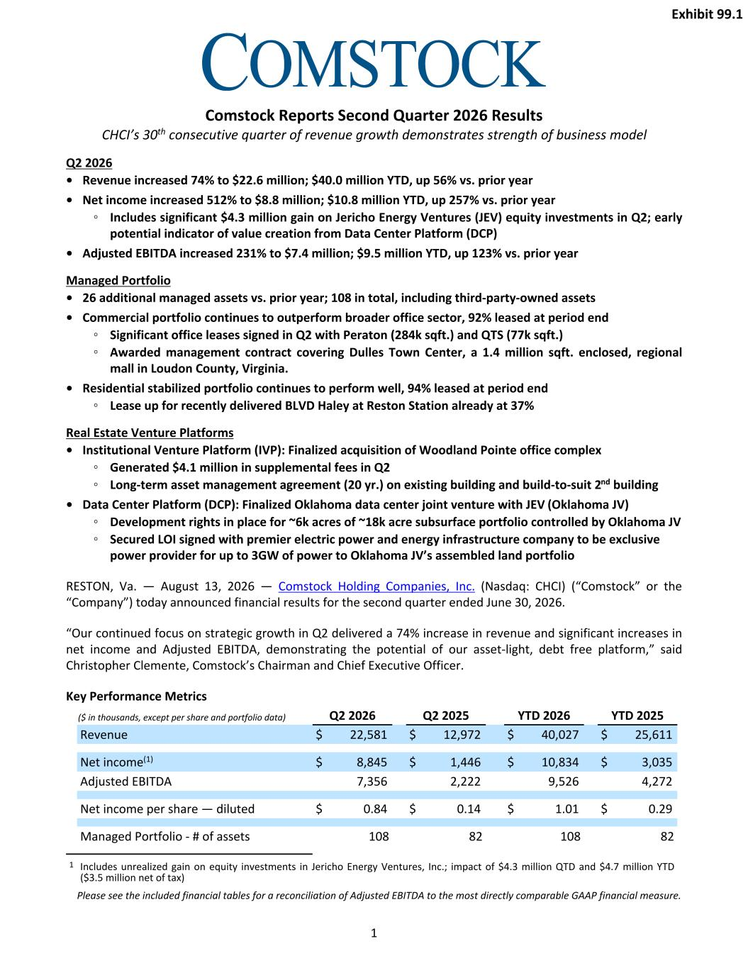

Comstock Reports Second Quarter 2026 Results CHCI’s 30th consecutive quarter of revenue growth demonstrates strength of business model Q2 2026 • Revenue increased 74% to $22.6 million; $40.0 million YTD, up 56% vs. prior year • Net income increased 512% to $8.8 million; $10.8 million YTD, up 257% vs. prior year ◦ Includes significant $4.3 million gain on Jericho Energy Ventures (JEV) equity investments in Q2; early potential indicator of value creation from Data Center Platform (DCP) • Adjusted EBITDA increased 231% to $7.4 million; $9.5 million YTD, up 123% vs. prior year Managed Portfolio • 26 additional managed assets vs. prior year; 108 in total, including third-party-owned assets • Commercial portfolio continues to outperform broader office sector, 92% leased at period end ◦ Significant office leases signed in Q2 with Peraton (284k sqft.) and QTS (77k sqft.) ◦ Awarded management contract covering Dulles Town Center, a 1.4 million sqft. enclosed, regional mall in Loudon County, Virginia. • Residential stabilized portfolio continues to perform well, 94% leased at period end ◦ Lease up for recently delivered BLVD Haley at Reston Station already at 37% Real Estate Venture Platforms • Institutional Venture Platform (IVP): Finalized acquisition of Woodland Pointe office complex ◦ Generated $4.1 million in supplemental fees in Q2 ◦ Long-term asset management agreement (20 yr.) on existing building and build-to-suit 2nd building • Data Center Platform (DCP): Finalized Oklahoma data center joint venture with JEV (Oklahoma JV) ◦ Development rights in place for ~6k acres of ~18k acre subsurface portfolio controlled by Oklahoma JV ◦ Secured LOI signed with premier electric power and energy infrastructure company to be exclusive power provider for up to 3GW of power to Oklahoma JV’s assembled land portfolio RESTON, Va. — August 13, 2026 — Comstock Holding Companies, Inc. (Nasdaq: CHCI) (“Comstock” or the “Company”) today announced financial results for the second quarter ended June 30, 2026. “Our continued focus on strategic growth in Q2 delivered a 74% increase in revenue and significant increases in net income and Adjusted EBITDA, demonstrating the potential of our asset-light, debt free platform,” said Christopher Clemente, Comstock’s Chairman and Chief Executive Officer. Key Performance Metrics ($ in thousands, except per share and portfolio data) Q2 2026 Q2 2025 YTD 2026 YTD 2025 Revenue $ 22,581 $ 12,972 $ 40,027 $ 25,611 Net income(1) $ 8,845 $ 1,446 $ 10,834 $ 3,035 Adjusted EBITDA 7,356 2,222 9,526 4,272 Net income per share — diluted $ 0.84 $ 0.14 $ 1.01 $ 0.29 Managed Portfolio - # of assets 108 82 108 82 1 Includes unrealized gain on equity investments in Jericho Energy Ventures, Inc.; impact of $4.3 million QTD and $4.7 million YTD ($3.5 million net of tax) Please see the included financial tables for a reconciliation of Adjusted EBITDA to the most directly comparable GAAP financial measure. 1 Exhibit 99.1

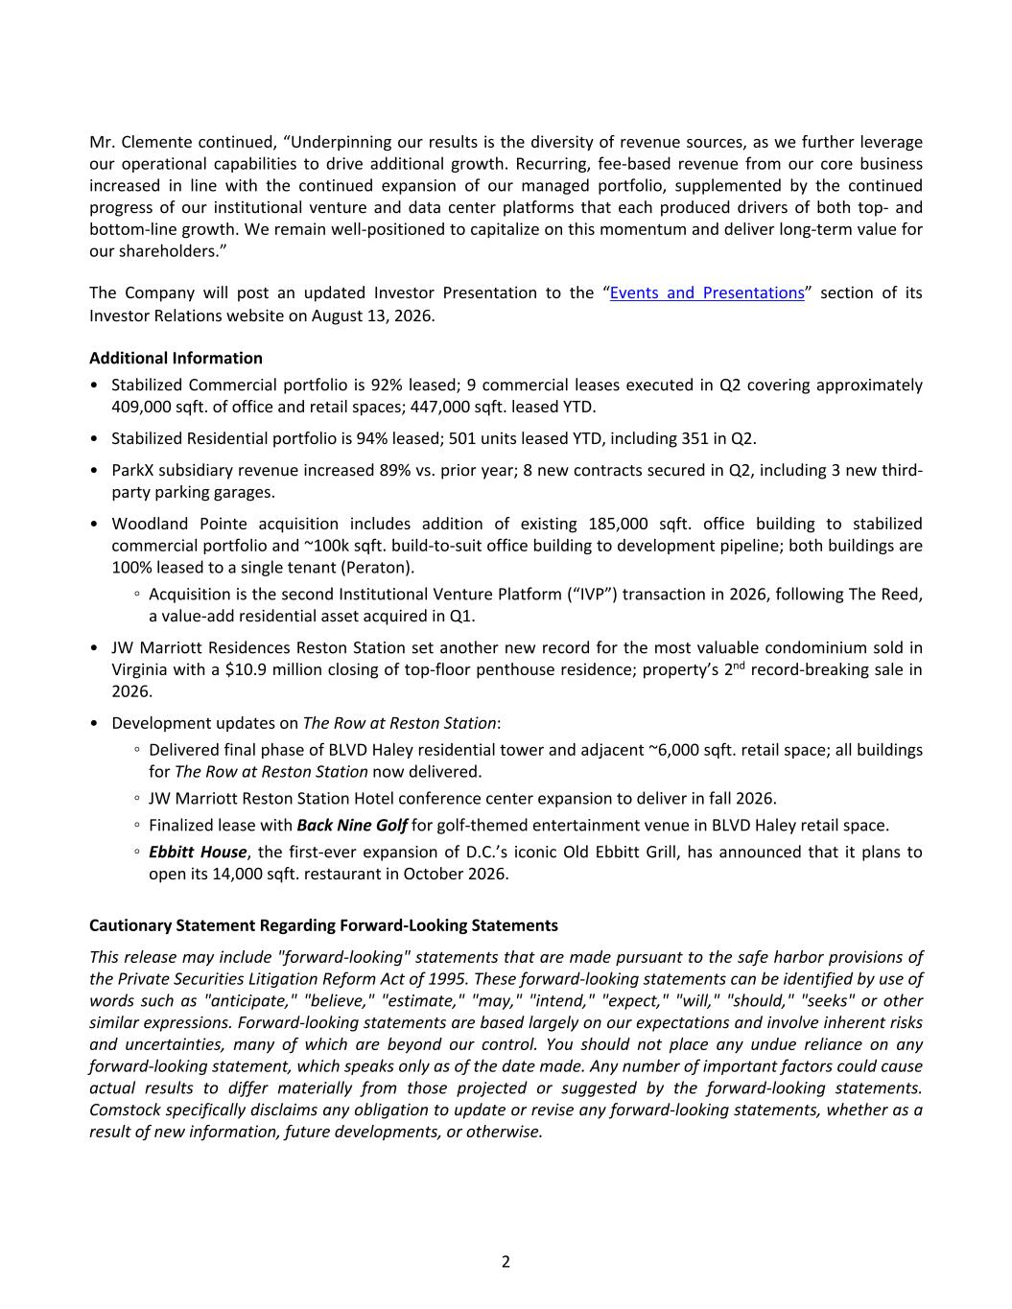
Mr. Clemente continued, “Underpinning our results is the diversity of revenue sources, as we further leverage our operational capabilities to drive additional growth. Recurring, fee-based revenue from our core business increased in line with the continued expansion of our managed portfolio, supplemented by the continued progress of our institutional venture and data center platforms that each produced drivers of both top- and bottom-line growth. We remain well-positioned to capitalize on this momentum and deliver long-term value for our shareholders.” The Company will post an updated Investor Presentation to the “Events and Presentations” section of its Investor Relations website on August 13, 2026. Additional Information • Stabilized Commercial portfolio is 92% leased; 9 commercial leases executed in Q2 covering approximately 409,000 sqft. of office and retail spaces; 447,000 sqft. leased YTD. • Stabilized Residential portfolio is 94% leased; 501 units leased YTD, including 351 in Q2. • ParkX subsidiary revenue increased 89% vs. prior year; 8 new contracts secured in Q2, including 3 new third- party parking garages. • Woodland Pointe acquisition includes addition of existing 185,000 sqft. office building to stabilized commercial portfolio and ~100k sqft. build-to-suit office building to development pipeline; both buildings are 100% leased to a single tenant (Peraton). ◦ Acquisition is the second Institutional Venture Platform (“IVP”) transaction in 2026, following The Reed, a value-add residential asset acquired in Q1. • JW Marriott Residences Reston Station set another new record for the most valuable condominium sold in Virginia with a $10.9 million closing of top-floor penthouse residence; property’s 2nd record-breaking sale in 2026. • Development updates on The Row at Reston Station: ◦ Delivered final phase of BLVD Haley residential tower and adjacent ~6,000 sqft. retail space; all buildings for The Row at Reston Station now delivered. ◦ JW Marriott Reston Station Hotel conference center expansion to deliver in fall 2026. ◦ Finalized lease with Back Nine Golf for golf-themed entertainment venue in BLVD Haley retail space. ◦ Ebbitt House, the first-ever expansion of D.C.’s iconic Old Ebbitt Grill, has announced that it plans to open its 14,000 sqft. restaurant in October 2026. Cautionary Statement Regarding Forward-Looking Statements This release may include "forward-looking" statements that are made pursuant to the safe harbor provisions of the Private Securities Litigation Reform Act of 1995. These forward-looking statements can be identified by use of words such as "anticipate," "believe," "estimate," "may," "intend," "expect," "will," "should," "seeks" or other similar expressions. Forward-looking statements are based largely on our expectations and involve inherent risks and uncertainties, many of which are beyond our control. You should not place any undue reliance on any forward-looking statement, which speaks only as of the date made. Any number of important factors could cause actual results to differ materially from those projected or suggested by the forward-looking statements. Comstock specifically disclaims any obligation to update or revise any forward-looking statements, whether as a result of new information, future developments, or otherwise. 2

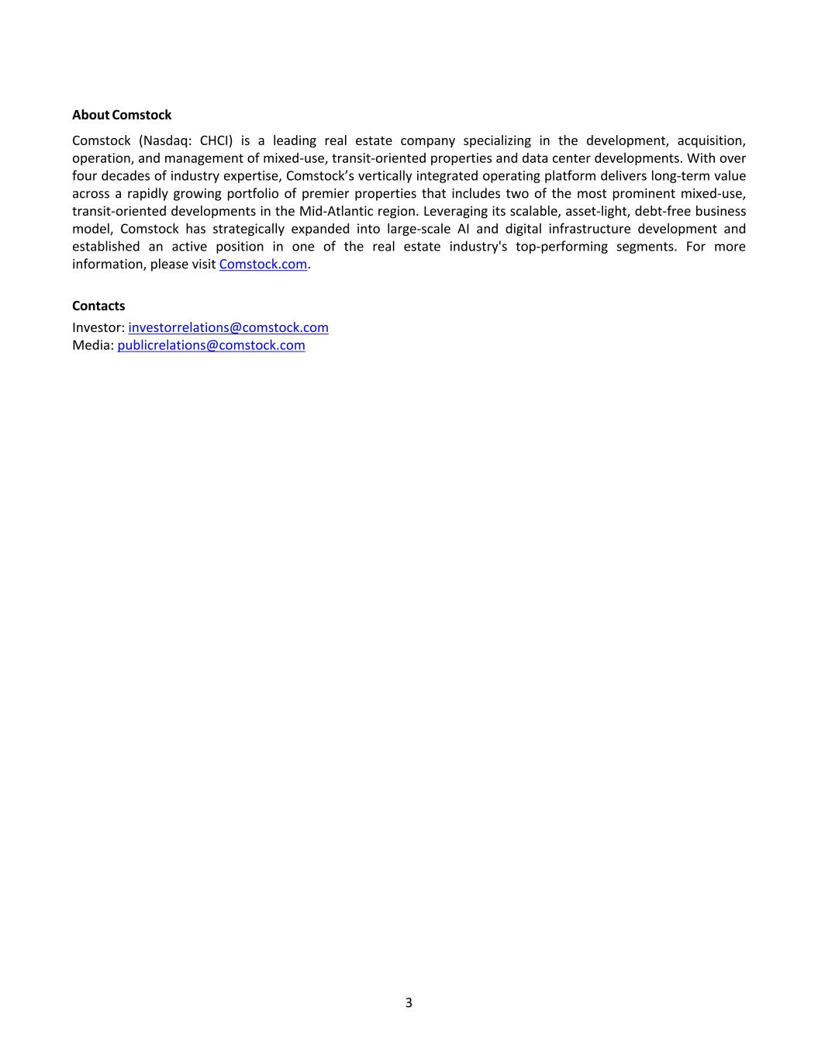
About Comstock Comstock (Nasdaq: CHCI) is a leading real estate company specializing in the development, acquisition, operation, and management of mixed-use, transit-oriented properties and data center developments. With over four decades of industry expertise, Comstock’s vertically integrated operating platform delivers long-term value across a rapidly growing portfolio of premier properties that includes two of the most prominent mixed-use, transit-oriented developments in the Mid-Atlantic region. Leveraging its scalable, asset-light, debt-free business model, Comstock has strategically expanded into large-scale AI and digital infrastructure development and established an active position in one of the real estate industry's top-performing segments. For more information, please visit Comstock.com. Contacts Investor: investorrelations@comstock.com Media: publicrelations@comstock.com 3

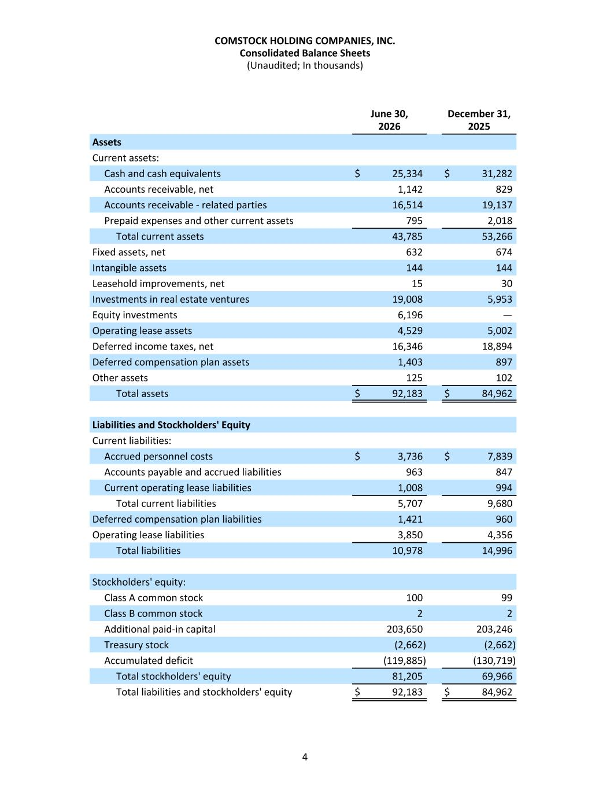
June 30, December 31, 2026 2025 Assets Current assets: Cash and cash equivalents $ 25,334 $ 31,282 Accounts receivable, net 1,142 829 Accounts receivable - related parties 16,514 19,137 Prepaid expenses and other current assets 795 2,018 Total current assets 43,785 53,266 Fixed assets, net 632 674 Intangible assets 144 144 Leasehold improvements, net 15 30 Investments in real estate ventures 19,008 5,953 Equity investments 6,196 — Operating lease assets 4,529 5,002 Deferred income taxes, net 16,346 18,894 Deferred compensation plan assets 1,403 897 Other assets 125 102 Total assets $ 92,183 $ 84,962 Liabilities and Stockholders' Equity Current liabilities: Accrued personnel costs $ 3,736 $ 7,839 Accounts payable and accrued liabilities 963 847 Current operating lease liabilities 1,008 994 Total current liabilities 5,707 9,680 Deferred compensation plan liabilities 1,421 960 Operating lease liabilities 3,850 4,356 Total liabilities 10,978 14,996 Stockholders' equity: Class A common stock 100 99 Class B common stock 2 2 Additional paid-in capital 203,650 203,246 Treasury stock (2,662) (2,662) Accumulated deficit (119,885) (130,719) Total stockholders' equity 81,205 69,966 Total liabilities and stockholders' equity $ 92,183 $ 84,962 COMSTOCK HOLDING COMPANIES, INC. Consolidated Balance Sheets (Unaudited; In thousands) 4

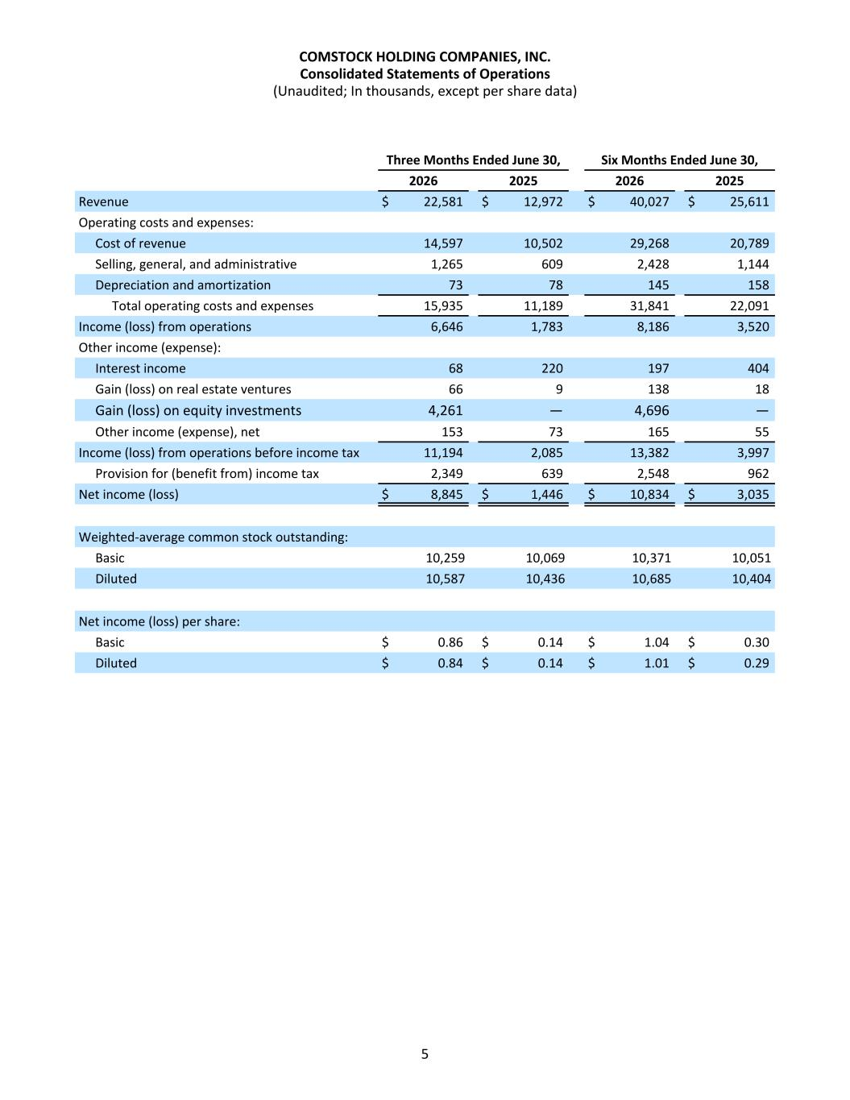
Three Months Ended June 30, Six Months Ended June 30, 2026 2025 2026 2025 Revenue $ 22,581 $ 12,972 $ 40,027 $ 25,611 Operating costs and expenses: Cost of revenue 14,597 10,502 29,268 20,789 Selling, general, and administrative 1,265 609 2,428 1,144 Depreciation and amortization 73 78 145 158 Total operating costs and expenses 15,935 11,189 31,841 22,091 Income (loss) from operations 6,646 1,783 8,186 3,520 Other income (expense): Interest income 68 220 197 404 Gain (loss) on real estate ventures 66 9 138 18 Gain (loss) on equity investments 4,261 — 4,696 — Other income (expense), net 153 73 165 55 Income (loss) from operations before income tax 11,194 2,085 13,382 3,997 Provision for (benefit from) income tax 2,349 639 2,548 962 Net income (loss) $ 8,845 $ 1,446 $ 10,834 $ 3,035 Weighted-average common stock outstanding: Basic 10,259 10,069 10,371 10,051 Diluted 10,587 10,436 10,685 10,404 Net income (loss) per share: Basic $ 0.86 $ 0.14 $ 1.04 $ 0.30 Diluted $ 0.84 $ 0.14 $ 1.01 $ 0.29 COMSTOCK HOLDING COMPANIES, INC. Consolidated Statements of Operations (Unaudited; In thousands, except per share data) 5

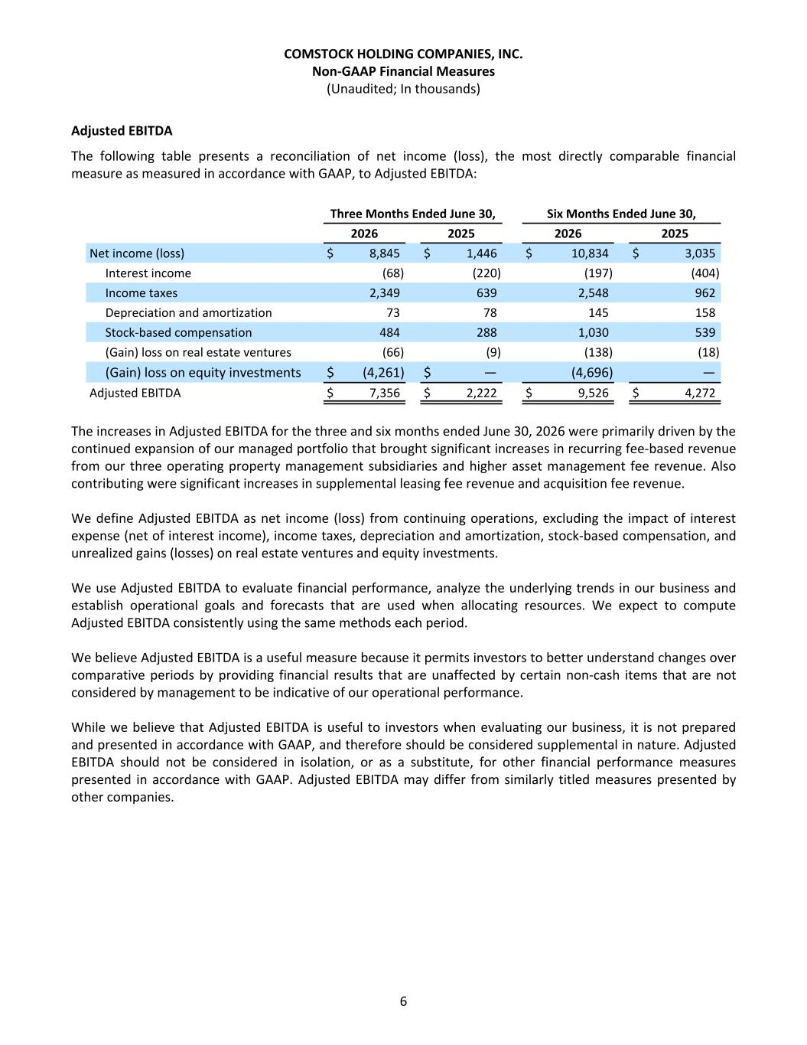
Adjusted EBITDA The following table presents a reconciliation of net income (loss), the most directly comparable financial measure as measured in accordance with GAAP, to Adjusted EBITDA: Three Months Ended June 30, Six Months Ended June 30, 2026 2025 2026 2025 Net income (loss) $ 8,845 $ 1,446 $ 10,834 $ 3,035 Interest income (68) (220) (197) (404) Income taxes 2,349 639 2,548 962 Depreciation and amortization 73 78 145 158 Stock-based compensation 484 288 1,030 539 (Gain) loss on real estate ventures (66) (9) (138) (18) (Gain) loss on equity investments $ (4,261) $ — (4,696) — Adjusted EBITDA $ 7,356 $ 2,222 $ 9,526 $ 4,272 The increases in Adjusted EBITDA for the three and six months ended June 30, 2026 were primarily driven by the continued expansion of our managed portfolio that brought significant increases in recurring fee-based revenue from our three operating property management subsidiaries and higher asset management fee revenue. Also contributing were significant increases in supplemental leasing fee revenue and acquisition fee revenue. We define Adjusted EBITDA as net income (loss) from continuing operations, excluding the impact of interest expense (net of interest income), income taxes, depreciation and amortization, stock-based compensation, and unrealized gains (losses) on real estate ventures and equity investments. We use Adjusted EBITDA to evaluate financial performance, analyze the underlying trends in our business and establish operational goals and forecasts that are used when allocating resources. We expect to compute Adjusted EBITDA consistently using the same methods each period. We believe Adjusted EBITDA is a useful measure because it permits investors to better understand changes over comparative periods by providing financial results that are unaffected by certain non-cash items that are not considered by management to be indicative of our operational performance. While we believe that Adjusted EBITDA is useful to investors when evaluating our business, it is not prepared and presented in accordance with GAAP, and therefore should be considered supplemental in nature. Adjusted EBITDA should not be considered in isolation, or as a substitute, for other financial performance measures presented in accordance with GAAP. Adjusted EBITDA may differ from similarly titled measures presented by other companies. COMSTOCK HOLDING COMPANIES, INC. Non-GAAP Financial Measures (Unaudited; In thousands) 6

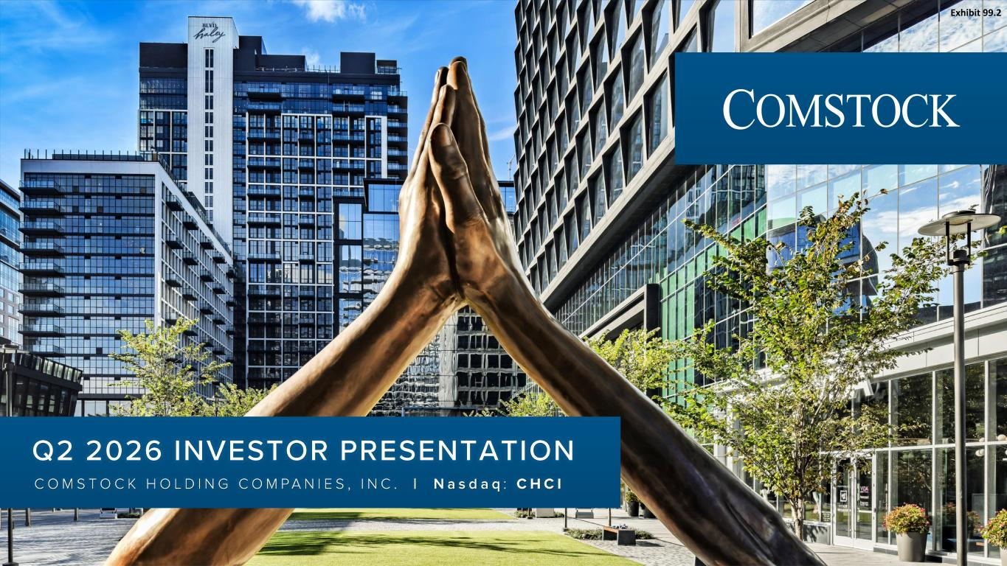
Nasdaq: CHCI COMSTOCK HOLDING COMPANIES, INC. | Nasdaq : CHCI Q2 2026 INVESTOR PRESENTATION Exhibit 99.2

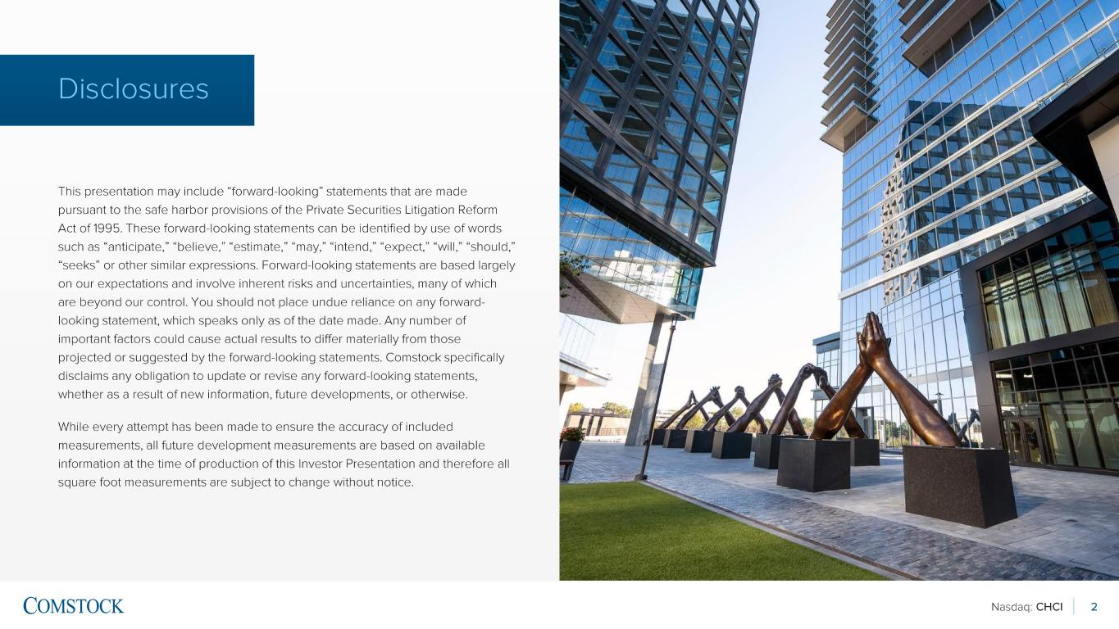
Nasdaq: CHCI 2 Disclosures This presentation may include “forward -looking” statements that are made pursuant to the safe harbor provisions of the Private Securities Litigation Reform Act of 1995. These forward -looking statements can be identified by use of words such as “anticipate,” “believe,” “estimate,” “may,” “intend,” “expect,” “will,” “should,” “seeks” or other similar expressions. Forward -looking statements are based largely on our expectations and involve inherent risks and uncertainties, many of which are beyond our control. You should not place undue reliance on any forward - looking statement, which speaks only as of the date made. Any number of important factors could cause actual results to differ materially from those projected or suggested by the forward -looking statements. Comstock specifically disclaims any obligation to update or revise any forward -looking statements, whether as a result of new information, future developments, or otherwise. While every attempt has been made to ensure the accuracy of included measurements, all future development measurements are based on available information at the time of production of this Investor Presentation and therefore all square foot measurements are subject to change without notice.

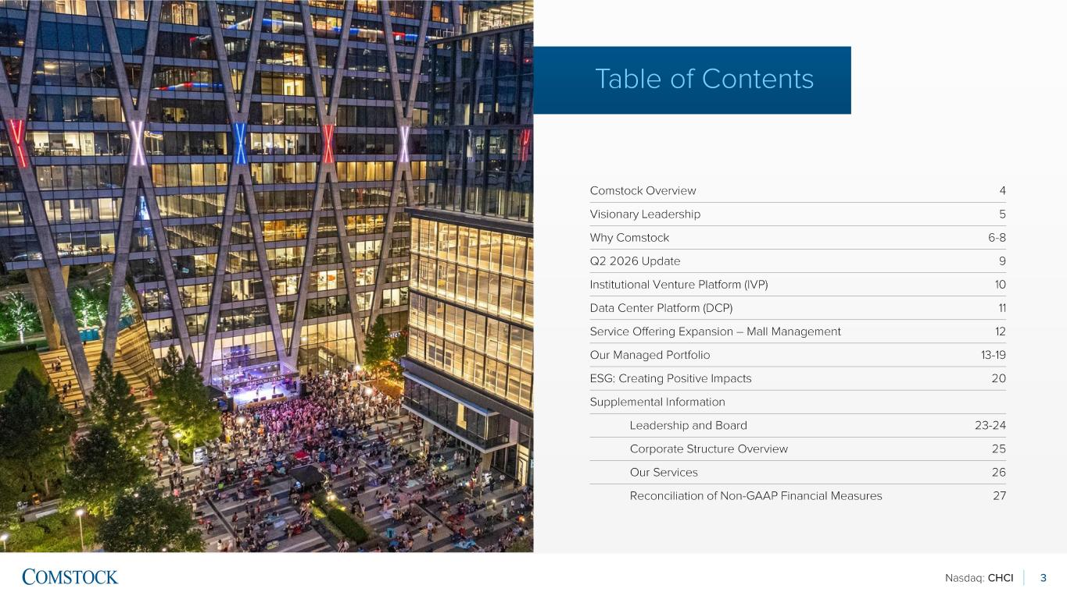
Nasdaq: CHCI 3 Table of Contents Comstock Overview 4 Visionary Leadership 5 Why Comstock 6-8 Q2 2026 Update 9 Institutional Venture Platform (IVP) 10 Data Center Platform (DCP) 11 Service Offering Expansion – Mall Management 12 Our Managed Portfolio 13-19 ESG: Creating Positive Impacts 20 Supplemental Information Leadership and Board 23 -24 Corporate Structure Overview 25 Our Services 26 Reconciliation of Non -GAAP Financial Measures 27

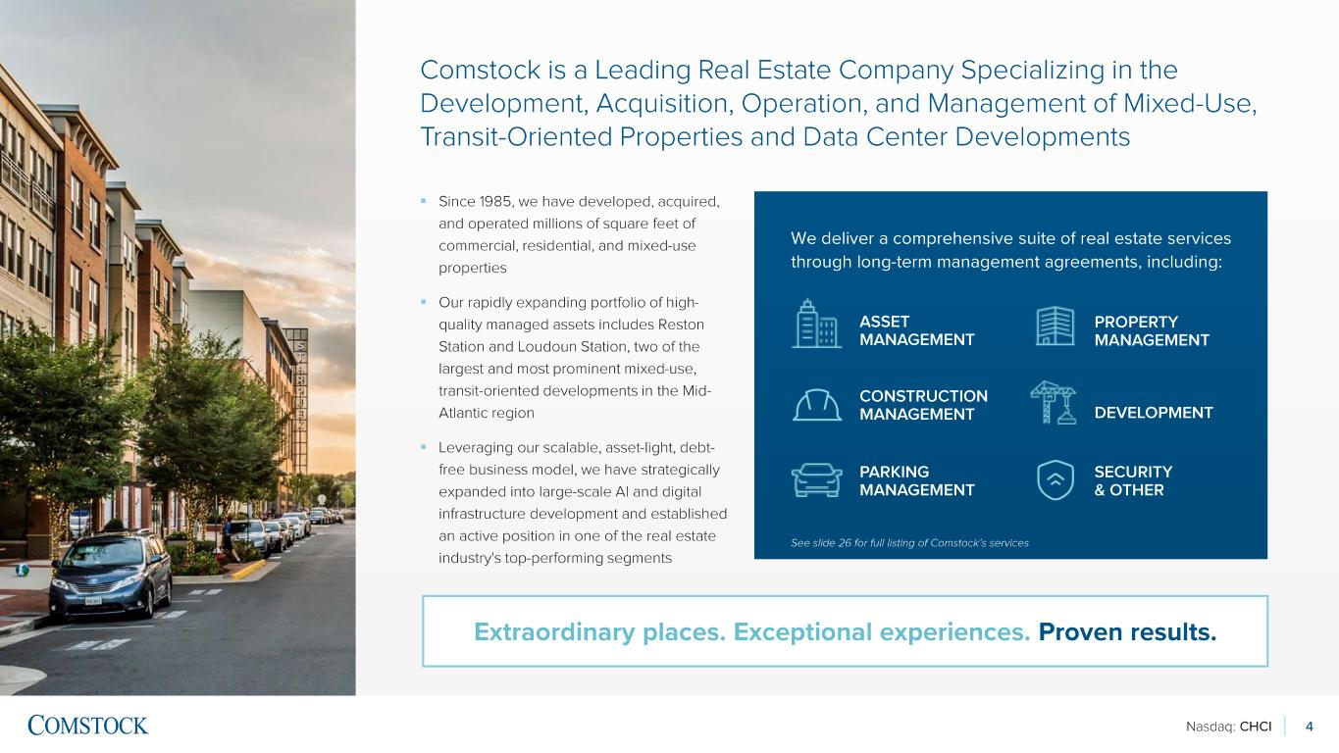
Nasdaq: CHCI 4 Comstock is a Leading Real Estate Company Specializing in the Development, Acquisition, Operation, and Management of Mixed -Use, Transit-Oriented Properties and Data Center Developments ▪ Since 1985, we have developed, acquired, and operated millions of square feet of commercial, residential, and mixed -use properties ▪ Our rapidly expanding portfolio of high - quality managed assets includes Reston Station and Loudoun Station, two of the largest and most prominent mixed -use, transit-oriented developments in the Mid - Atlantic region ▪ Leveraging our scalable, asset -light, debt - free business model, we have strategically expanded into large -scale AI and digital infrastructure development and established an active position in one of the real estate industry's top -performing segments Extraordinary places. Exceptional experiences. Proven results. We deliver a comprehensive suite of real estate services through long -term management agreements, including: ASSET MANAGEMENT DEVELOPMENT CONSTRUCTION MANAGEMENT PROPERTY MANAGEMENT PARKING MANAGEMENT SECURITY & OTHER See slide 26 for full listing of Comstock’s services

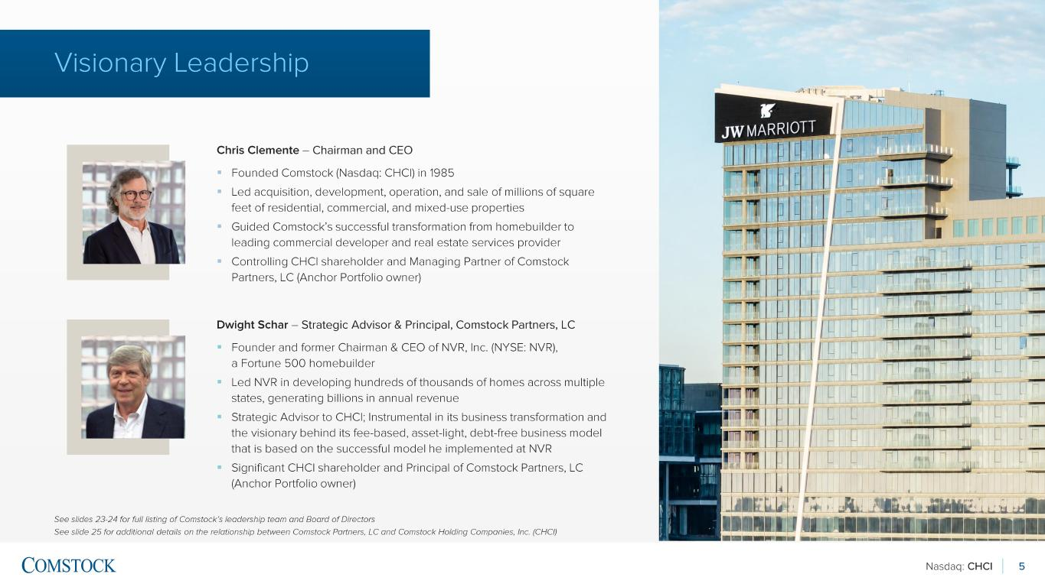
Nasdaq: CHCI 5 Visionary Leadership Chris Clemente – Chairman and CEO ▪ Founded Comstock (Nasdaq: CHCI) in 1985 ▪ Led acquisition, development, operation, and sale of millions of square feet of residential, commercial, and mixed -use properties ▪ Guided Comstock’s successful transformation from homebuilder to leading commercial developer and real estate services provider ▪ Controlling CHCI shareholder and Managing Partner of Comstock Partners, LC (Anchor Portfolio owner) See slides 23 -24 for full listing of Comstock’s leadership team and Board of Directors See slide 25 for additional details on the relationship between Comstock Partners, LC and Comstock Holding Companies, Inc. (C HCI ) Dwight Schar – Strategic Advisor & Principal, Comstock Partners, LC ▪ Founder and former Chairman & CEO of NVR, Inc. (NYSE: NVR), a Fortune 500 homebuilder ▪ Led NVR in developing hundreds of thousands of homes across multiple states, generating billions in annual revenue ▪ Strategic Advisor to CHCI ; Instrumental in its business transformation and the visionary behind its fee -based, asset -light, debt -free business model that is based on the successful model he implemented at NVR ▪ Significant CHCI shareholder and Principal of Comstock Partners, LC (Anchor Portfolio owner)

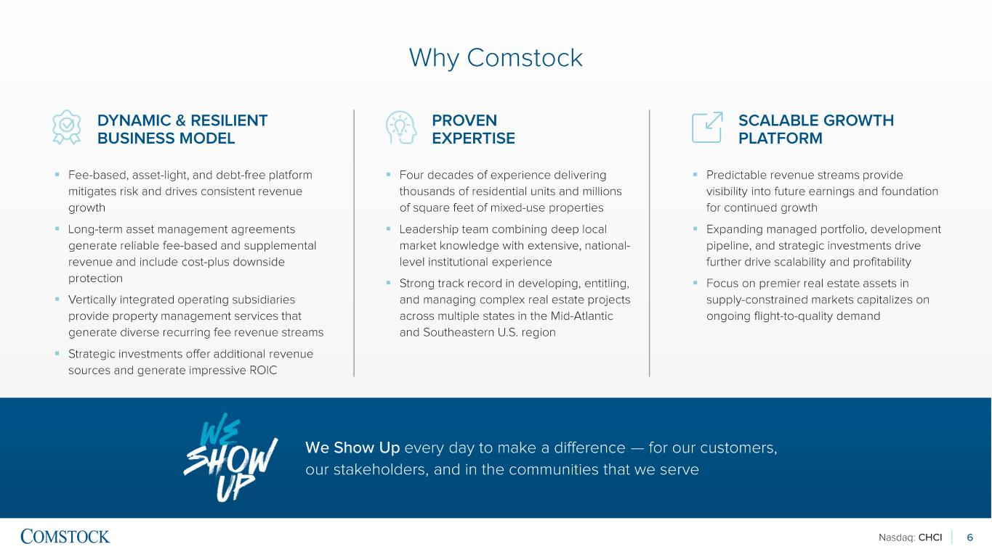
Nasdaq: CHCI 6 Why Comstock DYNAMIC & RESILIENT BUSINESS MODEL PROVEN EXPERTISE ▪ Fee -based, asset -light, and debt -free platform mitigates risk and drives consistent revenue growth ▪ Long -term asset management agreements generate reliable fee -based and supplemental revenue and include cost -plus downside protection ▪ Vertically integrated operating subsidiaries provide property management services that generate diverse recurring fee revenue streams ▪ Strategic investments offer additional revenue sources and generate impressive ROIC ▪ Four decades of experience delivering thousands of residential units and millions of square feet of mixed -use properties ▪ Leadership team combining deep local market knowledge with extensive, national - level institutional experience ▪ Strong track record in developing, entitling, and managing complex real estate projects across multiple states in the Mid -Atlantic and Southeastern U.S. region ▪ Predictable revenue streams provide visibility into future earnings and foundation for continued growth ▪ Expanding managed portfolio, development pipeline, and strategic investments drive further drive scalability and profitability ▪ Focus on premier real estate assets in supply -constrained markets capitalizes on ongoing flight -to-quality demand SCALABLE GROWTH PLATFORM We Show Up every day to make a difference — for our customers, our stakeholders, and in the communities that we serve

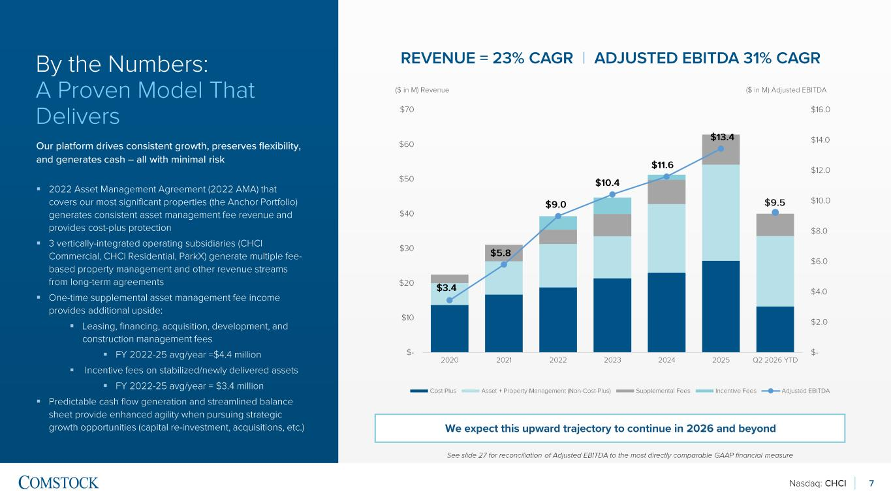
Nasdaq: CHCI $3.4 $5.8 $9.0 $10.4 $11.6 $13.4 $- $2.0 $4.0 $6.0 $8.0 $10.0 $12.0 $14.0 $16.0 $- $10 $20 $30 $40 $50 $60 $70 2020 2021 2022 2023 2024 2025 Q2 2026 YTD Cost Plus Asset + Property Management (Non-Cost-Plus) Supplemental Fees Incentive Fees Adjusted EBITDA 7 By the Numbers: A Proven Model That Delivers Our platform drives consistent growth, preserves flexibility, and generates cash – all with minimal risk ▪ 2022 Asset Management Agreement (2022 AMA) that covers our most significant properties (the Anchor Portfolio) generates consistent asset management fee revenue and provides cost -plus protection ▪ 3 vertically -integrated operating subsidiaries (CHCI Commercial, CHCI Residential, ParkX ) generate multiple fee - based property management and other revenue streams from long -term agreements ▪ One -time supplemental asset management fee income provides additional upside: ▪ Leasing, financing, acquisition, development, and construction management fees ▪ FY 2022 -25 avg/year =$4.4 million ▪ Incentive fees on stabilized/newly delivered assets ▪ FY 2022 -25 avg/year = $3.4 million ▪ Predictable cash flow generation and streamlined balance sheet provide enhanced agility when pursuing strategic growth opportunities (capital re -investment, acquisitions, etc.) See slide 27 for reconciliation of Adjusted EBITDA to the most directly comparable GAAP financial measure REVENUE = 23% CAGR | ADJUSTED EBITDA 31% CAGR ($ in M) Revenue ($ in M) Adjusted EBITDA We expect this upward trajectory to continue in 2026 and beyond $9.5

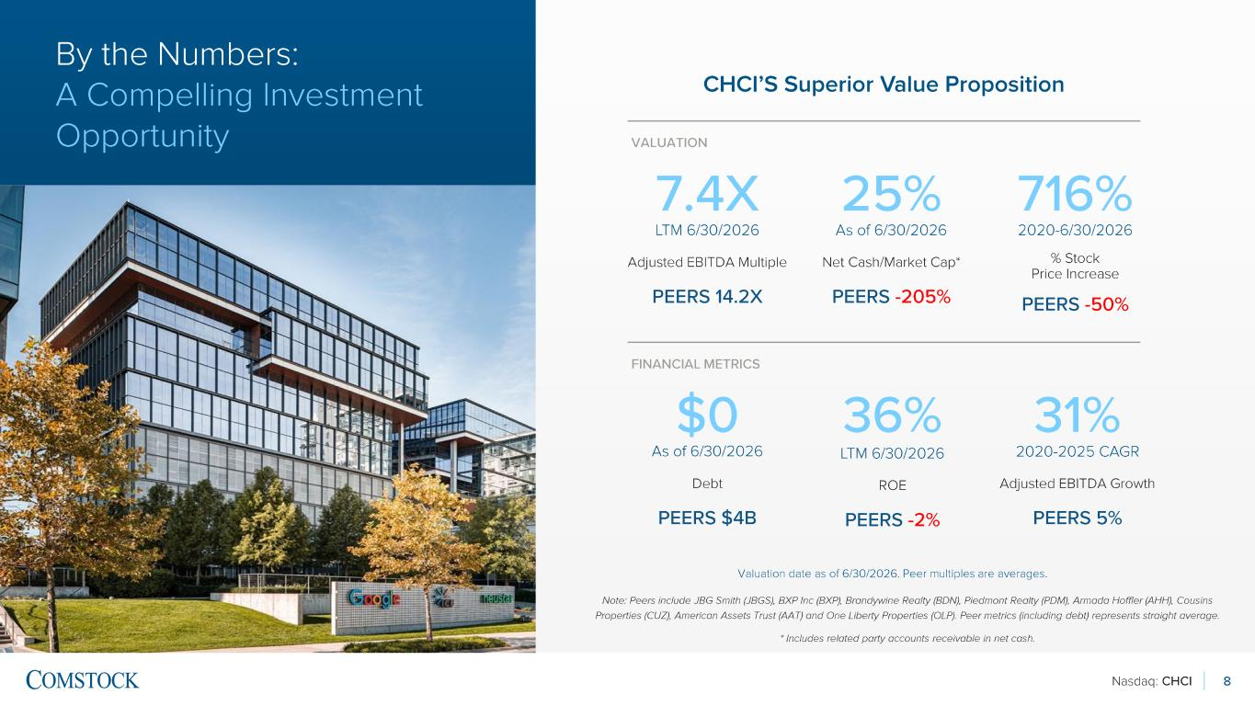
Nasdaq: CHCI 8 CHCI’S Superior Value Proposition Note: Peers include JBG Smith (JBGS), BXP Inc (BXP), Brandywine Realty (BDN), Piedmont Realty (PDM), Armada Hoffler (AHH), Co usins Properties (CUZ), American Assets Trust (AAT) and One Liberty Properties (OLP). Peer metrics (including debt) represents stra ight average. * Includes related party accounts receivable in net cash. Valuation date as of 6/30/2026. Peer multiples are averages. 7.4X LTM 6/30/2026 Adjusted EBITDA Multiple PEERS 14.2X 25% As of 6/30/2026 Net Cash/Market Cap* PEERS -205% 716% 2020 -6/30/2026 % Stock Price Increase PEERS -50% VALUATION $0 As of 6/30/2026 Debt PEERS $4B FINANCIAL METRICS 36% LTM 6/30/2026 ROE PEERS -2% 31% 2020 -2025 CAGR Adjusted EBITDA Growth PEERS 5% By the Numbers: A Compelling Investment Opportunity

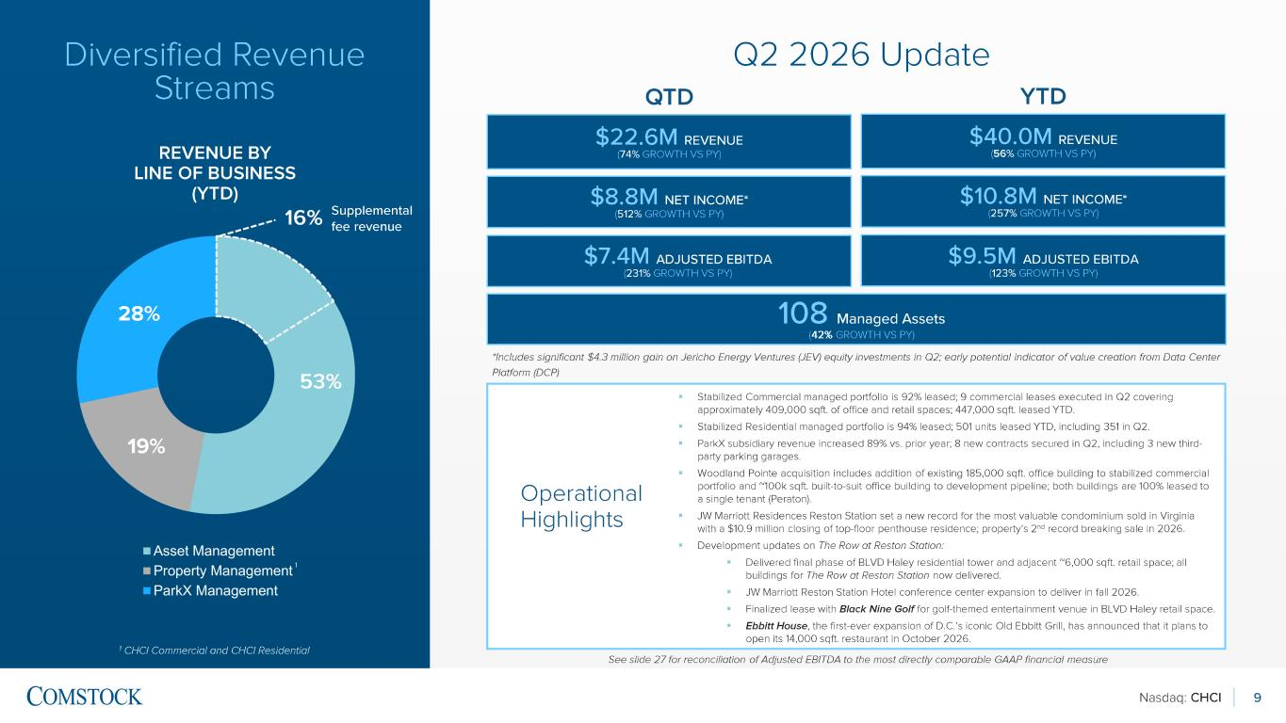
Nasdaq: CHCI 9 Diversified Revenue Streams 1 CHCI Commercial and CHCI Residential 19% 28% Asset Management Property Management ParkX Management REVENUE BY LINE OF BUSINESS (YTD) ▪ Stabilized Commercial managed portfolio is 92% leased; 9 commercial leases executed in Q2 covering approximately 409,000 sqft. of office and retail spaces; 447,000 sqft. leased YTD. ▪ Stabilized Residential managed portfolio is 94% leased; 501 units leased YTD, including 351 in Q2. ▪ ParkX subsidiary revenue increased 89% vs. prior year; 8 new contracts secured in Q2, including 3 new third - party parking garages. ▪ Woodland Pointe acquisition includes addition of existing 185,000 sqft. office building to stabilized commercial portfolio and ~100k sqft. built-to-suit office building to development pipeline; both buildings are 100% leased to a single tenant ( Peraton ). ▪ JW Marriott Residences Reston Station set a new record for the most valuable condominium sold in Virginia with a $10.9 million closing of top -floor penthouse residence; property’s 2 nd record breaking sale in 2026. ▪ Development updates on The Row at Reston Station: ▪ Delivered final phase of BLVD Haley residential tower and adjacent ~6,000 sqft. retail space; all buildings for The Row at Reston Station now delivered. ▪ JW Marriott Reston Station Hotel conference center expansion to deliver in fall 2026. ▪ Finalized lease with Black Nine Golf for golf-themed entertainment venue in BLVD Haley retail space. ▪ Ebbitt House , the first-ever expansion of D.C.’s iconic Old Ebbitt Grill, has announced that it plans to open its 14,000 sqft. restaurant in October 2026 . Operational Highlights See slide 27 for reconciliation of Adjusted EBITDA to the most directly comparable GAAP financial measure Q2 2026 Update 1 Supplemental fee revenue 53% 16% $22.6M REVENUE (74% GROWTH VS PY) $7.4M ADJUSTED EBITDA (231% GROWTH VS PY) QTD $8.8M NET INCOME * (512% GROWTH VS PY) 108 Managed Assets (42% GROWTH VS PY) $40.0M REVENUE (56 % GROWTH VS PY) $9.5M ADJUSTED EBITDA (123% GROWTH VS PY) YTD $10.8M NET INCOME * (257% GROWTH VS PY) *Includes significant $4.3 million gain on Jericho Energy Ventures (JEV) equity investments in Q2; early potential indicator of value creation from Data Center Platform (DCP )

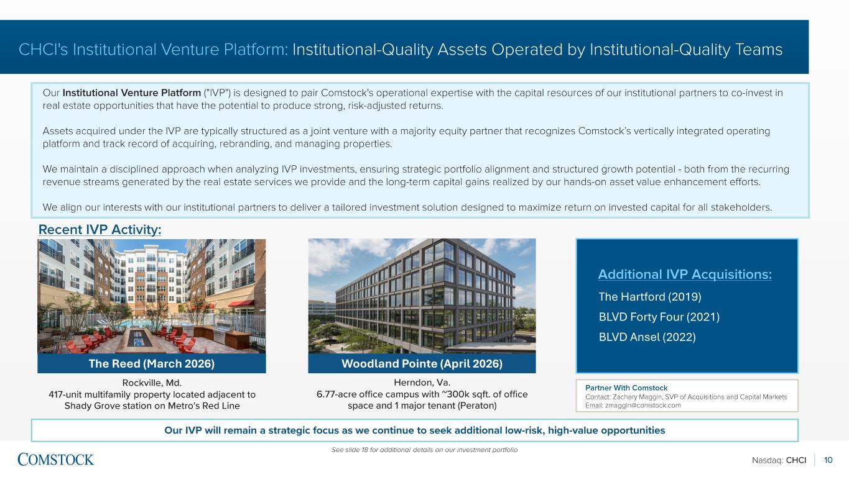
Nasdaq: CHCI 10 CHCI's Institutional Venture Platform: Institutional-Quality Assets Operated by Institutional -Quality Teams Our Institutional Venture Platform ("IVP") is designed to pair Comstock's operational expertise with the capital resources of our institutional partners to co -invest in real estate opportunities that have the potential to produce strong, risk -adjusted returns. Assets acquired under the IVP are typically structured as a joint venture with a majority equity partner that recognizes Coms tock’s vertically integrated operating platform and track record of acquiring, rebranding, and managing properties. We maintain a disciplined approach when analyzing IVP investments, ensuring strategic portfolio alignment and structured grow th potential - both from the recurring revenue streams generated by the real estate services we provide and the long -term capital gains realized by our hands -on asset value enhancement efforts. We align our interests with our institutional partners to deliver a tailored investment solution designed to maximize return on invested capital for all stakeholders. Our IVP will remain a strategic focus as we continue to seek additional low -risk, high -value opportunities The Reed (March 2026) See slide 18 for additional details on our investment portfolio Woodland Pointe (April 2026) Additional IVP Acquisitions: Recent IVP Activity: The Hartford (2019) BLVD Forty Four (2021) BLVD Ansel (2022) Rockville, Md. 417-unit multifamily property located adjacent to Shady Grove station on Metro's Red Line Herndon, Va. 6.77-acre office campus with ~300k sqft. of office space and 1 major tenant ( Peraton ) Partner With Comstock Contact : Zachary Maggin , SVP of Acquisitions and Capital Markets Email: zmaggin@comstock. com

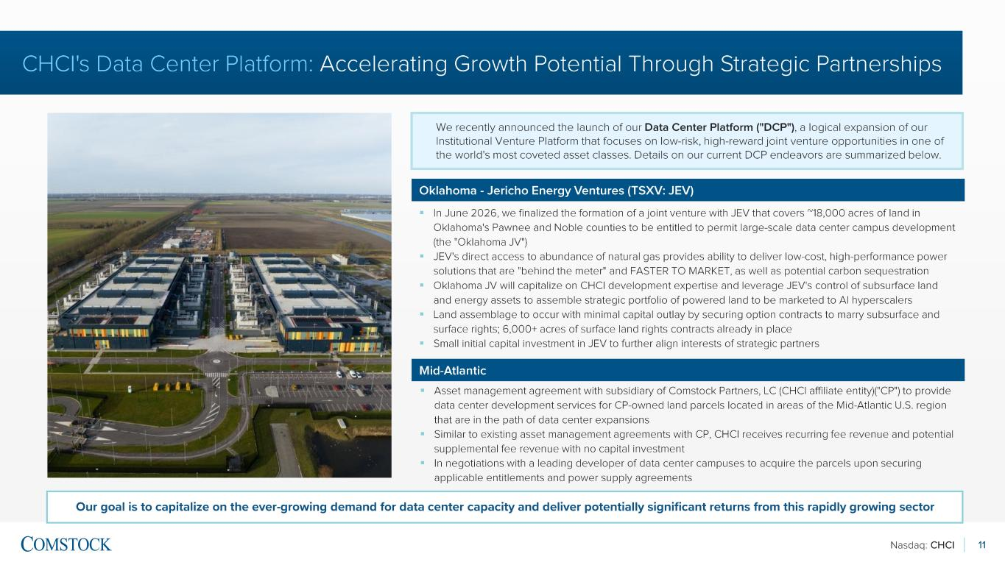
Nasdaq: CHCI 11 CHCI's Data Center Platform: Accelerating Growth Potential Through Strategic Partnerships We recently announced the launch of our Data Center Platform ("DCP") , a logical expansion of our Institutional Venture Platform that focuses on low -risk, high -reward joint venture opportunities in one of the world's most coveted asset classes. Details on our current DCP endeavors are summarized below. \ Oklahoma - Jericho Energy Ventures (TSXV: JEV) ▪ In June 2026, we finalized the formation of a joint venture with JEV that covers ~18,000 acres of land in Oklahoma's Pawnee and Noble counties to be entitled to permit large -scale data center campus development (the "Oklahoma JV") ▪ JEV's direct access to abundance of natural gas provides ability to deliver low -cost, high -performance power solutions that are "behind the meter" and FASTER TO MARKET, as well as potential carbon sequestration ▪ Oklahoma JV will capitalize on CHCI development expertise and leverage JEV's control of subsurface land and energy assets to assemble strategic portfolio of powered land to be marketed to AI hyperscalers ▪ Land assemblage to occur with minimal capital outlay by securing option contracts to marry subsurface and surface rights; 6,000+ acres of surface land rights contracts already in place ▪ Small initial capital investment in JEV to further align interests of strategic partners Mid-Atlantic ▪ Asset management agreement with subsidiary of Comstock Partners, LC (CHCI affiliate entity)("CP") to provide data center development services for CP -owned land parcels located in areas of the Mid -Atlantic U.S. region that are in the path of data center expansions ▪ Similar to existing asset management agreements with CP, CHCI receives recurring fee revenue and potential supplemental fee revenue with no capital investment ▪ In negotiations with a leading developer of data center campuses to acquire the parcels upon securing applicable entitlements and power supply agreements Our goal is to capitalize on the ever -growing demand for data center capacity and deliver potentially significant returns from t his rapidly growing sector

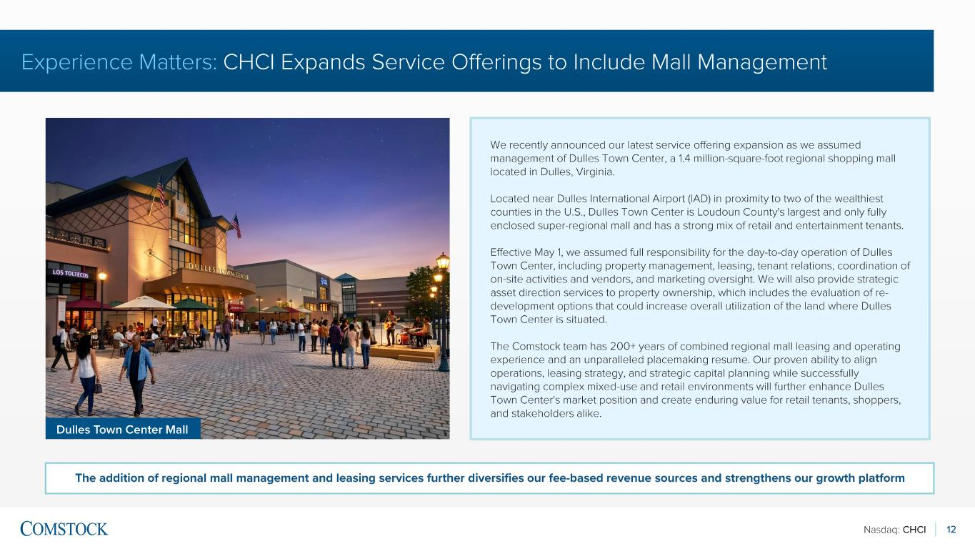
Nasdaq: CHCI 12 Experience Matters: CHCI Expands Service Offerings to Include Mall Management We recently announced our latest service offering expansion as we assumed management of Dulles Town Center, a 1.4 million -square -foot regional shopping mall located in Dulles, Virginia. Located near Dulles International Airport (IAD) in proximity to two of the wealthiest counties in the U.S., Dulles Town Center is Loudoun County's largest and only fully enclosed super -regional mall and has a strong mix of retail and entertainment tenants. Effective May 1, we assumed full responsibility for the day -to-day operation of Dulles Town Center, including property management, leasing, tenant relations, coordination of on-site activities and vendors, and marketing oversight. We will also provide strategic asset direction services to property ownership, which includes the evaluation of re - development options that could increase overall utilization of the land where Dulles Town Center is situated. The Comstock team has 200+ years of combined regional mall leasing and operating experience and an unparalleled placemaking resume. Our proven ability to align operations, leasing strategy, and strategic capital planning while successfully navigating complex mixed -use and retail environments will further enhance Dulles Town Center's market position and create enduring value for retail tenants, shoppers, and stakeholders alike. The addition of regional mall management and leasing services further diversifies our fee -based revenue sources and strengthens our growth platform Dulles Town Center Mall

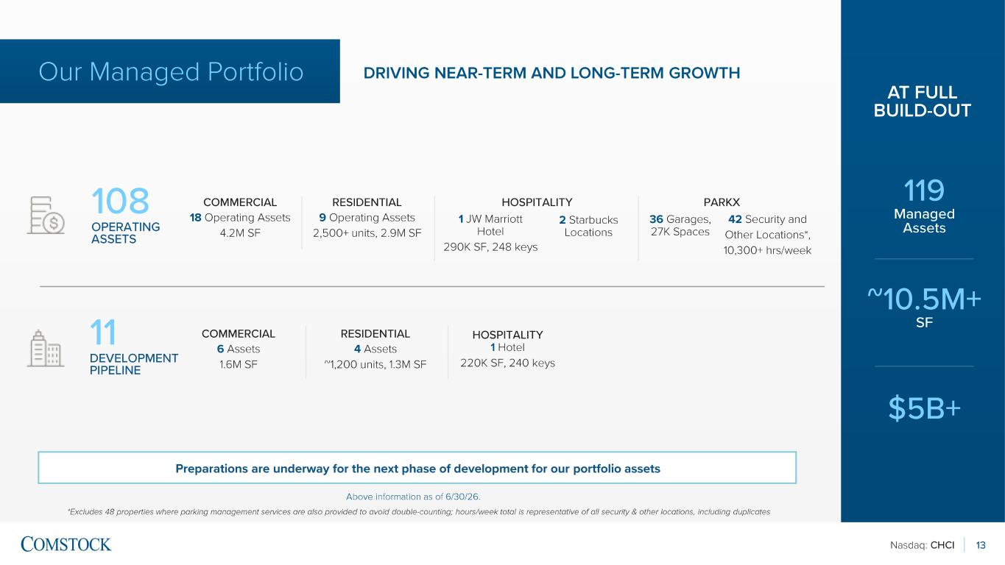
Nasdaq: CHCI 13 Above information as of 6/30/26. *Excludes 48 properties where parking management services are also provided to avoid double -counting; hours/week total is repres entative of all security & other locations, including duplicates COMMERCIAL 18 Operating Assets 4.2M SF RESIDENTIAL 9 Operating Assets 2,500+ units, 2.9M SF 36 Garages, 27K Spaces 42 Security and Other Locations*, 10,300+ hrs/week 1 JW Marriott Hotel 290K SF, 248 keys COMMERCIAL 6 Assets 1.6M SF RESIDENTIAL 4 Assets ~1,200 units, 1.3M SF HOSPITALITY 1 Hotel 220K SF, 240 keys 108 OPERATING ASSETS 11 DEVELOPMENT PIPELINE Our Managed Portfolio DRIVING NEAR -TERM AND LONG -TERM GROWTH 119 Managed Assets ~10.5M+ SF $5B+ AT FULL BUILD -OUT PARKX Preparations are underway for the next phase of development for our portfolio assets 2 Starbucks Locations HOSPITALITY

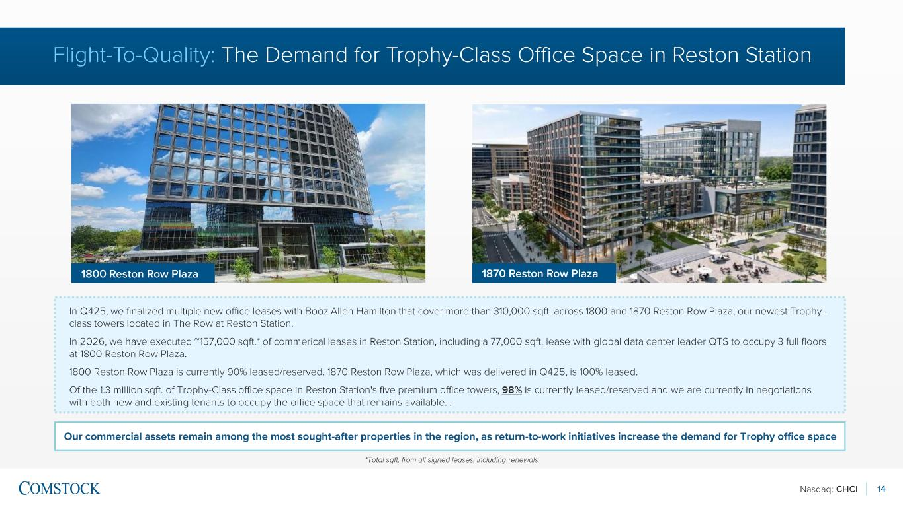
Nasdaq: CHCI 14 Flight-To-Quality: The Demand for Trophy -Class Office Space in Reston Station Our commercial assets remain among the most sought -after properties in the region, as return -to-work initiatives increase the de mand for Trophy office space In Q425, we finalized multiple new office leases with Booz Allen Hamilton that cover more than 310,000 sqft. across 1800 and 1870 Reston Row Plaza, our newest Trophy - class towers located in The Row at Reston Station. In 2026, we have executed ~157,000 sqft.* of commerical leases in Reston Station, including a 77,000 sqft. lease with global data center leader QTS to occupy 3 full floors at 1800 Reston Row Plaza. 1800 Reston Row Plaza is currently 90% leased/reserved. 1870 Reston Row Plaza, which was delivered in Q425, is 100% leased. Of the 1.3 million sqft. of Trophy -Class office space in Reston Station's five premium office towers, 98% is currently leased/reserved and we are currently in negotiations with both new and existing tenants to occupy the office space that remains available. . *Total sqft. from all signed leases, including renewals 1870 Reston Row Plaza1800 Reston Row Plaza

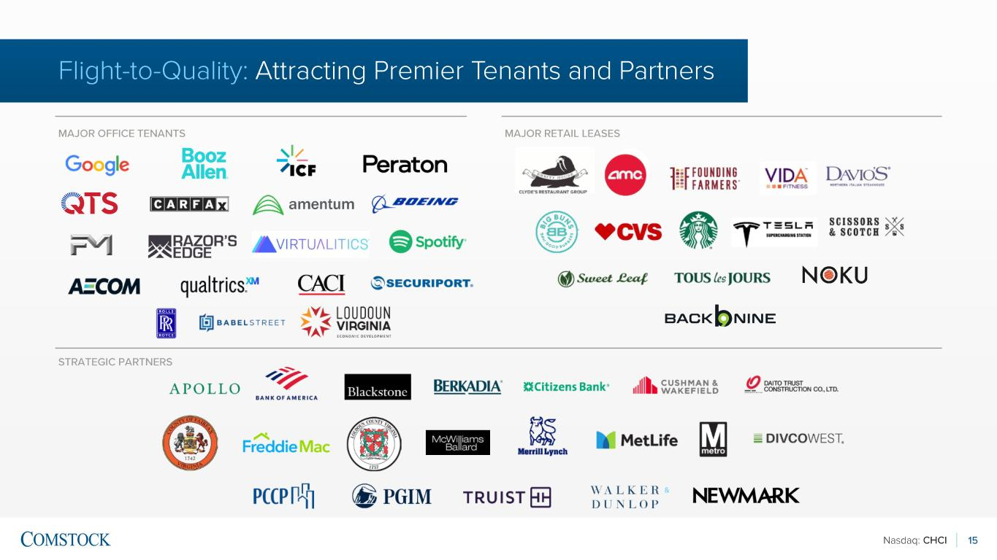
Nasdaq: CHCI 15 Flight-to-Quality: Attracting Premier Tenants and Partners MAJOR OFFICE TENANTS MAJOR RETAIL LEASES STRATEGIC PARTNERS

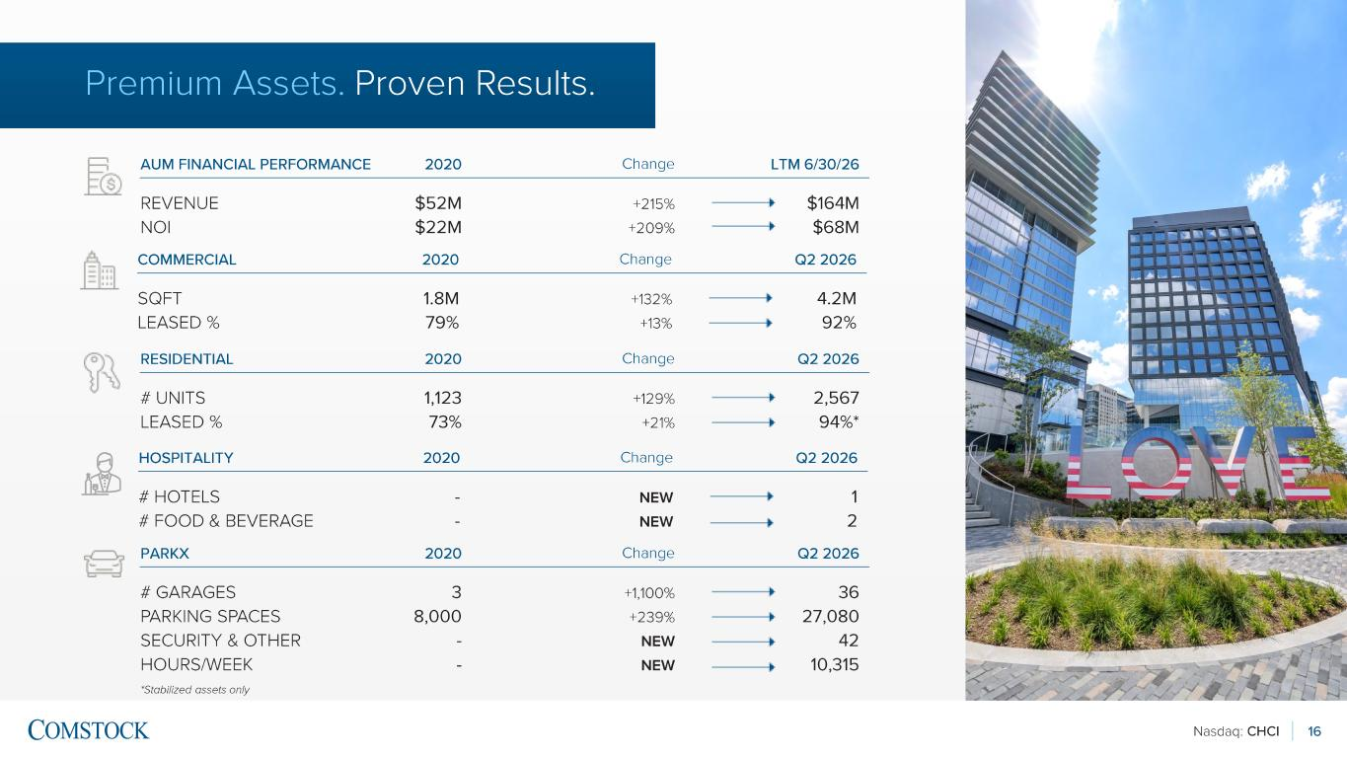
Nasdaq: CHCI 16 Premium Assets. Proven Results. AUM FINANCIAL PERFORMANCE 2020 LTM 6/30/26Change REVENUE NOI $52M $22M $164M $68M +215% +209% RESIDENTIAL 2020 Q2 2026Change # UNITS LEASED % 1,123 73% 2,567 94%* +129% +21% COMMERCIAL 2020 Q2 2026Change SQFT LEASED % 1.8M 79% 4.2M 92% +132% +13% PARKX 2020 Q2 2026Change # GARAGES PARKING SPACES SECURITY & OTHER HOURS/WEEK 3 8,000 - - 36 27,080 42 10,315 +1,100% +239% NEW NEW *Stabilized assets only HOSPITALITY 2020 Q2 2026Change # HOTELS # FOOD & BEVERAGE - - 1 2 NEW NEW

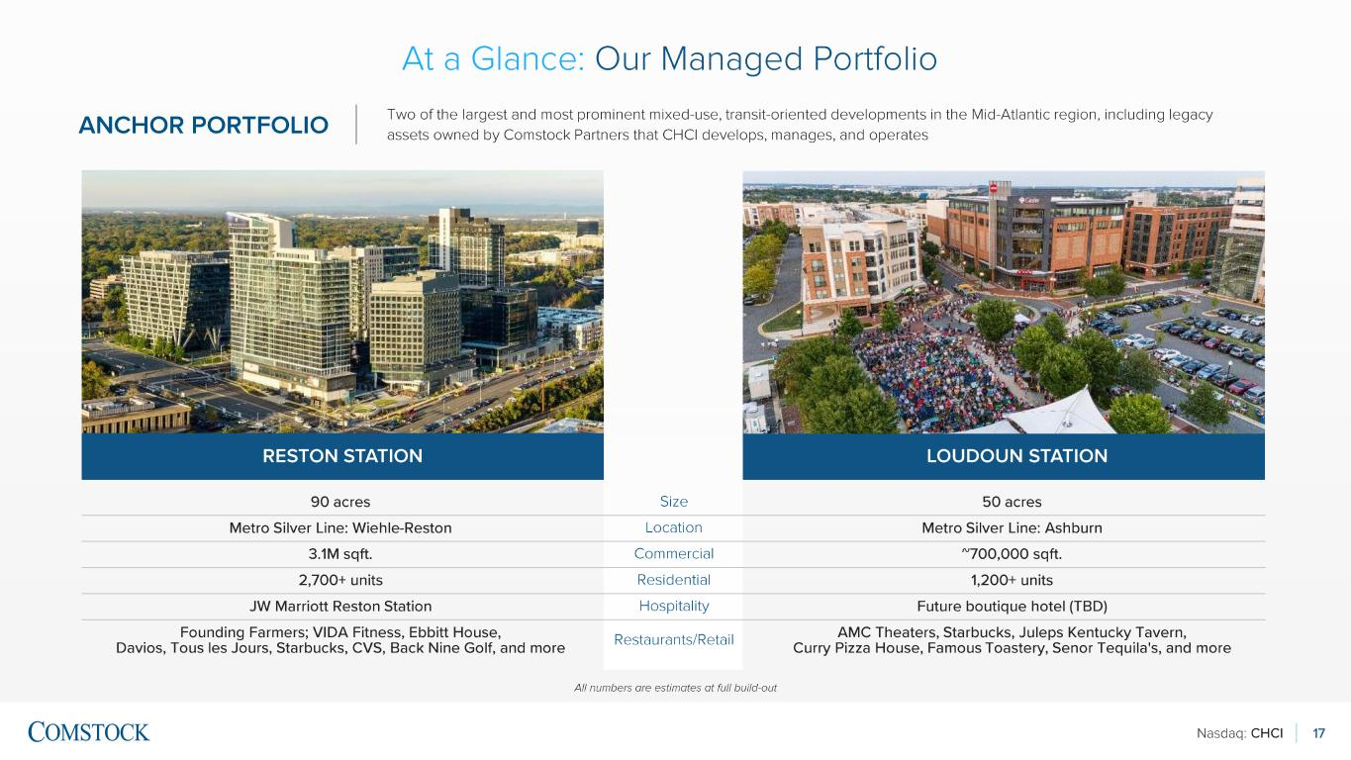
Nasdaq: CHCI 17 ANCHOR PORTFOLIO Two of the largest and most prominent mixed -use, transit-oriented developments in the Mid -Atlantic region, including legacy assets owned by Comstock Partners that CHCI develops, manages, and operates RESTON STATION LOUDOUN STATION 90 acres Size 50 acres Metro Silver Line: Wiehle -Reston Location Metro Silver Line: Ashburn 3.1M sqft. Commercial ~700,000 sqft. 2,700+ units Residential 1,200+ units JW Marriott Reston Station Hospitality Future boutique hotel (TBD) Founding Farmers; VIDA Fitness, Ebbitt House, Davios, Tous les Jours , Starbucks, CVS, Back Nine Golf, and more Restaurants/Retail AMC Theaters, Starbucks, Juleps Kentucky Tavern, Curry Pizza House, Famous Toastery , Senor Tequila's, and more All numbers are estimates at full build -out At a Glance : Our Managed Portfolio

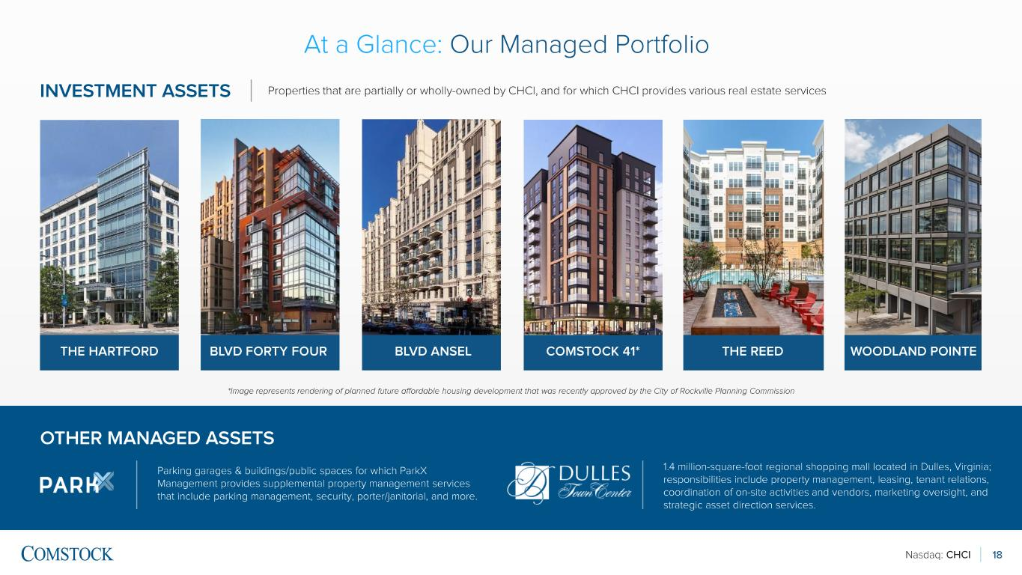
Nasdaq: CHCI INVESTMENT ASSETS 18 THE HARTFORD BLVD FORTY FOUR COMSTOCK 41*BLVD ANSEL Parking garages & buildings/public spaces for which ParkX Management provides supplemental property management services that include parking management, security, porter/janitorial, and more. OTHER MANAGED ASSETS Properties that are partially or wholly -owned by CHCI, and for which CHCI provides various real estate services At a Glance : Our Managed Portfolio *Image represents rendering of planned future affordable housing development that was recently approved by the City of Rockvi lle Planning Commission THE REED 1.4 million-square -foot regional shopping mall located in Dulles, Virginia; responsibilities include property management, leasing, tenant relations, coordination of on -site activities and vendors, marketing oversight, and strategic asset direction services. WOODLAND POINTE

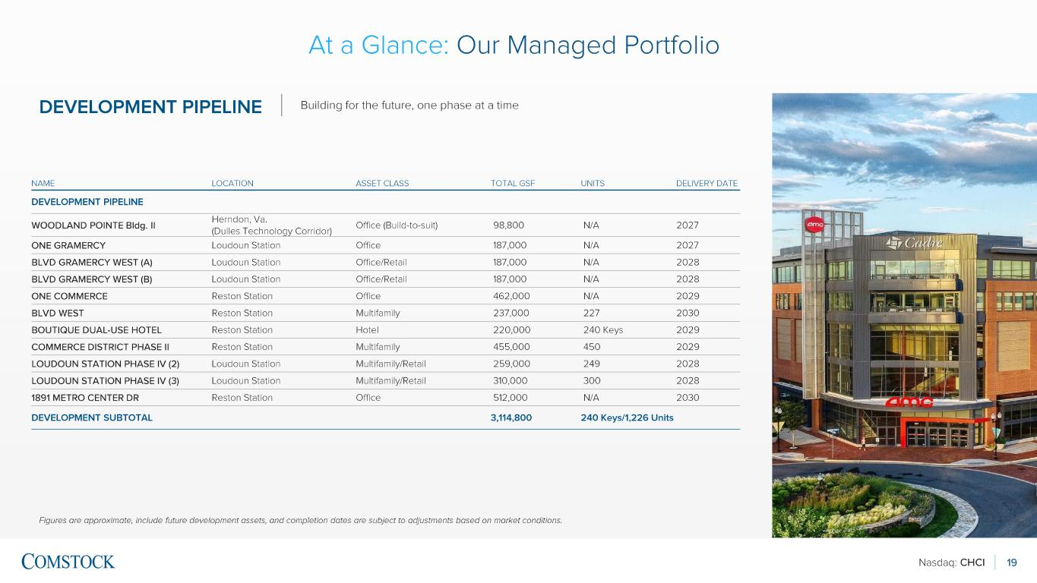
Nasdaq: CHCI 19 DEVELOPMENT PIPELINE Figures are approximate, include future development assets, and completion dates are subject to adjustments based on market c ond itions. NAME LOCATION ASSET CLASS TOTAL GSF UNITS DELIVERY DATE DEVELOPMENT PIPELINE WOODLAND POINTE Bldg. II Herndon, Va. (Dulles Technology Corridor ) Office (Build -to-suit) 98,800 N/A 2027 ONE GRAMERCY Loudoun Station Office 187,000 N/A 2027 BLVD GRAMERCY WEST (A) Loudoun Station Office/Retail 187,000 N/A 2028 BLVD GRAMERCY WEST (B) Loudoun Station Office/Retail 187,000 N/A 2028 ONE COMMERCE Reston Station Office 462,000 N/A 2029 BLVD WEST Reston Station Multifamily 237,000 227 2030 BOUTIQUE DUAL -USE HOTEL Reston Station Hotel 220,000 240 Keys 2029 COMMERCE DISTRICT PHASE II Reston Station Multifamily 455,000 450 2029 LOUDOUN STATION PHASE IV (2) Loudoun Station Multifamily/Retail 259,000 249 2028 LOUDOUN STATION PHASE IV (3) Loudoun Station Multifamily/Retail 310,000 300 2028 1891 METRO CENTER DR Reston Station Office 512,000 N/A 2030 DEVELOPMENT SUBTOTAL 3,114,800 240 Keys/1,226 Units At a Glance : Our Managed Portfolio Building for the future, one phase at a time

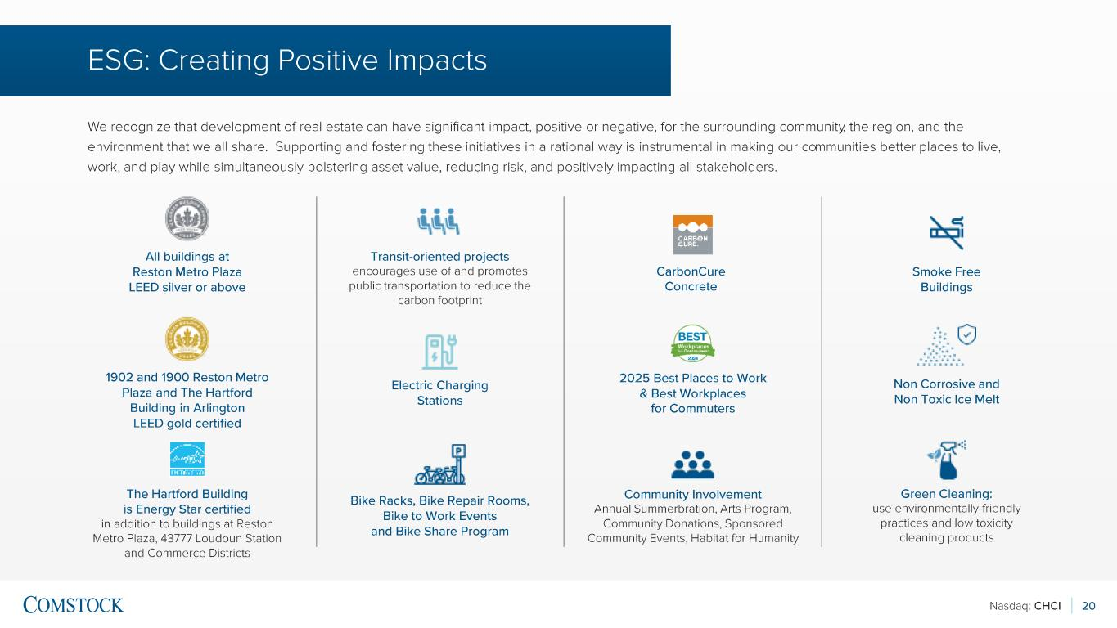
Nasdaq: CHCI 20 We recognize that development of real estate can have significant impact, positive or negative, for the surrounding community , the region, and the environment that we all share. Supporting and fostering these initiatives in a rational way is instrumental in making our co mmunities better places to live, work, and play while simultaneously bolstering asset value, reducing risk, and positively impacting all stakeholders. All buildings at Reston Metro Plaza LEED silver or above Green Cleaning: use environmentally -friendly practices and low toxicity cleaning products Electric Charging Stations 1902 and 1900 Reston Metro Plaza and The Hartford Building in Arlington LEED gold certified CarbonCure Concrete Bike Racks, Bike Repair Rooms, Bike to Work Events and Bike Share Program The Hartford Building is Energy Star certified in addition to buildings at Reston Metro Plaza, 43777 Loudoun Station and Commerce Districts Smoke Free Buildings Community Involvement Annual Summerbration , Arts Program, Community Donations, Sponsored Community Events, Habitat for Humanity Transit -oriented projects encourages use of and promotes public transportation to reduce the carbon footprint Non Corrosive and Non Toxic Ice Melt 2025 Best Places to Work & Best Workplaces for Commuters ESG: Creating Positive Impacts

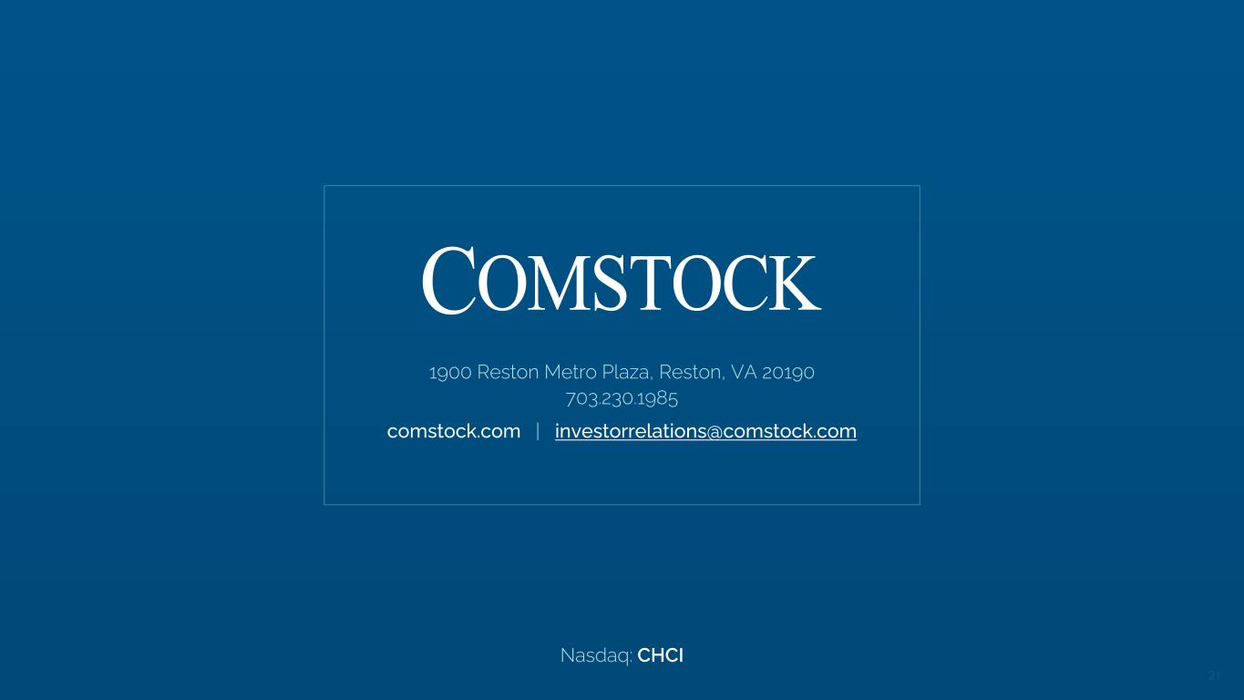
Nasdaq: CHCI 21 1900 Reston Metro Plaza, Reston, VA 20190 703.230.1985 comstock.com | investorrelations@comstock.com Nasdaq: CHCI


Nasdaq: CHCI 22 SUPPLEMENTAL INFORMATION

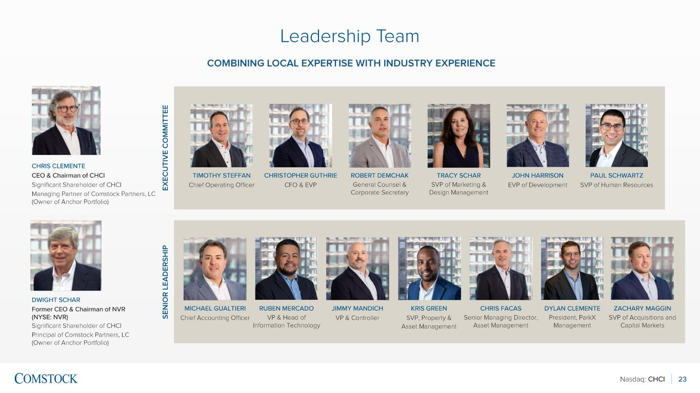
Nasdaq: CHCI 23 Leadership Team EX EC U TI V E C O M M IT TE E SE N IO R L EA D ER SH IP TIMOTHY STEFFAN Chief Operating Officer CHRISTOPHER GUTHRIE CFO & EVP ROBERT DEMCHAK General Counsel & Corporate Secretary TRACY SCHAR SVP of Marketing & Design Management JOHN HARRISON EVP of Development PAUL SCHWARTZ SVP of Human Resources MICHAEL GUALTIERI Chief Accounting Officer RUBEN MERCADO VP & Head of Information Technology JIMMY MANDICH VP & Controller KRIS GREEN SVP, Property & Asset Management CHRIS FACAS Senior Managing Director, Asset Management DYLAN CLEMENTE President, ParkX Management CHRIS CLEMENTE CEO & Chairman of CHCI Significant Shareholder of CHCI Managing Partner of Comstock Partners, LC (Owner of Anchor Portfolio) DWIGHT SCHAR Former CEO & Chairman of NVR (NYSE: NVR) Significant Shareholder of CHCI Principal of Comstock Partners, LC (Owner of Anchor Portfolio) COMBINING LOCAL EXPERTISE WITH INDUSTRY EXPERIENCE ZACHARY MAGGIN SVP of Acquisitions and Capital Markets

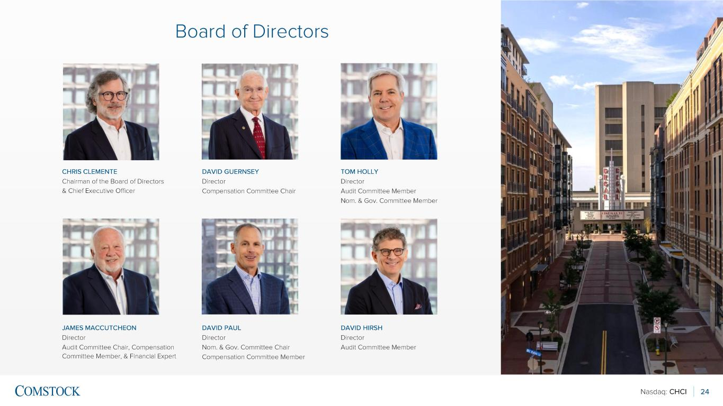
Nasdaq: CHCI 24 Board of Directors CHRIS CLEMENTE Chairman of the Board of Directors & Chief Executive Officer DAVID GUERNSEY Director Compensation Committee Chair TOM HOLLY Director Audit Committee Member Nom. & Gov. Committee Member JAMES MACCUTCHEON Director Audit Committee Chair, Compensation Committee Member, & Financial Expert DAVID PAUL Director Nom. & Gov. Committee Chair Compensation Committee Member DAVID HIRSH Director Audit Committee Member

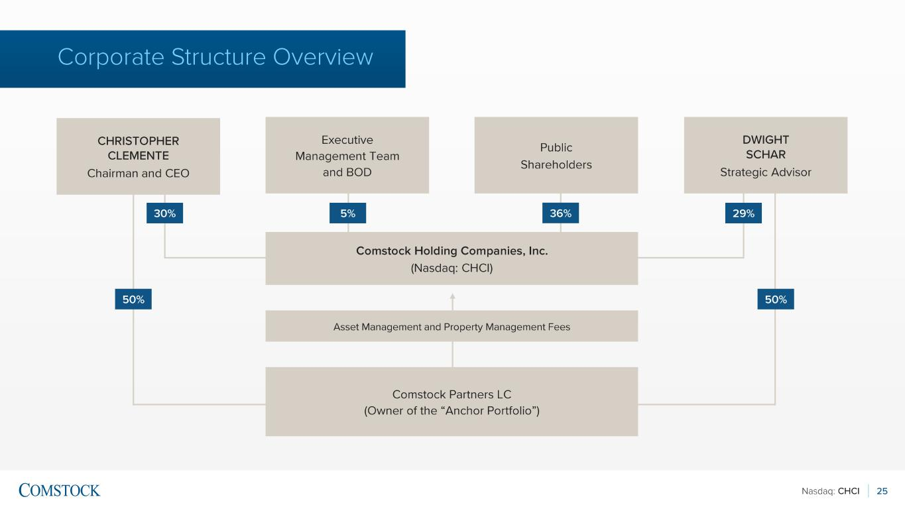
Nasdaq: CHCI 25 Corporate Structure Overview CHRISTOPHER CLEMENTE Chairman and CEO Executive Management Team and BOD Public Shareholders DWIGHT SCHAR Strategic Advisor Comstock Holding Companies, Inc. (Nasdaq: CHCI) Asset Management and Property Management Fees Comstock Partners LC (Owner of the “Anchor Portfolio”) 30% 5% 29% 50%50% 36%

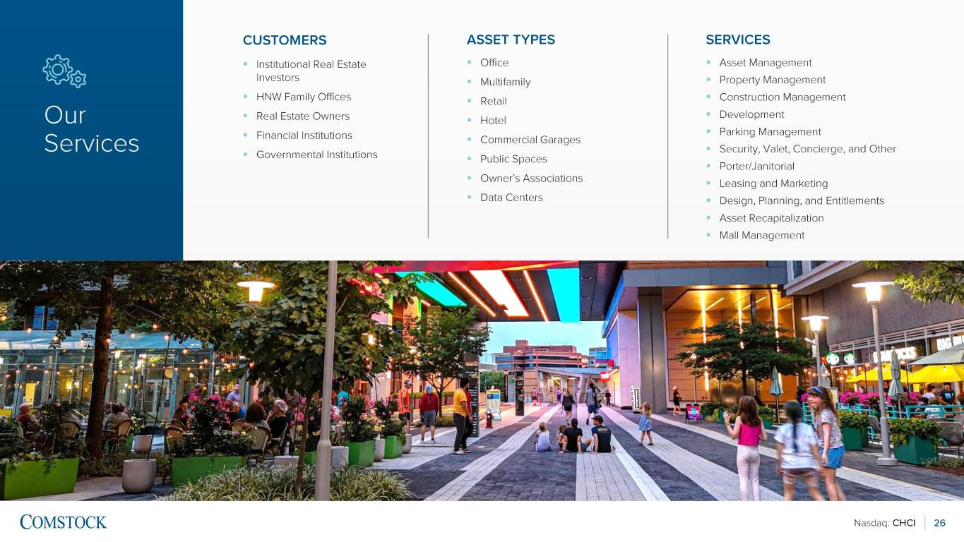
Nasdaq: CHCI 26 CUSTOMERS ▪ Institutional Real Estate Investors ▪ HNW Family Offices ▪ Real Estate Owners ▪ Financial Institutions ▪ Governmental Institutions ASSET TYPES ▪ Office ▪ Multifamily ▪ Retail ▪ Hotel ▪ Commercial Garages ▪ Public Spaces ▪ Owner’s Associations ▪ Data Centers SERVICES ▪ Asset Management ▪ Property Management ▪ Construction Management ▪ Development ▪ Parking Management ▪ Security, Valet, Concierge, and Other ▪ Porter/Janitorial ▪ Leasing and Marketing ▪ Design, Planning, and Entitlements ▪ Asset Recapitalization ▪ Mall Management Our Services

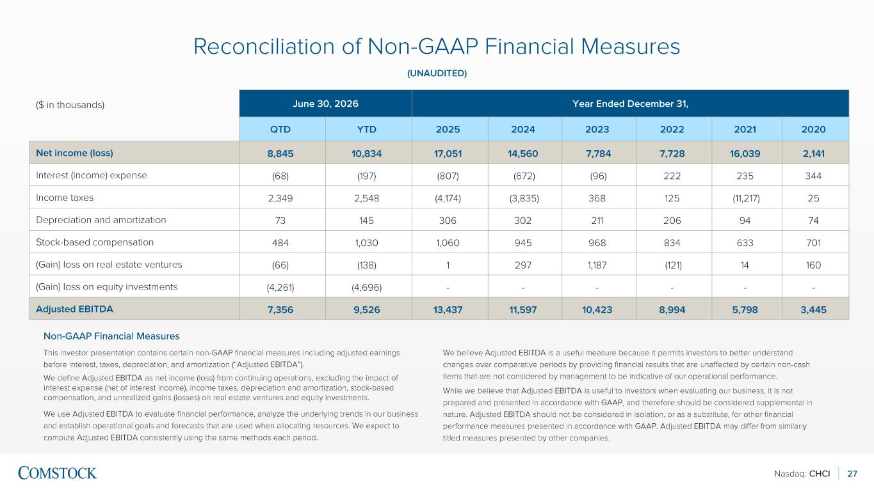
Nasdaq: CHCI 27 This investor presentation contains certain non -GAAP financial measures including adjusted earnings before interest, taxes, depreciation, and amortization (“Adjusted EBITDA”). We define Adjusted EBITDA as net income (loss) from continuing operations, excluding the impact of interest expense (net of interest income), income taxes, depreciation and amortization, stock -based compensation, and unrealized gains (losses) on real estate ventures and equity investments. We use Adjusted EBITDA to evaluate financial performance, analyze the underlying trends in our business and establish operational goals and forecasts that are used when allocating resources. We expect to compute Adjusted EBITDA consistently using the same methods each period. We believe Adjusted EBITDA is a useful measure because it permits investors to better understand changes over comparative periods by providing financial results that are unaffected by certain non -cash items that are not considered by management to be indicative of our operational performance. While we believe that Adjusted EBITDA is useful to investors when evaluating our business, it is not prepared and presented in accordance with GAAP, and therefore should be considered supplemental in nature. Adjusted EBITDA should not be considered in isolation, or as a substitute, for other financial performance measures presented in accordance with GAAP. Adjusted EBITDA may differ from similarly titled measures presented by other companies. Reconciliation of Non -GAAP Financial Measures (UNAUDITED) Non -GAAP Financial Measures ($ in thousands) June 30, 2026 Year Ended December 31, QTD YTD 2025 2024 2023 2022 2021 2020 Net income (loss) 8,845 10,834 17,051 14,560 7,784 7,728 16,039 2,141 Interest (income) expense (68) (197) (807) (672) (96) 222 235 344 Income taxes 2,349 2,548 (4,174) (3,835) 368 125 (11,217) 25 Depreciation and amortization 73 145 306 302 211 206 94 74 Stock -based compensation 484 1,030 1,060 945 968 834 633 701 (Gain) loss on real estate ventures (66) (138) 1 297 1,187 (121) 14 160 (Gain) loss on equity investments (4,261) (4,696) - - - - - - Adjusted EBITDA 7,356 9,526 13,437 11,597 10,423 8,994 5,798 3,445

